MODULE LESSONS
Kindergarten: Module 4
Enjoying and Appreciating Trees — Performance Task
Language Arts Curriculum
Summary of Task
Writing Opinion and High-Quality Artwork: Tree Appreciation Cards
In this two-part performance task, students write and create artwork to showcase their understanding of trees and inspire members of the community to enjoy and appreciate trees. Over the course of several lessons, students first write an opinion statement to complete the sentence stem “Trees are nice because ______.” Students create this statement by revising their writing from the Unit 3 Assessment to be more specific and focused. They then create a high-quality piece of artwork showcasing a specific part of a tree to match their writing. These two parts (opinion writing and high-quality artwork) come together to create a Tree Appreciation card. For the second part of the performance task, students select a specific part of a tree to match their writing and engage in several rounds of pencil sketching. Students then outline their final pencil sketch in black ink and apply watercolor in layers to create their final piece of artwork to include on the Tree Appreciation card. This task addresses CCSS ELA W.K.1, W.K.5, W.K.6, W.K.8, L.K.2a, and L.K.2b.

Recall that EL Education believes that high-quality work is a reflection and result of the high expectations teachers have for all students. Thus, it is a means to excellence and equity. The performance task for this module allows for students to create high-quality work based on their deep knowledge of trees. Using the literacy skills built throughout the school year; knowledge built in Modules 3–4; and cycles of drafting, critique, and revision, students are able to create a high-quality product that showcases their learning for the year. Unit 3 supports this work for the performance task with both the design of its lessons and the use of optional flex days.

In addition to the opportunities for critique, feedback, and revision, students are given an opportunity to present their Tree Appreciation cards to an audience during the End of Module Celebration. Creating work for an authentic audience motivates students to meet standards and engage in revision, so, in addition to students’ families and friends, consider inviting local tree experts and enthusiasts, arborists, and park officials to celebrate students’ hard work with them at the celebration.

The purpose of the optional flex days in this unit is to allow for additional time, as needed, to support students with the use of technology, drafting of artwork, and student presentations for a high-quality end of year performance task. Refer to the Unit-at-a-Glance chart in the Unit 3 Overview for additional information.
Format
Two Parts: Opinion Writing and High-Quality Artwork: Tree Appreciation Cards

Part I: Opinion Writing
- Students complete the sentence stem “Trees are nice because ____________.”
- Students revise their sentence from the Unit 3 Assessment to be more focused and detailed and to include a specific tree part.
- The writing task is scaffolded through the use of a familiar written structure, a sentence stem, anchor charts, oral processing, and teacher modeling.

Part II: High-Quality Artwork
- The task includes high-quality artwork that students create throughout the unit with multiple drafts and revisions. The subject of their art is the “zoomed-in” part of the tree they address in their writing.
Standards Addressed through This Task
- W.K.1: Use a combination of drawing, dictating, and writing to compose opinion pieces in which they tell a reader the topic or the name of the book they are writing about and state an opinion or preference about the topic or book (e.g., My favorite book is...).
- W.K.5: With guidance and support from adults, respond to questions and suggestions from peers and add details to strengthen writing as needed.
- W.K.6: With guidance and support from adults, explore a variety of digital tools to produce and publish writing, including in collaboration with peers.
- W.K.8: With guidance and support from adults, recall information from experiences or gather information from provided sources to answer a question.
- L.K.2a: Capitalize the first word in a sentence and the pronoun I.
- L.K.2b: Recognize and name end punctuation.
Student-Friendly Task Invitation/Task Description
We have learned how we can benefit from and enjoy trees. Use everything you know to inspire people in our community to appreciate and enjoy trees just as much as we do. You will make a card on which you write an opinion statement about what makes trees nice. Your card will also include a pencil sketch of a tree part that you will revise, outline in black ink, and then complete with layers of watercolor.
You will share your cards with our community at our End of Module Celebration so we can make sure they know the many reasons to appreciate trees!
 Key Criteria for Success (Aligned with CCSS ELA)
Below are key criteria students need to address when completing this task. Specific lessons during the module build in opportunities for students to understand the criteria.

Students’ writing should include:
- Completion of the following sentence stem with a specific reason: “Trees are nice because______.”
- Revisions to the completed sentence from the Unit 3 Assessment to include more details such as a specific tree part and edits for conventions
- Information from the Reasons to Plant a Tree anchor chart
Students’ art should include:
- An accurate and neat pencil sketch, outlined in black ink, of a specific part of a tree that matches their writing
- Neutral watercolor background and accurate watercolor applied in layers to the pencil sketched tree part
Options for Students
- Students could create a tree fact page to share during the End of Module Celebration.
- Student writing could be various lengths, the minimum being one sentence for those for whom language is a barrier or longer for those needing an extension.
- Differentiate support for students who may be in different places with inventive spelling.
- Students could practice rereading their writing.
Options for Teachers
- Students may present their projects to their own class, to other classes in the school, or to parents or other adults.
- Consider capturing student revisions to their Unit 3 Assessment writing through oral dictation.
- Consider other audiences from the community for students to present their Tree Appreciation cards (e.g., pre-K class, local library).
- Consider creating copies of the Tree Appreciation cards to distribute or sell to the community to help encourage a love of trees.
- Consider videotaping students reading their cards to share with family members who are unable to attend the End of Module Celebration.
- Flex days can be used at any point in the process to help students spend time where it is most needed.
Resources and Links
Central Text and Informational Texts
- Muldrow, Diane. We Planted a Tree. Random House Children’s, 2010. ISBN: 9780553539035 (one per classroom)
- Napoli, Donna Jo. Mama Miti: Wangari Maathai and the Trees of Kenya. Simon & Schuster, 2010. ISBN: 9781416935056 (one per classroom)
- Udry, Janice May. A Tree Is Nice. HarperCollins, 1956. ISBN: 9780064431477 (six per classroom)
Model Performance Task:
Tree Appreciation Card
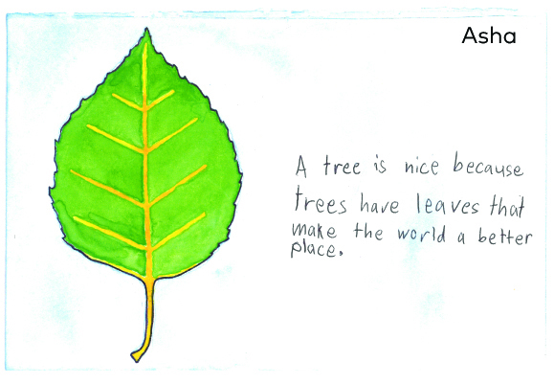
Model First Draft Sketches
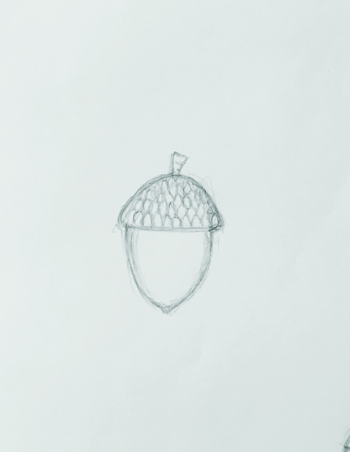 | 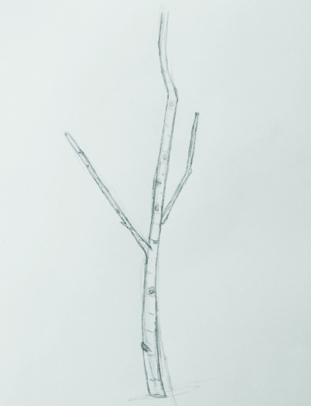
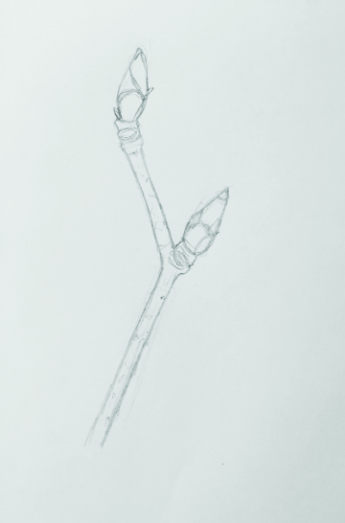 | 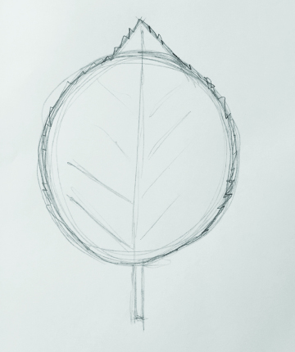
Model Second Draft Sketch
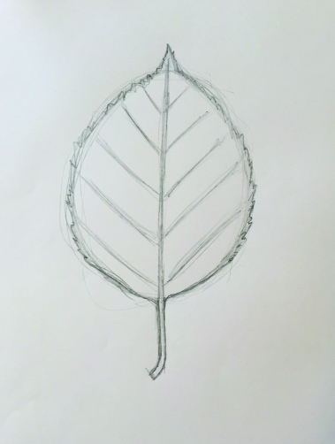
Model Final Sketch
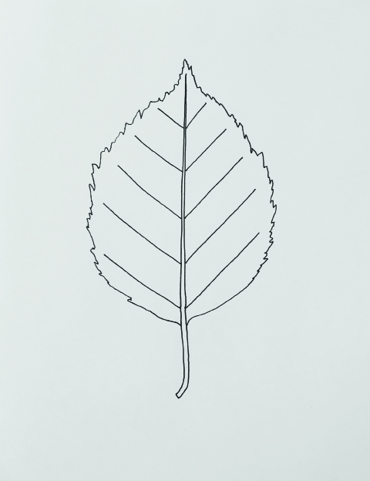
Model Watercolor 1
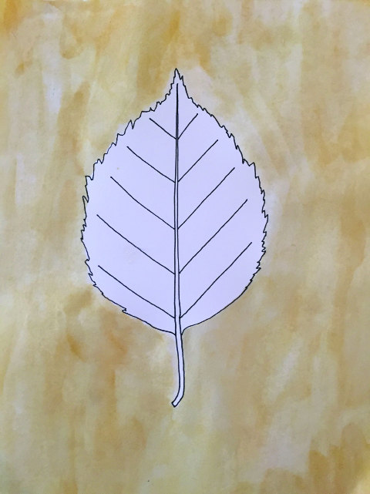
Model Watercolor 2
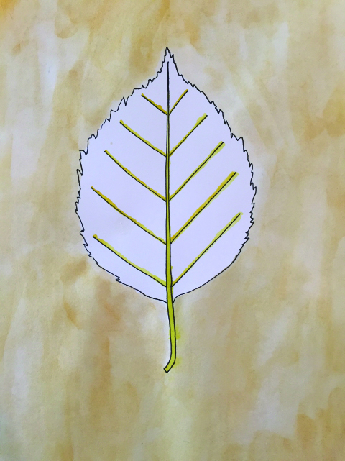
Model Watercolor 3
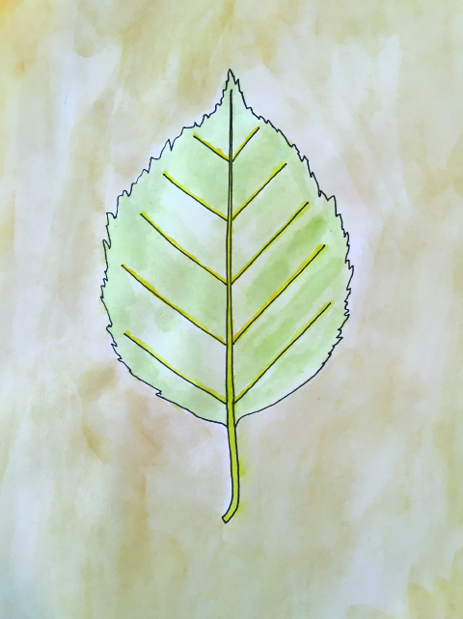
Performance Task Artwork Template
Name: ____________________________________ Date: ___________________
Paste final student writing from the Performance Task Writing Template here
Performance Task Writing Template
Note to Teacher: Cut out the boxes below and distribute one per student. Once students have published their writing in the box, affix the box to their final Performance Task Artwork template to create their Tree Appreciation card.

Image Credits
Pages 6-12. Model artwork by Anna Loring for EL Education.

