MODULE LESSONS
Grade 1: Module 1: Unit 2
Tools and Work — Assessment
Language Arts Curriculum
Unit 2 Assessment: Focused Read Aloud Session 4 and Writing about Habits of Character
(For Teacher Reference)
This assessment centers on CCSS ELA RL.1.1, RL.1.3, RL.1.4, RL.1.7, W.1.2, and SL.1.1. For this assessment, students engage in a focused read aloud of The Little Red Pen. Students ask and answer questions about the characters’ words and actions, use context to determine the meaning of unfamiliar vocabulary from the text, and make connections between the illustrations and the text. Students then write to show their understanding of the text by responding to the final focusing question using evidence from the text: “How are the characters showing collaboration in this part of the text? What work does this help them do?” (RL.1.1, RL.1.3, RL.1.4, RL.1.7, W.1.2, SL.1.1).

CCSS Assessed:
- RL.1.1: Ask and answer questions about key details in a text.
- RL.1.3: Describe characters, settings, and major events in a story, using key details.
- RL.1.4: Identify words and phrases in stories or poems that suggest feelings or appeal to the senses.
- RL.1.7: Use illustrations and details in a story to describe its characters, setting, or events.
- W.1.2: Write informative/explanatory texts in which they name a topic, supply some facts about the topic, and provide some sense of closure.
- SL.1.1: Participate in collaborative conversations with diverse partners about grade 1 topics and texts with peers and adults in small and larger groups.

Assessment Directions:
Parts I and II are both administered in Unit 2, Lesson 10.

Part I: Focused Read-aloud: The Little Red Pen, Pages 37-46
1. Move students into pre-determined partnerships.
2. Distribute Session 4, Feeling Words: Student Response Sheets and materials for response sheets (see Teaching Notes).
3. Display Tools and read pages 37-46, pausing to engage students in asking and answering questions about the text with a partner.
4. Collect students’ Session 4, Feeling Words: Student Response Sheets.
5. Ask students to turn and talk with their partner:
“What happened once all the characters were saved from the pit?” (They decided to work together and grade the papers.)
6. Circulate to collect information on the Reading Literature Checklist (RL.1.1, RL.1.3, and RL.1.7).

Part II: Independent Writing: “What Work Does Collaboration Help the Characters Do?”
1. Transition students back to their workspaces and orient them to the Unit 2 Assessment: Student Response Sheet.
2. Facilitate students’ progression through the response sheet by reading the directions and waiting for student to complete each task before moving on.
Unit 2 Assessment: Student Response Sheet
Name: ________________________ Date: _______________
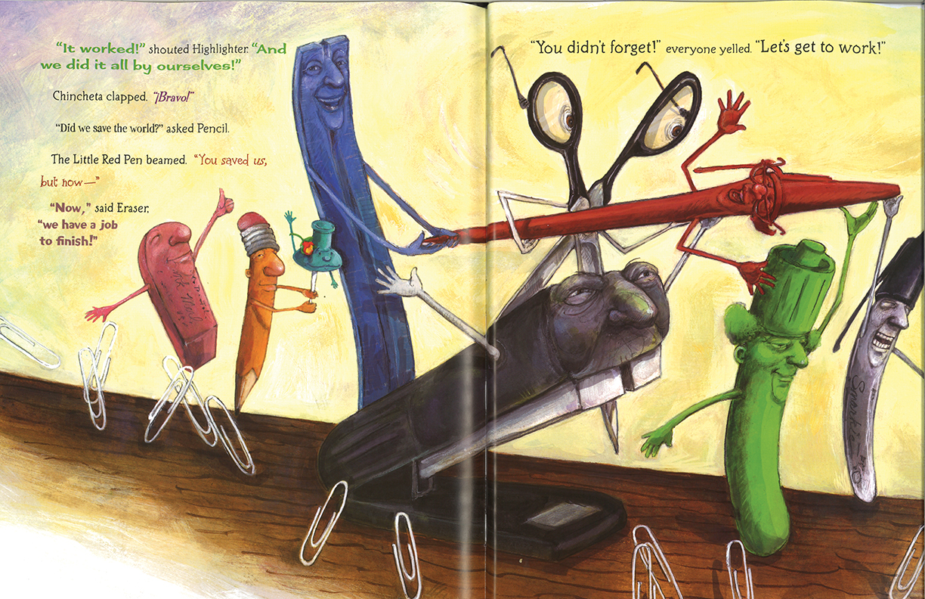

In this part of the text, how is the Little Red Pen feeling?
Circle the face that shows you how she is feeling.




Circle the word in this sentence that helped you know how she was feeling.
The Little Red Pen beamed.
In this part of the text, how are the characters showing collaboration? What work does collaboration help them do? Write on the lines below. Use evidence to support your answer.

These characters are showing collaboration.

This is one way they got the job done.
Unit 2 Assessment: Student Response Sheet
(Answers, for Teacher Reference)

In this part of the text, how is the Little Red Pen feeling?
Circle the face that shows you how she is feeling.

Circle the word in this sentence that helped you know how she was feeling.

The Little Red Pen beamed.

In this part of the text, how are the characters showing collaboration? What work does collaboration help them do? Write on the lines below. Use evidence to support your answer.

These characters are showing collaboration.

The characters are showing collaboration by working together OR helping each other OR each doing part of the job.

This helps them grade the papers.

This is one way they got the job done.
Image Credits

Page 4-7. From THE LITTLE RED PEN by Janet Stevens and Susan Stevens Crummel. Text copyright © 2011 by Janet Stevens and Susan Stevens Crummel. Illustrations copyright © 2011 by Janet Stevens. Reprinted by permission of Houghton Mifflin Harcourt Publishing Company. All rights reserved

