READING FOUNDATIONS
SKILLS BLOCK
Grade K: Module 3: Cycle 17: Lesson 89
Language Arts Curriculum
Rhyming Picture Cards
 |  |  | 
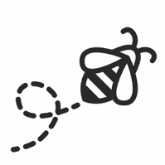 |  | 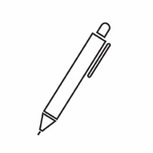 | 
 |  |  | 
 |  |  | 
 |  | 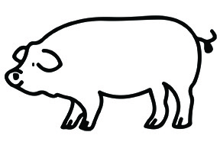 | 
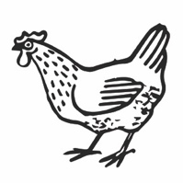 |  |  | 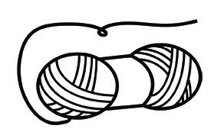
Interactive Poem:
“Jumping on the Bed”
Directions: When writing the poem on sentence strips, omit the underlined words.

Jumping on the Bed
My mom says not to jump on the bed,
But I did, and now my leg is red!
I jumped up on top,
And I did not stop.
It was a bad fall and my feet were not set;
I wish under my bed, I had a big net.
If I had a net, it would have saved me,
By now I’d feel better, and better I’d be!
Snapshot Assessment (optional)
Name: ___________________________________________ Date: _________________
Student Can: |  | Student Can: |  | Notes:
Create a new rhyming word by changing the first sound in a given word |  | Write the letter or letters for most of the consonants
Point to each word in a line of memorized text |  | Write the letter “i” for the vowel sound /i/
Point to words in a shared poem |  | Print many lowercase letters
Write the letter “i” for the vowel sound /ī/

Rhyme Matching Sheet
Directions: Paste matching pairs of rhyming words together.

Rime Pattern Pictures
 |  |  | 
 |  | 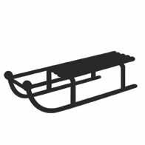 | 
 |  | 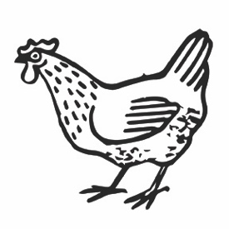 | 
   | 
Rime Pattern Sort Sheet
-ed | -en | -ig | -ap | -un

