READING FOUNDATIONS
SKILLS BLOCK
Grade K: Module 3: Cycle 16: Lesson 84
Language Arts Curriculum
Rhyming Picture Cards

 |  |  | 
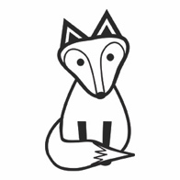 |  |  | 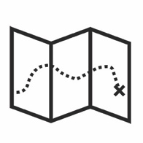
 |  |  | 
 |  |  | 
 |  |  | 

Interactive Poem: “Popcorn!”
Directions: When writing the poem on sentence strips, omit the underlined words.

Popcorn!

Popcorn pops when it is hot.

Pop-pop-pop, the sound of hopping in a pot!

Quick! Put a lid on the top.

If we don’t, we’ll need a mop.

I want to help by doing this job.

Much better than eating corn on the cob!

Snapshot Assessment (optional)
Name: ___________________________________________ Date: _________________
Student Can: |  | Student Can: |  | Notes:
Create a new rhyming word by changing the first sound in a given word |  | Write the letter “o” for the vowel sound /o/
Point to each word in a line of memorized text |  | Write the letter or letters for most of the consonants
Point to words in a shared poem |  | Print many lowercase letters

Rhyme Matching Sheet
Directions: Paste matching pairs of rhyming words together.
Rime Pattern Pictures
 |  |  | 
 |  |  | 
   |  |  | 
 |  | 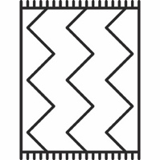 | 

Rime Pattern Sort Sheet
-ot | -og | -ock | -un | -ug

