READING FOUNDATIONS
SKILLS BLOCK
Grade K: Module 3: Cycle 14: Lesson 74
Language Arts Curriculum
Snapshot Assessment (optional)
Name: ___________________________________________ Date: _________________
Student Can: |  | Student Can: |  | Notes:
Create a new rhyming word by changing the first sound in a given word |  | Write the letter or letters for most of the consonants
Point to each word in a line of memorized text |  | Write the letter “i” for the vowel sound /i/
Point to words in a shared poem |  | Print many lowercase letters

Interactive Poem: “Bee Sting”
Directions: When writing the poem on chart paper or sentence strips, omit the underlined words.

Bee Sting
I have a bee sting on my lip
At first the bee landed on my hip
And then it flew to another kid
So I ran behind a tree and hid
But that bee flew back to my chin
Now I have a big red spot on my skin!
Rhyming Picture Cards
 |  |  | 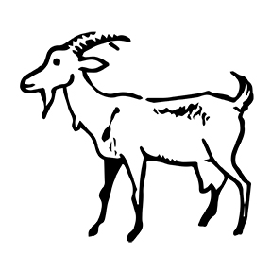
 |  |  | 
 |  |  | 
 |  | 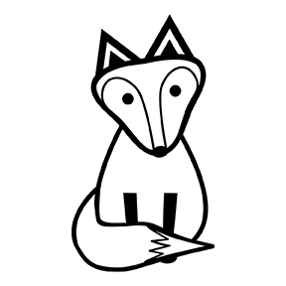 | 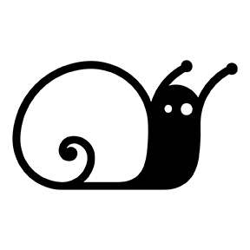
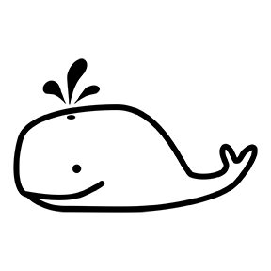 |  |  | 
Rhyme Matching Sheet
Directions: Paste matching pairs of rhyming words together.

Rime Pattern Pictures
 |  | 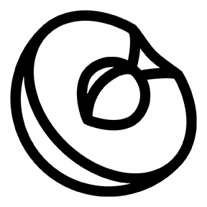 | 
 |  |  | 
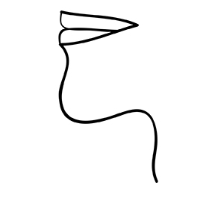 | 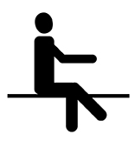 | 
Rime Pattern Sort Sheet
-in | -it | -ib | -ig

