READING FOUNDATIONS
SKILLS BLOCK
Grade K: Module 3: Cycle 13: Lesson 69
Language Arts Curriculum
Interactive Poem:
“Where Are We Going?”
Directions: When writing the poem on sentence strips, omit the underlined words.

Where Are We Going?
My dad said, “Let’s go! I’ll grab the map!”
I grabbed my coat and put on my cap.
My mom said, “Let’s go! I’ll pack some jam.”
I grabbed my dog and my teddy bear, Sam.
My sis said, “Let’s go! I’ll bring my bag.”
But as my dog’s tail began to wag …
I stopped to think just for a tad,
“Hey, where are we going, Mom and Dad?”

Snapshot Assessment (optional)
Name: ___________________________________________ Date: _________________
Student Can: |  | Student Can: |  | Notes:
Create a new rhyming word by changing the first sound in a given word |  | Write the letter or letters for most of the consonants
Point to each word in a line of memorized text |  | Write the letter “a” for the vowel sound /a/
Point to words in a shared poem |  | Print many lowercase letters

Rhyming Picture Cards

 |  |  | 
 |  | 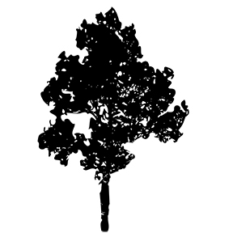 | 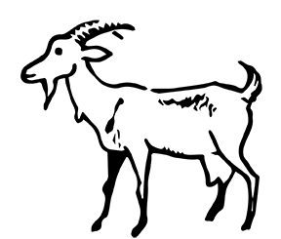
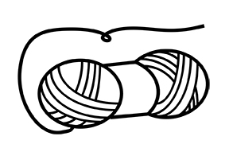 |  | 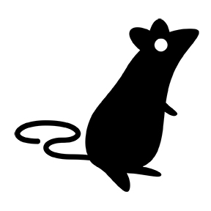 | 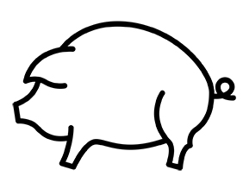
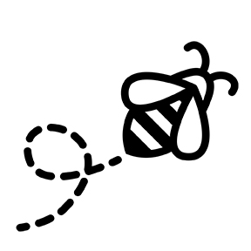 | 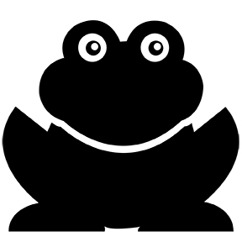 | 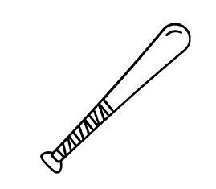 | 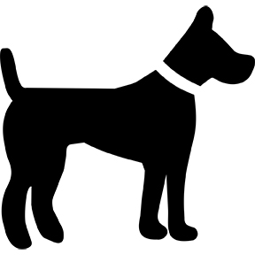
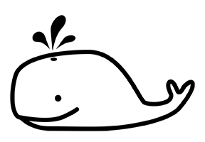 | 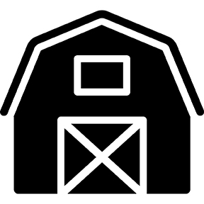 | 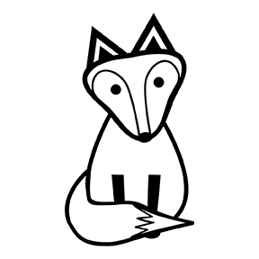 | 
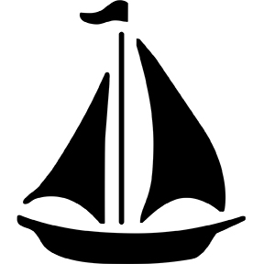 |  |  | 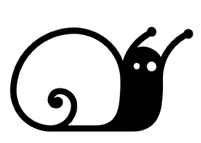
Rhyme Matching Sheet
Directions: Paste matching pairs of rhyming words together.

Rime Pattern Pictures
 |  | 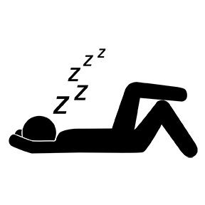 | 
 |  |  | 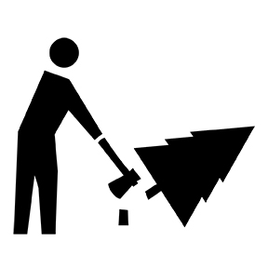
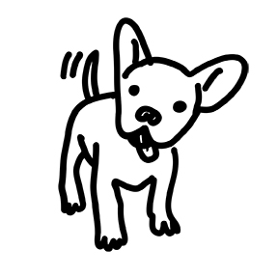 |  |  | 
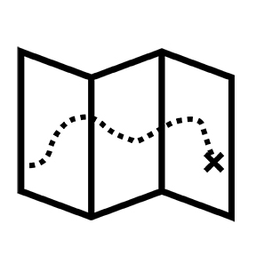 | 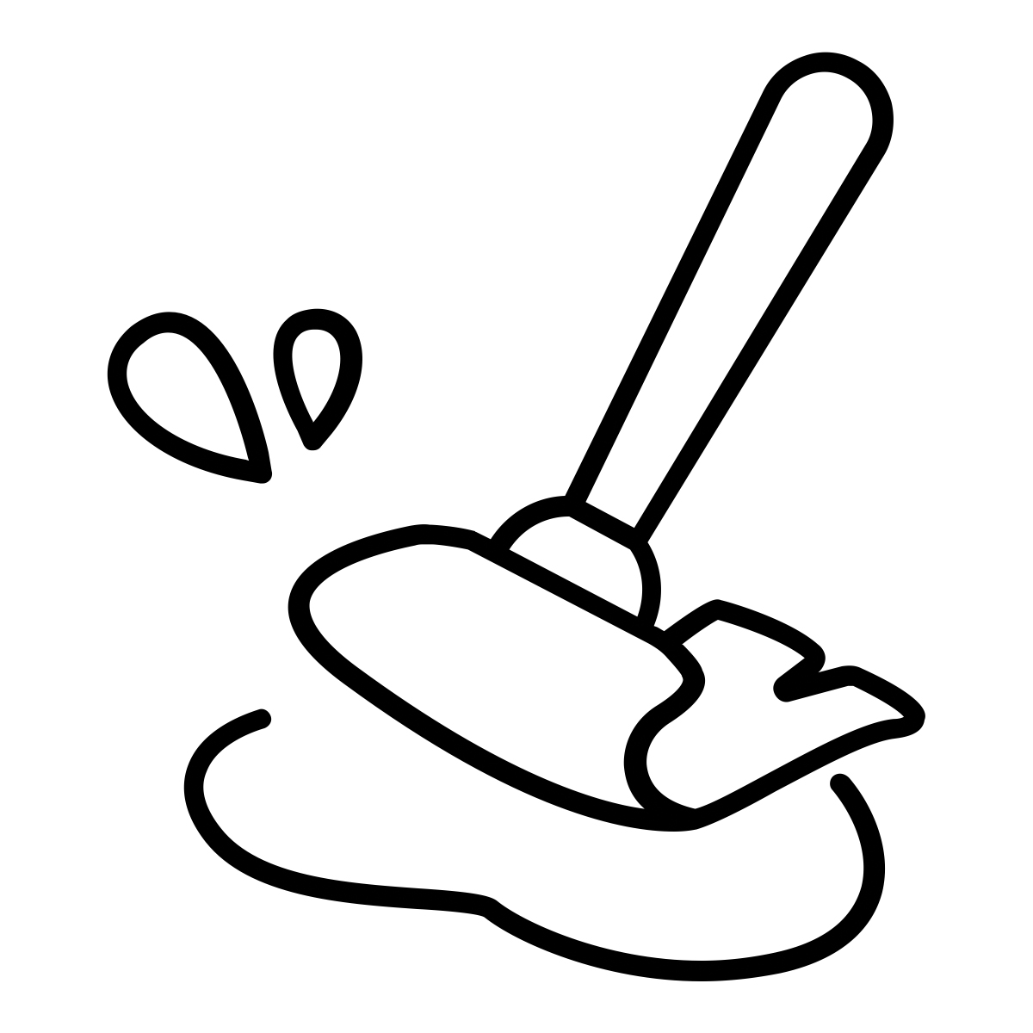 | 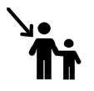 | 
Rime Pattern Sort Sheet
-op | -ug | -ad | -ag | -ap

