MODULE LESSONS
Kindergarten: Module 2: Unit 3: Lesson 1
Speaking and Listening: Preparing to Write Weather Stories
Language Arts Curriculum

“Sofia the Storyteller”
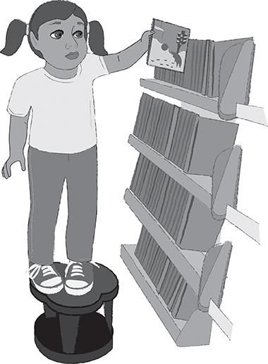

Sofia just loves library time at school because she gets to look at lots of different kinds of books and learn all about the world around her (because, as you know, Sofia is a very curious young girl!). One day Sofia was exploring a bookshelf in her school library when she noticed a cover of a book that caught her eye. Right there on the cover stood a little boy wearing a red coat and pants. He was standing in front of a large pile of snow, and he was looking at his footprints. Sofia thought to herself, “I think this book is about snow! I love snow! In fact, I just love the weather!”
“Sofia the Storyteller”
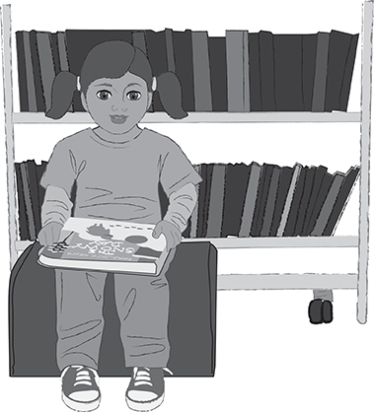

Sofia sat down and started flipping through the pages of the book. She saw pictures of the little boy looking out the window, playing in the snow, and taking a bath. Sofia wondered, “I wonder who this little boy is and what he is doing?” She couldn’t yet read all the words on her own, but she thought maybe her teacher would read it aloud to her if she borrowed it from the library.
“Sofia the Storyteller”
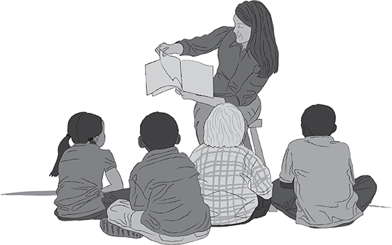

Sure enough, when Sofia got back to class, her teacher agreed to read the book to her (and the whole class, for that matter!).

Teacher commentary: Do you all want to hear the story? I thought so!
“Sofia the Storyteller”

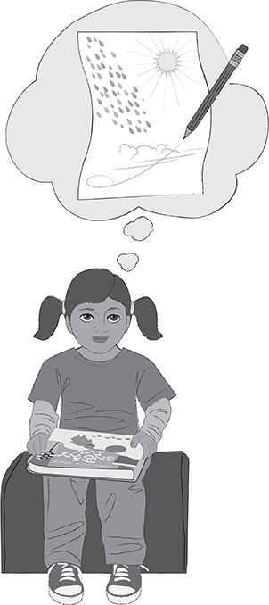
After Sofia’s teacher finished reading aloud The Snowy Day, Sofia started to think about how fun it would be to write her own weather story just as Ezra Jack Keats did. She was very curious about how she might turn some of the interesting facts she had learned about weather into a book that someone else would like to read. Sofia wondered, “How can I write a story that teaches my reader about weather?”

Teacher commentary: “Do you all think you could write weather stories like Ezra Jack Keats does? I thought so! Let’s get started!”

Written by EL Education for Instructional Purposes.
930L
Unit 3 Guiding Question Anchor Chart
- How can I write a story that teaches my reader about the weather?
Snowy Day Chart
Note to Teachers: Students will work collaboratively with the teacher to create this chart during Work Time B. This chart will serve as the model for students as they create charts in small groups during the latter part of Work Time B.
Snowy Day
Clothing to Wear:
(Students select and attach icons.)

Activities to Do:
(Each student draws a picture on an index card and attaches it. Be sure to add labels to this.)

Hot Day Chart
Note to Teachers: Students will work collaboratively in small groups to create this chart during Work Time B.
Hot Day
Clothing to Wear:
(Students select and attach icons.)

Activities to Do:
(Each student draws a picture on an index card and attaches it. Be sure to add labels to this.)

Windy Day Chart
Note to Teachers: Students will work collaboratively in small groups to create this chart during Work Time B.
Windy Day
Clothing to Wear:
(Students select and attach icons.)

Activities to Do:
(Each student draws a picture on an index card and attaches it. Be sure to add labels to this.)

Rainy Day Chart
Note to Teachers: Students will work collaboratively in small groups to create this chart during Work Time B.
Rainy Day
Clothing to Wear:
(Students select and attach icons.)

Activities to Do:
(Each student draws a picture on an index card and attaches it. Be sure to add labels to this.)

Clothing Pictures
Note to Teachers: Copy one set of pictures for each expert meteorologist chart. Cut out pictures in advance and
pre-distribute with charts before Work Time B.
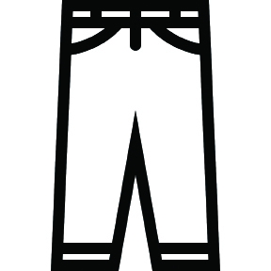 |  | 
 |  | 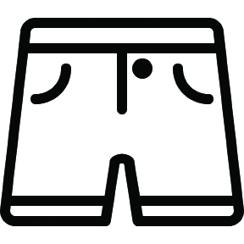
Clothing Pictures
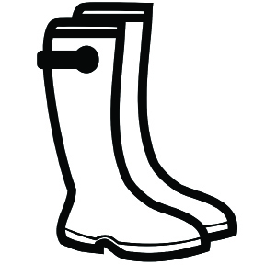 | 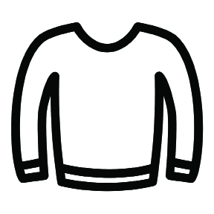 | 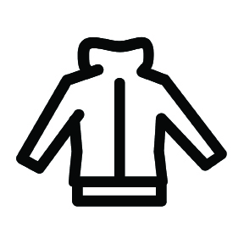
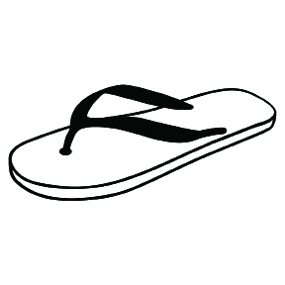 |  | 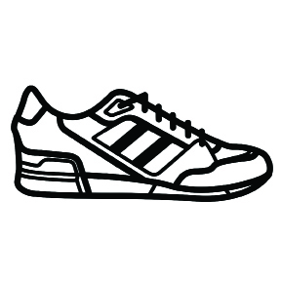

Image Credits
Pages 2-5. Illustrations by Stacey Posnett for EL Education.

