MODULE LESSONS
Grade 1: Module 2: Unit 2: Lesson 4
Close Read-aloud, Session 3:
What Makes Day and Night
Language Arts Curriculum

Adjectives Anchor Chart
(For Teacher Reference)
L.1.1f

Note to Teachers: Create this anchor chart before beginning the lesson. Below are adjectives that may have been circled/highlighted during Lesson 2.

An adjective is …
A word that describes a person, place, or thing.
round  orange  rising  large  yellow  bright  red  fiery  thin  dim | big  crescent  gibbous  white  gray  shiny  tiny  twinkly  high
“What We See: The Sun, Moon, and Stars” Poem Version 2
(Example, for Teacher Reference)
Note to Teachers: The blanks will be filled in during the Opening by referencing the Adjectives anchor chart.

“What We See: The Sun, Moon, and Stars”

In the morning, when the day has begun,

I see a _________ and _________rising sun.

During midday, I shade my eyes

Because the sun looks _________, _________, and _________.

By evening time, though the day is not over yet,

The sun looks _________and _________as it sinks below the horizon to set.

The moon can look different from night to night.

Sometimes it is _________and _________, sometimes it is _________and _________.

From _________moon to _________moon, it waxes and wanes;

Each night, the shape of the moon seems to change.

The moon can look _________, or _________, or _________,

Its color can change in a number of ways.

At night the stars _________and look so _________.
They are _________and _________, and give off some light.

There are so many stars that we can see in the dark sky.

They are far, far, away and so very _________.

The sun, moon, and stars can look different in so many ways;

It makes them interesting to observe in a deep gaze.
Working to Become Ethical People
Anchor Chart
(For Teacher Reference)

Habits for how we treat others

Habit of Character | What does it mean?
 | Respect | I treat myself, others, and the environment with care.
 | Integrity | I do the right thing even when it’s hard.
Sun Photograph 3
Note to Teachers: Display or copy this photograph in color (if possible).

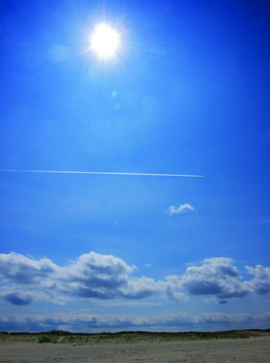
Moon Photograph 3
Note to Teachers: Display or copy this photograph in color (if possible).

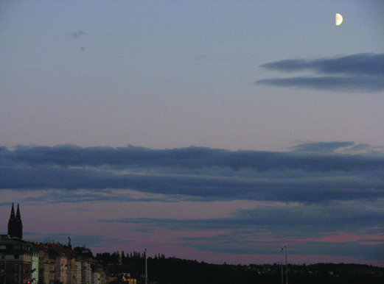

Sky Notebook
Name: ____________________________________________________ Date: _________________________
Page 1

W.1.8, L.1.1f, L.1.1i, L.1.1j, L.1.6

What does the sun look like?

Sky Notebook
Page 1

W.1.8, L.1.1f, L.1.1i, L.1.1j, L.1.6

(Answers, for Teacher Reference)

What does the sun look like?

Sketches will vary.

The sun is bright.

Sky Notebook
Name: ____________________________________________________ Date: __________________________
Page 2

W.1.8, L.1.1f, L.1.1i, L.1.1j, L.1.6

What does the moon look like?

Sky Notebook
Page 2

W.1.8, L.1.1f, L.1.1i, L.1.1j, L.1.6

(Answers, for Teacher Reference)

What does the moon look like?

Sketches will vary.

The moon is tiny.
Sky Notebook
Name: ____________________________________________________ Date: __________________________
Page 3

W.1.8, L.1.1f, L.1.1i, L.1.1j, L.1.6

What does the sun look like?

Sky Notebook
Page 3

W.1.8, L.1.1f, L.1.1i, L.1.1j, L.1.6

(Answers, for Teacher Reference)

What does the sun look like?

Sketches will vary.

The sun is yellow and large.
Sky Notebook
Name: ____________________________________________________ Date: __________________________
Page 4

W.1.8, L.1.1f, L.1.1i, L.1.1j, L.1.6

What does the moon look like?

Sky Notebook
Page 4

W.1.8, L.1.1f, L.1.1i, L.1.1j, L.1.6

(Answers, for Teacher Reference)

What does the moon look like?

Sketches will vary.

The moon is butterscotch.

Sky Notebook
Name: ____________________________________________________ Date: __________________________
Page 5

W.1.8, L.1.1f, L.1.1i, L.1.1j, L.1.6

What does the sun look like?

Where do we see the sun? (Or where in the sky is the sun?)

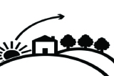 |  |  |  | 

Sky Notebook
Page 5

W.1.8, L.1.1f, L.1.1i, L.1.1j, L.1.6

(Answers, for Teacher Reference)

What does the sun look like?

The sun looks like a small, white ball.

Where do we see the sun? (Or where in the sky is the sun?)

 |  |  |  | 

The sun is above the horizon.
Sky Notebook
Name: ____________________________________________________ Date: __________________________
Page 6

W.1.8, L.1.1f, L.1.1i, L.1.1j, L.1.6

What does the moon look like? (Circle one.)

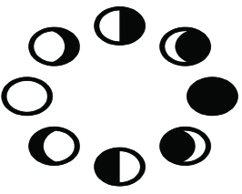

Where do we see the moon? (Or where in the sky is the moon?)

Sky Notebook
Page 6

W.1.8, L.1.1f, L.1.1i, L.1.1j, L.1.6

(Answers, for Teacher Reference)
What does the moon look like? (Circle one.)

The moon looks like a thin crescent.

Where do we see the moon? (Or where in the sky is the moon?)

The moon is just above the hill. (or) The moon is beside the hill.

Sky Notebook
Name: ____________________________________________________ Date: __________________________
Page 7

W.1.8, L.1.1f, L.1.1i, L.1.1j, L.1.6

What does the sun look like?

Where do we see the sun? (Or where in the sky is the sun?)

Sky Notebook
Page 7

W.1.8, L.1.1f, L.1.1i, L.1.1j, L.1.6

(Answers, for Teacher Reference)

What does the sun look like?

The sun looks like a bright, yellow ball in the sky.

Where do we see the sun? (Or where in the sky is the sun?)

The sun is behind the buildings. (or) The sun is on top of the buildings.

Sky Notebook
Name: ____________________________________________________ Date: __________________________
Page 8

W.1.8, L.1.1f, L.1.1i, L.1.1j, L.1.6

What does the moon look like? (Circle one.)

Where do we see the moon? (Or where in the sky is the moon?)

Sky Notebook
Page 8

W.1.8, L.1.1f, L.1.1i, L.1.1j, L.1.6

(Answers, for Teacher Reference)

What does the moon look like? (Circle one.)

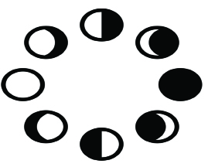

The moon looks big and gray.

Where do we see the moon? (Or where in the sky is the moon?)

The moon is high in the sky. (or) The moon is up in the sky.
Sky Notebook
Name: ____________________________________________________ Date: __________________________
Page 9

W.1.8, L.1.1f, L.1.1i, L.1.1j, L.1.6

What does the sun look like?

Where do we see the sun? (Or where in the sky is the sun?)

Sky Notebook
Page 9

W.1.8, L.1.1f, L.1.1i, L.1.1j, L.1.6

(Answers, for Teacher Reference)

What does the sun look like?

The sun looks orange and fiery.

Where do we see the sun? (Or where in the sky is the sun?)

The sun is below the horizon. (or) The sun is behind the bridge.

Sky Notebook
Name: ____________________________________________________ Date: __________________________
Page 10

W.1.8, L.1.1f, L.1.1i, L.1.1j, L.1.6

What are people doing?

Sky Notebook
Page 10

W.1.8, L.1.1f, L.1.1i, L.1.1j, L.1.6

(Answers, for Teacher Reference)

What are people doing?

Sketches will vary.

People are playing outside in the sun.

Sky Notebook
Name: ____________________________________________________ Date: __________________________
Page 11

W.1.8, L.1.1f, L.1.1i, L.1.1j, L.1.6

What does the moon look like? (Circle one.)

Where do we see the moon? (Or where in the sky is the moon?)

Sky Notebook
Page 11

W.1.8, L.1.1f, L.1.1i, L.1.1j, L.1.6

(Answers, for Teacher Reference)

What does the moon look like? (Circle one.)

The moon is thin and white.

Where do we see the moon? (Or where in the sky is the moon?)

The moon is above the mountain.
Sky Notebook
Name: ____________________________________________________ Date: __________________________
Page 12

W.1.8, L.1.1f, L.1.1i, L.1.1j, L.1.6

What do people do at night?

Sky Notebook
Page 12

W.1.8, L.1.1f, L.1.1i, L.1.1j, L.1.6

(Answers, for Teacher Reference)

What do people do at night?

Sketches will vary.

People go to bed at night.

Sky Notebook
Name: ____________________________________________________ Date: __________________________
Page 13

W.1.8, L.1.1f, L.1.1i, L.1.1j, L.1.6

What does the sun look like?

Where do we see the sun? (Or where in the sky is the sun?)

Sky Notebook
Page 13

W.1.8, L.1.1f, L.1.1i, L.1.1j, L.1.6

(Answers, for Teacher Reference)

What does the sun look like?

The sun looks big and yellow. (or) The sun is round and bright.

Where do we see the sun? (Or where in the sky is the sun?)

The sun is behind the trees.

Sky Notebook
Name: ____________________________________________________ Date: __________________________
Page 14

W.1.8, L.1.1f, L.1.1i, L.1.1j, L.1.6

What are people doing?

Sky Notebook
Page 14

W.1.8, L.1.1f, L.1.1i, L.1.1j, L.1.6

(Answers, for Teacher Reference)

What are people doing?

Sketches will vary.

People are eating dinner.

Sky Notebook
Name: ____________________________________________________ Date: __________________________
Page 15

W.1.8, L.1.1f, L.1.1i, L.1.1j, L.1.6

What does the moon look like? (Circle one.)

Where do we see the moon? (Or where in the sky is the moon?)

Sky Notebook
Page 15

W.1.8, L.1.1f, L.1.1i, L.1.1j, L.1.6

(Answers, for Teacher Reference)

What does the moon look like? (Circle one.)

The moon is round and large.

Where do we see the moon? (Or where in the sky is the moon?)

The moon is just above the water and buildings.

Sky Notebook
Name: ____________________________________________________ Date: __________________________
Page 16

W.1.8, L.1.1f, L.1.1i, L.1.1j, L.1.6

What do people do at night?

Sky Notebook
Page 16

W.1.8, L.1.1f, L.1.1i, L.1.1j, L.1.6

(Answers, for Teacher Reference)

What do people do at night?

Sketches will vary.

People are relaxing before going to bed.

Image Credits
Page 6. Dronkert, E. “Zon boven de duinen.” Photograph. Flickr. 31 July 2011.
Page 7. Migulski, Bogdan. “Half Moon Over Prague.” Photograph. Flickr. 8 Sept 2008.

