MODULE LESSONS
Grade 1: Module 2: Unit 1: Lesson 1
Noticing and Wondering: Observing and Asking Questions about the Sun, Moon, and Stars

Language Arts Curriculum
“Elvin, the Boy Who Loved the Sky”
Part 1
Once there lived a boy named Elvin, who loved the sky. When he was outside, he loved to stand and gaze up. Sometimes he would even lie down if there was grass to be found. One day he would see a bright blue sky. Another day, one that was gray and cloudy. At night he would look out his window into the deep blackness of the sky. But what the boy loved most about the sky were the sun and the moon. And he wondered about them.

Each morning on his way to school, he would search for the sun. To him it was like a beautiful face looking down on him. In the morning it was always behind him, big and orange. As it rose in the sky it watched him walk along the road to school. Each afternoon at recess he looked for the sun. Some days it would look down from the middle of the sky, high above the playground, small and bright yellow. Other days the sun could not be seen. It would hide behind the white clouds. But the boy knew that it was still there because sometimes it would peek through, looking pale. In the evening, if it was a clear sky, the boy saw the sun through his apartment window. The sun would slowly set behind the buildings, leaving orange and pink light behind.
And the boy wondered about the sun, about how it moved. And he wondered about its size and its colors and light.

Then there was the moon! Oh, how he loved the moon. It was such a mystery. Sometimes large, sometimes small, and sometimes hiding, unseen in the dark of the night. Just like the sun, it would rise up from behind the glittering buildings. Sometimes the boy saw it rise, but other times he was asleep. And sometimes, but not often, the boy might see it during the day, pale and small, half awake. And he wondered about the moon, about how it moved. And he wondered about how it changed shape, and about its size and its colors and light.

One day while the boy was wondering deeply about the sun and moon, he decided he must find someone with whom to share his wonderings. So he walked along until he found a photographer. He told the photographer all that he wondered, but the photographer did not answer his questions. Instead, she gave him these ...

Written by EL Education for Instructional Purposes.
550L
Mystery Sky Photos
Note to Teachers: Copy enough of these onto cardstock such that each student receives one photo.
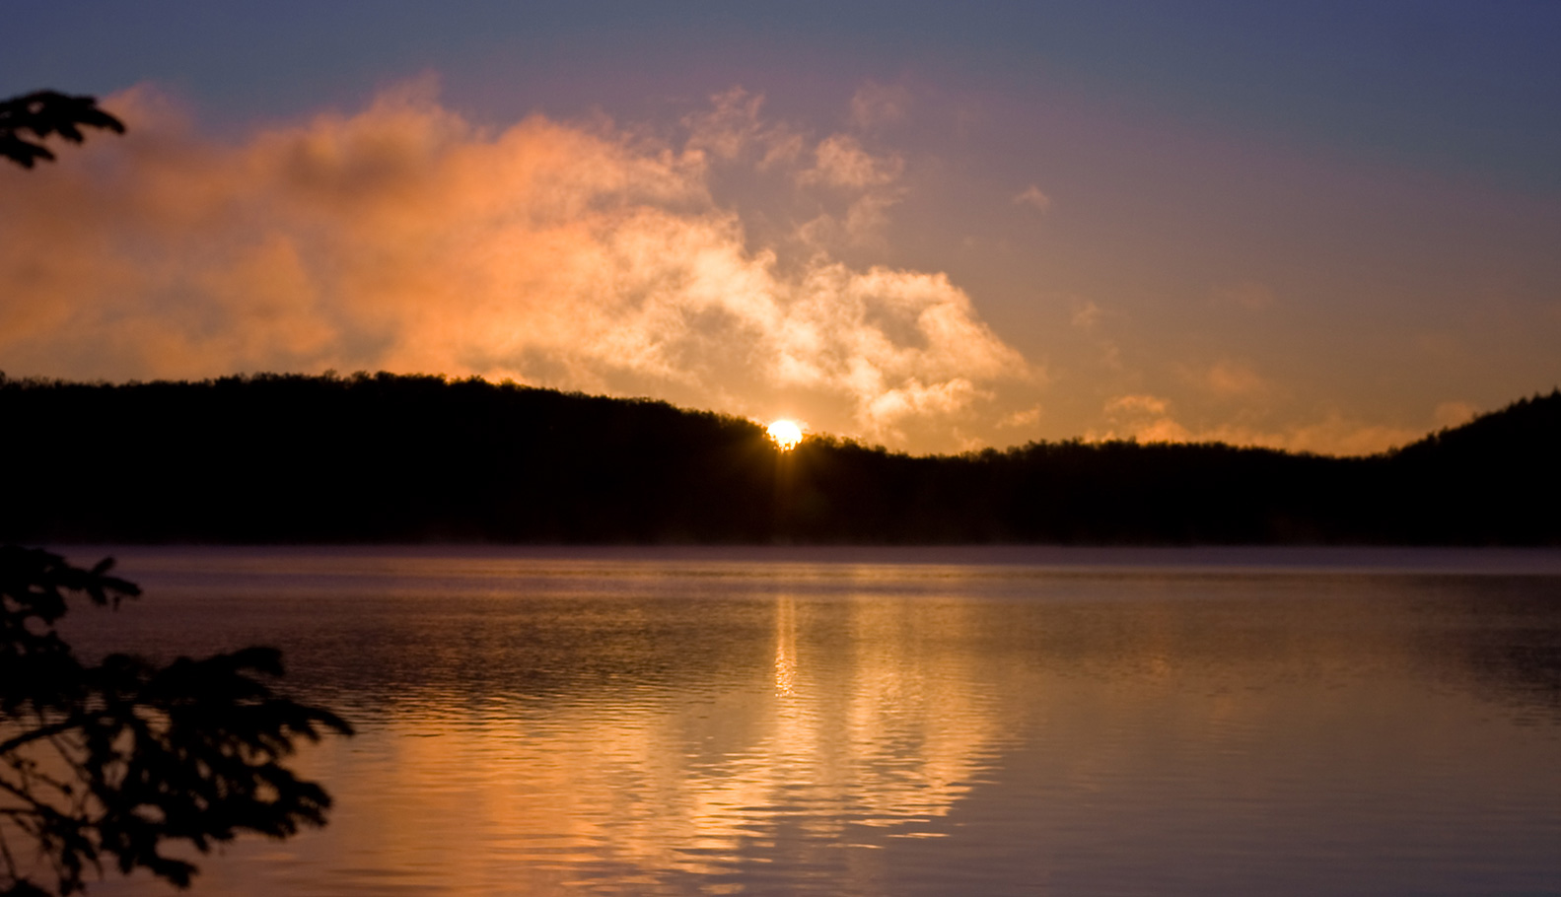 | 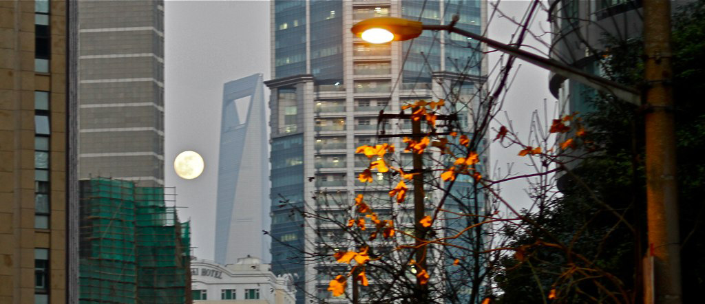
 | 
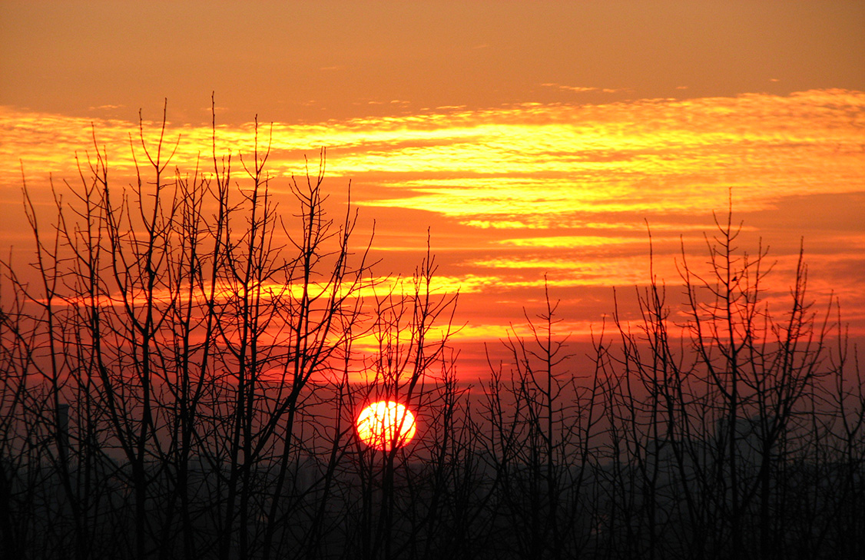 | 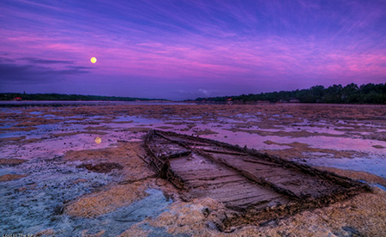
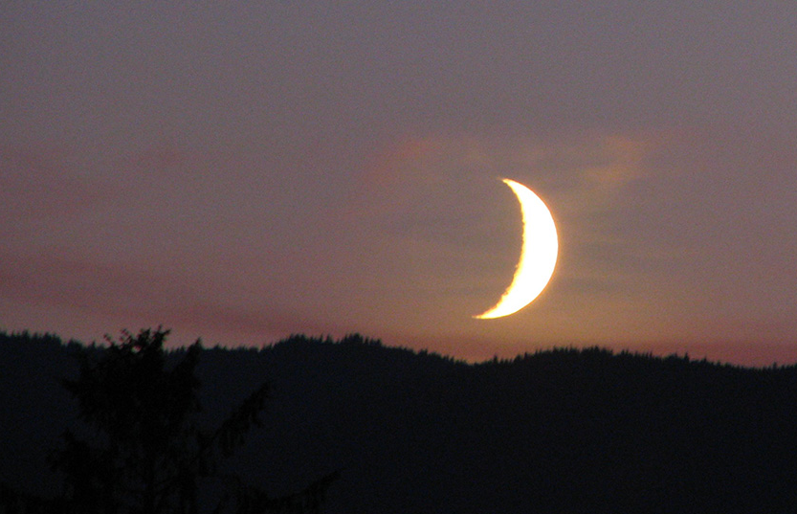 | 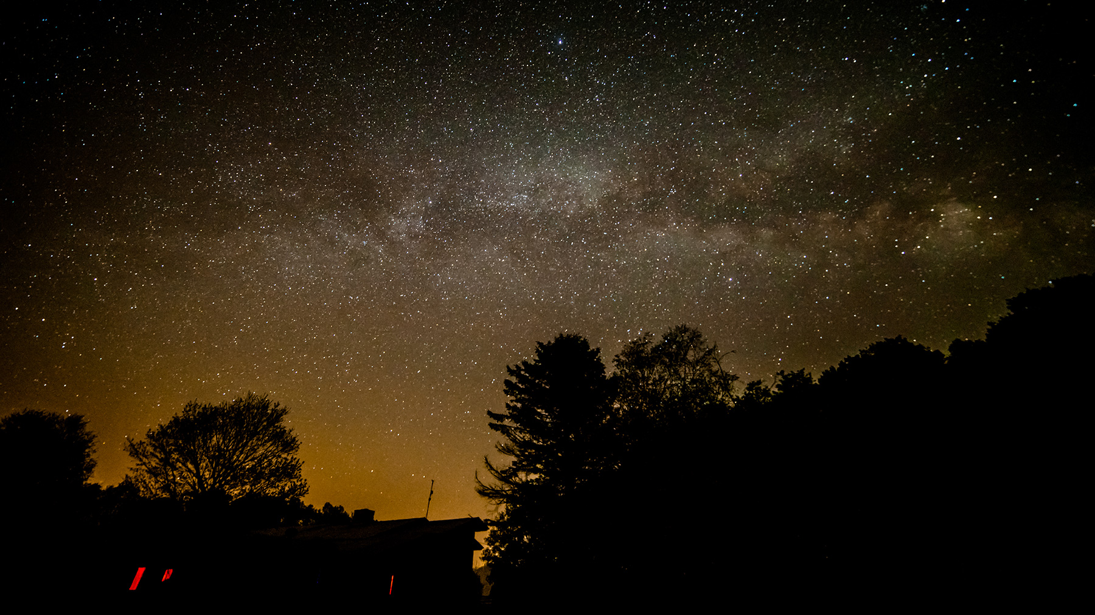
Picture Tea Party Protocol Anchor Chart
(Example, for Teacher Reference)
Picture Tea Party Protocol
 | Look closely at your picture.
 | Listen for the teacher’s signal.
 | Once you hear the signal, each group member shares his or her ideas while the other group members listen.
 | After all group members have shared, raise your hand.
 | Calmly and quietly walk around the room to form a new group of three or four students.
 | Sit in a circle with your group.
 | Each group member shares a prediction or question about his or her picture while the other group members listen.
 | After all group members have shared, raise your hand.

Noticing and Wondering Response Sheet
Name: __________________________ Date: ______________
SL.1.2
What I notice about the sun, moon, and stars | What I wonder about the sun, moon, and stars
Noticing and Wondering Response Sheet
(Example, for Teacher Reference)
SL.1.2
What we notice about the sun, moon, and stars | What we wonder about the sun, moon, and stars
Image Credits
Indigo, Alex. “Sunrise.” Photograph. Flickr. 18 May 2008.
Sung ming whang. “Moon rise.” Photograph. Flickr. 31 December 2009.
Soe Lin. “Jamaica Pond, Boston Straight into the sun, flare colors.” Photograph. Flickr. 30 October 2011.
Balogh, Timothy. “Sunrise.” Photograph. Flickr. 12 September 2012.
Fdecomite. “Sunset.” Photograph. Flickr. 08 December 2012.
Greg. “Blue Moon Set at Sunrise Part Deux.” Photograph. Flickr. 31 January 2010.
Wolf-Ray, Phoenix. “setting crescent moon.” Photograph. Flickr. 25 July 2009.
Hallock, Ryan. “barred spiral beauty.” Photograph. Flickr. 14 May 2015.

