MODULE LESSONS
Kindergarten: Module 2: Unit 2: Lesson 4
Reading, Speaking, and Listening:
The Weather of Australia, Kenya, and Argentina
Language Arts Curriculum

Mystery Photos: Australia, Kenya, Argentina
Set 1:

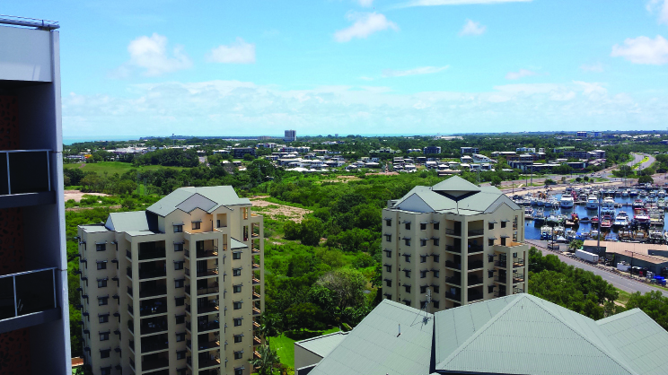 | 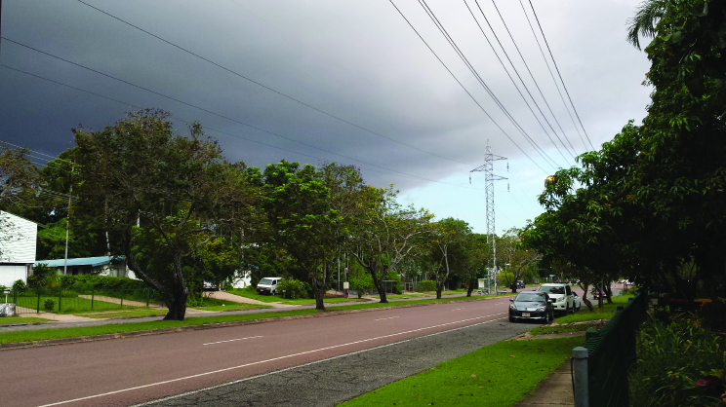 | 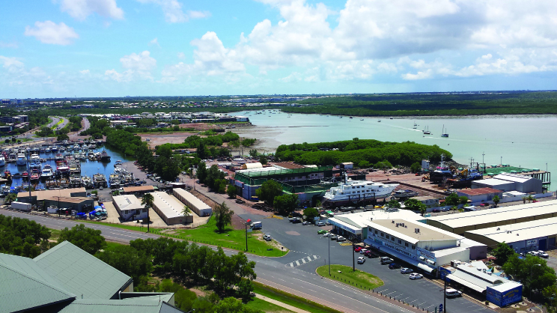

Set 2:

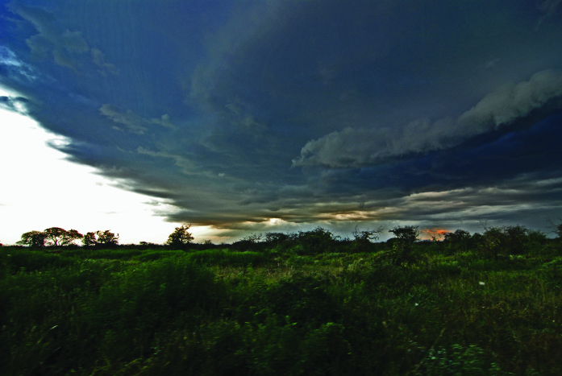 | 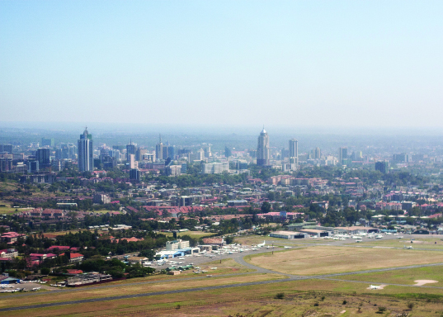 | 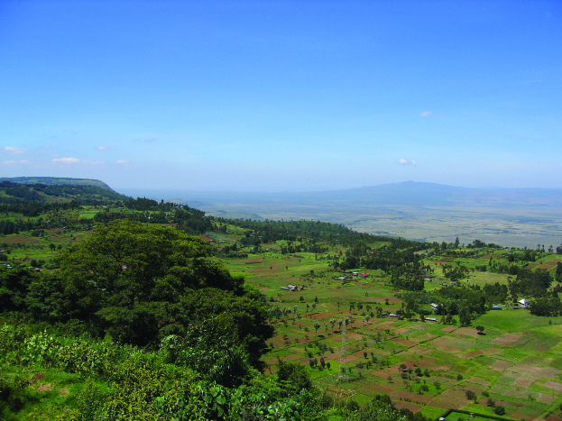

Set 3:

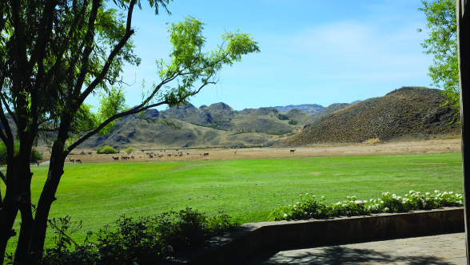 | 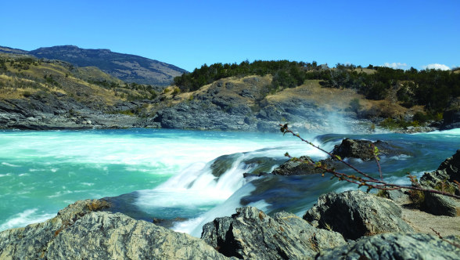 | 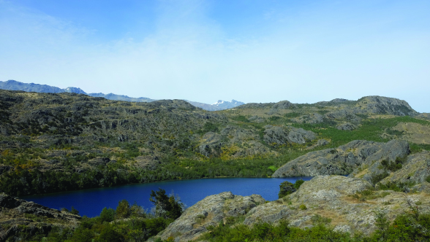
Weather around the World Anchor Chart
(For Teacher Reference)
RI.K.1, RI.K.2, RI.K.4

Note to Teachers: Create a blank version of this chart and add to it during the focused read-aloud sessions of On the Same Day in March: A Tour of the World’s Weather. Consider displaying visuals or pages from the text for each of the locations below to support students in recalling details from the text.

Place | The weather is ... | So people …  (wear, do)
Alberta, Canada | cold, windy, snowy | wear hats, scarves  do winter activities like skiing and sledding
Paris, France | sunny but cold | wear scarves and coats huddle close to one another
Central Thailand | sunny and hot | wear shorts, sandals, and short-sleeved shirts  stay in the shade; go to school
New York City | cold, with sleet, snow, and freezing rain | warm sweaters and hats stay inside, but some still play outside
Xian, China | warm, with winds and some rain showers | short sleeves  have picnics outside
Darwin, Australia | windy and warm | short sleeves and shorts  board up windows and take boats out of the water
Northern Kenya | warm, with lots of rain in one day | shorts, sandals, and dresses  play in the river; use the river for water
Patagonia, Argentina | cool, cloudy, and foggy | warm sweaters and tall boots  ride horses outside
Responding to Text: Australia, Kenya, Argentina Chart
(For Teacher Reference)
RI.K.1, RI.K.2, RI.K.4

Note to Teachers: Copy this onto chart paper.

“What is the weather like in this place?”
“What do the people wear and do because of the weather?”

Part I: Darwin, Australia
- In Darwin, Australia, the weather is ___________ in March.
- The people have to wear ______________.
- The people like to ____________.

Part II: Northern Kenya
- In northern Kenya, the weather is ___________ in March.
- The people have to wear ______________.
- The people like to ____________.

Part III: Patagonia, Argentina
- In Patagonia, Argentina, the weather is ___________ in March.
- The people have to wear ______________.
- The people like to ____________.
Image Credits
Page 2. Gaynor. “Duck Pond to Stuart Park.” Photograph. Flickr. 12 March 2016.
Page 2. Gaynor. “Storms coming Darwin.” Photograph. Flickr. 24 March 2016.
Page 2. Gaynor. “Duck Pond and Sadgroves Creek.” Photograph. Flickr. 12 March 2016.
Page 2. Mannix, Paul. “Stormy sky, Selenkay, Kenya.” Photograph. Flickr. 11 February 2007.
Page 2. Cappellacci, Ben. “Downtown Nairobi.” Photograph. Flickr. 15 March 2016.
Page 2. Rostad, Bernt. “Going to the Rift Valley.” Photograph. Flickr. 05 March 2007.
Page 2. Altamirano, Fernando Ruiz. “Patagonia Park.” Photograph. Flickr. 05 March 2016.
Page 2. Altamirano, Fernando Ruiz. “Confluencia en lento.” Photograph. Flickr. 02 March 2016.
Page 2. Altamirano, Fernando Ruiz. “R.o Cochrane desde sendero los carpinteros en reserva nacional Tamango.” Photograph. Flickr. 04 March 2016.

