MODULE LESSONS
Kindergarten: Module 2: Unit 1: Lesson 9
Reading, Speaking, and Writing: Clouds
Language Arts Curriculum

Interactive Word Wall Protocol Anchor Chart
(SL.1.4)

- Face your group members and label yourselves A, B, and C. Put the word cards and arrow cards in the middle. | 
- Partner A chooses one word to connect with another word using an arrow card.* | 
- Partner A explains the connection by answering the question: Why do the words belong together? | 
- Repeat Steps 2–3 for partner B and partner C. | 
- Repeat Steps 2–4 until all words are connected. | 

*It is okay to connect words more than once.
Interactive Word Wall Cards
Note to Teachers: Cut these cards out to use during the Opening. In Lesson 11 and after, copy and make sets. There should be one set of cards per four or five students.

weather
light
rain
wind
heat
snow
sun
temperature
Arrow Cards
Note to Teachers: Cut these cards out to use during the Opening. In Lessons 11 and after, copy and make sets. There should be one set of cards per four or five students.

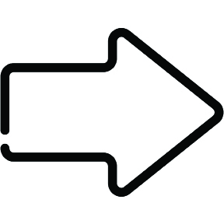

Mystery Photos: Clouds
Note to Teachers: These photos should be used during the Picture Tea Party protocol at the beginning of Work Time A.

 | 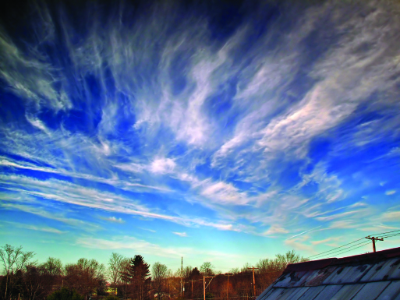
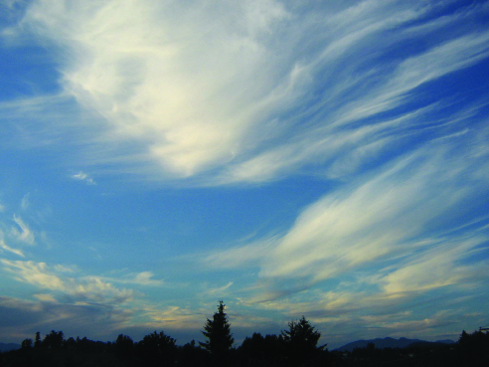
Cloud Facts Chart
Cloud Facts
Clouds are made of droplets of water.
Droplets move to make clouds.
White, fluffy clouds mean the weather will be sunny.
Flat, gray clouds mean the weather will be rainy.

Other possible facts:
There are different kinds of clouds.
Clouds tell us if it is going to rain or what the weather will be like.
Clouds have different names and shapes.

Image Credits
Page 5. Madigan, Mary. “Cumulous over the Painted desert.” Photograph. Flickr. 26 April 2012.
Page 5. Tonelli, Nicholas A. “Wispy.” Photograph. Flickr. 28 March 2007.
Page 5. Bald, Sam. “Clouds.” Photograph. Flickr. 26 July 2007.

