MODULE LESSONS
Kindergarten: Module 2: Unit 1: Lesson 8
Reading, Speaking, and Listening: Focused Read-aloud of Weather and Launching Science Talks
Language Arts Curriculum

Mystery Photos: Sun
Note to Teachers: Make color copies of this page and cut out photos. There should be one photo per student, to be used during the Picture Tea Party protocol in Work Time A.

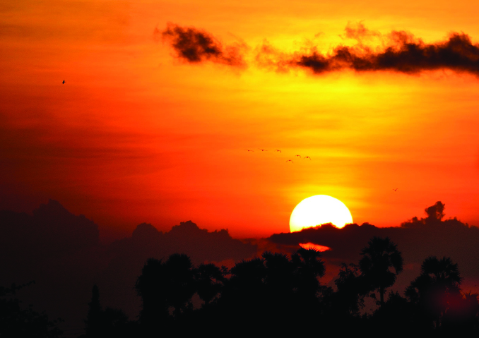 | 
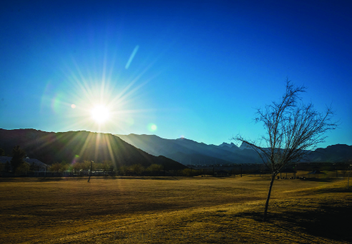 | 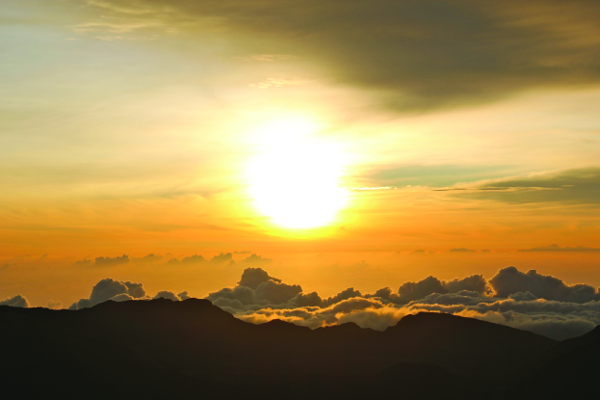
Sun Facts Chart
Sun Facts
It warms the land, air, and water.
Heat and light help things grow.
Sunshine helps plants and animals live.
Science Talk Protocol Anchor Chart
Science Talk
Sit with your Science Talk group.

Take turns. Listen when others are speaking.

Talk about the question.

Weather Talking Stick Icons
Note to Teachers: To make a weather talking stick, cut out the icon and attach it to a Popsicle stick or drinking straw. There should be one weather talking stick for each Science Talk Group.

 | 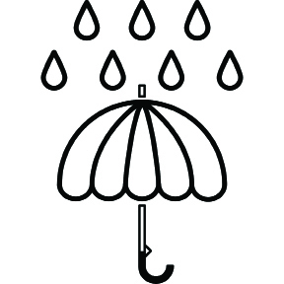
 | 
Science Talk Groups Chart
Science Talk Groups
Group 1  Write student names here. | Group 2 | Group 3
Group 4 | Group 5 | Group 6
Sun Fact Page
Note to Teachers: Prepare this page by copying the template onto large chart paper.

Sun

Fact about the Sun:

Image Credits
Page 2. Kumaravel, Thangaraj. “Sunset.” Photograph. Flickr. 01 January 2012.
Page 2. Garman, Edmund. “Red Hawaiian Sun 3.” Photograph. Flickr. 08 December 2014.
Page 2. Shanna S. “Project 365 20015-1-15-2015 Just Before The Sun Sets.” Photograph. Flickr. 15 January 2015.
Page 2. Daveynin. “House of the Sun.” Photograph. Flickr. 04 April 2012.

