MODULE LESSONS
Kindergarten: Module 2: Unit 1: Lesson 4
Reading, Speaking, and Listening: Close Read-aloud, Session 3 and Discussion about Temperature
Language Arts Curriculum

Frayer Model: Temperature Chart
(Completed, for Teacher Reference)

RI.K.1, RI.K.2, RI.K.4

Note to Teachers: Create a blank version of this chart on chart paper

Definition | Examples
The degree of heat or cold in an object or the environment | Hot summer  Cold winter
Temperature
Pictures | Words to Describe This Weather Component:  - mild  - chilly  - warm  - hot  - cold
Temperature Pictures
Note to Teachers: Copy these on cardstock, cut them out, and place them on the Frayer Model: Temperature during the close read-aloud. See the Close Read-aloud Guide.


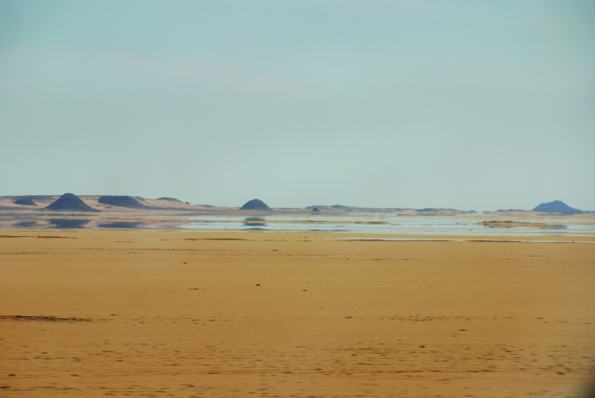

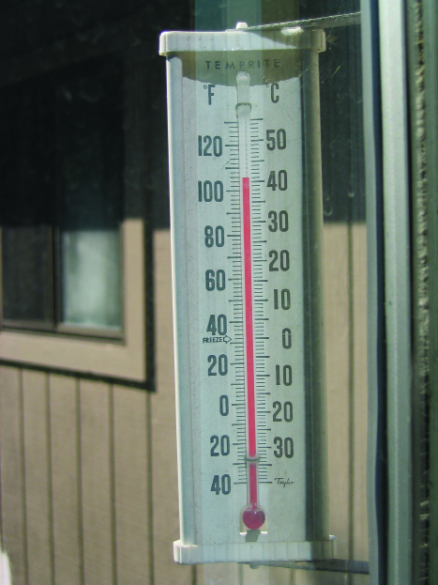
Sofia Paper Doll
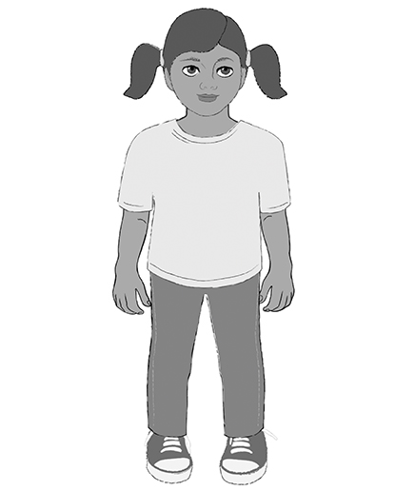
Image Credits
Page 3. Keating, Ian D. “Good Morning #1.” Photograph. Flickr. 28 August 2015.
Page 3. Gwyther-Jones, Michael. “Mirage in the Desert.” Photograph. Flickr. 26 January 2008.
Page 4. Tamiag, Nils. “Cold as ice.” Photograph. Flickr. 09 March 2015.
Page 4. Marshall, Ken. “IMG_5677.” Photograph. Flickr. 03 August 2006.
Page 5. Illustration by Stacey Posnett for EL Education.

