READING FOUNDATIONS
SKILLS BLOCK
Grade 1: Module 2: Cycle 5: Lesson 26
Language Arts Curriculum
Short “o” Anchor Chart

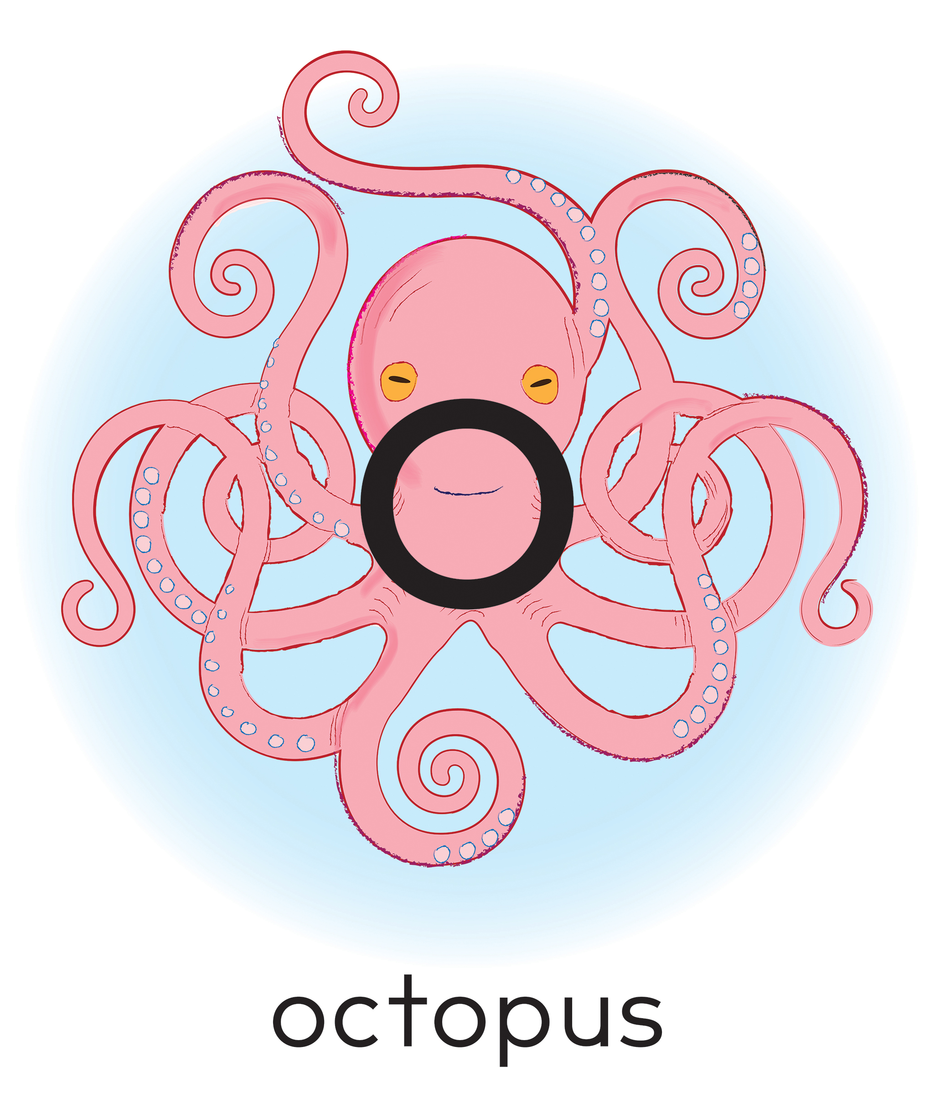
“ow” Diphthong Anchor Chart

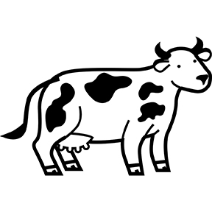
Cow Words!
Movable Letters: Letter Cards

a | b | c | d | e | f | g
h | i | j | k | l | m | n
o | p | 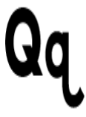 | r | s | t | 
v | w | x | y | z

Articulatory Gestures Chart
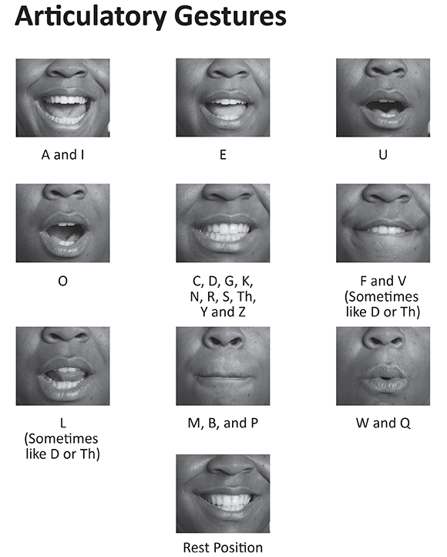
Letter Formation Chart
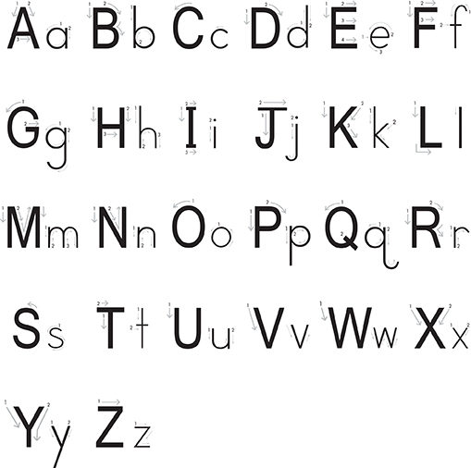

Snapshot Assessment (optional)
Name: ___________________________________________ Date: _________________
Student Can: |  | Student Can: |  | Notes:
Segment given word(s) from Cycle 4 (e.g., “box,” “fox,” “ox”) |  | Write grapheme (j) for phoneme (/j/)
Isolate each sound in given word(s) |  | Write grapheme (x) for phoneme (/ks/)
Blend each sound in given word(s) |  | Write grapheme (b) for phoneme (/b/)
Write grapheme (p) for phoneme (/p/) |  | Write grapheme (w) for phoneme (/w/)
Write grapheme (sh) for phoneme (/sh/) |  | Write grapheme (o) for phoneme (/o/)
Write grapheme (f) for phoneme (/f/) |  | Write grapheme (h) for phoneme (/h/)
Write grapheme (g) for phoneme (/g/) |  | Write grapheme (t) for phoneme (/t/)

Word List Guidance
Note to teacher: Most students in early first grade are likely at the Partial Alphabetic phase of word acquisition. Accompanying this lesson is a Word List to be used with students in the Full and Consolidated Alphabetic phases. It includes patterns connected to the cycle in this lesson that extend beyond what is typically expected at early first grade. Consider using some or all of the words on this list, based on the needs of your students. For example, if some students working in the Full Alphabetic phase are not automatic with all consonant clusters, consider taking some words out or shortening the list.

Suggested Routine
- Teacher shares the Word Lists with students, noting connections to the phonemes/graphemes introduced in the whole group lesson. Teacher reviews the daily independent work time tasks that students should complete.

- During independent work time on the first day of the cycle:
- Students read the list of words to themselves or with a friend and circle any that are unfamiliar or that they are not able to read “automatically” (right away; do not need to decode each phoneme separately).
- Students sort words into categories (see Word Cards and Sorting Words Template). Students write or cut and paste at least five words for each category.
- At the end of independent work time, students return their lists and their completed sorting words to the teacher. These are their exit tickets for the first day. (Teacher looks through, noting any challenges or misconceptions, to be addressed during differentiated small group instruction.)

- During independent work time on the second day of the cycle:
- Students choose three to five words from the Word List and write a sentence with each word. This is their exit ticket for the second day. (Teacher later looks through, noting any issues—such as failure to capitalize the first word in the sentence, improper punctuation, or misspelling or misuse of a word—to be addressed during differentiated small group instruction.)

Other suggestions for using the Word Lists:
- Students find and identify words with similar patterns from their AIR books to add to the sort.
- Students identify nouns and create an illustration of the person, place, thing, or animal.
- Students sort words in different ways: concept, affix, syllable number, syllable type, etc.
Word List
ox  box  fox  pox  lox  sob  bob  cob  lob  job  hot  not  rot  got  shot  log  dog  jog  fog  hog  cog  bog  shop  top  cop  lop  mop  pop  bop  hop  how  now  wow  cow  bow  sow  pow | ding  ring  swing  sting  spring  fling  king  ting  bring  thing  wing  ding  bling  string  zing  swung  sung  dung  rung  strung  slung  lung  long  belong  song  tong  dong  gong  pong  strong  owl  down  howl  frown  prowl  gown  town  brow | brown  gown  prowl  clown  crown  town  fowl  song  wrong  bang  dang  sang  fang  bang  hang  stung  rang  clang  gang  slang  twang  crop  stop  flop  plop  prop  shop  slop  glob  blob  blog  frog  snot  blog  clog  flog  slog
Word Card Template
box | wow | now | not
dog | bop | log | how
now | top | ox | rot
shop | pop | got | pox
fox | jog | hog | fog
Sorting Words Template
Two Categories

Two phonemes | Three phonemes

