MODULE LESSONS
Grade K: Module 2: Cycle 9: Lesson 48
Reading Foundations Skills Block
Language Arts Curriculum

Snapshot Assessment (optional)
Date: |  | Student:
Student Can: |  | Student Can: |  | Notes:
Count the number of words in a sentence |  | Demonstrate one-to-one correspondence in shared text
Point to the first word in a sentence |  | Read the high-frequency word: “a”
Point to the last word in a sentence |  | Count the number of letters in a word
Letter-Picture Match Cards
Aa | 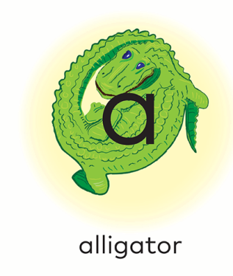 | Hh | 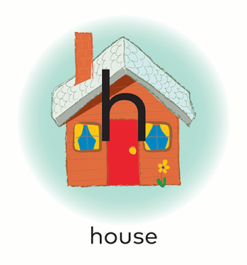
Tt |  | Pp | 

Cc | 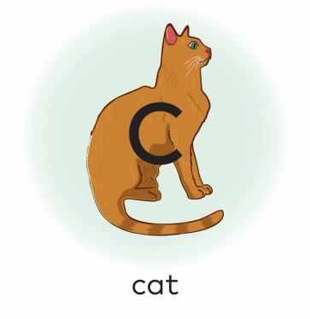 | Nn | 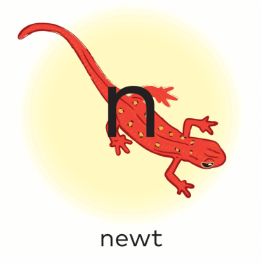
Mm |  | Rr | 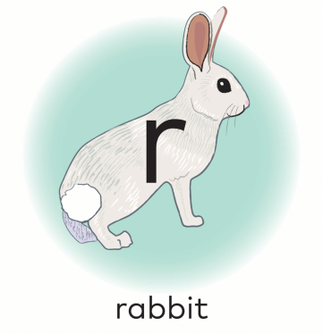

Vv |  | Ss | 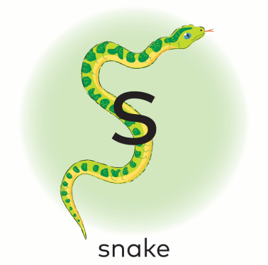
Ii | 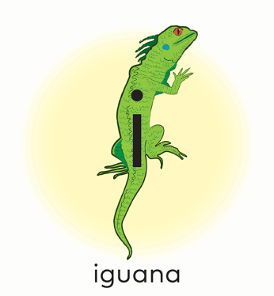 | Gg | 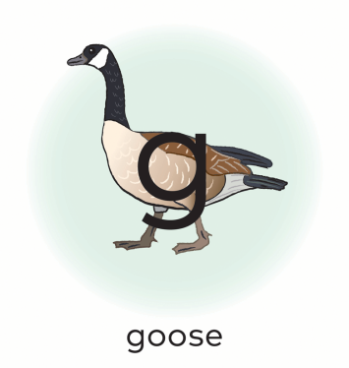

Dd | 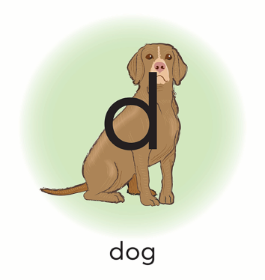 | Ff | 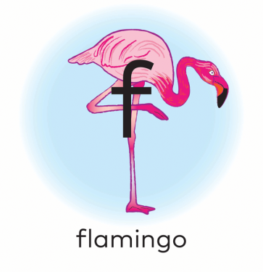
Ll | 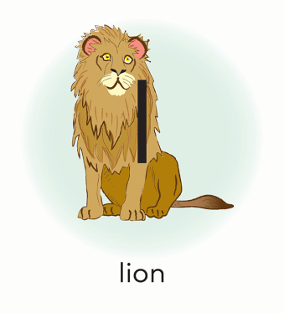 | Kk | 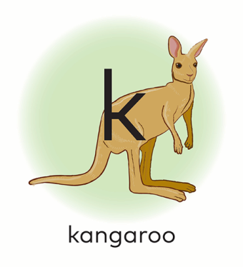

Yy |  | Qq | 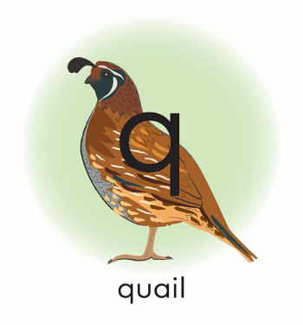
Uu |  | Xx | 

