READING FOUNDATIONS
SKILLS BLOCK
Grade K: Module 2: Cycle 9: Lesson 46
Language Arts Curriculum

Snapshot Assessment (optional)
Name: ___________________________________________ Date: _________________
Student Can: |  | Student Can: |  | Notes:
Recognize uppercase and lowercase “u” in a printed text |  | Say the sound for the letter “x” (/ks/)
Recognize uppercase and lowercase “q” in a printed text |  | Print uppercase “U”
Recognize uppercase and lowercase “x” in a printed text |  | Print lowercase “u”
Identify the name of the letter “u” |  | Print uppercase “Q”
Identify the name of the letter “q” |  | Print lowercase “q”
Identify the name of the letter “x” |  | Print uppercase “X”
Say the sound for the letter “u” (/u/) |  | Print lowercase “x”
Say the sound for the letter “q” (/kw/)

Keyword Picture Cards: “q”
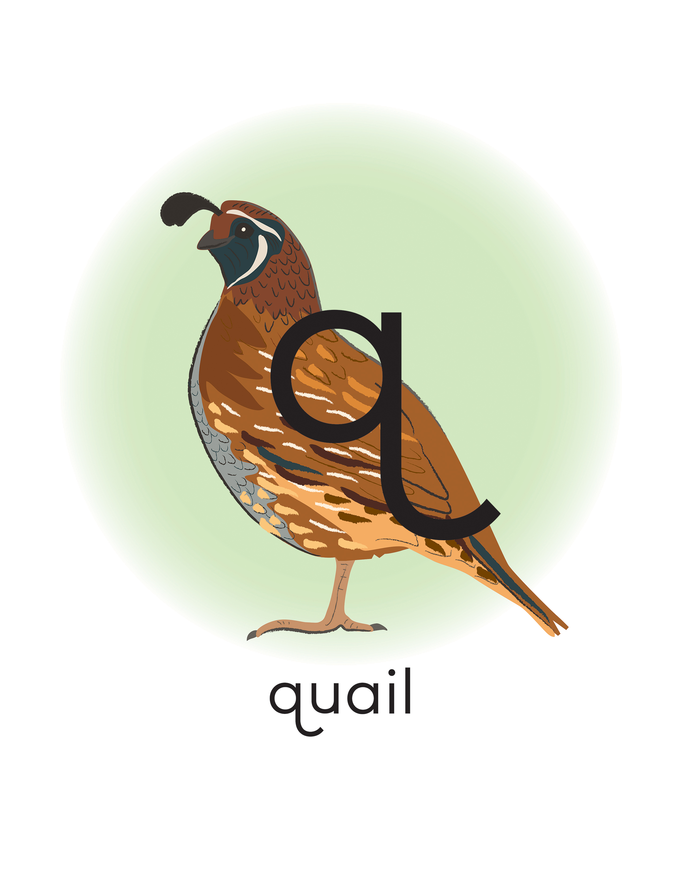
Keyword Picture Cards: “u”

Keyword Picture Cards: “x”
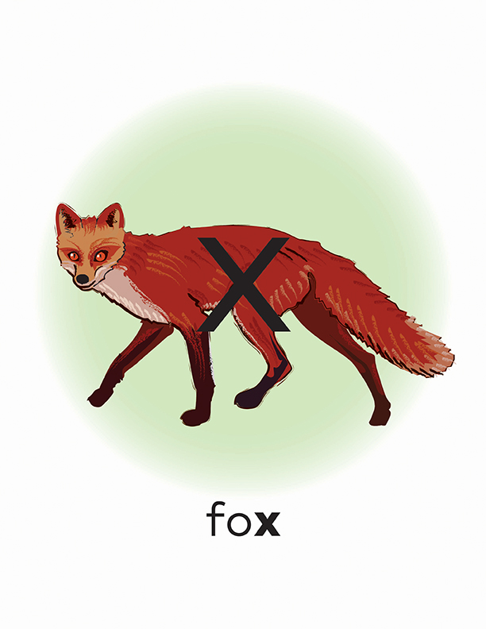
Articulatory Gestures Chart
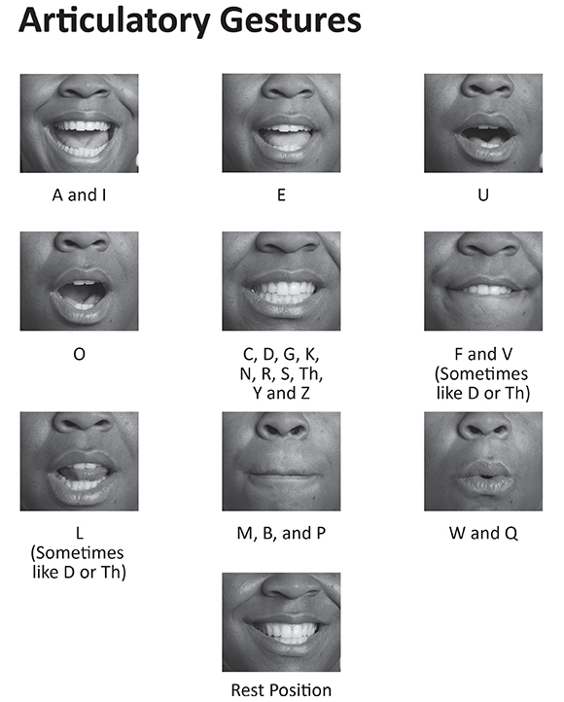
Sound Sort Pictures
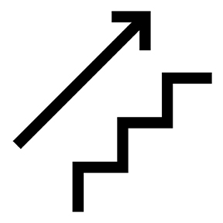 |  |  | 
 |  |  | 
 |  |  | 

Sound Sort Sheet

