READING FOUNDATIONS
SKILLS BLOCK
Grade K: Module 2: Cycle 6: Lesson 31
Language Arts Curriculum
Keyword Picture Card: “g”

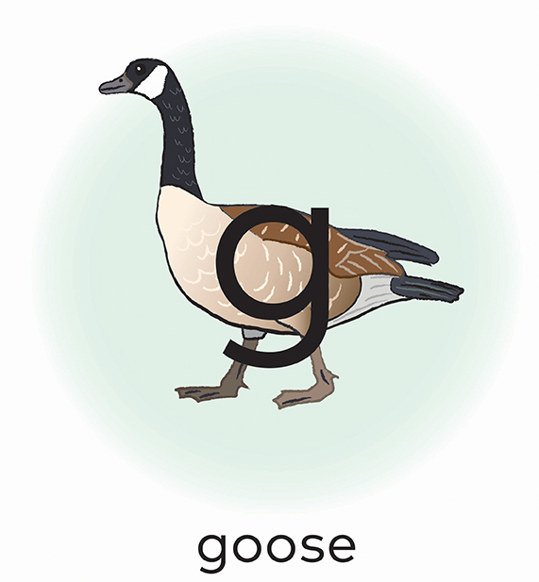
Keyword Picture Card: “i”

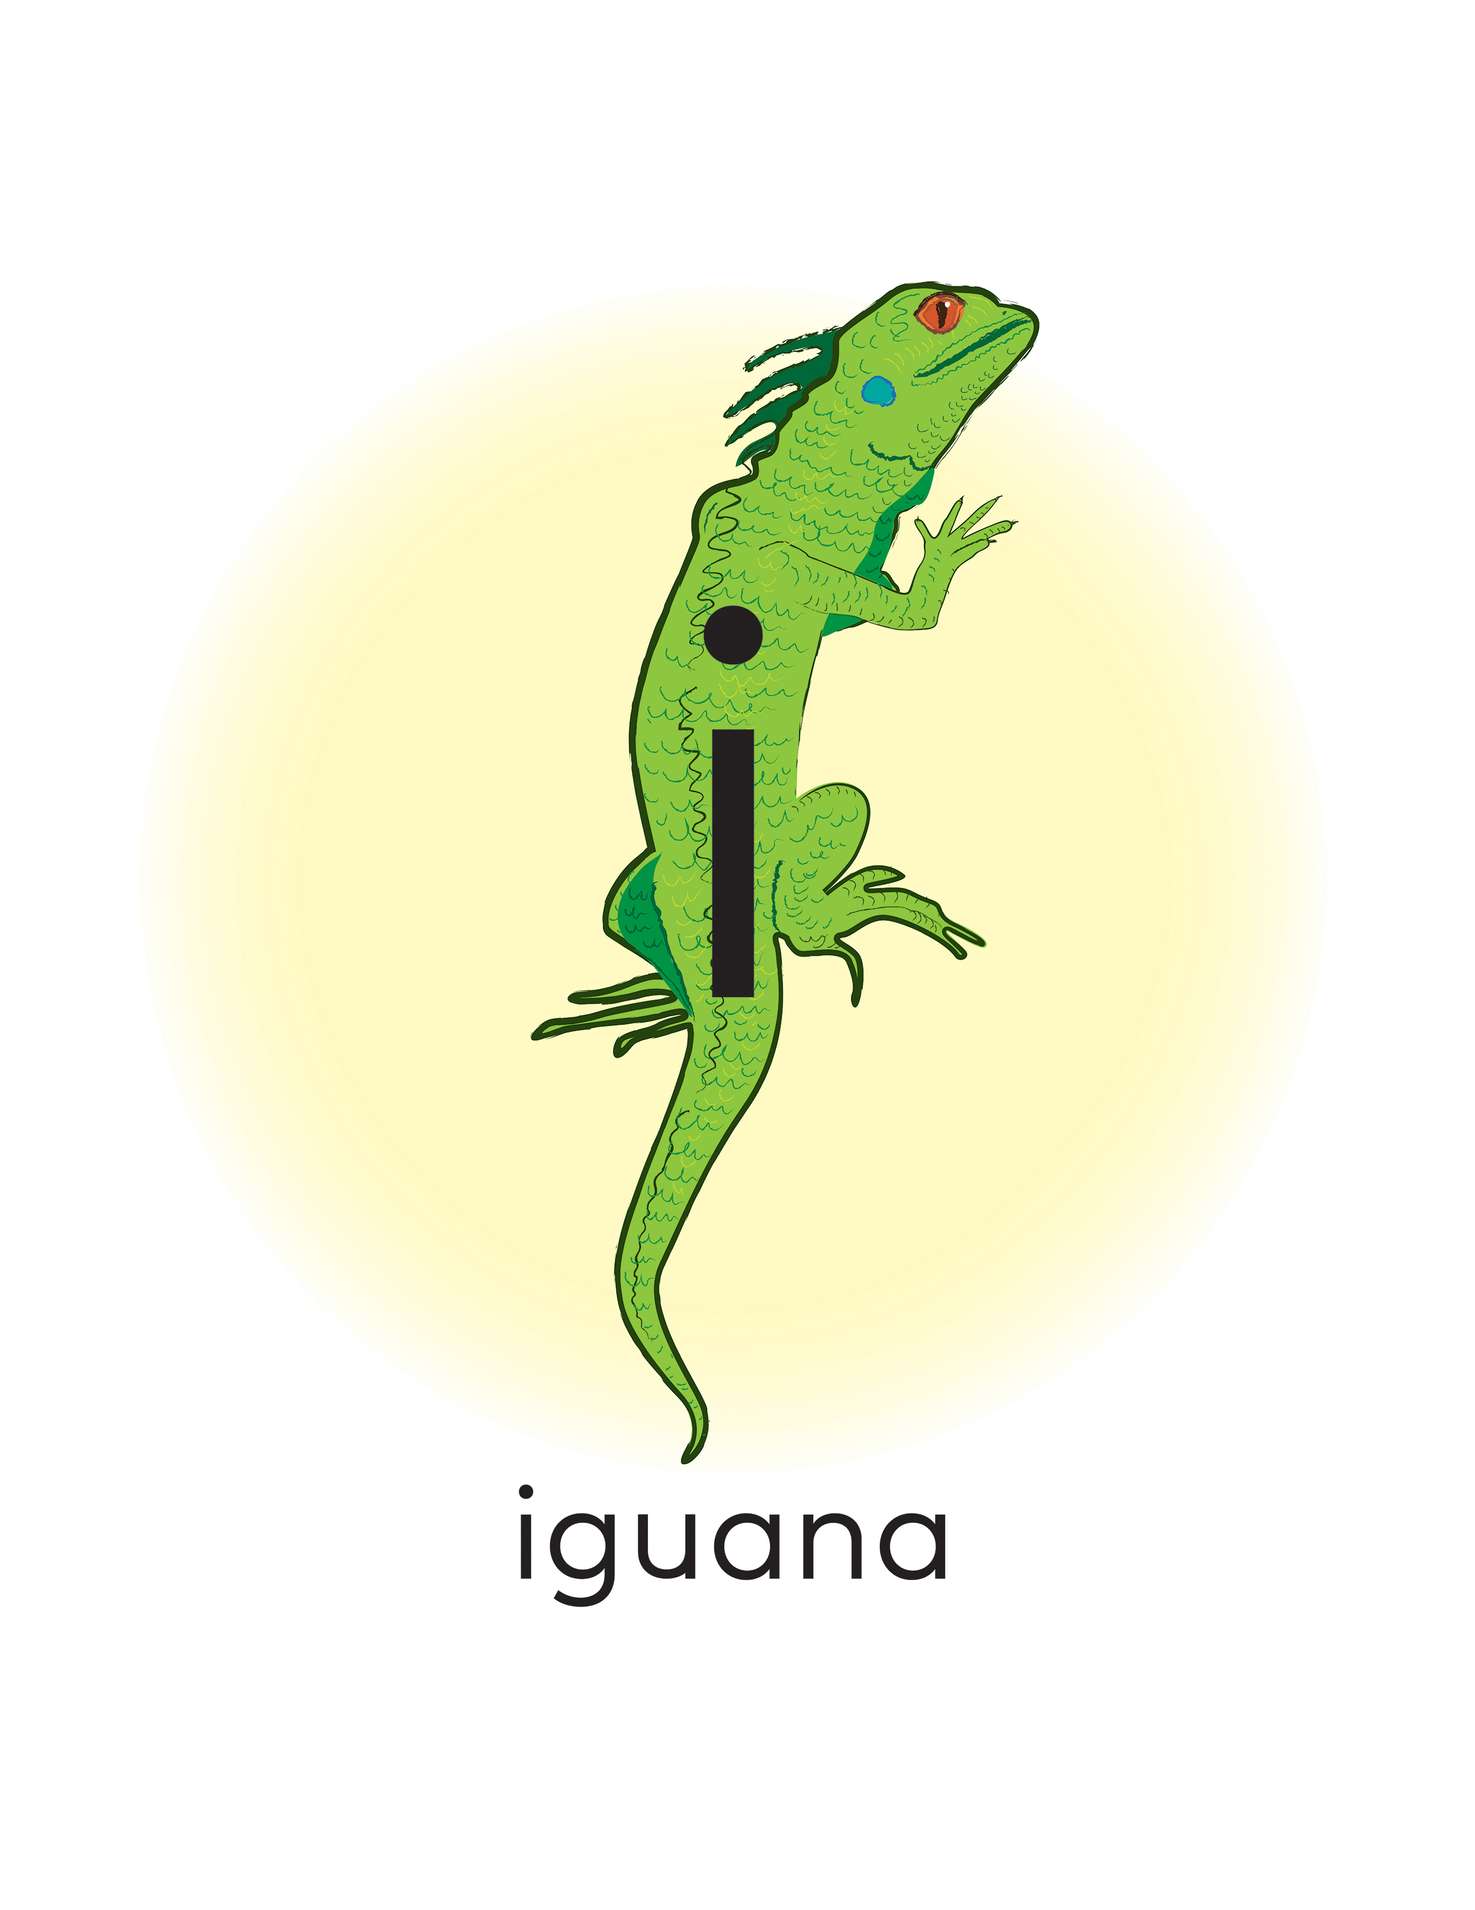
Articulatory Gestures Chart
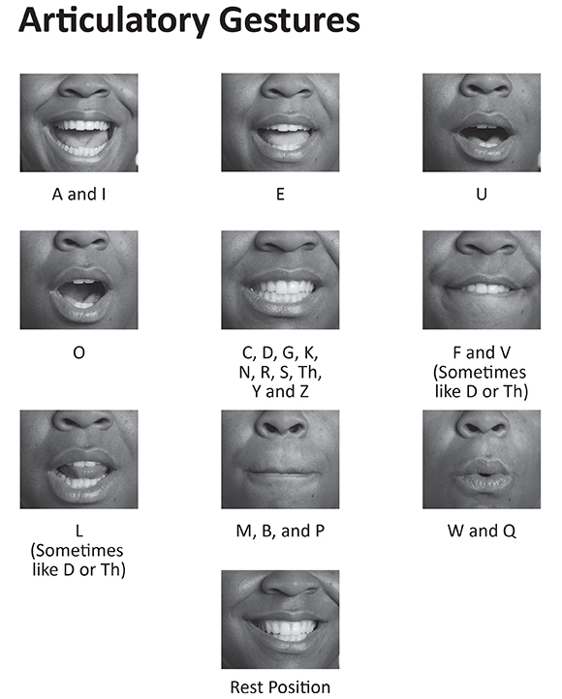

Snapshot Assessment (optional)
Name: ___________________________________________ Date: _________________
Student Can: |  | Student Can: |  | Notes:
Identify the name of the letter “i” |  | Identify the sound for the letter “i” (/i/)
Identify the name of the letter “g” |  | Identify the sound for the letter “g” (/g /)

Initial Sound Sort Pictures
 |  |  | 
 |  |  | 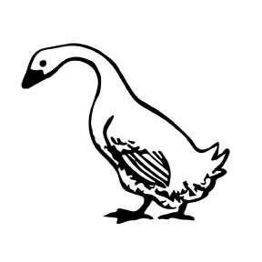
 |  | 

Initial Sound Sort Sheet
Words That Start with “i” | 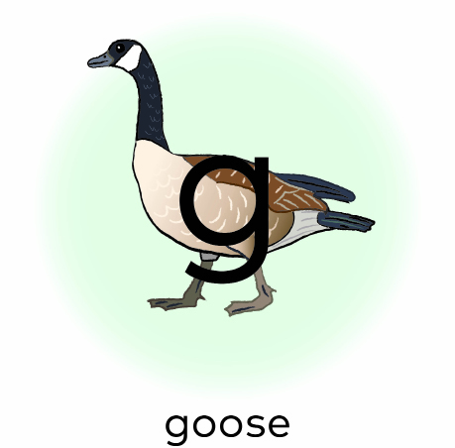  Words That Start with “g”

Initial and Final Sound Sort Pictures
 |  |  | 
 |  |  | 

Initial and Final Sound Sort Sheet
 |  | 

