READING FOUNDATIONS
SKILLS BLOCK
Grade K: Module 2: Cycle 5: Lesson 26
Language Arts Curriculum
Poem: “Victor the Sleepy Vulture”
Victor the Sleepy Vulture sat in a very tall tree

Enjoying the view and all he could see.

He spotted a slithery snake down on the ground.

He flew down to see if any food could be found.

The slithery snake left in a snap.

Victor sighed and said, “It’s time for my nap.”
Keyword Picture Card: “v”

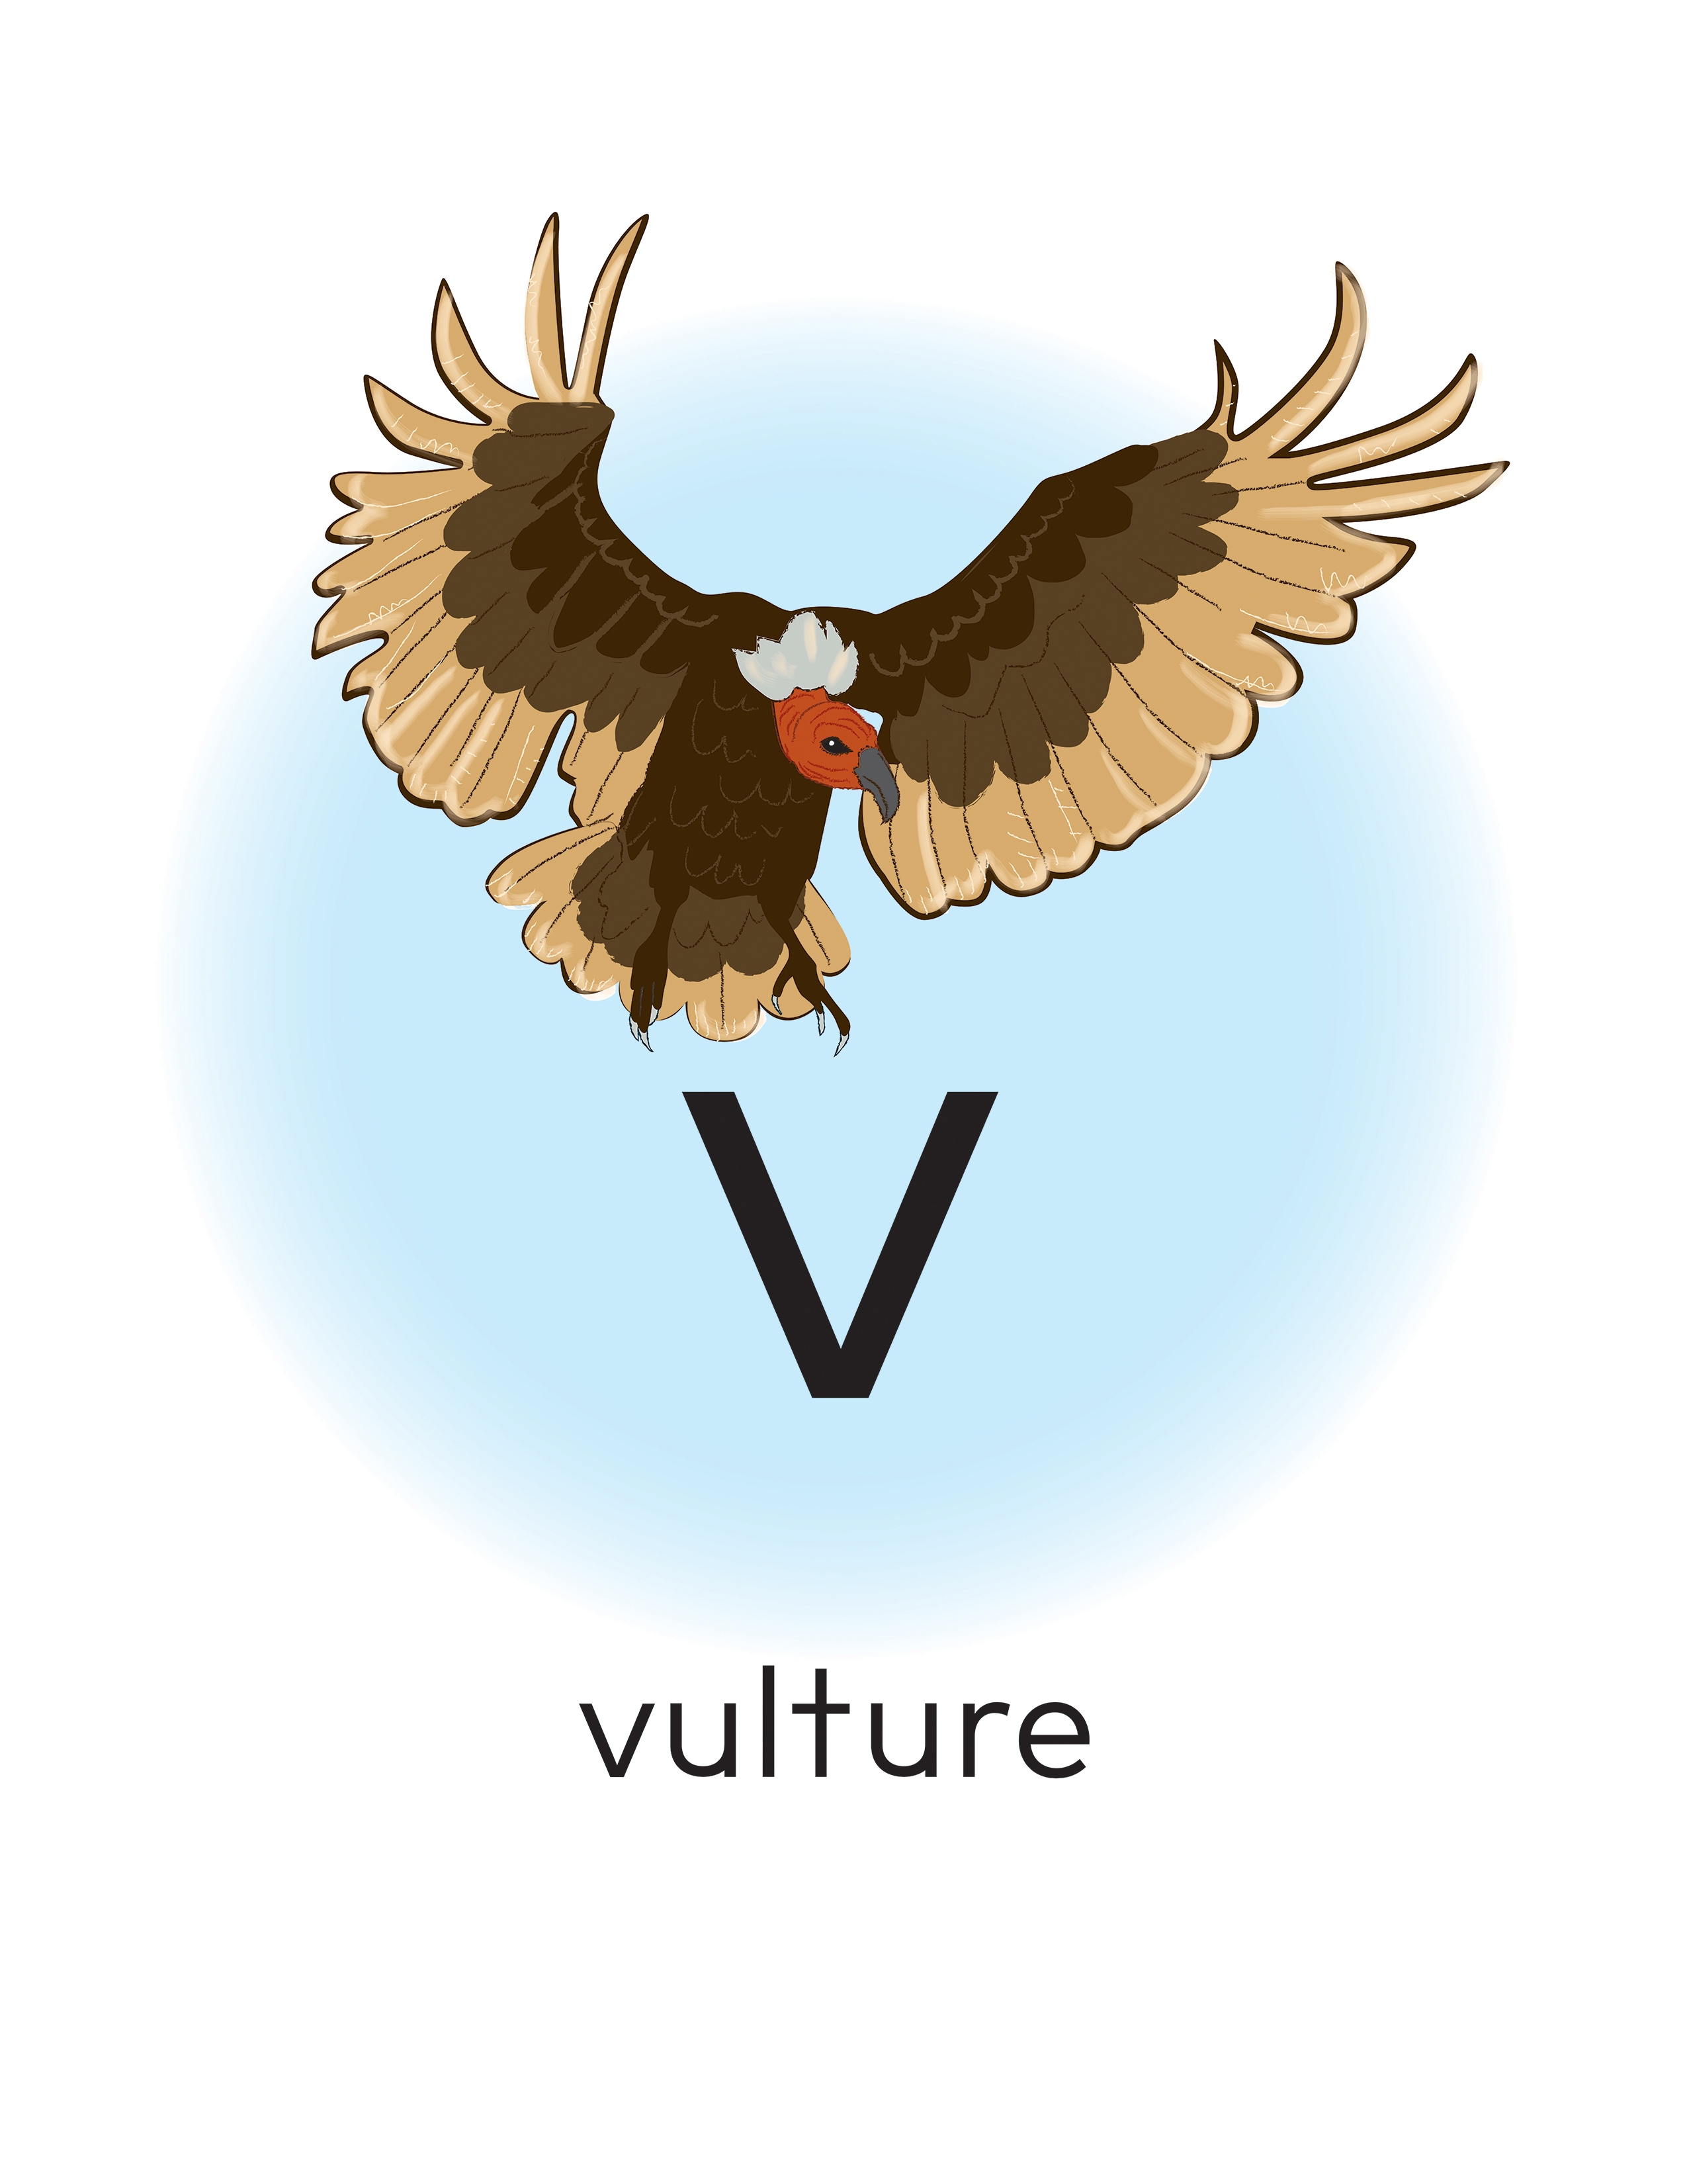
Keyword Picture Card: “s”

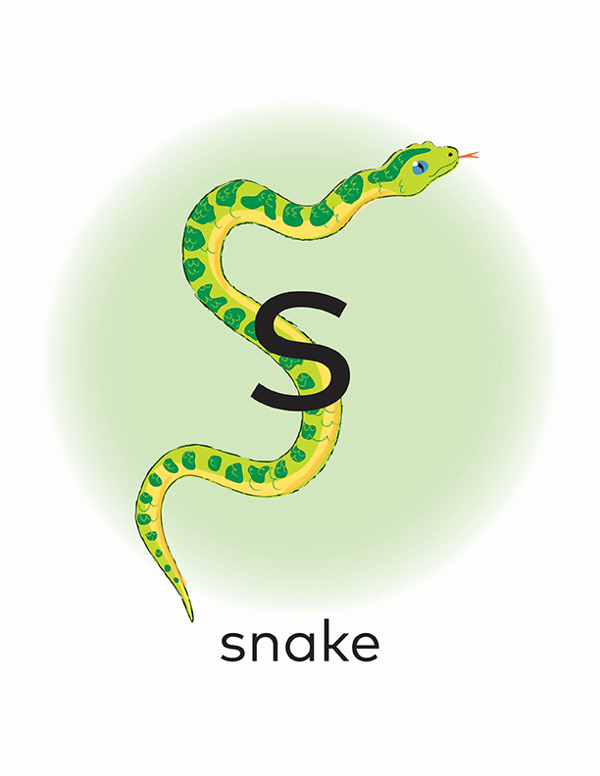
Initial Sound Sort Pictures

 |  | 
 |  | 
 |  | 
 |  | 

Initial Sound Sort Sheet
Words That Start with “s” | Words That Start with “v”

Initial and Final Sound Sort Pictures

 |  |  | 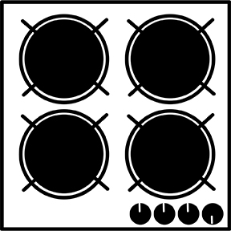
 |  |  | 

Initial and Final Sound Sort Sheet
 |  | yes | stove
Snapshot Assessment (optional)
Name: ___________________________________________ Date: _________________
Student Can: |  | Student Can: |  | Notes:
Count the number of words in a sentence |  | Identify the name of the letter “v”
Point to the first word in a sentence |  | Identify the name of the letter “s”
Point to the last word in a sentence |  | Identify the sound for the letter “v” (/v/)
Demonstrate one-to-one correspondence in shared text |  | Identify the sound for the letter “s” (/s/)

