Picture Puzzles: Space Race and the Cold War
Note to Teachers: Print each image onto cardstock, including the caption. Cut off the caption to use as a guide to help students understand the type of image they should be assembling. Cut each Picture Puzzle image into several pieces. Place all of the pieces of each puzzle in a plastic bag or envelope with the corresponding image number. Make several copies of each puzzle so that students can work in small groups (some groups will assemble the same puzzle). Instruct students to find and read the caption before beginning to assemble the puzzle. Make one copy of each complete picture image and caption to display in Opening A.
Puzzle Image 1
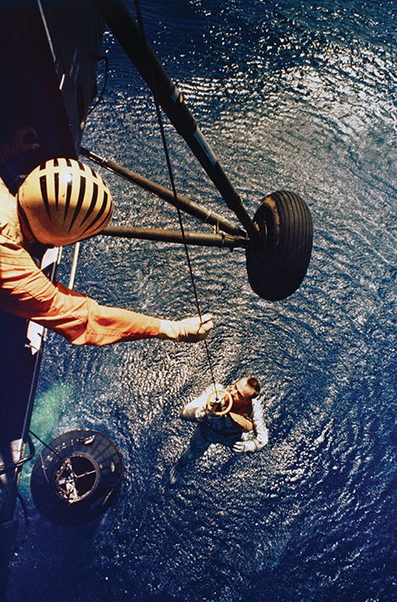
Alan Shepard, the first American to enter outer space, is recovered from his space capsule, Freedom 7, on May 5, 1961.
Puzzle Image 2
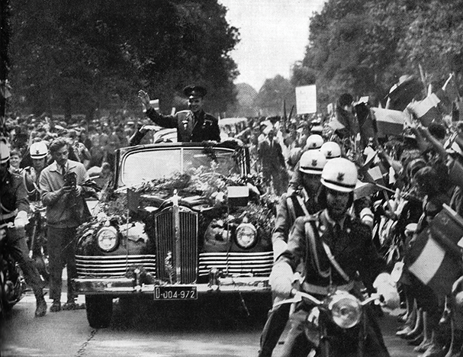 |  | Soviet cosmonaut Yuri Gargarin became an international celebrity for being the first human being to successfully travel to outer space on April 12, 1961.

Puzzle Image 3
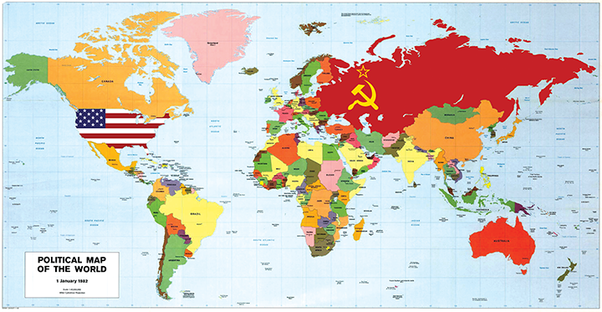 | After World War II, former allies the United States and the Soviet Union entered into a Cold War. Tension between the two countries was caused by a number of issues: Americans feared that Russia’s Communist political system would allow another dictator to come to power, and Russia was resentful that the USA delayed in entering WWII while millions of Russians died.
Puzzle Image 4
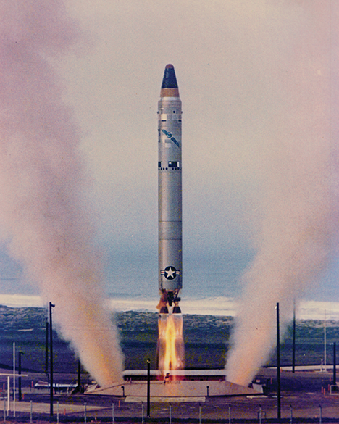
Besides a Space Race, the Cold War also involved an arms race, during which the United States and the USSR worked to develop the most advanced weapons. By 1953, both countries had created intercontinental ballistic missiles that could attack each other from great distances.
Image Credits
“Astronaut Alan B. Shepard Jr., pilot of the Mercury-Redstone 3 (MR-3) suborbital spaceflight, is retrieved by a helicopter from the USS Lake Champlain during recovery operations in the western Atlantic Ocean.” Photograph. NASA. 5 May 1961. Web. Public domain.
“Yuri Gagarin welcome Warsaw 1961.” Photograph. 1961. Wikimedia. Web. Public domain.
Scribe Concepts for EL Education.
“Titan Test.” Photograph. U.S. Department of Defense. 8 Nov. 1978. Web. Public domain.

Text: “This Is How the Space Race Changed
the Great Power Rivalry Forever”
Name: Date:
- The Space Race between the United States and the Union of Soviet Socialist Republics post World War II was a tipping point in the history of mankind. This superpower race intensified the Cold War rivalry because for the first time mankind was looking to compete in the arena of space. Dominance over space and the race to outdo one another became a matter of pride for both the United States and USSR.
- The competition to conquer space was so huge that a new benchmark was set by one of the two superpowers almost every year throughout 1950s and 1960s. There were many “firsts” during the Space Race. The first intercontinental ballistic missile in 1957, the first artificial satellite (Sputnik 1) in 1957, the first dog in orbit (sent by Sputnik 2) in 1957, the first solar-powered satellite, the first communication satellite, etc.
- The Space Race didn’t just leave an impact on the area of space research, it left a wider impact in the field of technology. The technological superiority required for the dominance of space was deemed a necessity for national security, and it was symbolic of ideological superiority. The Space Race spawned pioneering efforts to launch artificial satellites. It prompted competitive countries to send unmanned space probes to the Moon, Venus and Mars. It also made possible human spaceflight in low Earth orbit and to the Moon.
- The zeal the United States and USSR had to outperform one another proved quite beneficial to the progress of science. The work culture of the two superpowers was poles apart yet both were trying to be better than the other in order to become the best in the world. While the USSR had a highly centralized setup that had an impact on the source of investments in their space program, the United States, on the other hand, got private players to invest in their space program. NASA, the premiere space research agency, was also built in 1958 during the Space Race to counter the early success in USSR in outer space.
- The Space Race started with the USSR launching Sputnik 1 in 1957, which created a furor worldwide. The governments and masses were excited to see mankind taking another leap towards progress. When the human race ventured into space, it was a “paradigm shift” moment. Neil Armstrong landing on the Moon is still regarded as one of the breakpoints in history and his words, “That’s one small step for man, one giant leap for mankind,” are now one of the most quoted phrases in literature.
- In a May 1961 speech to Congress, President John F. Kennedy presented his views on the Space Race when he said, “These are extraordinary times and we face an extraordinary challenge. Our strength as well as our convictions have imposed upon this nation the role of leader in freedom’s cause.”
- “If we are to win the battle that is now going on around the world between freedom and tyranny, the dramatic achievements in space which occurred in recent weeks should have made clear to us all, as did the Sputnik in 1957, the impact of this adventure on the minds of men everywhere, who are attempting to make a determination of which road they should take. . . . Now it is time to take longer strides—time for a great new American enterprise—time for this nation to take a clearly leading role in space achievement, which in many ways may hold the key to our future on Earth,” he added.
- The space programs of both the superpowers were not just for civilian purposes; it was as much about the military-space program. Through this, the idea was to fight the battle with the rival by displaying power without actually having to fight an actual war. At that point, the United Nations had to step in to ensure that outer space didn’t become a battleground for the superpowers.
- That is when the Outer Space Treaty came into the picture. The Outer Space Treaty represents the basic legal framework of international-space law. Formally known as the Treaty on Principles Governing the Activities of States in the Exploration and Use of Outer Space, including the Moon and Other Celestial Bodies, the treaty bars states party to the treaty from placing weapons of mass destruction in orbit of Earth, installing them on the Moon or any other celestial body, or otherwise stationing them in outer space.
- It exclusively limits the use of the Moon and other celestial bodies to peaceful purposes and expressly prohibits their use for testing weapons of any kind, conducting military maneuvers, or establishing military bases, installations and fortifications. Soviets were reluctant to sign this treaty because, in their opinion, the treaty would restrict their dominance over the United States in the Space Race. They later signed the treaty in 1967 when it was opened for signatures. To date, more than one hundred nations have become signatories to the treaty.
- The Space Race didn’t have an end date and in many ways the race still continues. But the “space rivalry” ended between the United States and USSR in 1975, when the first multinational human-crewed mission went to space under the Apollo-Soyuz joint-test mission. In that mission, three U.S. astronauts and two Soviet cosmonauts became part of the first joint U.S.-Soviet space flight.
- The Space Race left a legacy in the field of space research worldwide. As the pioneers of space missions, both the United States and USSR helped their allies build their space missions through the training of scientists and engineers, the transferring of technology, and by allowing other researchers to visit their space laboratories. That way, both superpowers could learn and improve their knowledge and skills related to space research.
- The Indian space mission was in its very nascent stage when the Space Race was at its peak. The Indian space program owes its development and expansion to the aid and assistance of both the United States and the USSR because Indian space scientists and engineers were sent to train in both those countries. As a nonaligned country, India maintained a delicate balance between keeping good relations with both the superpowers, especially in the arena of space cooperation. As a result, the Indian Space Research Organization went on to become one of the best space research institutions in the world.
- In conclusion, the Space Race is one of the most iconic moments in the history of mankind. It is quite difficult to assess its full impact in the area of space research and technology. One thing is for sure though—if there had been no Space Race, then surely the world of space research and space missions would be quite different from what it is today.

Source: Jha, Martand. “This Is How the Space Race Changed the Great Power Rivalry Forever.” The National Interest. 27 July 2017. Web. Used by permission.
1310L
Close Reading Guide: “This Is How the Space Race Changed the Great Power Rivalry Forever”
RI.6.1, RI.6.2, RI.6.4, RI.6.6
(For Teacher Reference)
Purpose and Notes
- The purpose of this close read is for students to determine the author’s point of view toward the Space Race and identify key details that convey that point of view. Using context, affixes, and reference resources, students will determine the meanings of unfamiliar and technical words to understand the impact the Space Race had on the world. Finally, students synthesize their learning to determine the author’s purpose for writing this article. This sets them up to begin their argument analysis of the article in the next lesson.
- Read the text aloud the first time in its entirety. After the first full reading, students will reread portions of the text as they answer text-dependent questions.
- A note-catcher along with text-dependent questions provide an opportunity for students to capture how the author is building the argument.
- Continue to use discussion protocols (e.g., Think-Pair-Share, Conversation Cues, and total participation techniques) to engage all students in collaborative discussion about the text.
- Note that the culminating task for this close read is not completed until the Closing and Assessment section of this lesson.

Before reading, display a world map, and point out the United States and Russia. | - Explain that in the 1950s and 1960s, Russia was part of a large and powerful country called the Union of Soviet Socialist Republics. The USSR had a communist government, with only one party in power. The United States, on the other hand, had a democratic government where people could vote for different parties. The United States and the USSR were known as the world’s superpowers.  - Explain that just a few years before, in 1945, the world had emerged from World War II, which claimed the lives of millions of people—both in the military and civilians. Though they were allies during WWII, the United States and USSR grew suspicious of each other after the war, and tensions quickly arose between the two superpowers.

Excerpt of Text | Questions and Directions
Read the entire article. | - Read the whole article aloud as students read along silently.  - Ask: “What is this text about?” (the Space Race between the United States and the USSR)  - Explain that you have just read an argument essay. As students will remember, an argument essay is a piece of writing where the author has an opinion, or claim, about what they are writing. In a good argument, the author supports that claim with some accurate information, or evidence.  - Explain that in the next lesson we will look closely at sections of the text in order to better understand how the author builds his argument. For now, we will concentrate on understanding the key ideas in the text, including several new terms.

Excerpt of Text | Questions and Directions
Reread paragraph 1. | - Reread the first sentence in the article.  - Ask: “What does the phrase tipping point mean? (the point at which something changes a lot)  - If helpful, demonstrate a book standing up, then slowly push on the top of the book until it falls over. Explain that the point at which the balance shifted, causing the book to finally fall, was the tipping point.  - Ask: “What does this sentence show about how important the Space Race was?” (It made a big difference in the world. The relationship between the United States and the USSR was deeply affected by the Space Race.)  - Underline the words race, compete, rivalry, and outdo.  - Ask: “How are all these words related?” (They all have to do with people trying to win something or to surpass an opponent.)  - Explain that all of these terms have to do with the Cold War.  - Ask: “What do you think the term Cold War might mean? How might a cold war differ from a hot war?” (A Cold War is a rivalry between two countries. It is not hot because it does not use weapons and destruction, but carries on the rivalry in other ways.)  - Look at the last sentence of this paragraph again, and take turns paraphrasing it with a partner.  - Turn and Talk: “What does this final sentence of the paragraph tell us about space and the Cold War?” (The Space Race was an important part of the way the Cold War unfolded.)  - Pause to add vocabulary and responses to the Close Read: “This Is How the Space Race Changed the Great Power Rivalry Forever” note-catcher.

Excerpt of Text | Questions and Directions
Reread paragraphs 2 and 3. | - Ask: “How many firsts involving space that occurred during these years are mentioned in these paragraphs?” (five)  - Focus on the word intercontinental.  - Ask: “What root word do you recognize inside of intercontinental?” (continent)  - Ask: “Use your affix list; what does the prefix inter- mean?” (between)  - Ask: “Based on these parts, what does intercontinental seem to mean?” (between continents)  - Direct one student to use a dictionary to look up ballistic missile. (a long-range missile that reaches its target by falling freely at extremely high speed along a precalculated trajectory)  - Ask: “What does the phrase intercontinental ballistic missile mean?” (a weapon that can travel far enough to be launched from one continent and strike a target on another continent)  - Point to the phrase national security.  - Ask: “Use the context; what does this phrase mean?” (keeping your country safe from attack)  - Turn and Talk: “What connection do these paragraphs make between the Space Race, technology, and national security?” (New weapons meant that the USSR and the United States could fight each other from a distance. Competing to create the newest and best technology was not just a matter of pride but of survival for each nation’s citizens.)  - Pause to add vocabulary and responses to the Close Read: “This Is How the Space Race Changed the Great Power Rivalry Forever” note-catcher.

Excerpt of Text | Questions and Directions
Reread paragraph 4. | - Ask: “What do you think the word zeal means? (great energy or enthusiasm for something; passion)  - Direct one student to use a dictionary to verify the preliminary definition of zeal and have students record it on their note-catchers.  - Ask: “What does this word show us about how committed the United States and the USSR were to being the most powerful?” (They were extremely passionate about and committed to it.)

Excerpt of Text | Questions and Directions
Reread paragraph 5. | - Direct students to underline the phrase the Space Race started in this paragraph.  - Ask: “What does this phrase signal about the type of information this next paragraph might include?” (It includes words about time, so it looks like the writer may talk about the history of the Space Race.)  - Ask: “What does the word leap mean in this paragraph?” (a big jump)  - Turn and Talk: “What kind of leap is the writer describing here? Why do you think he chooses that word?” (here, leap is not a physical jump, but a big change. The writer wants to show what a big change this new thinking about technology creates)  - Ask: “Think about the term paradigm shift in the context of this whole paragraph. Even without knowing what a paradigm is, what does this term seem to mean? What makes you think so?” (A whole new way of thinking. He calls it a breakthrough.)  - Explain that a paradigm is a view of the world, and here the landing on the moon made people see their world in a different way.  - Turn and Talk: “Can you think of a time you had a paradigm shift in your life? What event caused you to see the world in a new way?” (Responses will vary, but may include: when my grandmother died, it made me realize that life is short, and I should appreciate each day more.)  - Pause to add vocabulary to the Close Read: “This Is How the Space Race Changed the Great Power Rivalry Forever” note-catcher.

Excerpt of Text | Questions and Directions
Reread paragraphs 6 and 7. | - Turn and Talk: “These two paragraphs give us part of a speech by President Kennedy in 1961. Think back to the idea of national security. What words do you see in this speech that remind you of the importance of national security and the Cold War in the space race?” (I see “leader in freedom’s cause,” “battle between freedom and tyranny,” “great new American enterprise,” and “leading role in space achievement.”)  - Ask: “What is President Kennedy’s point of view toward the goals of the Space Race?” (He believes that advancing space technology is a matter of freedom, national security, and the future of planet Earth.)  - Pause to add responses to the Close Read: “This Is How the Space Race Changed the Great Power Rivalry Forever” note-catcher.

Excerpt of Text | Questions and Directions
- Reread paragraphs 8, 9, and 10. | - Ask: “What is the gist of these three paragraphs?” (A treaty to limit how countries used the moon was created by the United Nations.)  - Direct students to underline the second sentence in paragraph 8.  - Say: “Try paraphrasing that sentence.” (The two countries were fighting without an actual war, by using the space race.)  - Turn and Talk: “Why do you think the United Nations had to step in to make the Outer Space Treaty? Why might both countries have decided to go along with it?” (Responses will vary, but may include: The world was still recovering from two global wars. The United Nations probably realized that space could easily become another possible battleground, and they wanted to set ground rules before things got that serious. The United States and USSR probably agreed because they had been involved in both world wars and did not want to suffer any more losses.)  - Pause to add responses to the Close Read: “This Is How the Space Race Changed the Great Power Rivalry Forever” note-catcher.

Excerpt of Text | Questions and Directions
Reread paragraph 11. | - Ask: “According to this article, what is one event that led to the end of the space rivalry in 1975?” (The United States and the USSR worked together on a joint space project.)  - Explain that the Cold War did not officially end until 1991, but the end of the most intense part of the space race helped to ease tensions between the two nations in the early 1970s.

Excerpt of Text | Questions and Directions
Reread paragraphs 12 and 13. | - Point to the first sentence in paragraph 12.  - Ask: “Based on this topic sentence, what kind of information do you expect to read about in this next section?” (How the space race affected other countries besides the United States and the USSR.)  - Ask: “What is the author’s point of view towards the United States and the USSR’s decision to cooperate with space programs in other countries?” (His point of view is that sharing knowledge was beneficial to everyone involved. The Indian space program is one of the best in the world because they learned from both Russia and the United States.)  - Ask: “What words or phrases convey that point of view?” (Responses will vary, but may include: “pioneers,” “both superpowers could learn and improve,” “owes its development,” “best space research institutions in the world.”)  - Ask: “The text tells us that the Space Race left a legacy. From the context of the rest of the two paragraphs, what do you think legacy means?” (The result or impact from an important event.)  - Pause to add responses to the Close Read: “This Is How the Space Race Changed the Great Power Rivalry Forever” note-catcher.

Excerpt of Text | Questions and Directions
Reread paragraph 14. | - Students independently complete the Culminating Task on their Close Read: “This Is How the Space Race Changed the Great Power Rivalry Forever” note-catcher during the Closing and Assessment of this lesson.  - Ask: “What is the author’s purpose for writing this article? What words or phrases indicate that purpose?” (Responses will vary, but may include: The author’s purpose for writing this article is to persuade the reader that “the Space Race is one of the most iconic moments in the history of mankind.” This is demonstrated by the author’s use of language that clearly shows an opinion or bias. For example, the author uses words and phrases like tipping point and benchmark to talk about the impact the Space Race had. The author also indicates that “dominance” in space science would require technological and ideological “superiority.” These words have strong connotations which the author chose on purpose to persuade the audience to agree with his point of view toward the topic.)

Source: Jha, Martand. “This Is How the Space Race Changed the Great Power Rivalry Forever.” The National Interest, July 27, 2017
1310L
Close Read: “This Is How the Space Race
Changed the Great Power Rivalry Forever”
Note-Catcher
RI.6.1, RI.6.2, RI.6.4, RI.6.6
(Example for Teacher Reference)
Directions: Follow along as your teacher reads the article in its entirety. As you reread and examine each section, record key vocabulary and important insights.
Paragraph 1
Key Vocabulary
- tipping point:
the point at which something changes a lot
- Cold War:
a rivalry between two countries; it is not hot because it does not use weapons and destruction, but carries on the rivalry in other ways
Important Insights
- What does this final sentence of the paragraph tell the reader about space and the Cold War?
The Space Race was an important part of the way the Cold War unfolded.
Paragraphs 2 and 3
Key Vocabulary
- intercontinental:
between continents
- national security:
keeping your country safe from attack
Important Insights
- What connection do these paragraphs make between the Space Race, technology, and national security?
New weapons meant that the USSR and the United States could fight each other from a distance. Competing to create the newest and best technology was not just a matter of pride but of survival for each nation’s citizens.
Paragraph 4
Key Vocabulary
- zeal:
great energy or enthusiasm for something; passion
Paragraph 5
Key Vocabulary
- paradigm shift:
a whole new way of thinking
Paragraphs 6 and 7
Important Insights
- What is President Kennedy’s point of view toward the goals of the space race?
He believes that advancing space technology is a matter of freedom, national security, and the future of planet Earth.
Paragraphs 8, 9, and 10
Important Insights
- Why do you think the United Nations had to step in to make the Outer Space Treaty? Why might both the United States and the USSR have decided to go along with it?
Responses will vary, but may include: The world was still recovering from two global wars. The United Nations probably realized that space could easily become another possible battleground and they wanted to set ground rules before things got that serious. The United States and USSR probably agreed because they had been involved in both world wars and did not want to suffer any more losses.
Paragraphs 12 and 13
Key Vocabulary
- legacy:
the result or impact from an important event
Important Insights
- What is the author’s point of view toward the United States and the USSR’s decision to cooperate with space programs in other countries?
His point of view is that sharing knowledge was beneficial to everyone involved. The Indian space program is one of the best in the world because they learned from both Russia and the United States.
- What words or phrases convey that point of view?
Responses will vary, but may include: “pioneers,” “both superpowers could learn and improve,” “owes its development,” “best space research institutions in the world.”
Culminating Task
- What is the author’s purpose for writing this article? What words or phrases indicate that purpose?
Responses will vary, but may include: The author’s purpose for writing this article is to persuade the reader that “the Space Race is one of the most iconic moments in the history of mankind.” This is demonstrated by the author’s use of language that clearly shows an opinion or bias. For example, the author uses words and phrases like “tipping point” and “benchmark” to talk about the impact the Space Race had. The author also indicates that “dominance” in space science would require technological and ideological “superiority.” These words have strong connotations which the author chose on purpose to persuade the audience to agree with his point of view toward the topic.

Source: Jha, Martand. “This Is How the Space Race Changed the Great Power Rivalry Forever.” The National Interest. 27 Jul 2017. Web. Used by permission.
Close Read: “This Is How the Space Race
Changed the Great Power Rivalry Forever”
Note-Catcher
RI.6.1, RI.6.2, RI.6.4, RI.6.6
Name: Date:
Directions: Follow along as your teacher reads the article in its entirety. As you reread and examine each section, record key vocabulary and important insights.
Paragraph 1
Key Vocabulary
- tipping point:

- Cold War:

Important Insights
- What does this final sentence of the paragraph tell the reader about space and the Cold War?

Paragraphs 2 and 3
Key Vocabulary
- intercontinental:

- national security:

Important Insights
- What connection do these paragraphs make between the Space Race, technology, and national security?

Paragraph 4
Key Vocabulary
- zeal:

Paragraph 5
Key Vocabulary
- paradigm shift:

Paragraphs 6 and 7
Important Insights
- What is President Kennedy’s point of view toward the goals of the space race?

Paragraphs 8, 9, and 10
Important Insights
- Why do you think the United Nations had to step in to make the Outer Space Treaty? Why might both the United States and the USSR have decided to go along with it?

Paragraphs 12 and 13
Key Vocabulary
- legacy:

Important Insights
- What is the author’s point of view toward the United States and the USSR’s decision to cooperate with space programs in other countries?

- What words or phrases convey that point of view?

Culminating Task
- What is the author’s purpose for writing this article? What words or phrases indicate that purpose?

Copyright License
Except where otherwise noted, EL Education’s Language Arts Curriculum is published under a Creative Commons Attribution-NonCommercial 4.0 International (CC BY-NC 4.0) License. To view a copy of this license, visit https://creativecommons.org/licenses/by-nc/4.0/.

Licensed third party content noted as such in this curriculum is the property of the respective copyright owner. Responsibility for securing any necessary permissions as to such third party content rests with parties desiring to use such content. For example, certain third party content may not be reproduced or distributed (outside the scope of fair use) without additional permissions from the content owner and it is the responsibility of the person seeking to reproduce or distribute this curriculum to either secure those permissions or remove the applicable content before reproduction or distribution.

For more information, visit our Terms of Use at https://curriculum.eleducation.org/terms-of-use.

