Entrance Ticket: Unit 3, Lesson 12
SL.8.5
Name: Date:
Directions: As you enter class, answer the following question.
In Lesson 6, you created graphic panels of a text reflection you wrote about a Holocaust upstander. What part of your narrative interview would you like to illustrate in graphic panels?

Model Graphic Panels
Name: Date:

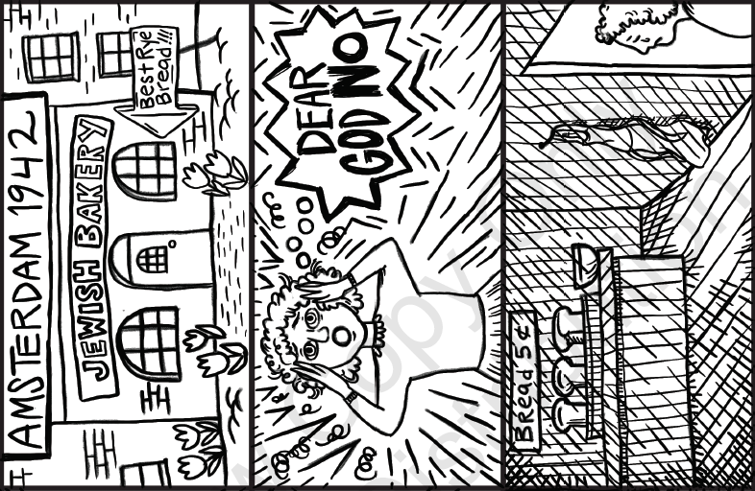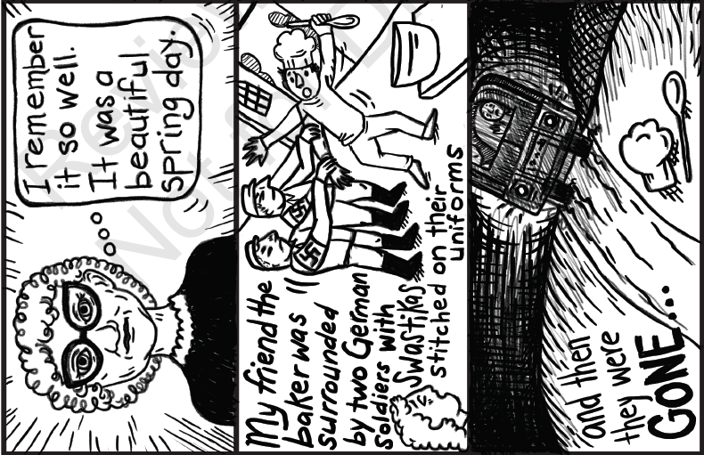
Katy Cummings for EL Education.

Model Graphic Panels Sequence Planner
SL.8.5
Directions: Use the following planner to determine how you will illustrate your interview narrative. Read each prompt carefully to guide your planning.
Excerpt from my narrative that I will explode on graphic panels:
I remember it so well. It was a beautiful spring day in 1942 in Amsterdam. I was studying to be a teacher, and I had so much work to do that night that I knew I wouldn’t have time to make dinner. So I decided to stop at the local Jewish bakery for a loaf of fresh-baked rye bread. The baker always made such wonderful bread—the whole neighborhood loved to stop by.
As I turned the corner, I heard shouts and scuffling. At first I couldn’t tell what was going on, but suddenly I realized that my friend the baker was surrounded by two or three German soldiers. They were dragging him out of his bakery. For that instant, time stood still. Horrified, I watched the soldiers muscle him into a military truck and drive away. As the siren’s scream filled the air, I could just barely hear beneath that sound the muffled screams of the baker—and then they were gone. The door to the bakery stood ajar, the baker’s apron hanging there on a hook as if the baker had just stepped out for a moment to buy butter. But a dreadful emptiness filled the place. I never saw him again.
Why I selected this portion:
In the interview, Anna Jensen describes the scene I drew very vividly. This is one incident, but it represents the countless tragic experiences of many Jewish people during the Holocaust. I felt that capturing this incident in visual format would help us to remember the injustices and horrors done to Jewish people in the Holocaust.
Panel 1
Text Represented | I remember it so well.
What I Want My Audience to Take Away | Anna Jensen still vividly remembers a traumatic event during the Holocaust.  Anna Jensen as an older woman
Notes or Simple Sketch | Thought bubble to indicate memory (including short text: “I remember it so well.”)

Panel 2
Text Represented | It was a beautiful spring day in 1942 in Amsterdam. I was studying to be a teacher, and I had so much work to do that night that I knew I wouldn’t have time to make dinner. So I decided to stop at the local Jewish bakery for a loaf of fresh-baked rye bread. The baker always made such wonderful bread—the whole neighborhood loved to stop by.
What I Want My Audience to Take Away | This was in 1942, many years ago . . . this awful event disrupted what were normal, routine lives and an ordinary bakery.
Notes or Simple Sketch | Label date at top to make the context clear.  The Jewish bakery (can include sign indicating business and another sign to highlight that it had the best rye bread)

Panel 3
Text Represented | As I turned the corner, I heard shouts and scuffling. At first I couldn’t tell what was going on, but suddenly I realized that my friend the baker was surrounded by two or three German soldiers. They were dragging him out of his bakery.
What I Want My Audience to Take Away | The baker was a victim in this event. The Nazi soldiers were forceful and scary.
Notes or Simple Sketch | Young Anna turning corner and seeing the baker being taken by soldiers.  Include dark, prominent lines to convey ominous energy of soldiers.  Use baker’s hat and tool to identify baker.  Keep bakery building features consistent to panel 2.

Panel 4
Text Represented | As the siren’s scream filled the air, I could just barely hear beneath that sound the muffled screams of the baker.
What I Want My Audience to Take Away | The sound and chaos and horror of this event were deeply felt by Anna.
Notes or Simple Sketch | Show young Anna covering her ears and sirens blaring.  Sketch should focus only on Anna, and show how scary this experience was.

Panel 5
Text Represented | For that instant, time stood still. Horrified, I watched the soldiers muscle him into a military truck and drive away.  —and then they were gone.
What I Want My Audience to Take Away | Anna witnessed the baker losing everything. All she can do is watch, and it is incredibly sad and painful.
Notes or Simple Sketch | Military tank is driving away in distance.  Baker’s hat and whisk left trailing on ground to make it clear that the baker’s identity and life have been left behind as is taken away. Baker is seen reaching out of back of truck, as if begging not to be taken.

Panel 6
Text Represented | The door to the bakery stood ajar, the baker’s apron hanging there on a hook as if the baker had just stepped out for a moment to buy butter. But a dreadful emptiness filled the place. I never saw him again.
What I Want My Audience to Take Away | The emptiness of the bakery is sad and quiet and no longer has life within it.
Notes or Simple Sketch | Empty bakery with apron hanging and some bread left behind. Darkness to convey the heavy sadness.

Graphic Panels Sequence Planner
SL.8.5
Name: Date:
Directions: Use the following planner to determine how you will illustrate your interview narrative. Read each prompt carefully to guide your planning.
Excerpt from my narrative that I will explode on graphic panels:

Why I selected this portion:

Panel 1
Text Represented
What I Want My Audience to Take Away
Notes or Simple Sketch

Panel 2
Text Represented
What I Want My Audience to Take Away
Notes or Simple Sketch

Panel 3
Text Represented
What I Want My Audience to Take Away
Notes or Simple Sketch

Panel 4
Text Represented
What I Want My Audience to Take Away
Notes or Simple Sketch

Panel 5
Text Represented
What I Want My Audience to Take Away
Notes or Simple Sketch

Panel 6
Text Represented
What I Want My Audience to Take Away
Notes or Simple Sketch

