MODULE LESSONS
Grade K: Module 1: Cycle 3: Lesson 18
Reading Foundations Skills Block
Language Arts Curriculum
Snapshot Assessment (optional)
Date: |  | Student:
Student Can: |  | Student Can: |  | Notes:
Count the number of words in a sentence |  | Demonstrate one-to-one correspondence in shared text
Point to the first word in a sentence |  | Read the high-frequency word: “the”
Point to the last word in a sentence |  | Count the number of letters in a word

Letter-Picture Match Cards
Aa | 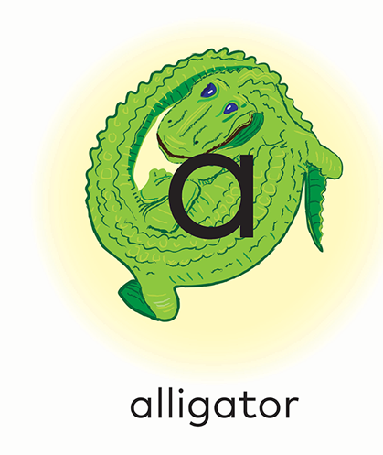 | Hh | 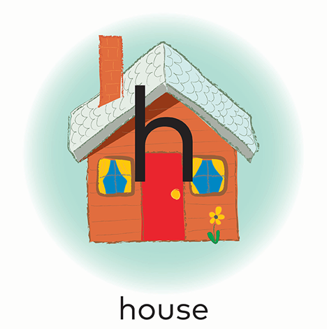
Tt | 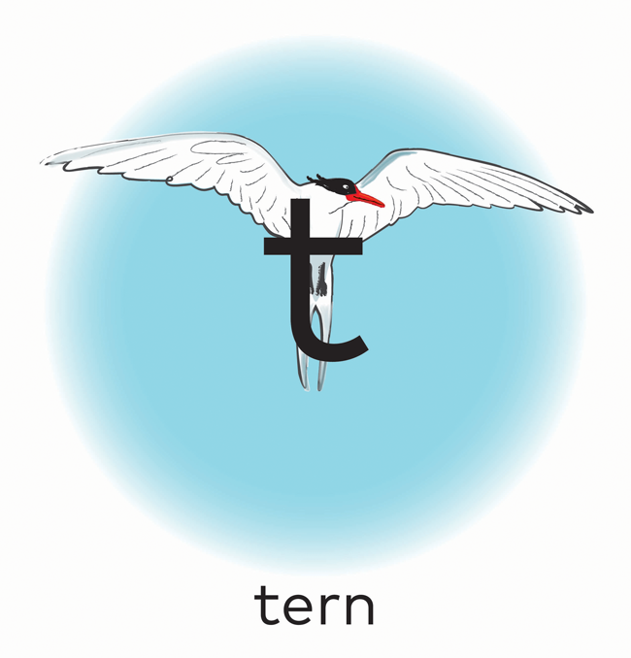 | Pp | 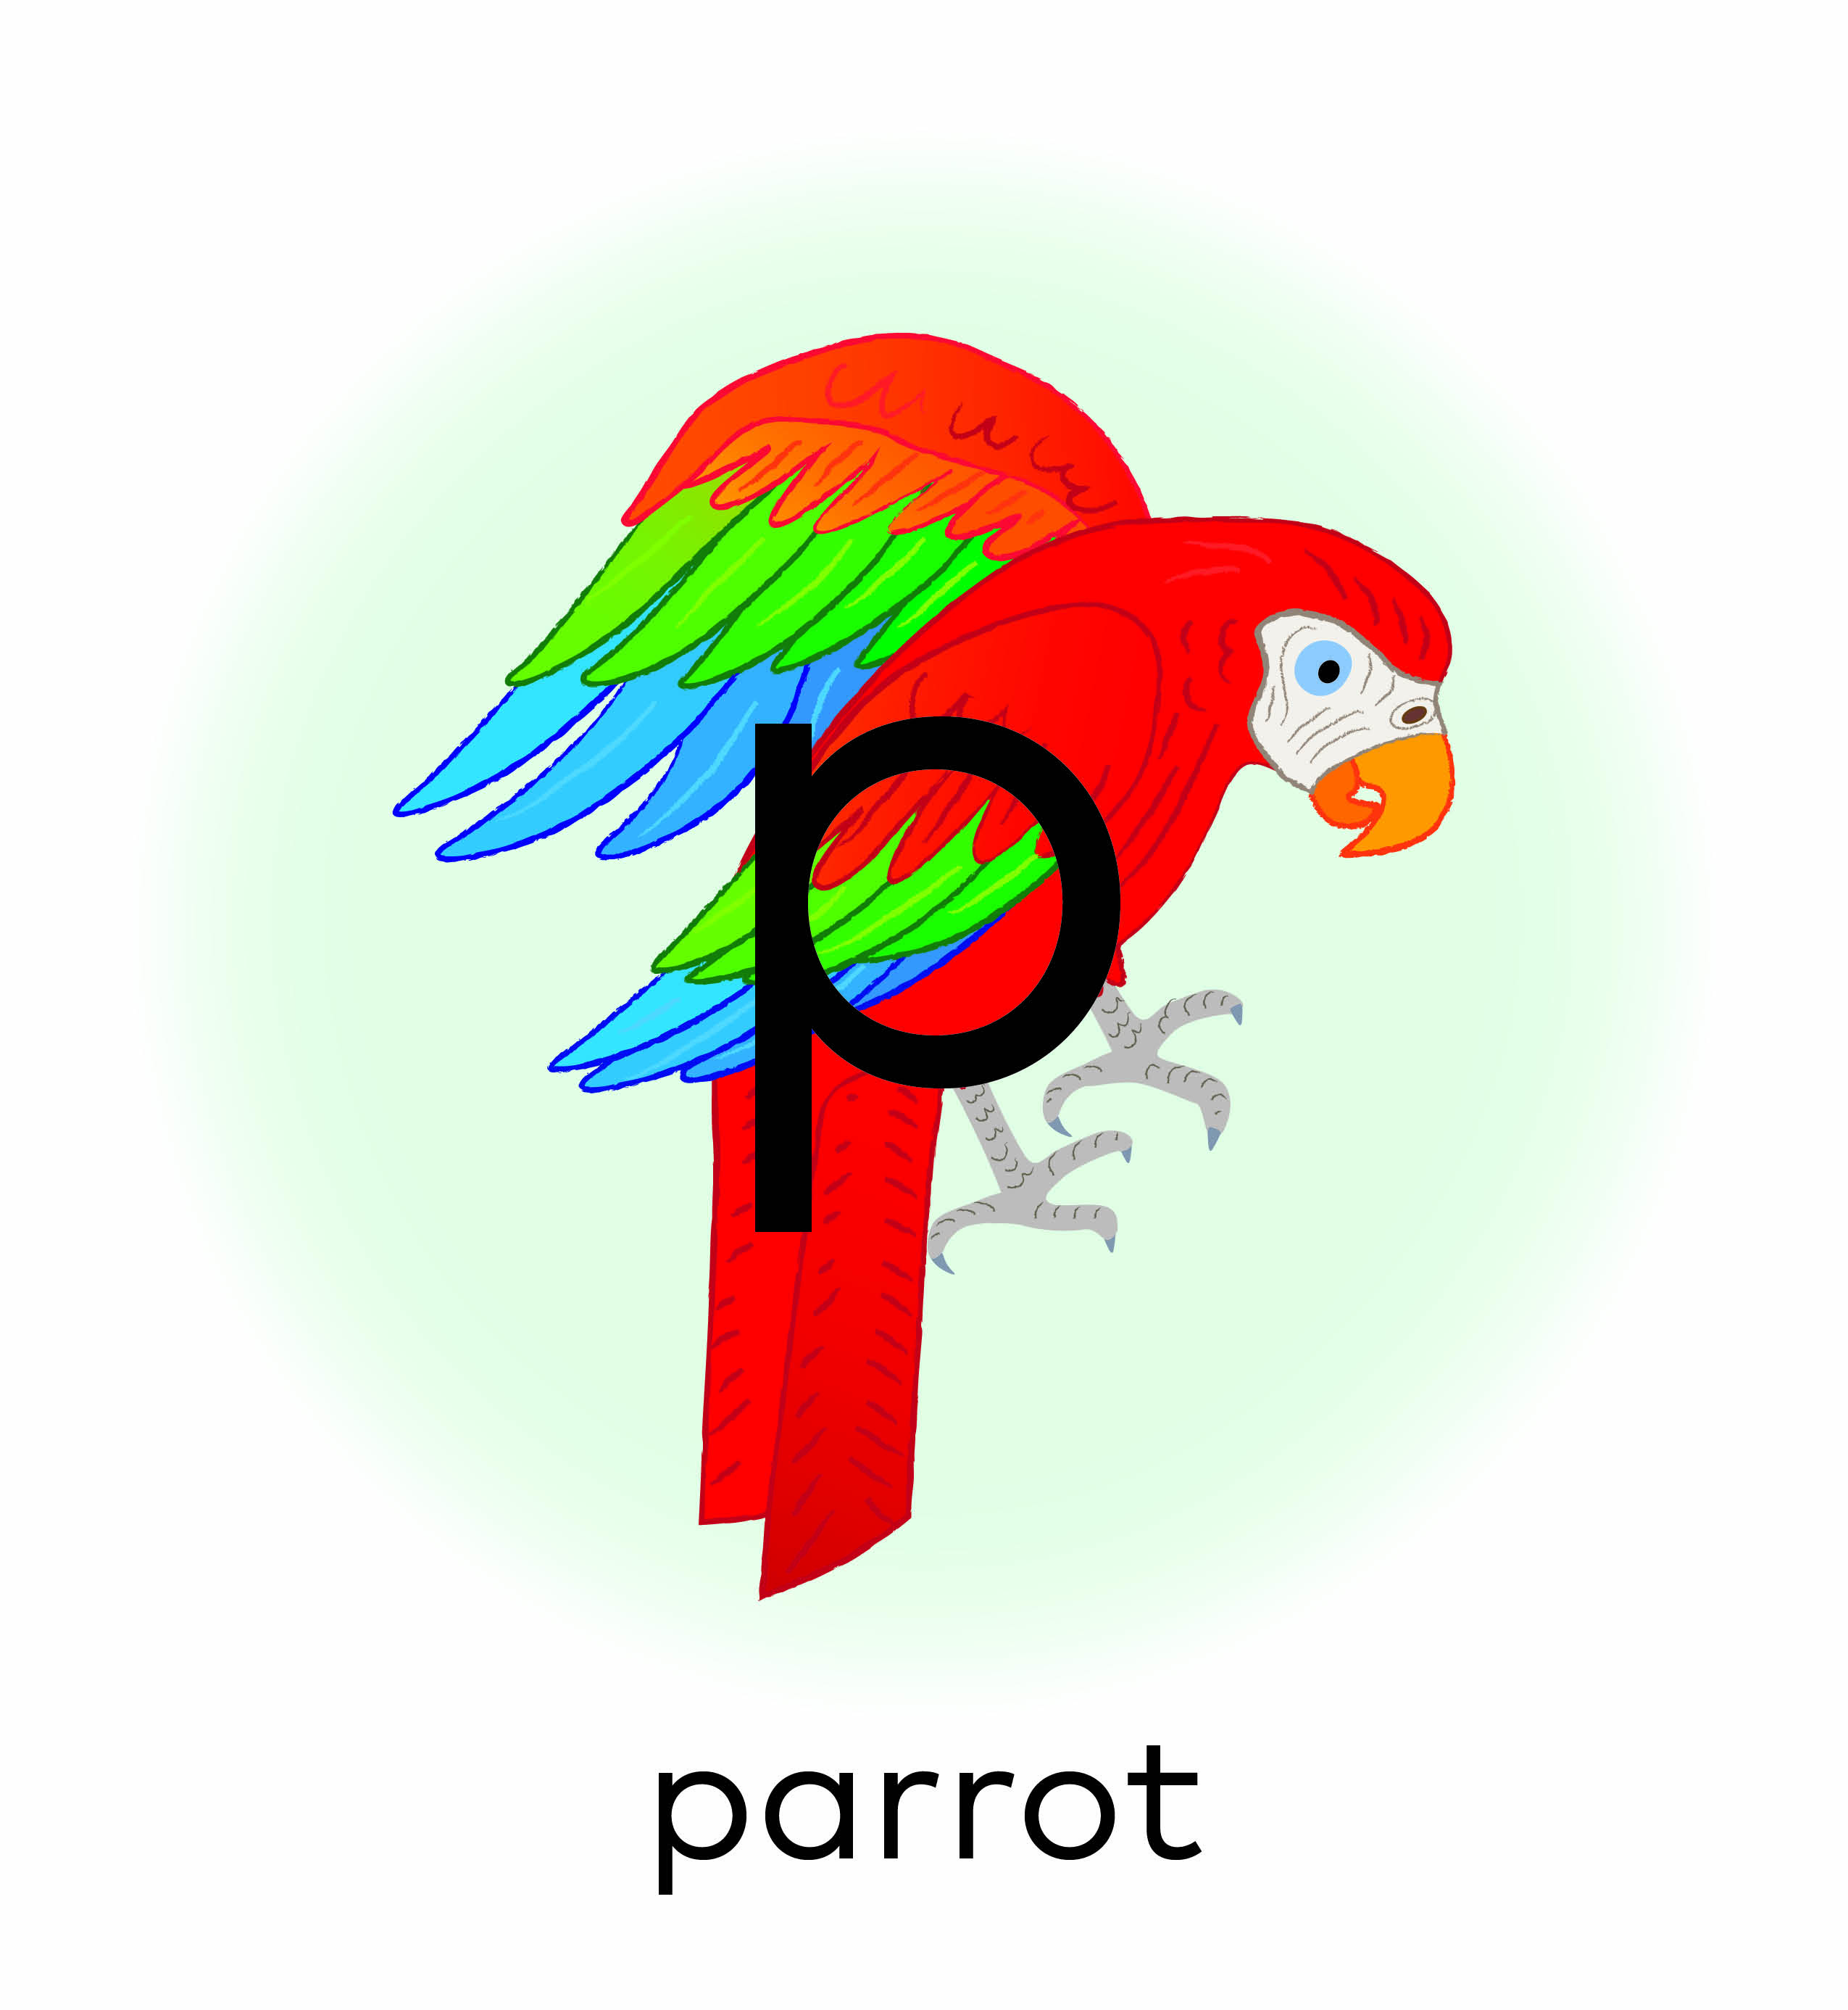
Nn | 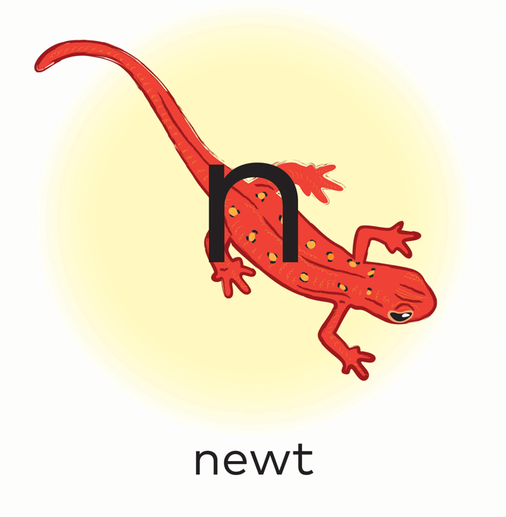 | Cc | 

