READING FOUDATIONS
SKILLS BLOCK
Grade K: Module 1: Cycle 3: Lesson 16
Language Arts Curriculum
Poem: “My Cat, Noodles”
My cat, Noodles, and I went for a hike one day
We walked near the creek and began to play
We saw a cute newt on a rock in the creek
We crept up slowly so we could take a peek
Noodles tried to catch it, but the newt was too fast!
It appeared again and I thought, “We’ll capture it at last!”
But the newt was very sneaky and still snuck past
Keyword Picture Card: “c”

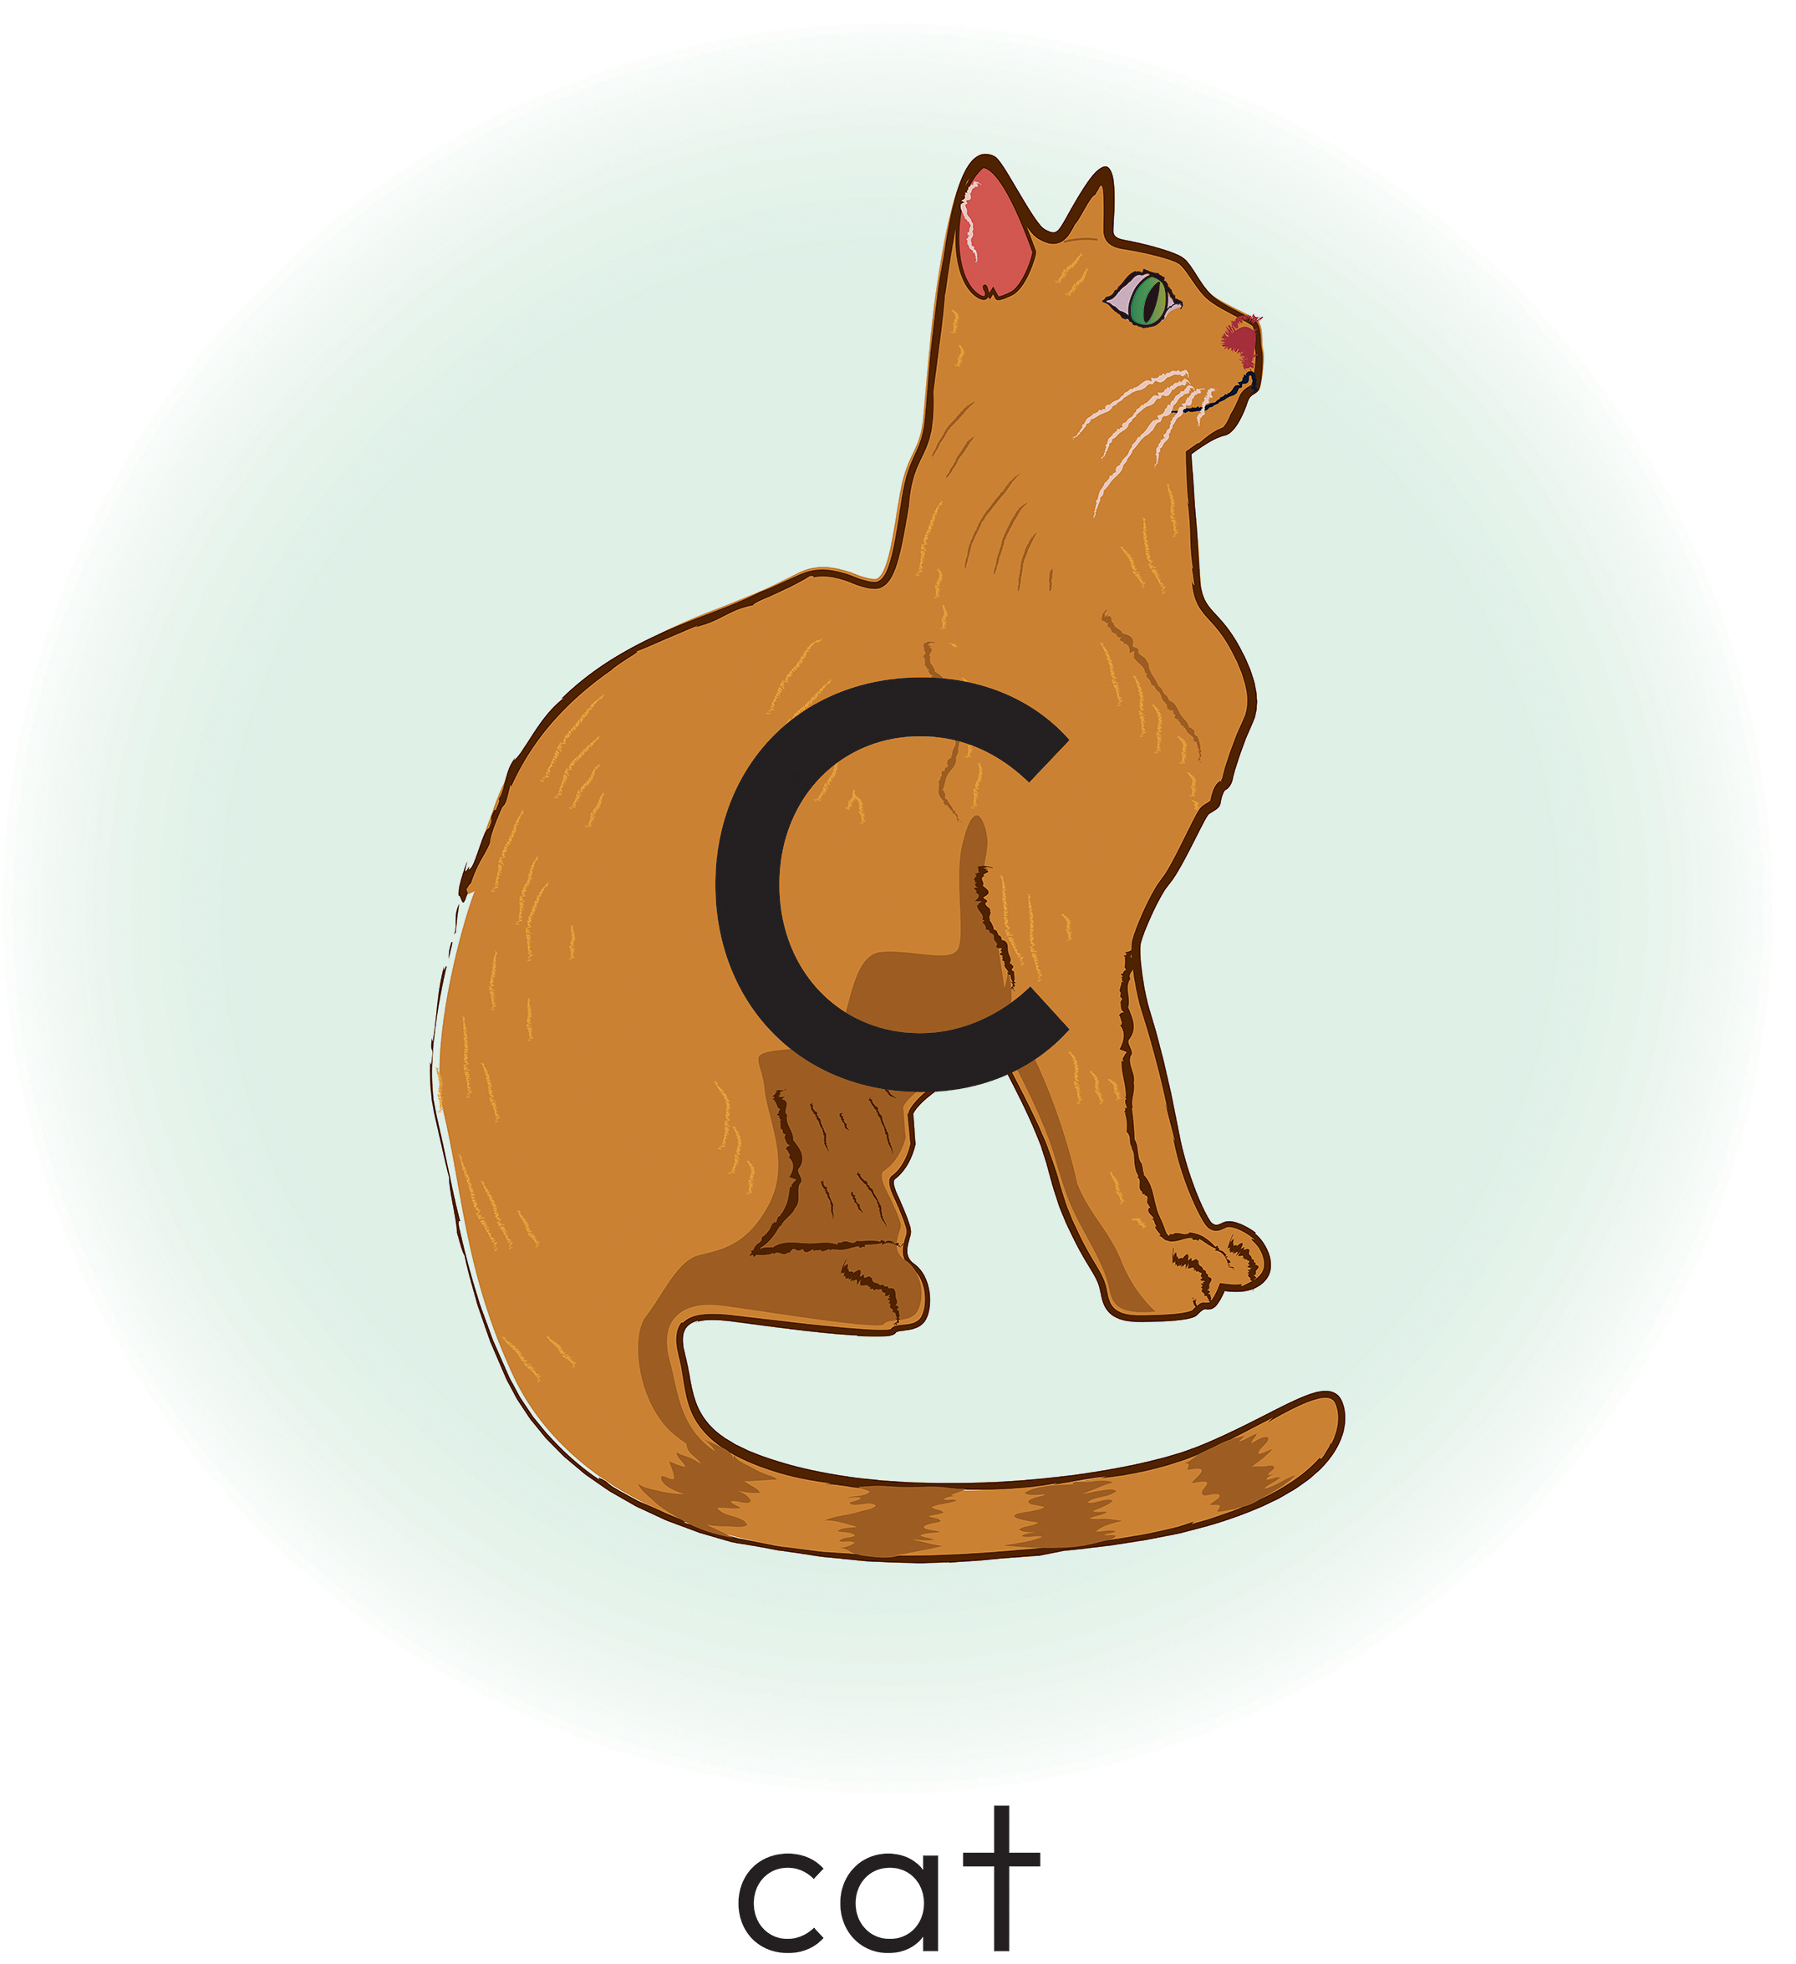
Keyword Picture Card: “n”

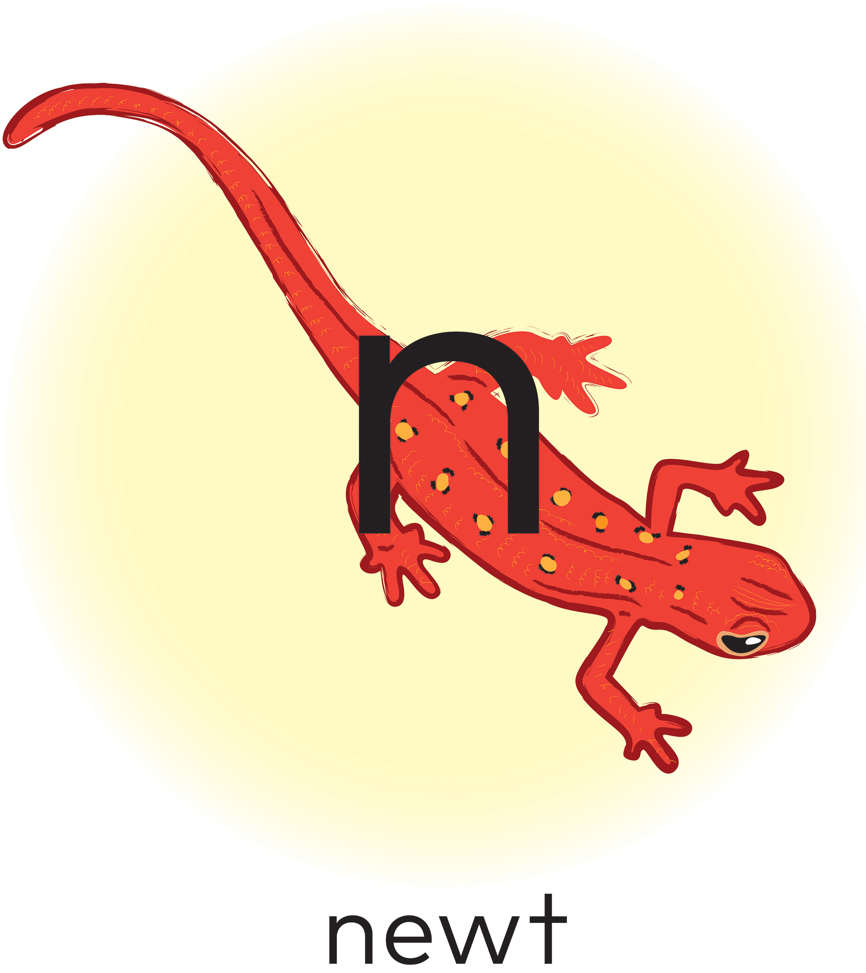
Snapshot Assessment (optional)
Name: _________________________________________________________ Date: ________________________
Student Can: |  | Student Can: |  | Notes:
Count the number of words in a sentence |  | Identify the name of the letter “c”
Point to the first word in a sentence |  | Identify the name of the letter “n”
Point to the last word in a sentence |  | Identify the sound for the letter “c” (/k/)
Demonstrate one-to-one correspondence in shared text |  | Identify the sound for the letter “n” (/n/)

Initial Sound Sort Pictures
 |  |  | 9
 | 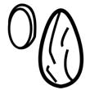 |  | 
 |  |  | 
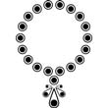 |  |  | 
 |  | 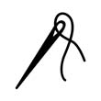 | 

Initial Sound Sort Sheet
Words That Start with “c” | Words That Start with “n”

Initial and Final Sound Sort Pictures
 |  |  | 

 |  | 

 |  | 

Initial and Final Sound Sort Sheet


Articulatory Gestures Chart


