READING FOUDATIONS
SKILLS BLOCK
Grade K: Module 1: Cycle 2: Lesson 13
Language Arts Curriculum
Letter-Picture Match Cards
 | 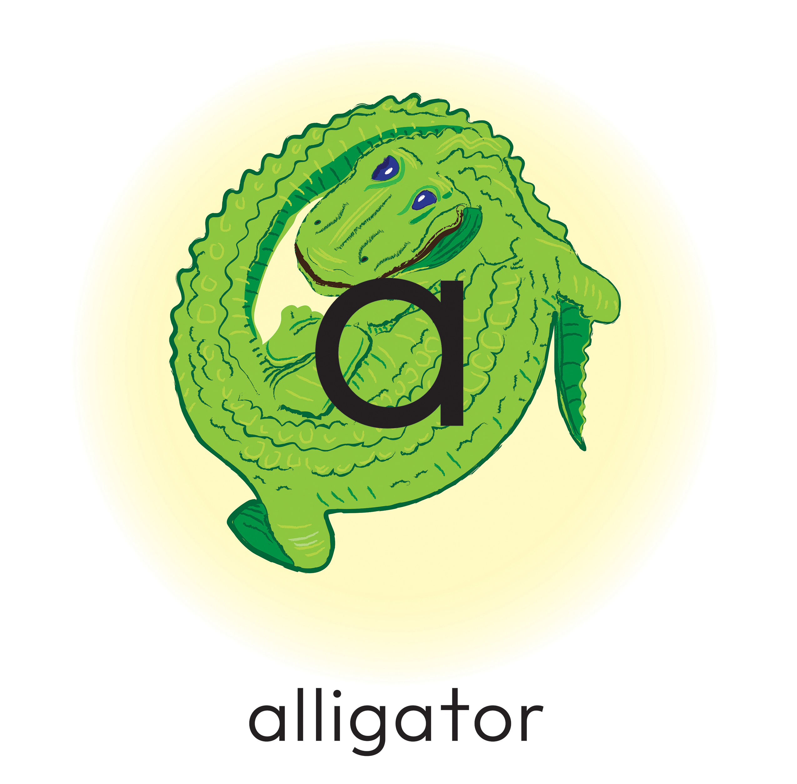 |  | 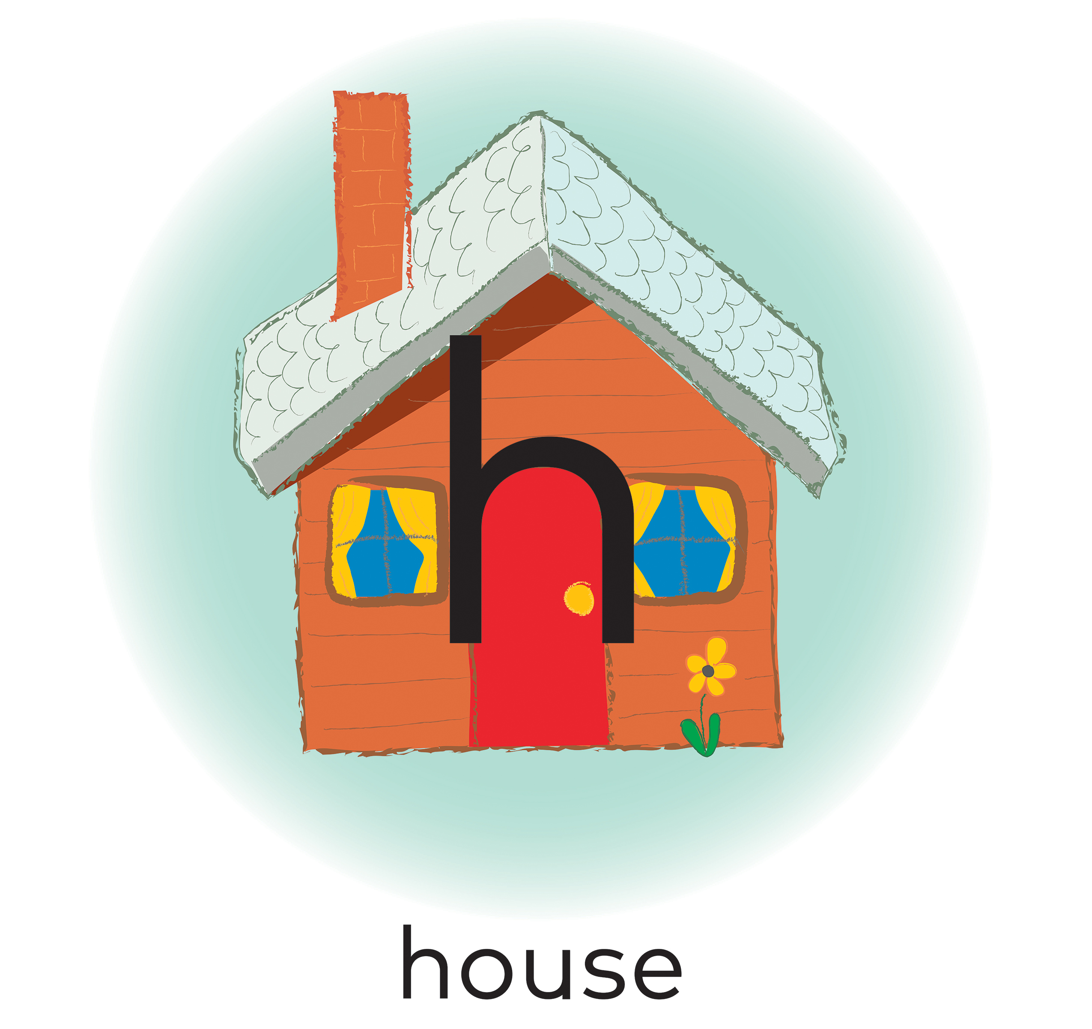
 | 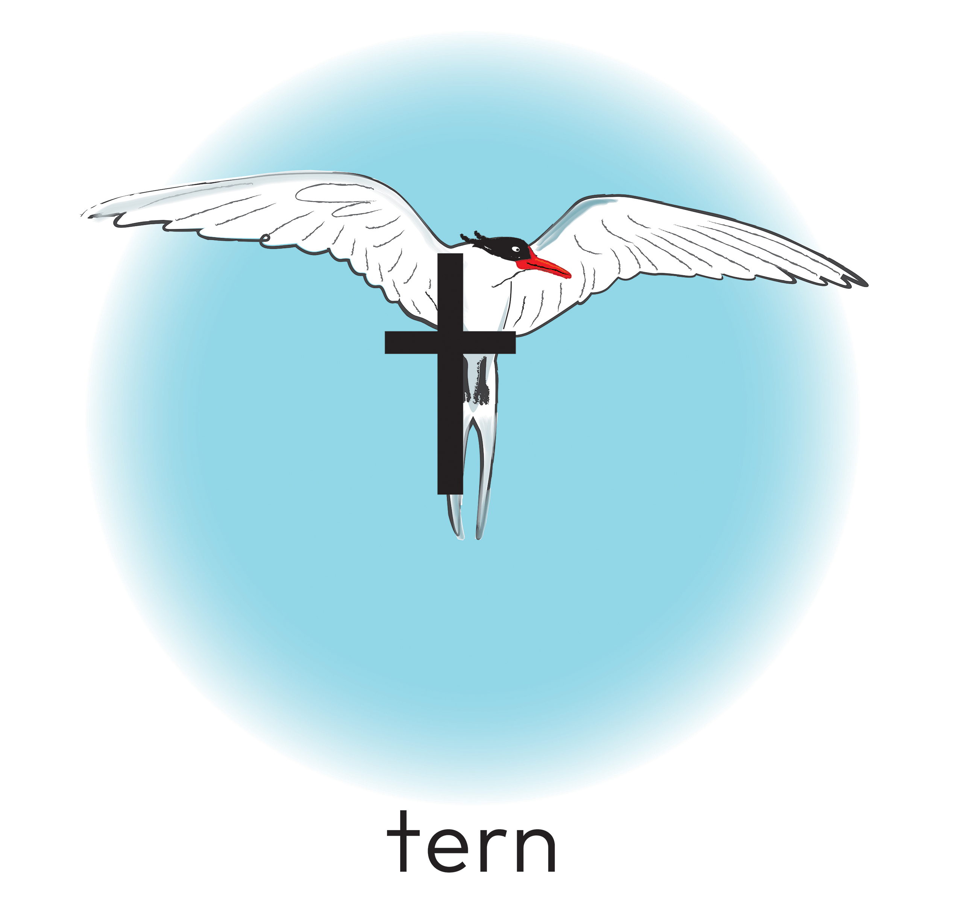 |  | 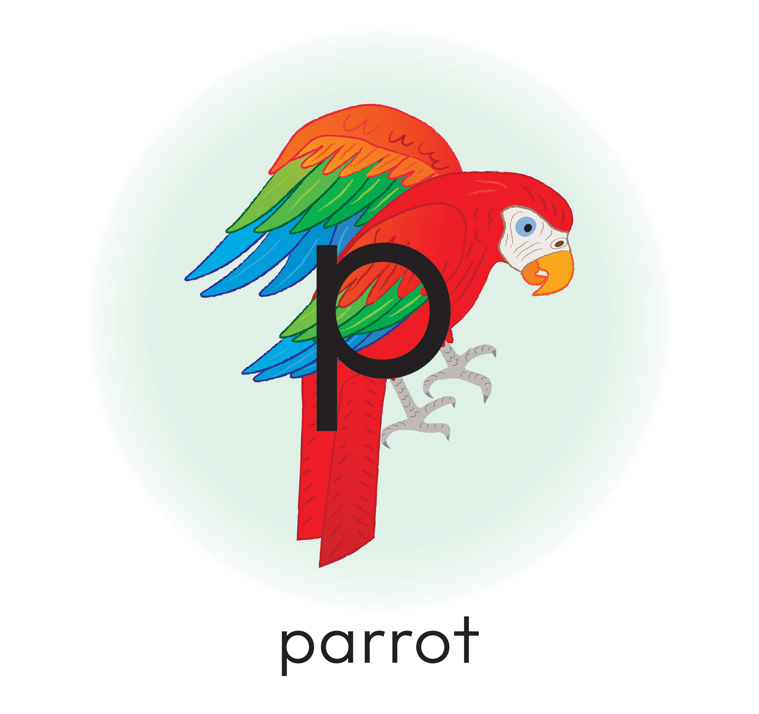

Articulatory Gestures Chart
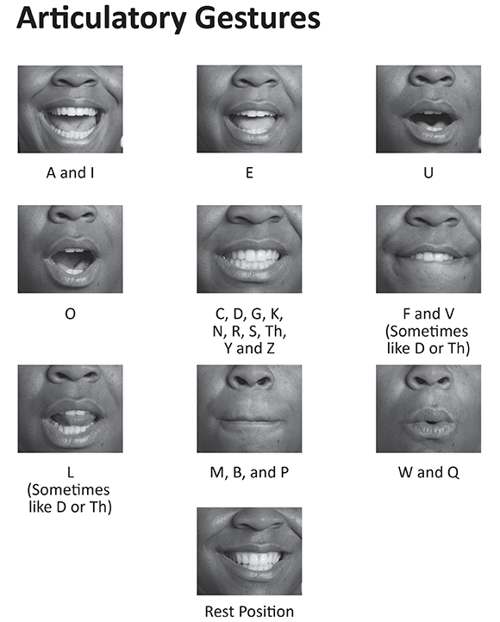

Snapshot Assessment
Name: _________________________________________________________ Date: ________________________
Student Can: |  | Student Can: |  | Notes:
Count the number of words in a sentence |  | Demonstrate one-to-one correspondence in shared text
Point to the first word in a sentence |  | Read the high-frequency word: “I”
Point to the last word in a sentence |  | Count the number of letters in a word

