READING FOUDATIONS
SKILLS BLOCK
Grade K: Module 1: Cycle 2: Lesson 11
Language Arts Curriculum
Articulatory Gestures Chart
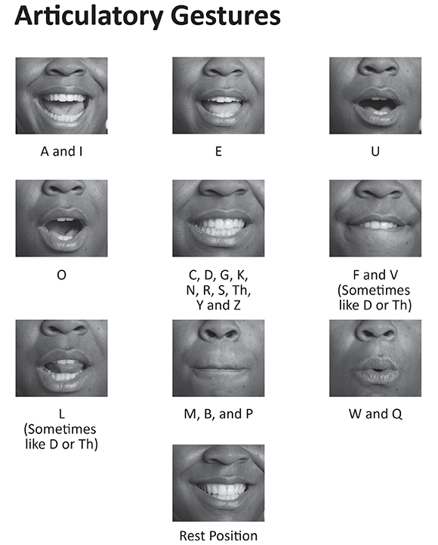
Keyword Picture Card: “p”
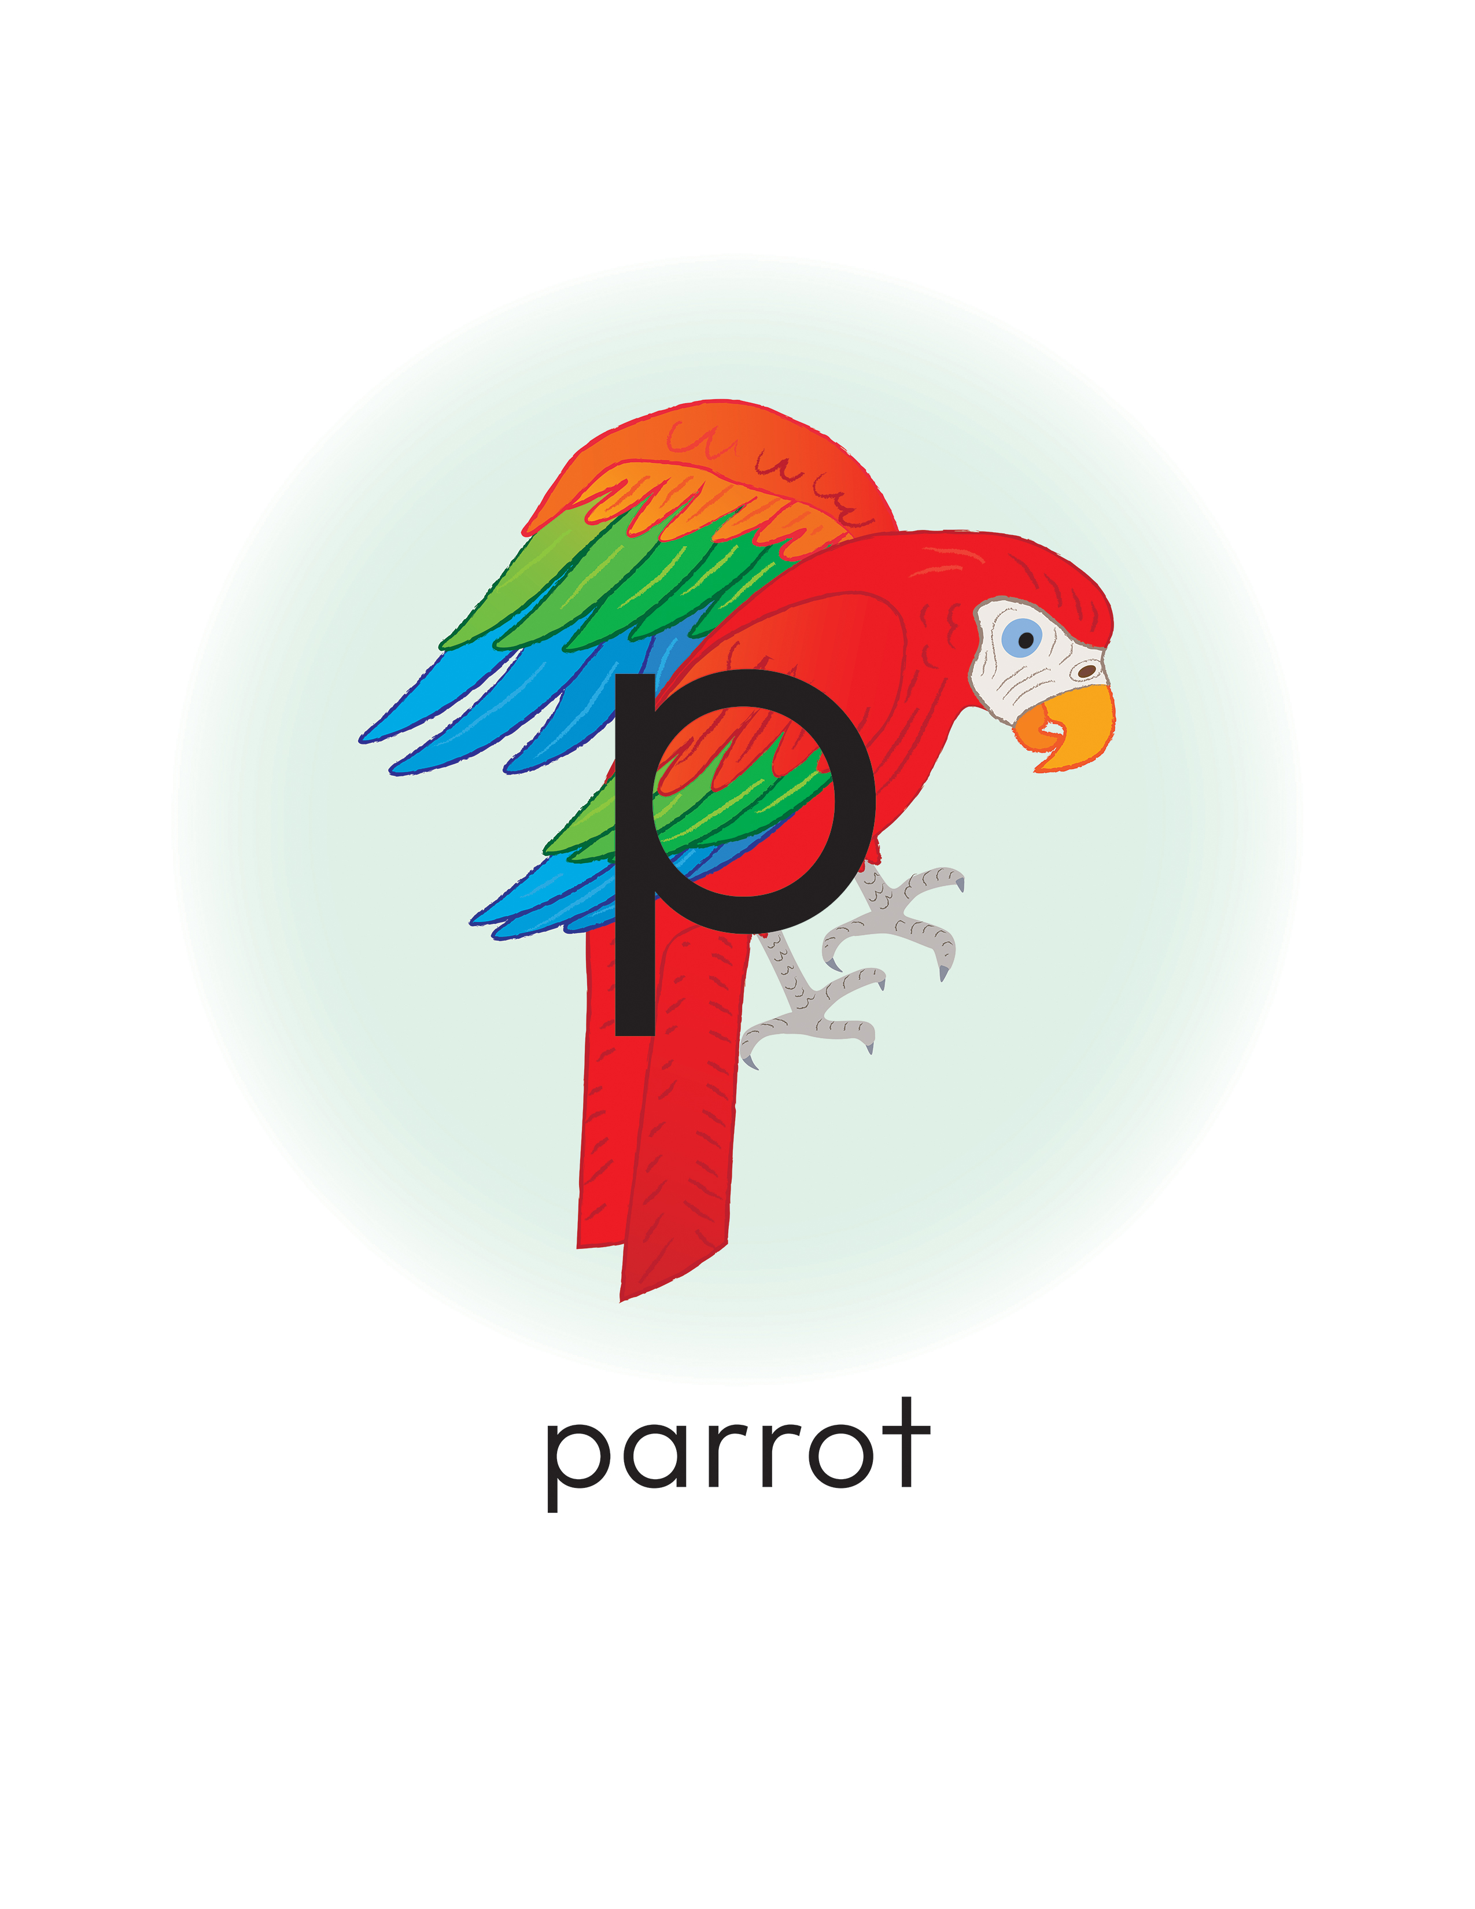
Keyword Picture Card: “h”
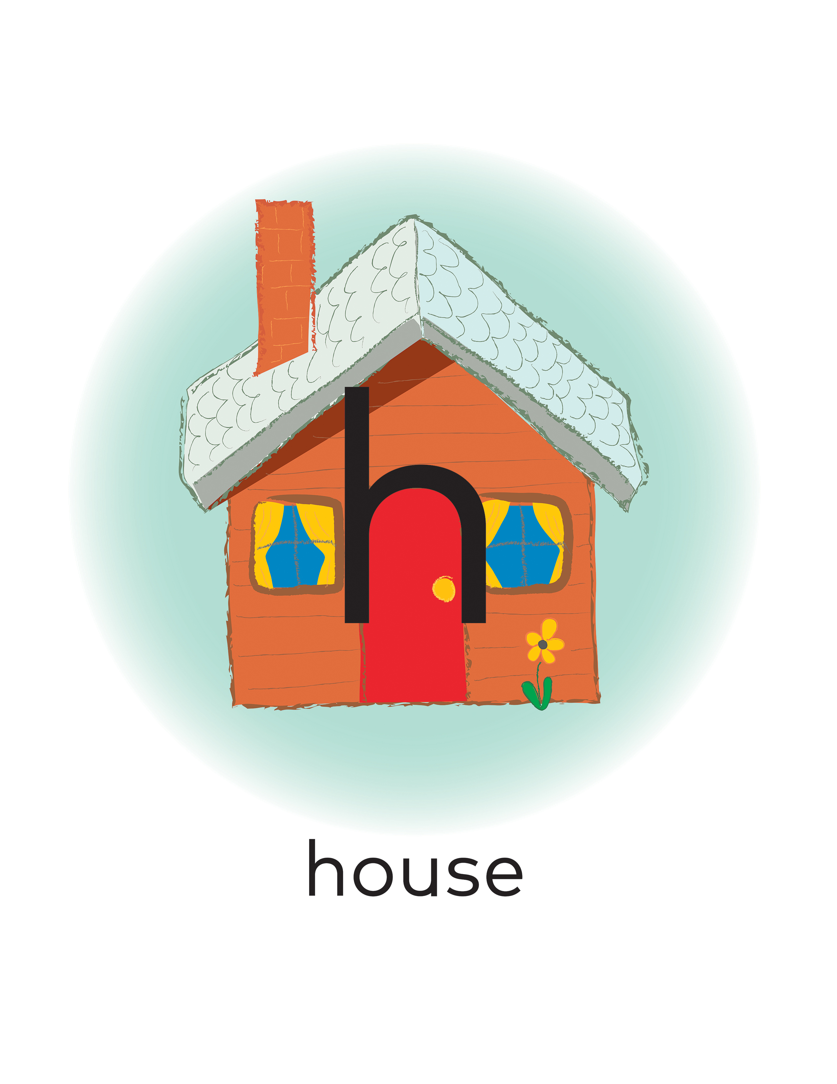

Snapshot Assessment (optional)
Name: _________________________________________________ Date: ________________________________
Student Can: |  | Student Can: |  | Notes:
Count the number of words in a sentence |  | Identify the name of the letter “h”
Point to the first word in a sentence |  | Identify the name of the letter “p”
Point to the last word in a sentence |  | Identify the sound for the letter “h” (/h/)
Demonstrate one-to-one correspondence in shared text |  | Identify the sound for the letter “p” (/p/)

Poem: “A Pink Parrot Took My Hat!”
I walked out of my house, ready for the day
When I saw a big pink parrot flying my way.
The bird swooped down and took my hat,
Then gave my head a little pat.
I was so surprised I just stopped and sat.
Have you ever heard of anything quite like that?
Initial Sound Sort Pictures
 |  |  | 
 |  |  | 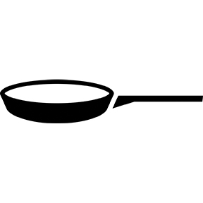
 |  |  | 
 |  |  | 
 |  |  | 

Initial Sound Sort Sheet
Words That Start with “h” | Words That Start with “p”

Initial and Final Sound Sort Pictures
 |  | 
 |  | 
 | 
 | 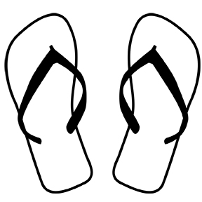 |  | 

Initial and Final Sound Sort Sheet


