Infer the Topic Resources
Note to Teacher: Post the following resources around the room. Consider writing the text in large writing on chart paper to make it easy to see. Or, make copies of each resource for each group or station.

Resource 1
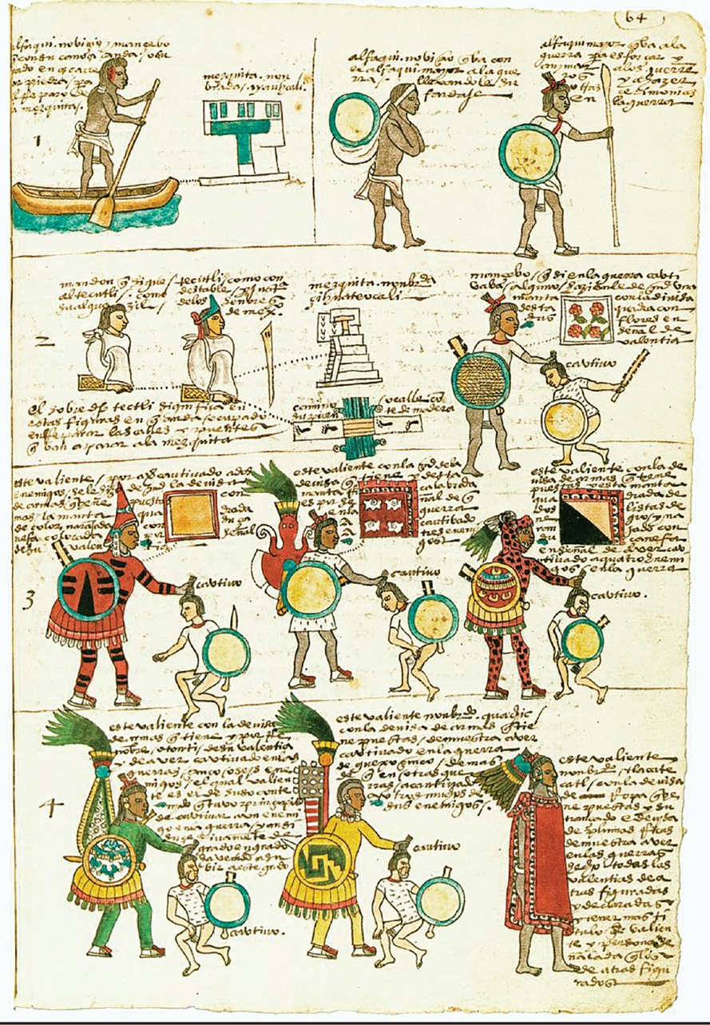
“Codex Mendoza.” Illustration. 16th century. Bodleian Library. Wikimedia. Web. Public domain.
Resource 2
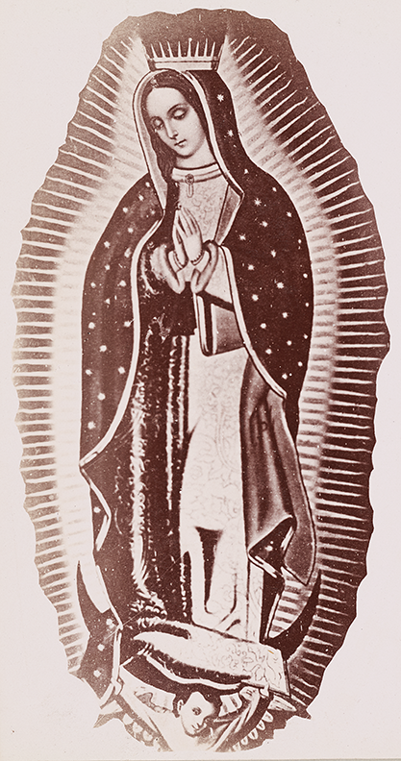
Mayo & Weed. “Virgin Mary.” Photograph. 1898. The Miriam and Ira D. Wallach Division of Art, Prints and Photographs: Photography Collection, The New York Public Library. The New York Public Library Digital Collections. Web. Public domain.
Resource 3
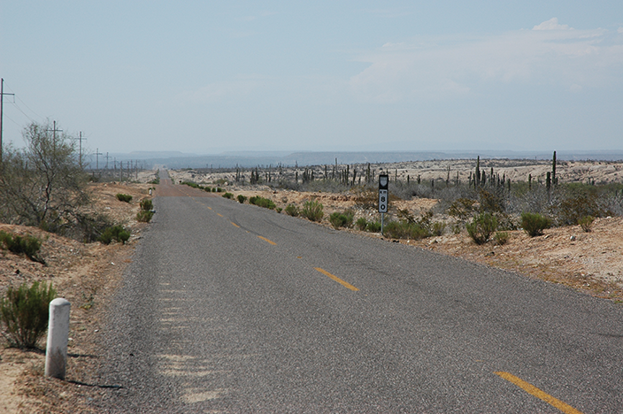
Wonderlane. “Endless desert highway 80, Baja California Sur, Mexico.” Photograph. Flickr. 21 May 2009. Web. Used under CC BY 2.0.
Resource 4

Ospr3yy. “American Snout.” Photograph. Wikimedia. 22 Nov. 2010. Web. Used under Free Art License 1.3.
Resource 5

Jonathan McIntosh. “Border Patrol Museum.” Photograph. Flickr. 15 Sep. 2009. Web. Used under CC BY 2.0.
Resource 6
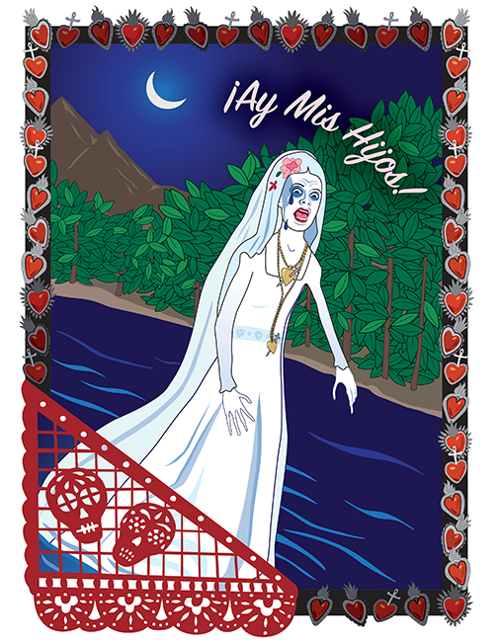

Stacey Posnett for EL Education.
Resource 7
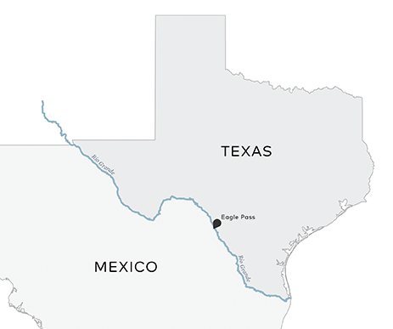

Scribe Concepts for EL Education.
Resource 8
“I have always been fascinated by the knowledge and wisdom of our ancestors, the Aztecas. Their culture, their scientific observations, their religion, their architecture, their language, their myths and legends—everything about them is extraordinary.”
McCall, Guadalupe Garcia. Summer of the Mariposas. Lee & Low, New York, 2017.

Resource 9
“I think of La Llorona in all her various mythological and legendary forms, and I feel sorry for her. As Malitzin, the Aztec slave girl given to Hernán Cortés, I find her to be one of our culture’s most controversial and misunderstood historical figures.”
McCall, Guadalupe Garcia. Summer of the Mariposas. Lee & Low, New York, 2017.

Resource 10
“‘My sisters are waiting,’ I said, trying to take my hand from hers so that I might escape if I had to.
La Llorona let go of my hand. ‘Please, try to have faith. I am here in your service, to guide and protect you,’ she said.
I put my hands under my arms to warm them. ‘Protect me? From what?’”
McCall, Guadalupe Garcia. Summer of the Mariposas. Lee & Low, New York, 2017.

Resource 11
“Everything is possible when you step into the magically real world of Latin American folklore—a buzzard can change places with a wife’s lazy husband; a hunter may hurl lightning bolts and thunder down on the tribesmen who cheated him of his share of the meat; . . . and the lizard a padre scoops off a dusty road may become an emerald when he hands it to a poor peasant who needs to buy medicine for his wife. . . . The folktales deal with timeless key human questions, and there are human truths in the magic they contain.”
Elswit, S.B. The Latin American Story Finder. McFarland and Company, Inc., Jefferson, NC, 2015.
Infer the Topic:
I Notice/I Wonder Note-Catcher
RI.8.1
Name: Date:
What do you think you will be learning about in this module?
I Notice  (things I see) | I Wonder  (questions I have)

Infer the Topic: I Notice/I Wonder Note-Catcher
RI.8.1
Name: Date:
What do you think you will be learning about in this module?
I Notice  (things I see) | I Wonder  (questions I have)
Write the letter for each item by the resource in which you notice it.  A. a butterfly  B. the city, El Paso  C. a truck  D. a statue  E. a bird  F. a religious painting  G. leaves  H. Durango  I. Texas  J. a highway  Resource 1 ___________________________  Resource 2 ___________________________  Resource 3 ___________________________  Resource 4 ___________________________  Resource 5 ___________________________  Resource 6 ___________________________  Resource 7 ___________________________  Resource 8 ___________________________  Resource 9 ___________________________  Resource 10 __________________________ | I wonder if  I wonder how  I wonder what  I wonder who
I notice these words I already know in resources 11–14: | I wonder when  I wonder where  I wonder why  I wonder what these words in resources 11–14 mean:

Directions for Infer the Topic
- Choose a starting resource. Take your I Notice/I Wonder note-catcher with you.
- Look carefully at the resource. Be respectful of others who might be looking at the same thing. Record what you notice (what you see) and what you wonder (questions) on your note-catcher. (3 minutes)
- When instructed, find a partner who looked at a different resource. Describe your resource, and share your notices and wonders. Explain what you think you are going to be learning about in this module. (2 minutes)
- When instructed, stay with your partner and together find another pair. Share your notices and wonders and what you think you are going to be learning about in this module.
(3 minutes)
- On your own, choose a new resource, and repeat steps 2–5.
Module Guiding Questions Anchor Chart
RL.8.1, W.8.8
What thoughts do you have about the guiding questions for the module?
Questions | Notes
Why do we see evidence of myths and traditional stories in modern narratives?

How and why can we modernize myths and traditional stories to be meaningful to today’s audiences?

Work to Become Ethical People Anchor Chart
(Example for Teacher Reference)
Treat others well, and stand up for what is right.
Habit of Character | I show respect.
What Does It Mean | This means I appreciate the abilities, qualities and achievements of others, and treat myself, others, and the environment with care.
What Does It Look Like? | - Applauding others when they have done well  - Taking care around the classroom not to break things or hurt people  - Returning borrowed items in the same condition you were given them  - Throwing trash in the trash can  - Recycling
What Does It Sound Like? | - “I really appreciate . . . because . . .”  - “You did a great job with . . . because . . .”
Habit of Character | I behave with integrity.
What Does It Mean | This means I am honest and do the right thing, even when it’s difficult, because it is the right thing to do.
What Does It Look Like? | - Admitting when at fault  - Doing homework  - Keeping eyes on own work
What Does It Sound Like? | - “I’m sorry, but I . . .”
Habit of Character | I show empathy.
What Does It Mean | This means I understand and I share or take into account the feelings, situation, or attitude of others.
What Does It Look Like? | - Listening carefully and showing the appropriate facial expression for the situation
What Does It Sound Like? | - “I understand how you feel.”  - “I can imagine how you feel.”
Habit of Character | I show compassion.
What Does It Mean | This means I notice when others are sad or upset and try to help them.
What Does It Look Like? | - Approaching a friend or classmate who looks upset
What Does It Sound Like? | - “You look upset, is everything OK? Is there anything I can do to help?”

Work to Become Ethical People Anchor Chart
Teacher Directions: Write the following on chart paper, leaving space to add to it throughout the unit.
Treat others well, and stand up for what is right.
Habit of Character | I show respect.
What Does It Mean | This means I appreciate the abilities, qualities and achievements of others, and treat myself, others, and the environment with care.
What Does It Look Like?
What Does It Sound Like?
Habit of Character | I behave with integrity.
What Does It Mean | This means I am honest and do the right thing, even when it’s difficult, because it is the right thing to do.
What Does It Look Like?
What Does It Sound Like?
Habit of Character | I show empathy.
What Does It Mean | This means I understand and I share or take into account the feelings, situation, or attitude of others.
What Does It Look Like?
What Does It Sound Like?
Habit of Character | I show compassion.
What Does It Mean | This means I notice when others are sad or upset and try to help them.
What Does It Look Like?
What Does It Sound Like?

Copyright License
Except where otherwise noted, EL Education’s Language Arts Curriculum is published under a Creative Commons Attribution-NonCommercial 4.0 International (CC BY-NC 4.0) License. To view a copy of this license, visit https://creativecommons.org/licenses/by-nc/4.0/.

Licensed third party content noted as such in this curriculum is the property of the respective copyright owner. Responsibility for securing any necessary permissions as to such third party content rests with parties desiring to use such content. For example, certain third party content may not be reproduced or distributed (outside the scope of fair use) without additional permissions from the content owner and it is the responsibility of the person seeking to reproduce or distribute this curriculum to either secure those permissions or remove the applicable content before reproduction or distribution.

For more information, visit our Terms of Use at https://curriculum.eleducation.org/terms-of-use.

