Entrance Ticket: Unit 1, Lesson 6
L.7.4c
(Answers for Teacher Reference)
Directions: As you enter class, answer the following question.
Read this sentence from A Long Walk to Water:
“The terrain changed from scrub to woodland; they walked among stands of stunted trees” (22–23).

Use a print or online dictionary, and copy the meaning of the word stunted as it is used in this sentence.
stopped or slowed the growth of
Entrance Ticket: Unit 1, Lesson 6
L.7.4c
Name: Date:
Directions: As you enter class, answer the following question.
Read this sentence from A Long Walk to Water:
“The terrain changed from scrub to woodland; they walked among stands of stunted trees” (22–23).
Use a print or online dictionary, and copy the meaning of the word stunted as it is used in this sentence.

Entrance Ticket: Unit 1, Lesson 6
L.7.4c
Name: Date:
Directions: As you enter class, answer the following question.
Read this sentence from A Long Walk to Water:
“The terrain changed from scrub to woodland; they walked among stands of stunted trees” (22–23).
Use a print or online dictionary, and copy the meaning of the word stunted as it is used in this sentence.

Synopsis: A Long Walk to Water, Chapter 4
RL.7.2
Name: Date:
- Nya stops at home for a bowl of boiled sorghum meal and then returns to the pond with her little sister Akeer.
- Salva leaves the old woman’s house.
- He joins a new group of people escaping, and they don’t want to include him as he’s another mouth to feed until a woman stands up for him.
- Unfortunately, no one from his family is with the group.
- Salva walks with a young man named Buksa, who leads the group to a beehive filled with honey.
Lesson 6: A Long Walk to Water Illustrations
by Jim Averbeck
These illustrations by artist Jim Averbeck may be used to support ELLs and other students with comprehension of the novel, beginning in chapter 4 of A Long Walk to Water. Also, any students may access these images for the Performance Task children’s ebook they create if they cannot draw or find online images they can manipulate.
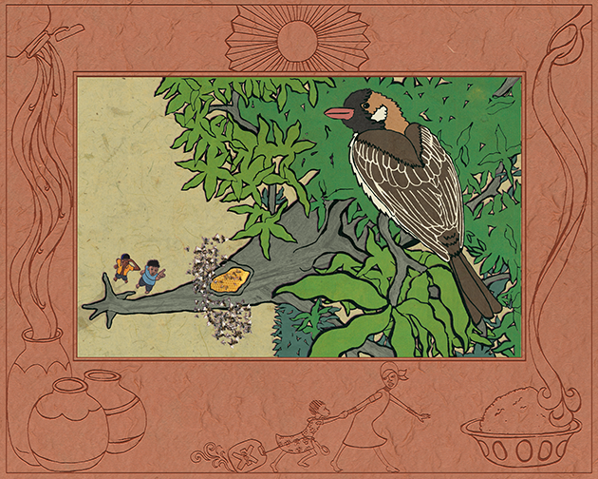
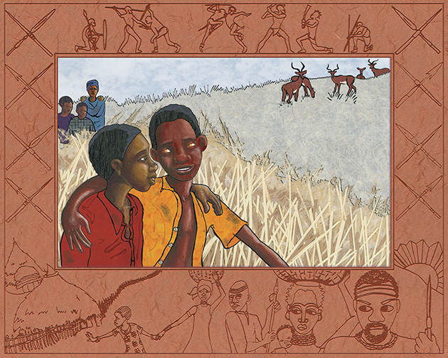
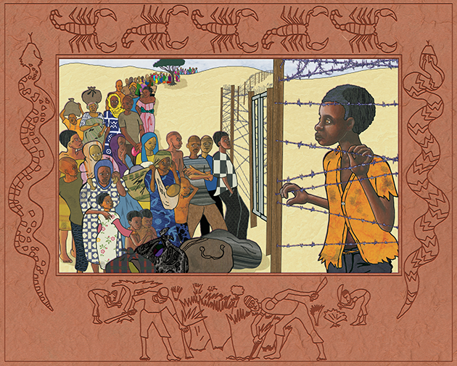
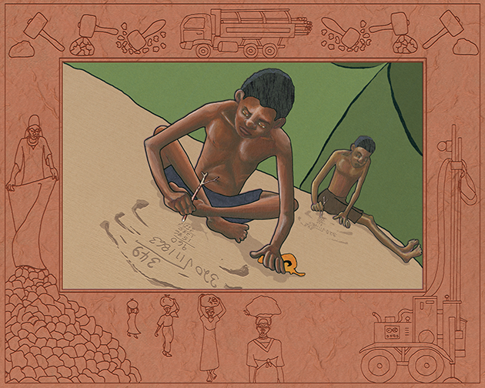
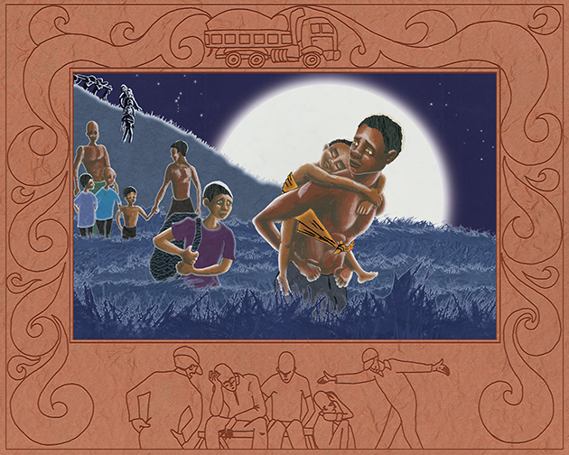
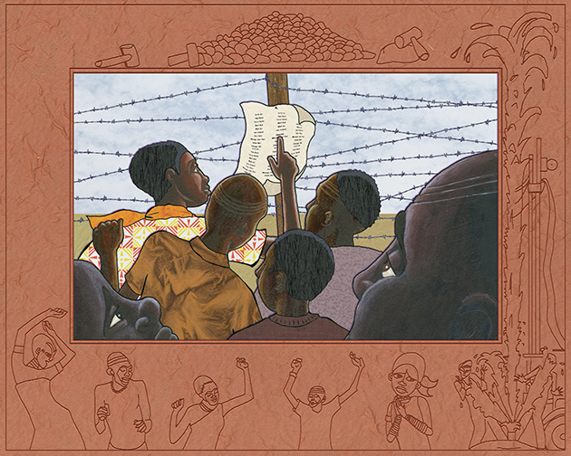
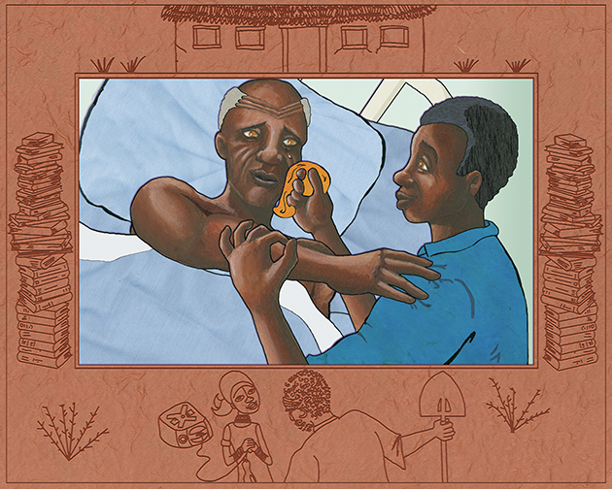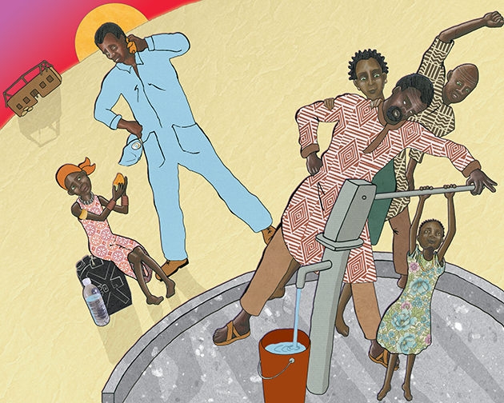

Illustrations © 2009 by Jim Averbeck. Used by permission. Additional teacher resources and school visit information available at http://www.jimaverbeckbooks.com/.
Copyright License
Except where otherwise noted, EL Education’s Language Arts Curriculum is published under a Creative Commons Attribution-NonCommercial 4.0 International (CC BY-NC 4.0) License. To view a copy of this license, visit https://creativecommons.org/licenses/by-nc/4.0/.

Licensed third party content noted as such in this curriculum is the property of the respective copyright owner. Responsibility for securing any necessary permissions as to such third party content rests with parties desiring to use such content. For example, certain third party content may not be reproduced or distributed (outside the scope of fair use) without additional permissions from the content owner and it is the responsibility of the person seeking to reproduce or distribute this curriculum to either secure those permissions or remove the applicable content before reproduction or distribution.

For more information, visit our Terms of Use at https://curriculum.eleducation.org/terms-of-use.

