Grade 8: Module 2A: Unit 1: Lesson 2
Taking a Stand: Equal Rights for Women

Taking a Stand:

Equal Rights for Women

Long-Term Targets Addressed (Based on ELA CCSS)
I can cite text-based evidence that provides the strongest support for an analysis of literary text. (RI.8.1)
Supporting Learning Targets | Ongoing Assessment
- I can cite the evidence that Shirley Chisholm uses to support her claims in “Equal Rights for Women.” | - Student Note-catcher with text-dependent questions

Taking a Stand:

Equal Rights for Women

Agenda | Teaching Notes
1. Opening  A. Engaging the Reader (3 minutes)  B. Review Learning Targets (2 minutes)  2. Work Time  A. Reading for the Gist: “Equal Rights for Women” by Shirley Chisholm (10 minutes)  B. Text-Dependent Questions (25 minutes)  3. Closing and Assessment  A. Debrief Learning Targets and Preview  4. Homework (5 minutes)  A. Why is Shirley Chisholm taking a stand for women’s rights rather than African American rights? | - The writing in Module 2A, Unit 1 will build on the skills students developed in Module 1, including QuickWrites (see in particular Module 1, Unit 1, Lesson 3) and summary writing (see in particular Module 1, Unit 2, Lesson 5).  - “Equal Rights for Women” is the focus of Lessons 2–5. Be sure students hold onto their copy of the speech throughout these lessons.  - Lessons 2–5 are based heavily on the Making Evidence-Based Claims units developed by Odell Education. For the original Odell Education units, go to www.odelleducation.com/resources.  - For Lesson 2, the text needs to be broken into sections. Before giving the students their text, mark the sections as follows:  - Section A: Paragraphs 1–4  - Section B: Paragraphs 5–7  - Section C: Paragraphs 8–9  - Section D: Paragraphs 10–11  - Section E: Paragraphs 12–14  - Section F: Paragraphs 15–17  - Beginning with Module 2, lessons that involve close reading will include a new type of supporting material, a Close Reading Guide (for Teacher Reference). See supporting materials. Use this guide to support you in facilitating work time in this lesson.  - Students refer to the Odell Education resource Reading Closely: Guiding Questions handout (provided here in supporting materials and also available as a stand-alone document on EngageNY.org and odelleducation.com/resources). (This document was first introduced in Module 1, Unit 2, Lesson 1).

Taking a Stand:

Equal Rights for Women

Agenda | Teaching Notes (continued)
- In this module, beginning with Shirley Chisholm’s speech and continuing with To Kill a Mockingbird, students will encounter racially charged words and phrases. It is important to stop for a moment to address this language. Be sure to explain that people used to use language like “old darkey,” but that it isn’t acceptable to use that language anymore because it is from a time when African Americans were not afforded equal rights or protection in the United States. If students react emotionally to this language, consider giving them space to process their feelings, whether it is in writing, in an open class discussion, or in private with you.
- In advance: Read Shirley Chisholm’s “Equal Rights for Women.”
- Post: Learning targets.

Lesson Vocabulary | Materials
taking a stand, advantages, disadvantages; characteristics | - “Equal Rights for Women” by Shirley Chisholm (one per student)  - Reading Closely: Guiding Questions handout (one per student)  - Document camera  - “Equal Rights for Women”: Lesson 2 Text-Dependent Questions (one per student)  - “Equal Rights for Women”: Lesson 2 Close Reading Guide (for Teacher Reference)

Taking a Stand:

Equal Rights for Women

Opening | Meeting Students’ Needs
A. Engaging the Reader (3 minutes)
- Invite students to partner up with someone nearby and share the Advantages/Disadvantages t-chart they completed for homework. Provide about two minutes for this, then share with them that in the future they will think more about the advantages and disadvantages of using photographs and other media types.
B. Review Learning Targets (2 minutes)  - Invite a student to read aloud the first learning target: “I can cite the evidence that Shirley Chisholm uses to support her claims in ‘Equal Rights for Women.’” Ask students: “What does it mean to cite evidence?” Cold call on a student. Ideally students will understand that to cite means to name or mention details from the text. | - Careful attention to learning targets throughout a lesson engages, supports, and holds students accountable for their learning. Consider revisiting learning targets throughout the lesson so that students can connect their learning with the activity they are working on.

Taking a Stand:

Equal Rights for Women

Work Time | Meeting Students’ Needs
A. Reading for the Gist: “Equal Rights for Women” by Shirley Chisholm (10 minutes)  - Pass out “Equal Rights for Women” by Shirley Chisholm. Tell students that they are going to read a speech where someone is taking a stand. Ask students to notice the title, author’s name, and date. Invite students to turn and talk to a partner to make a prediction about what the author will take a stand about. Ideally students will identify the title as taking a stand on ways to treat women equally.  - Share with students that they will be spending some time with this new text over the next five lessons.  - Display the Reading Closely: Guiding Questions handout using the document camera and ask students to think to themselves about which questions they should ask when getting a text for the first time. Ask them to turn and talk to their seat partner:  - “What questions do you think are important to ask? Why?”  - Cold call on a pair to share. Listen for students to point out the questions in the Approaching Texts row of the document, including:  * Who is the author?  * What is the title?  * What type of text is it?  * Who published the text?  * When was the text published?  - Tell students that they will be reading closely to understand the author’s view and how the author crafts the structure of the text to prove the claim.  - Ask students to read along silently and circle words they are unfamiliar with as you read the speech aloud.  - Invite them to turn to a partner and talk about the gist of the speech. | - Hearing a complex text read slowly, fluently, and without interruption or explanation promotes fluency for students: They are hearing a strong reader read the text aloud with accuracy and expression and are simultaneously looking at and thinking about the words on the printed page. Be sure to set clear expectations that students read along silently in their heads as you read the text aloud.  - Asking students to identify challenging vocabulary helps them to monitor their understanding of a complex text. When students annotate the text by circling these words, it can also provide a formative assessment for the teacher.

Taking a Stand:

Equal Rights for Women

Work Time (continued) | Meeting Students’ Needs
B. Text-Dependent Questions (25 minutes)  - Display and distribute “Equal Rights for Women”: Lesson 2 Text-Dependent Questions.  - Use the teacher resource “Equal Rights for Women”: Lesson 2 Close Reading Guide for guidance on how to help students work through the series of text-dependent questions. | - Text-dependent questions can be answered only by referring explicitly to the text being read. This encourages students to reread the text for further analysis and allows for a deeper understanding.

Closing and Assessment | Meeting Students’ Needs
A. Debrief Learning Targets and Preview Homework (5 minutes)
- Invite students to reflect on the first learning target. Cold call one or two students to cite an important piece of evidence they uncovered from the speech about women and equal rights.
- Preview the homework.
Homework | Meeting Students’ Needs
A. QuickWrite: Why is Shirley Chisholm taking a stand for women’s rights rather than African American rights? Use specific evidence from the text to write a paragraph that answers this question.
  - Answer the prompt completely
  - Provide relevant and complete evidence
  - Paragraph includes the following:
  - A focus statement
  - At least three pieces of evidence from the text
  - For each piece of evidence, an analysis or explanation: What does this evidence mean?
  - A concluding sentence

Grade 8: Module 2A: Unit 1: Lesson 2
Supporting Materials

“Equal Rights for Women”
Shirley Chisholm

Equal Rights for Women
Washington, D.C., May 21, 1969
Shirley Chisholm
 | Mr. Speaker, |  | P1
 | When a young woman graduates from college and starts looking for a job, she is  likely to have a frustrating and even demeaning experience ahead of her. If she walks  into an office for an interview, the first questions she will be asked is, “Do you type?” |  | P2
5 | There is a calculated system of prejudice that lies unspoken behind that question.  Why is it acceptable for women to be secretaries, librarians, and teachers, but totally  unacceptable for them to be managers, administrators, doctors, lawyers, and Members of  Congress? |  | P3
 | The unspoken assumption is that women are different. They do not have executive |  | P4
10 | ability, orderly minds, stability, leadership skills, and they are too emotional.
It has been observed before that society for a long time, discriminated against
another minority, the blacks, on the same basis – that they were different and inferior.
The happy little homemaker and the contented “old darkey” on the plantation were both
produced by prejudice.
demeaning: humiliating |  | “old darkey”: a derogatory and racist name for African-Americans used in the early 1900s

“Equal Rights for Women”
Shirley Chisholm

15 | As a black person, I am no stranger to race prejudice. But the truth is that in the  political world I have been far oftener discriminated against because I am a woman  than because I am black. |  | P6
 | Prejudice against blacks is becoming unacceptable although it will take years to  eliminate it. But it is doomed because, slowly, white America is beginning to admit |  | P7
20 | that it exists. Prejudice against women is still acceptable. There is very little understanding  yet of the immorality involved in double pay scales and the classification of most of the  better jobs as “for men only.”
 | More than half of the population of the United States is female. But women occupy  only 2 percent of the managerial positions. They have not even reached the level of |  | P8
25 | tokenism yet. No women sit on the AFL-CIO council or Supreme Court. There have been  only two women who have held Cabinet rank, and at present there are none. Only two  women now hold ambassadorial rank in the diplomatic corps. In Congress, we are down  to one Senator and 10 Representatives.
 | Considering that there are about 3 ½ million more women in the United States than |  | P9
30 | men, this situation is outrageous.
 | It is true that part of the problem has been that women have not been aggressive in  demanding their rights. This was also true of the black population for many years.  They submitted to oppression and even cooperated with it. Women have done the same  thing. But now there is an awareness of this situation particularly among the younger |  | P10
35 | segment of the population.
immorality: without moral principles |  | oppression: unjust or cruel power
tokenism: a policy of making only a symbolic effort, but not really meaning it

“Equal Rights for Women”
Shirley Chisholm

 | As in the field of equal rights for blacks, Spanish-Americans, the Indians, and other  groups, laws will not change such deep-seated problems overnight. But they can be  used to provide protection for those who are most abused, and to begin the process of  evolutionary change by compelling the insensitive majority to reexamine its |  | P11
40 | unconscious attitudes.
 | It is for this reason that I wish to introduce today a proposal that has been before  every Congress for the last 40 years and that sooner or later must become part of the  basic law of the land – the Equal Rights Amendment. |  | P12
 | Let me note and try to refute two of the commonest arguments that are offered |  | P13
45 | against this amendment. One is that women are already protected under the law and  do not need legislation. Existing laws are not adequate to secure equal rights for women.  Sufficient proof of this is the concentration of women in lower paying, menial,  unrewarding jobs, and their incredible scarcity in the upper level jobs. If women are  already equal, why is it such an event whenever one happens to be elected to Congress?
50 | It is obvious that discrimination exists. Women do not have the opportunities that  men do. And women that do not conform to the system, who try to break with the  accepted patterns, are stigmatized as odd and unfeminine. The fact is that a woman who  aspires to be chairman of the board, or a Member of the House, does so for exactly the  same reasons as any man. Basically, there are that she thinks she can do the job and she |  | P14
55 | wants to try.
evolutionary: gradual |  | unconscious: unaware
menial: lowly, unskilled

“Equal Rights for Women”
Shirley Chisholm

 | A second argument often heard against the Equal Rights Amendment is that is would  eliminate legislation that many States and the Federal Government have enacted  giving special protection to women and that it would throw the marriage and divorce  laws into chaos. |  | P15
60 | As for the marriage laws, they are due for a sweeping reform, and an excellent  beginning would be to wipe the existing ones off the books. Regarding special  protection for working women, I cannot understand why it should be needed. Women  need no protection that men do not need. What we need are laws to protect working  people, to guarantee them fair pay, safe working conditions, protection against sickness |  | P16
65 | and layoffs, and provision for dignified, comfortable retirement.
 | Men and women need these things equally. That one sex needs protection more  than the other is a male supremacist myth as ridiculous and unworthy of respect as  the white supremacist myths that society is trying to cure itself of at this time. |  | P17
sweeping: broad, large |  | supremacist: believing in the superiority of a particular group

Shirley Chisholm. "Equal Rights for Women." Address To The United States House Of Representatives, Washington, DC: May 21, 1969. Public Domain.

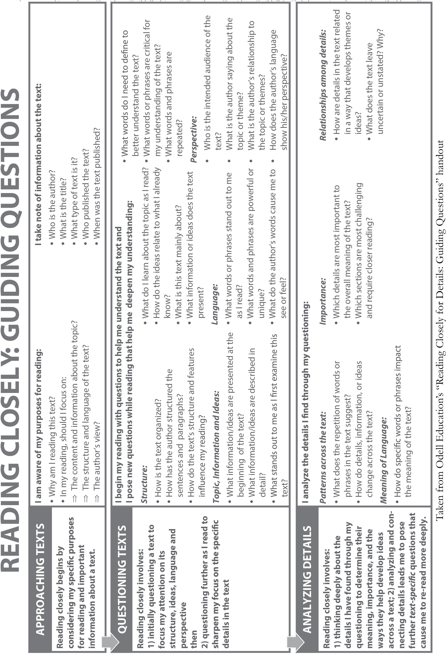
Used by permission.

“Equal Rights for Women”:

Lesson 2 Text Dependent Questions

Name:
Date:

Approaching the Text | Notes
Who is the author?
What is the title?
What type of text is it?
Who is the audience?

Read the text silently in your head as you hear it read aloud.

Text-Dependent Questions | Notes
1. What is prejudice?

2. According to Chisholm, what are the assumptions of the “calculated system of prejudice” that lies behind the question “Do you type?”
3. Look at Paragraph 5
What does Shirley Chisholm mean by the “happy little homemaker”?
What does Chisholm mean by the “contented ‘old darkey’”?

“Equal Rights for Women”:

Lesson 2 Text Dependent Questions

Name:
Date:

Text-Dependent Questions | Notes
4. Look at Paragraphs 5–7. What similarities and differences does Chisholm see between the experience of women and that of blacks?
5. Look at Paragraphs 8 and 9.What are the various statistics Chisholm uses to support her argument?
6. Choose one statistic and use your own words to explain what it means.

“Equal Rights for Women”:

Lesson 2 Text Dependent Questions
(For Teacher Reference)

Approaching the Text | Notes
Who is the author? | Prompt students to find the author’s name.  Add that Shirley Chisholm was a Congresswoman in the U.S. House of Representatives from Brooklyn in New York City. She served from 1969 to 1983.
What is the title? | Invite students to point to the title and then write it on their Note-catcher.
What type of text is it?  Who is the audience? | Ask students to think about what type of text this is. If they are struggling, help them narrow it down by asking questions like: “Is it a letter? A novel? A speech?”  Once students know it is a speech, ask them to identify to whom the speech is given.  “Who is ‘Mr. Speaker,’ identified at the beginning?”  After students take a minute to wrestle with it, let them know that Chisholm was addressing Congress. It is customary to start any address to Congress by directing your comment to the Speaker of the House, who is the leader of Congress.  Let students know that reading a speech is a bit different from reading other informational texts. They need to consider carefully the audience and purpose. Also, the writing will sound different because it is meant to be spoken aloud.  Point out that some words are in bold in the speech. Let students know that if a word is in bold, it means it is defined at the bottom of the pages.
Read for Gist | Teacher Guide
Read the speech aloud while students follow along.
Ask students to turn to a partner and talk about the gist of the speech.

“Equal Rights for Women”: Lesson 2
Close Reading Guide (For Teacher Reference)

Text Dependent Questions | Teacher Guide
1. What is prejudice? | Invite students to read the question with you.  Direct their attention to Paragraph 3 so they can see the word prejudice in context.  Invite pairs to discuss what they think the word means.  Invite pairs to record their ideas on their text-dependent questions handout.  Cold call on a pair to share their answer with the whole group and clarify what the word means if necessary.  Ask students to revise their notes where they are incorrect.  Answer: Prejudice is a judgment that disregards facts or truths.  Draw students’ attention to the prefix “pre” and the root “jud.” Ask them to think about what they might mean. Give students an opportunity to talk to their partner for a minute, then ask a pair to share with the class. Clarify what it means where necessary.  “pre” means before  “jud” means to judge  Connect to other words that are related, such as justice, just, jury, and justify.
2. According to Chisholm, what are the assumptions of the “calculated system of prejudice” that lies behind the question “Do you type?” | Repeat the numbered steps from the first question.  Answer: Chisholm uses the frequent experience women had when applying for jobs to frame the issue of women’s rights. Across the first three paragraphs she explains the question with the idea of a “calculated system of prejudice” and the “unspoken assumption” that women do not have the capabilities for positions with more responsibility.  Ensure that students have a thorough understanding of what calculated system of prejudice means before moving on, as understanding what this phrase means is crucial to understanding Chisholm’s speech in its entirety.
“Equal Rights for Women”: Lesson 2
Close Reading Guide (For Teacher Reference)

Text Dependent Questions | Teacher Guide
3. Look at Paragraph 5  What does Shirley Chisholm mean by the “happy little homemaker”?  What does Chisholm mean by the “contented ‘old darkey’”? | Repeat the numbered steps from the first question.  “Happy little homemaker”: Chisholm is referring to the idea that women were happy in their role as wives and mothers and not working outside the house.  “Contented ‘old darkey’”: Chisholm is referring to the idea that African Americans were happy to work on plantations without aspiring to do anything else.  If students are struggling, point them to the first sentence in the paragraph: “It has been observed before that society for a long time, discriminated against another minority, the blacks, on the same basis—that they were different and inferior.” Ask students who is being compared to “the blacks.” This will help them see that the focus of the paragraph is on comparing the experiences of women and African Americans. The comparison continues in the second sentence in the paragraph.
4. Look at Paragraphs 5–7.  What similarities and differences does Chisholm see between the experience of women and that of blacks? | Repeat the numbered steps from the first question.  Similarity: Both “were different and inferior.” (Paragraph 5)  Difference: “Prejudice against blacks is becoming unacceptable although it will take years to eliminate it. But it is doomed because, slowly, white America is beginning to admitthat it exists. Prejudice against women is still acceptable.” (Paragraph 7)
5. Look at Paragraphs 8 and 9.  What are the various statistics Chisholm uses to support her argument? | Repeat the numbered steps from the first question.  Two percent of managerial positions are held by women.  No women are on the council of the AFL-CIO or Supreme Court.  There are only two women ambassadors.  There is one female Senator and 10 female Representatives in Congress.  In the United States, there are 3.5 million more women than men.

“Equal Rights for Women”: Lesson 2
Close Reading Guide (For Teacher Reference)

Text Dependent Questions | Teacher Guide
6. Choose one statistic and use your own words to explain what it means. | Repeat the numbered steps from the first question.  Out of every 100 manager jobs, women have only two of them.  There are no women in the AFL-CIO leadership. (American Federation of Labor- Congress of Industrial Organizations is a federation of labor unions.)  The Supreme Court has no female justices.  Only two women in history have served on the president’s cabinet (Frances Perkins was Secretary of Labor under FDR; Oveta Culp Hobby was Secretary of Health, Education and Welfare under Dwight D Eisenhower).  At the time, only two women were ambassadors in other countries (Caroline Laise, Nepal; and Margaret Tibbets, Norway).  When Chisholm gave this speech, there were 10 Representatives (out of 435) and just one female Senator (out of 100).

