Grade 8: Module 1: Unit 2: Lesson 6
Building Background Knowledge: Challenges Bosnian Refugees Faced Fleeing and Finding Home

Long-Term Targets Addressed (Based on ELA CCSS)
I can cite text-based evidence that provides the strongest support for an analysis of informational text. (RI.8.1)
I can determine a theme or the central idea of an informational text. (RI.8.2)
I can analyze the connections and distinctions between individuals, ideas, or events in a text. (RI.8.3)
I can use a variety of strategies to determine the meaning of unknown words or phrases. (L.8.4)
Supporting Learning Targets | Ongoing Assessment
- I can identify the strongest evidence in the text “Children of War” that helps me explain what challenges refugees face when fleeing home.  - I can identify the strongest evidence in the text “Children of War” that helps me explain challenges refugees face finding home.  - I can identify common themes that connect the universal refugee experience. | - Structured notes (pages 180–195 from homework)  - Written summary of “Refugees: Who, What, Where” (from homework)  - Summary Writing graphic organizer: “Children of War”  - Evidence Sort

Agenda | Teaching Notes
- Opening  - Engaging the Reader: Think-Pair-Share “Inside Out” (5 minutes)  - Review Learning Targets (2 minutes)  - Work Time  - Independent Read: “Children of War” (10 minutes)  - Fleeing and Finding Home Anchor Charts (8 minutes)  - Rereading: Preparing to Summarize (10 minutes)  - Closing and Assessment  - Evidence Sort and Preview Homework (10 minutes)  - Homework  - Use the Summary Writing graphic organizer to write a summary paragraph of the article “Children of War.”  - Complete a first read of pages 180–195. Take notes (in your journal) using the Structured Notes graphic organizer. | - In this lesson, students read an interview with four refugees and answer questions similar to those they answered in Lessons 3–5. This text is somewhat simpler than other texts students have read, particularly because the speakers in the interview are children. Therefore, this text (and this lesson) is used primarily to help students identify how specific refugees’ stories fit the more general patterns identified in “Refugees: Who, Where, Why.” This easier text also was chosen so students can practice summary writing more independently (during Part C of Work Time and leading into their homework).  - This text is used in part to help reinforce the point that even though there are “universal” aspects of refugees’ experiences, each refugee has his or her own unique story to tell. Experiences across groups, even within one country, can vary widely.  - Many classes may have students who are themselves refugees. Handle this topic sensitively, being sure not to stereotype or generalize. If your classroom culture is safe enough, and your students are willing, consider tapping any students who are refugees as “resident experts” on this topic. Honor their experiences.  - Students continue to complete the Fleeing and Finding Home anchor charts during this lesson.  - Today, students annotate the article for evidence to answer the questions and then debrief as a group. This will give you a chance to monitor student progress and provide needed support immediately, and plan for differentiation to meet the needs of students who are still struggling with finding strong textual evidence.  - At the start of Work Time A, before students begin reading independently, collect their summaries (from homework) of “Refugees: Who, Where, Why.” As students read, do a spot-check of these summaries to look for patterns to inform instruction. Then, at the start of Work Time C, briefly name specific patterns of strength and one or two focus areas for improvement. Consider identifying a strong example to share with the class. Students will have a chance during Work Time C to immediately apply that feedback during their group work, which includes time to talk together to plan a summary of “Children of War.”  - Note that before students read independently, they are given just a few key bits of background information about the text they will read. Do not explain more: This is an opportunity for students to view the text as the expert and build their own knowledge of the world through their independent read.  - The closing of this lesson includes an “evidence sort” activity. Prepare in advance: Cut sentence strips and quote cards for each group. Clip together or put in envelopes.  - Post: learning targets, Fleeing Home anchor chart, Finding Home anchor chart.

Lesson Vocabulary | Materials
commonalities, common themes, discriminated against, targeted, summary, summarize, unique; Muslim, ethnic | - Inside Out & Back Again (book; one per student)  - “Children of War” (one per student)  - Fleeing Home and Finding Home anchor charts (created in Lesson 5; post around the room where students can see the charts)  - Summary Writing graphic organizer: “Children of War” (one per student)  - Document camera  - Sentence Strips: Claims from “Refugees: Who, Where, Why” (one set per group)  - Quote Cards: Evidence from “Children of War” (one set per group)  - Extension Question (optional)

Opening | Meeting Students’ Needs
A. Engaging the Reader: Think-Pair-Share “Inside Out” (5 minutes)  - Students should be sitting in their Numbered Heads groups. They will work with their odd or even partner. Invite students to review their structured notes silently for a minute. Be sure to collect the students’ written summaries (from homework) (see teaching note above).  - Ask students to refer to their structured notes and Think-Pair-Share:  - “Is Ha’s life still ‘inside out’? What is the strongest evidence from your reading last night?”  - Explain that there is not just one correct answer to this question; students are simply stating their opinion and providing evidence they think best illustrates this idea of being turned “inside out.”  - Cold call on students to share their thinking whole group. Listen for them to identify examples of how Ha’s life is not settled. Possible answers include: “Someone throws eggs at their house,” “The neighbors won’t talk to them,” “She still has a lot of wishes that aren’t coming true,” and “Kids are still picking on her at school with ‘ha, ha, ha.’”  - Note that some students may argue that Ha’s life is no longer “inside out”: She is beginning to “find home.” She now has a tutor to teach her English. | - Consider partnering ELLs who speak the same home language when discussion of complex content is required. This can allow students to have more meaningful discussions and clarify points in their native language.

Opening (continued) | Meeting Students’ Needs
B. Review Learning Targets (2 minutes)  - Focus the class on the learning targets, and point out that they are very similar to yesterday’s targets. Ask:  - “What is different about the first target today compared to those of the last few lessons?”  - Listen for students to notice that they are still doing the same kind of thinking, just with a different text.  - Be sure to emphasize that every individual refugee’s experience is unique, but that there are some predictable or common patterns for anyone who moves to a new place.  - Continue to emphasize the rigor of not just finding evidence, but of thinking about the strongest evidence: What details best support your thinking, and why?  - Focus most on the third learning target. Cold call on a student to read it aloud:  - “I can identify common themes that connect the universal refugee experience.”  - Point out to students that they are reading a variety of texts that will help them begin to notice patterns and themes. They have read the novel, of course, and in Lesson 3 they revisited “Panic Rises in Saigon, but the Exits Are Few,” which they first encountered in Unit 1. They also read “Refugees: Who, Where, Why” in Lessons 4 and 5. As they read today, they should notice how refugee experiences align to and expand upon some patterns we identified. | - Posting learning targets for students allows them to reference them throughout the lesson to check their understanding. This also provides a reminder to students and teachers about the intended learning behind a given lesson or activity.

Work Time | Meeting Students’ Needs
A. Independent Read: “Children of War” (10 minutes)  - Distribute the text “Children of War.” Remind students of how they have been learning about approaching texts. Invite students to briefly scan the text to notice how this informational text is different from the one they read for the previous lesson. (Students should be able to identify that it is an interview.) Ask:  - “What year was this article written?”  - Do not give too much background on the text. But tell students that because they may not know the history of the war in Bosnia, you want to give them several key points that will help them understand the interviews:  - This text is about refugees from the war in Bosnia in the 1990s.  - A statistic from “Refugees: Who, Where, Why” that supports our understanding of this text: “1990s … War in the Balkans forces thousands to leave their homes as Yugoslavia breaks apart.”  - There is a key vocabulary word they may have heard, but you want to be sure they understand: Muslim. Define Muslim for students: a follower of the religion of Islam. Explain that there are Muslims in many countries, and sometimes they have been discriminated against or targeted because of their religion.  - Another key vocabulary word is the word ethnic. Review this term, which was used in “Refugees: Who, Where, Why.” Ask students:  - “What is an ethnic group?”  - Listen for them to say something about large groups with common characteristics. Clarify and provide a specific definition: Ethnic is an adjective used to describe large groups of people with common religious, tribal, cultural, racial, or national origins.  - Tell students that because this text is relatively easy, they will be reading it on their own. Set their purpose for reading: As they read, they should underline the strongest evidence they find in the text to answer the following questions, posted on the board:  - “What challenges did the Bosnian refugees face as they fled home?”  - “What challenges did they face in the United States?”  - As students read silently, do a spot-check of these summaries to look for patterns to inform instruction. Consider identifying a strong example to share with the class at the start of Work Time C, as time permits. Then circulate, encouraging students to annotate the text. | - Hearing a complex text read slowly, fluently, and without interruption or explanation promotes fluency for students: They are hearing a strong reader read the text aloud with accuracy and expression, and are simultaneously looking at and thinking about the words on the printed page. Be sure to set clear expectations that students read along silently as you read the text aloud.  - Choose confident readers to help you read the interview aloud to ensure students experience a fluent read-aloud of the interview.  - To further support ELLs, consider providing definitions of challenging vocabulary in students’ home language. Resources such as Google Translate and bilingual translation dictionaries can assist with one-word translation.  - ELLs may be unfamiliar with more vocabulary words than are mentioned in this lesson. Check for comprehension of general words that most students would know.

Work Time (continued) | Meeting Students’ Needs
- Consider partnering ELLs who speak the same home language when discussion of complex content is required. This can allow students to have more meaningful discussions and clarify points in their native language.
- For students who struggle with reading grade-level text, consider chunking the text for them onto separate sheets of paper. This makes the reading of complex texts more manageable and allows them to focus on one small section at a time.
B. Fleeing and Finding Home Anchor Charts (8 minutes)  - Post the Fleeing and Finding Home anchor charts. Focus students whole group. They should continue to work with their odd or even partner. Ask students to Think-Pair-Share about the evidence they underlined as they read:  - “After reading this article, what other reason can we add for challenges refugees face when fleeing home? What is the strongest evidence from the article to support this?”  - Cold call on students for answers to complete the top part of the anchor chart. Consider having the class use “thumbs-up/thumbs-down” to indicate whether reasons and evidence are strong enough for the anchor chart. Possible answers include lack of food, extremely unsafe conditions, or others, with appropriate quotes from the text (“we were walking on this bridge over the river and the Serbs started shooting,” “or risk getting shot,” “they tried to kill me because of my religion”).  - Ask students to Think-Pair-Share:  - “What challenges do refugees face finding home? What is the strongest evidence to support your answer?” | - Anchor charts serve as note-catchers when the class is co-constructing ideas.

Work Time (continued) | Meeting Students’ Needs
- Cold call on students for answers to complete the top part of the anchor chart. Consider having the class use “thumbs-up/thumbs-down” to indicate whether reasons and evidence are strong enough for the anchor chart. Possible answers include life not being as good in the new country, worrying about friends and family left behind, or others, with appropriate evidence from the text (“It’s not as good as it was in Bosnia,” “I want to get my family here,” “without friends”).
- Give students specific positive praise for ways in which you noticed them citing evidence from this text and the novel. Note in particular if you heard students beginning to approach the actual eighth-grade standard, which requires them to cite not just any evidence, but the strongest evidence to support their analysis.
C. Rereading: Preparing to Summarize (10 minutes)  - Tell students that they will now reread the article on their own and now begin the the Summary Writing graphic organizer: “Children of War.” Tell them that this graphic organizer is just like the one they did for “Refugees: Who, Where, Why.” Cold call on a student to explain what it means to summarize, such as a brief description of the main points. Include any necessary teaching points from the review of student homework such as review of “key details,” controlling idea, etc. Consider sharing a strong example on the document camera if time allows. Explain that after the individual work time, they will have an opportunity to share and discuss with their classmates.  - Circulate and monitor students as they answer the questions, providing support where needed.  - Invite students to pair up to share their answers. Refocus the group and invite some volunteers to share their answers with the whole group. | - Text-dependent questions can be answered only by referring explicitly to the text being read. This encourages students to reread the text for further analysis and allows for a deeper understanding.  - Some students may benefit from having access to “hint cards”: small slips of paper or index cards that they turn over for hints about how/where to find the answers to text-dependent questions. For example, a hint card might say, “Check back in the third paragraph.”

Closing and Assessment | Meeting Students’ Needs
A. Evidence Sort and Preview Homework (10 minutes)  - Students should work with their Numbered Heads groups. Distribute the Sentence Strips: Claims from “Refugees: Who, Where, Why” and the Quote Cards: Evidence from “Children of War” (one set per group).  - Explain the activity: “In the past few lessons, you have been identifying evidence to support your thinking on the common themes that connect the universal refugee experience. Today, after reading about actual refugee experiences, you are going to think about how those experiences relate to the article ‘Refugees: Who, Where, Why.’”  - Tell the class that although there are aspects of the refugee experience that are universal, each refugee experience is also unique—one of a kind. Remind students that the prefix “uni-” means “one”—in some ways, all refugees share one experience; but it is equally true that each refugee has his or her own “one” experience. Even the four teens who were interviewed had things in common and experiences that were unique to them—this was even true for the two teens who were brother and sister. However, these unique experiences can still be categorized under those more universal themes.  - Give directions:  - Find and read the three sentence strips (from “Refugees: Who, Where, Why”) aloud as a group.  - Read each quote card (from the four Bosnian teens).  - Discuss which sentence each quote goes with and why.  - Note: Many of the quotes could be matched with more than one sentence strip. There is not always one “right” answer. Your job is to provide reasons for why you think a specific quote is especially strong evidence for a certain sentence strip.  - Check that students understand the process; then invite them to begin. Circulate and listen in. Provide support as needed without providing answers. Ask probing questions such as:  - “Why did you match that piece of evidence with that part of the refugees article?”  - “Explain your thinking”  - “Say more.”  - When you hear students providing reasons or details, give specific praise such as: “I like how you explained your thinking as to why this quote belonged here.”  - When all groups have evidence sorted, call on a Numbered Head to share one quote card and the sentence strip they matched it with and explain their reasons. | - For students who are finished early, consider distributing the Extension Question (optional).

Closing and Assessment (continued) | Meeting Students’ Needs
- If time permits, review the third learning target:
  - “I can identify common themes that connect the universal refugee experience.”
- Ask students to self-evaluate using Fist to Five.
Homework | Meeting Students’ Needs
- Use the Summary Writing graphic organizer: “Children of War” to write a summary paragraph of the article “Children of War.”  - Complete a first read of pages 180–195. Take notes (in your journal) using the Structured Notes graphic organizer. Focus on the strongest evidence that reveals how Ha is being turned “inside out” (the challenges Ha faces and her dynamic character), plus vocabulary that helps you understand her challenges and responses. | - Vocabulary can be a source of difficulty for readers who struggle. Provide a brief list with explanations of the challenging vocabulary words from the reading homework. This should be done only for students who need this support.  - Most important is to provide words that cannot be easily determined from context. There are few of these in the novel. On pages 180–195, these words might include the following: firm (tighten) (page 184) or relieved (free from fear or worry) (page 185).

Grade 8: Module 1: Unit 2: Lesson 6
Supporting Materials
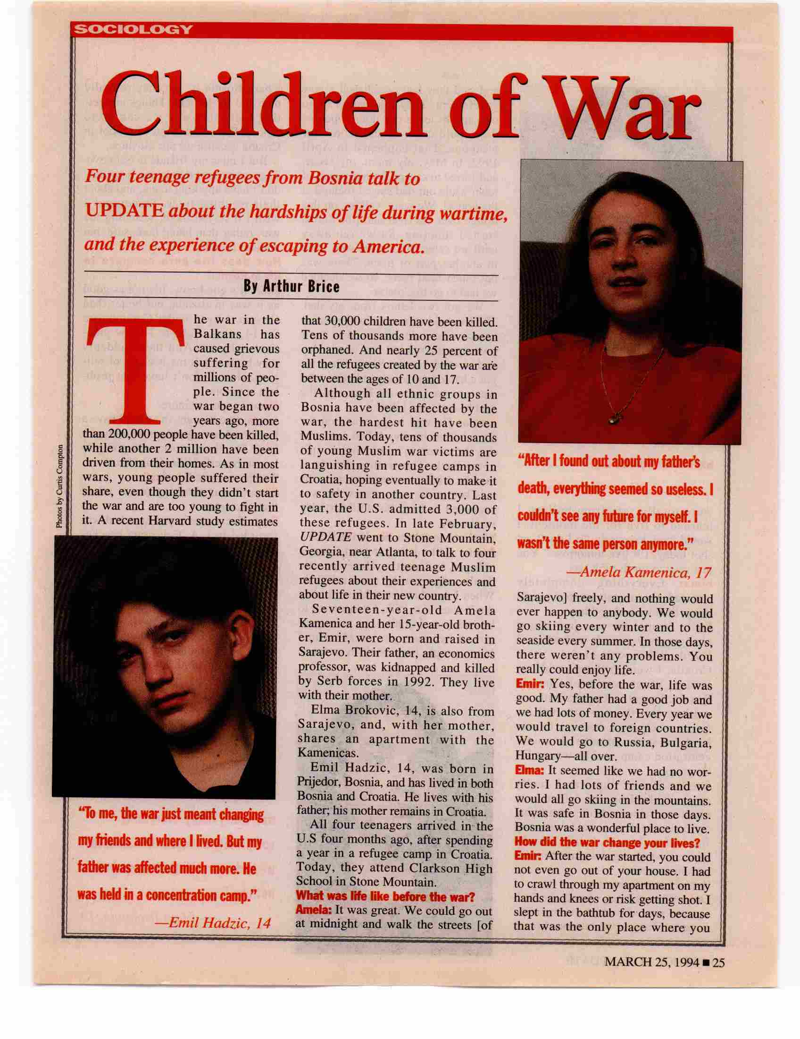

From Scholastic Update, March 25, 1994. Copyright © 1994 by Scholastic Inc. Reprinted by permission of Scholastic Inc.

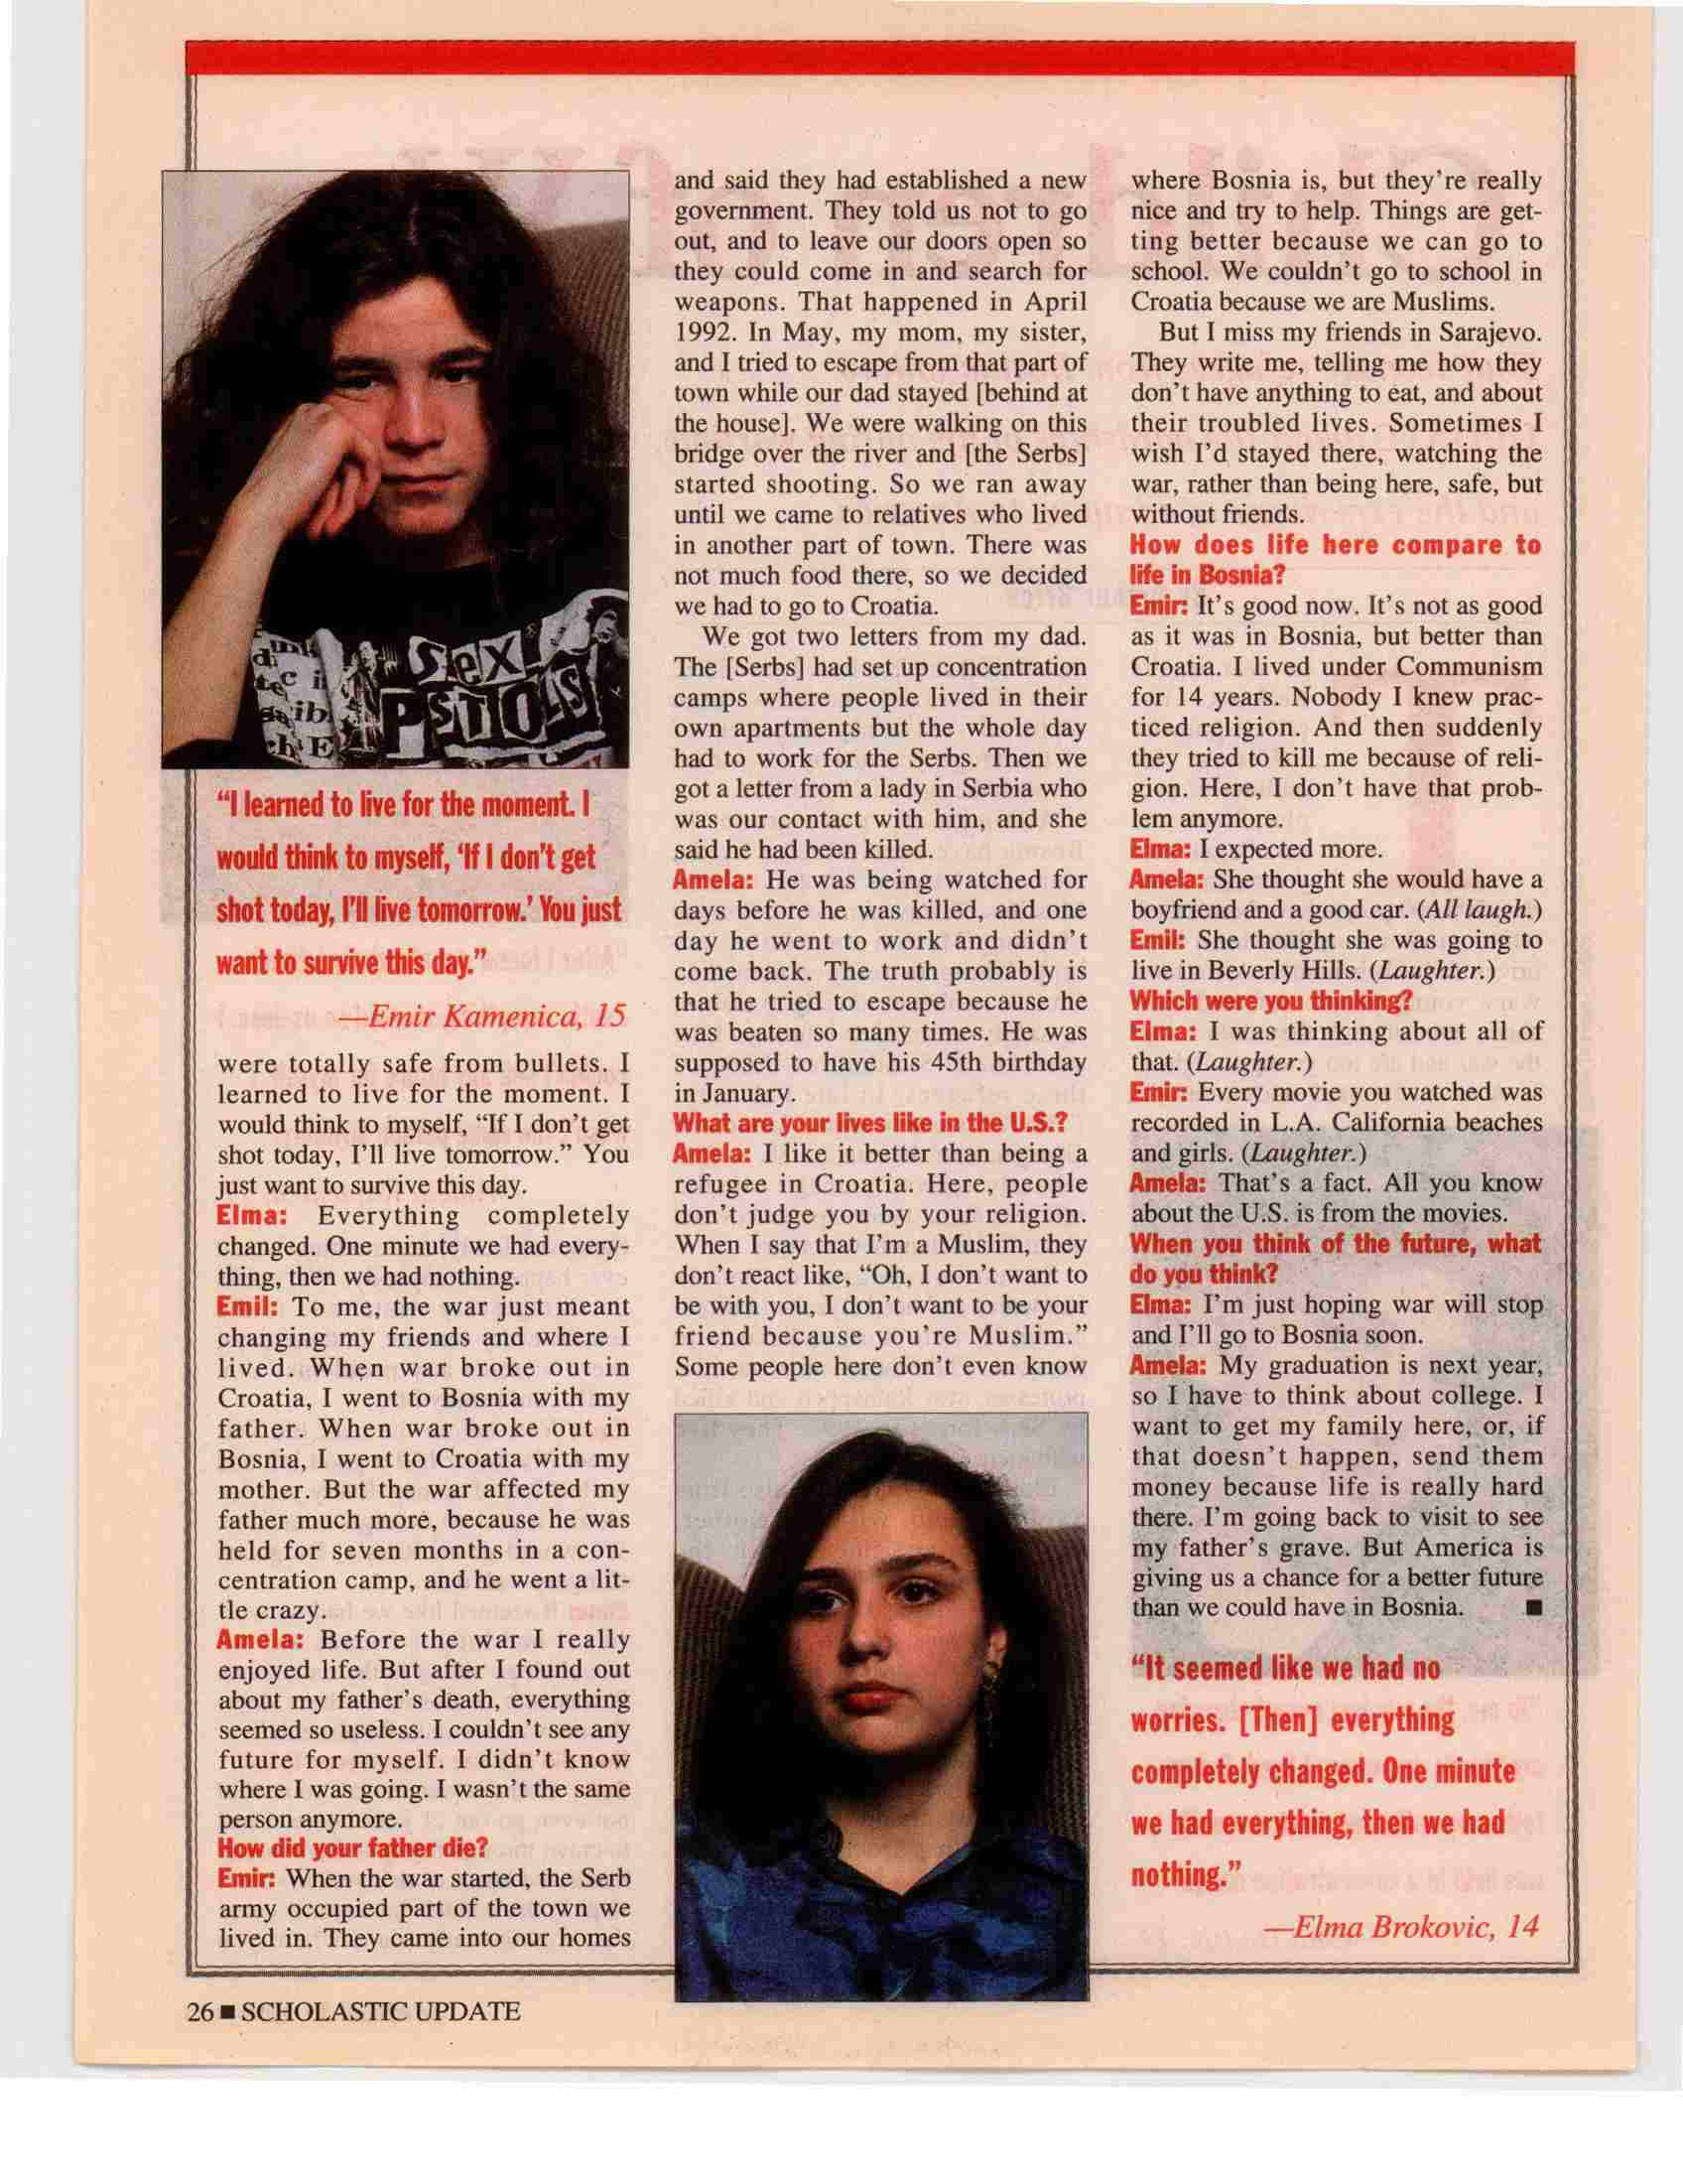

From Scholastic Update, March 25, 1994. Copyright © 1994 by Scholastic Inc. Reprinted by permission of Scholastic Inc.
Name:
Date:

- When you are reading actively, one of the most important things you do is figure out what the point of it is. This means you are recognizing the controlling idea of the text.
- Once you have done that, you have really done the hardest work.
- Still, there is more! You need to figure out what the key details in the text are, and write a great closing sentence, a clincher.
- Once that is done, you are ready to write up the notes into a summary paragraph. At that point, you will have gotten a good, basic understanding of the text you are reading.
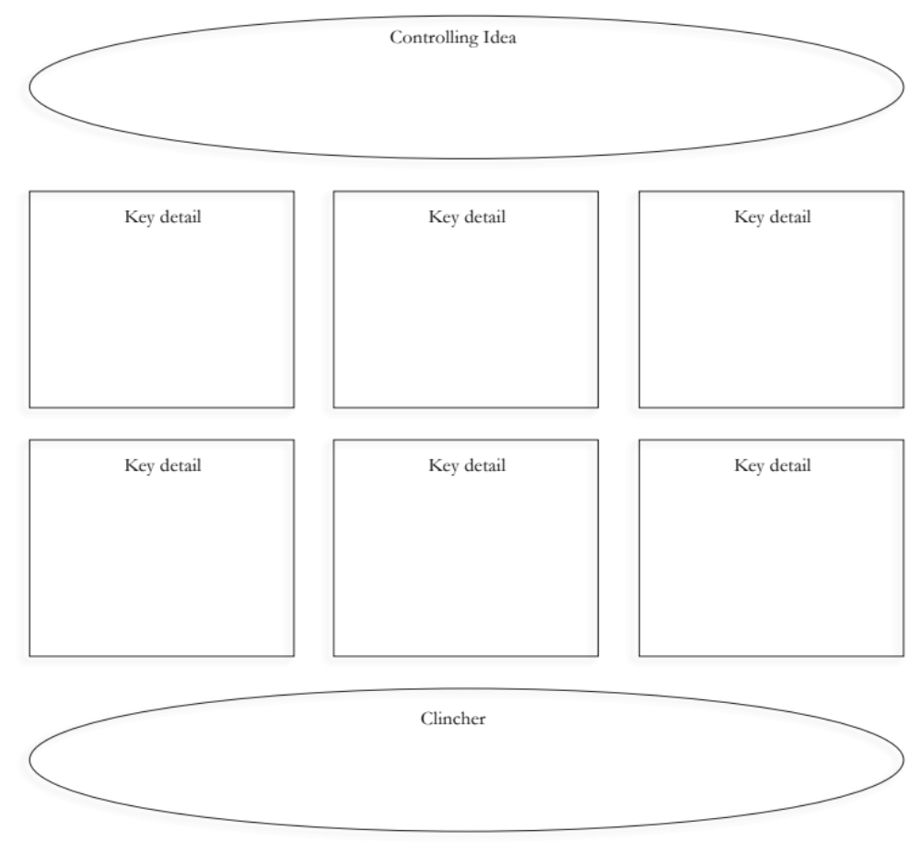

Teacher directions: Make enough copies of this page for each small group. Cut the sentence so they are on different strips.

“Today, more than 14 million men, women, and children have been forced to flee their homes, towns, and countries because they are afraid to stay.”



“Some refugees cannot return home, nor can they stay in their country of asylum. They must resettle in a new country.”

“Perceptions of unfairness, such as unequal treatment or denial of rights based on race, religion, economic status, or political
thought, instigate war; so does unequal access to land, food, water, and other necessary resources.”

Teacher Directions: Make enough copies of this page for each small group. Cut the quotes so each of the nine is on a separate
quote card.
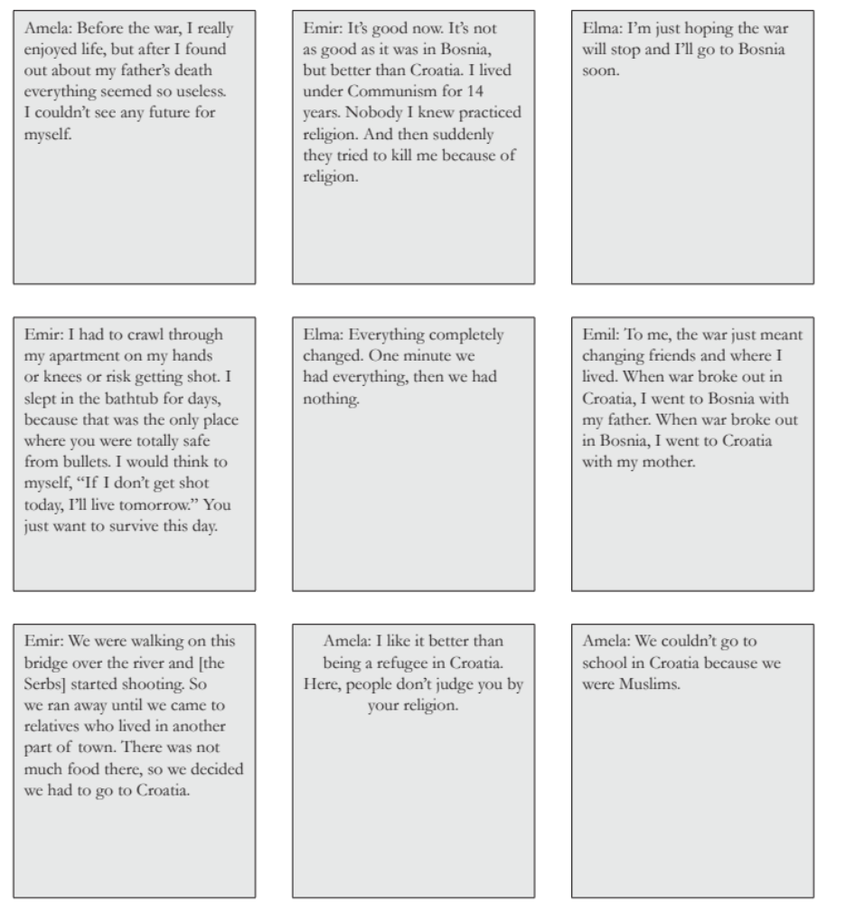

Look back in Inside Out & Back Again and reread the poem “Neigh Not Hee” (page 134). How does this poem connect with the
experience of one or more of the teens in “Children of War”? Use details from the poem to support your answer.

