MODULE LESSONS
Kindergarten: Module 1: Unit 2: Lesson 3
Reading and Discussion: Describing the Shape and Texture of Toys
Language Arts Curriculum

Toy Riddles, Pages 7–10
Page 7

What feels smooth and bumpy, with so many little pieces to use?
Toy Riddles, Pages 7–10
Page 8

We are plastic building bricks! Build us into anything you choose.

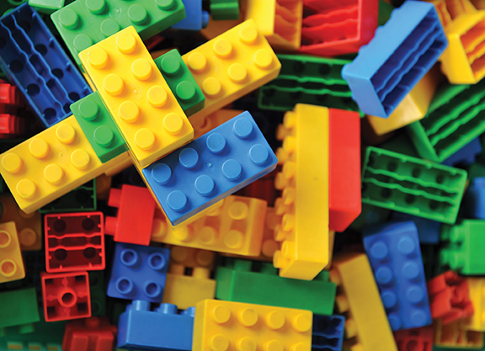
Toy Riddles, Pages 7–10
Page 9

What is squishy and soft and can be rolled into a ball?

Toy Riddles, Pages 7–10
Page 10

I’m play dough! You can make me flat or tall.

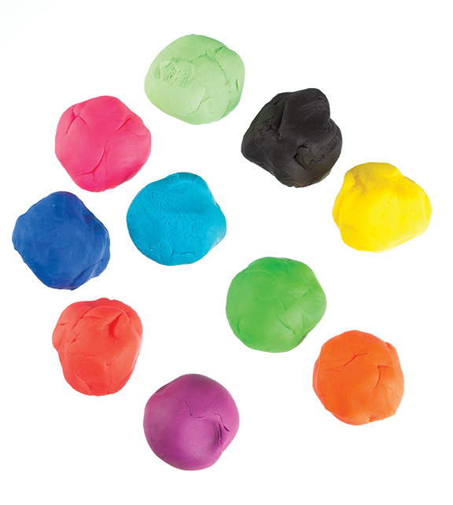
Attributes of Toys, Pages 5–9
Page 5

Toys can be many shapes. Look at the blocks. What shapes do you see?
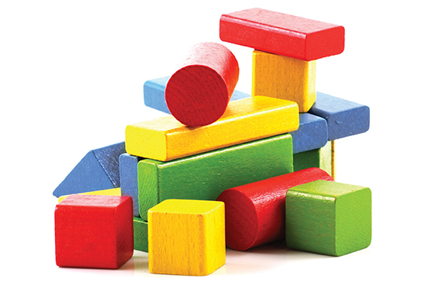
Attributes of Toys, Pages 5–9
Page 6

Some toys are made of many shapes. Look at the truck. Do you see circles and rectangles? How many shapes can you find?
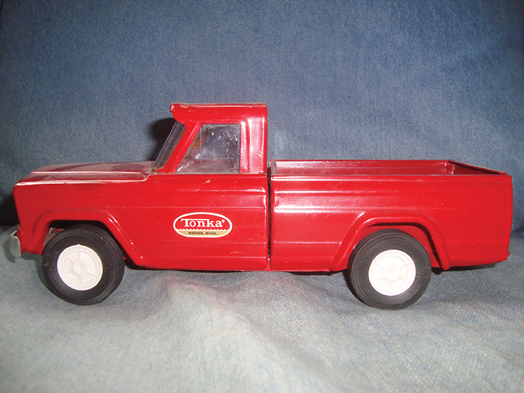
Attributes of Toys, Pages 5–9
Page 7

Toys can be many different textures. Texture is how something feels. A toy might feel smooth or rough. It might feel soft or hard. It might feel squishy or bumpy.
Attributes of Toys, Pages 5–9
Page 8

How do you think play dough feels? How do you think plastic building bricks feel?

Attributes of Toys, Pages 5–9
Page 9

Toys can be described in many ways. If you look closely at the colors, sizes, shapes, and textures of toys, you will become a toy expert for sure!

Shape Cards
Note to teachers: Print on cardstock, if possible, and cut out along the dotted line. One set is enough for a class to play the I Spy game.

Square | Circle | Rectangle
 |  | 
Oval | Triangle | Blob
 |  | 
Cylinder | Cube
 | 

Texture Cards
Note to teachers: Print on cardstock, if possible, and cut out along the dotted line. One set is enough for a class to play the I Spy game.

Fluffy | Soft | Rough
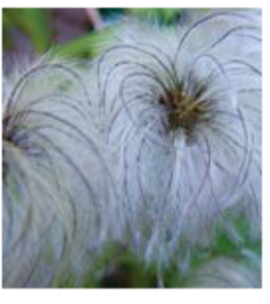 | 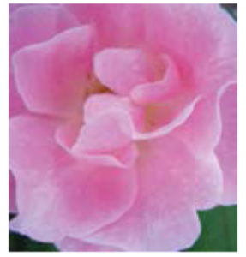 | 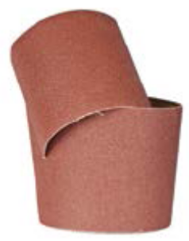
Hard | Smooth | Bumpy
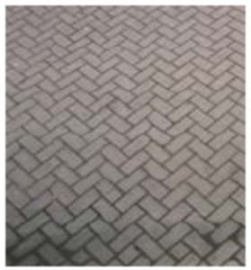 |  | 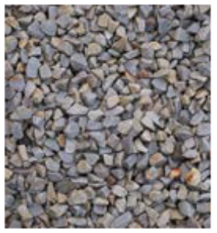
Slippery | Sticky | Fuzzy
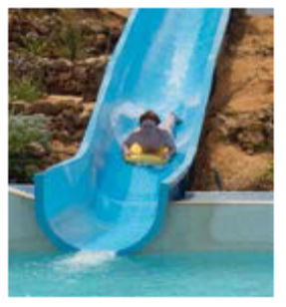 | 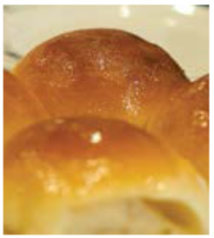 | 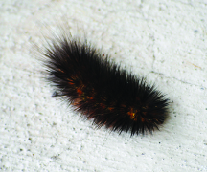

Shape Words Anchor Chart
Shape Words
(sample student responses)
Triangle
Circle
Square

Texture Words Anchor Chart
Texture Words
(sample student responses)
Soft
Fuzzy
Hard

Image Credits
Page 3. Hxdbzxy. “Plastic toy blocks on white background.” Photograph. Shutterstock. n.d. Web. 9 June 2016.
Page 5. Lodimup. “Group of modelling clay.” Photograph. Shutterstock. n.d. Web. 2 May 2017
Page 6. Nenov Brothers Images. “Wooden building blocks.” Photograph. Shutterstock. Web. June 2017.
Page 7. Programmer13. “1960’s Tonka truck in front of a blue background.” Photograph. Wikimedia Commons. 5 April 2008. Web. 30 April 2017.
Page 12. Hay, Andy. “Fluffy seedheads,” Photograph. Flickr. 22 August 2007. Web. 30 April 2017.
Page 12. Audrey. “Soft Pink Rose.” Photograph. Flickr. 27 August 2006. Web. 30 April 2017.
Page 12. Flas100. “Brown sandpaper for your woodwork.” Photograph. Shutterstock. n.d. Web. 2 May 2017.
Page 12. Gabovich, Iwan. “/\ shaped brick ground/floor.” Photograph. Flickr. 16 January 2009. Web. 30 April 2017.
Page 12. Meyer, Jeff. “Liquid.” Photograph. Flickr. 8 October 2008. Web. 30 April 2017.
Page 76. Warby, William. “Gravel Texture.” Photograph. Flickr. 8 October 2010. Web. 30 April 2017.
Page 12. Warby, William. “Water Slides.” Photograph. Flickr. 1 July 2015. Web. 30 April 2017.
Page 12. Liu, John. “Sticky buns (160/365).” Photograph. Flickr. 10 June 2011. Web. 30 April 2017.
Page 12. Schultz, Sandy. “fuzzy.” Photograph. Flickr. 3 June 2010. Web. 30 April 2017.

