Grade 6: Module 1: Unit 2: Lesson 8
Exploring Allusions to Myths in The Lightning Thief: Close Reading Part 1 of “Prometheus”

Long-Term Targets Addressed (Based on ELA CCSS)
I can cite text-based evidence to support an analysis of literary text. (RL.6.1)
I can analyze how an author’s word choice affects tone and meaning in a literary text. (RL.6.4)
I can use a variety of strategies to determine the meaning of unknown words and phrases. (L.6.4)
Supporting Learning Targets | Ongoing Assessment
- I can explore how the allusion to the myth of Prometheus improves my understanding of The Lightning Thief.  - I can explain how key vocabulary adds to meaning in an excerpt of The Lightning Thief.  - I can get the gist of the myth of Prometheus. | - Myth of Prometheus annotated for the gist

Agenda | Teaching Notes
- Opening  - Engaging the Reader: Sharing Unfamiliar Vocabulary from Chapter 16 of The Lightning Thief (10 minutes)  - Work Time  - Engaging the Reader: Pages 155–156 of The Lightning Thief (5 minutes)  - Looking Closely at Vocabulary in the Prometheus Allusion in The Lightning Thief (10 minutes)  - Close Read, Part 1 of the Myth of Prometheus: Getting the Gist (15 minutes)  - Closing and Assessment  - Self Assessing Achievement of Learning Targets (5 minutes)  - Homework  - Read Chapter 17: How does Percy show he is a hero in this chapter? | - In previous lessons, students learned how to recognize what makes a myth a myth and the themes in a myth, by reading closely for details of mythological elements.  - Throughout this unit, the allusions in The Lightning Thief serve as an entry point to a deeper study of specific myths. In this lesson, students are introduced to the myth of Prometheus through an allusion to it in The Lightning Thief. They analyze key vocabulary in this excerpt to determine how it contributes to the meaning, and they explain how the allusion to Prometheus helps them to better understand The Lightning Thief.  - Students then identify questions to guide their close reading for the gist of the Prometheus myth using the Odell Education handout Reading Closely: Guiding Questions (provided in supporting materials and available as a stand-alone document on EngageNY.org and odelleducation.com/resources).  - In advance: Review the questions on the Reading Closely: Questioning Texts document at the end of this lesson, which is taken from the second row of the Odell handout. Focus on the Topic, Information, and Ideas questions, as those are the most relevant to getting the gist.  - Review the Prometheus Allusion Vocabulary Questions before reviewing the Prometheus allusion in The Lightning Thief, pages 155–156, beginning: “So what was it like … before the gods?” and ending at “… and Western civilization was born.” When reading, keep the vocabulary questions in mind to determine the meaning of the key vocabulary words and phrases in that context.  - Review the myth of Prometheus on page 72 of “Prometheus”.  - Post: learning targets

Lesson Vocabulary | Materials
allusion, gist; in vain, defied, wrath, downfall | - The Lightning Thief (book; one per student)  - Tickets—pieces of paper large enough to write one word (three per triad)  - Prometheus Allusion Vocabulary Questions (one per discussion triad)  - Reading Closely: Guiding Questions handout (from Lesson 2; one for display) (See stand-alone document on EngageNY.org and odelleducation.com/resources)  - Reading Closely: Questioning Texts (one per student)  - “Prometheus” (one per student)  - Homework: Purpose for Reading—Chapter 17 (one per student)  - Evidence flags (four per student)

Opening | Meeting Students’ Needs
A. Engaging the Reader: Sharing Unfamiliar Vocabulary from Chapter 16 of The Lightning Thief (10 minutes)  - Be sure students have their texts, The Lightning Thief. Invite students to get into discussion triads. Ask triads to look for three unfamiliar words that more than one member of the group listed on their charts as unfamiliar vocabulary words from Chapter 16 of The Lightning Thief. Give each triad three tickets, one for each word they have chosen. Invite triads to record one word on each ticket and the location of the word in the text.  - Collect the tickets. Pick three words from the selection to focus on—choose words that more than one triad have chosen.  - Take one word at a time. Post it for all to see and then read it in the sentence from The Lightning Thief. Model using the following strategies to help students understand what the word means:  - Read from the sentence around the word to help students understand the meaning from the context.  - Read words from the sentences or paragraphs around the word that might provide context clues.  - Invite other students to help you explain what the word means.  - If the above strategies fail, tell students what the word means.  - Invite students to turn and talk about the various strategies modeled:  - “How might this strategy help me as a reader?” | - Many students will benefit from seeing the vocabulary words. Discuss only one vocabulary word at a time to keep students focused.  - Keep the other unfamiliar words from the text and address them when time is available.

Work Time | Meeting Students’ Needs
A. Engaging the Reader: Pages 155–156 of The Lightning Thief (5 minutes)  - Students remain in their discussion triads. Post the first learning target for students and invite them to follow along silently as you read aloud:  - “I can explore how the allusion to the myth of Prometheus improves my understanding of The Lightning Thief.”  - Ask students to Think-Pair-Share:  - “What is an allusion?”  - Ask a few volunteers to briefly share any of the allusions they find for homework.  - Explain that they are going to be reading an allusion in The Lightning Thief. Invite them to follow along in their The Lightning Thief books as you read page 155 and 156, beginning “So what was it like … before the gods?” and ending at “… and Western civilization was born.”  - Ask triads to discuss the following questions, one at a time. After each question, give the triads time to discuss before selecting a triad to share their thinking with the rest of the class. Between each question, check for understanding and clarify any misconceptions by inviting other triads to provide additional input, elaborate, or restate another group’s answer. Then move on to the next question:  - “Which characters from Greek mythology are discussed in this excerpt?”  - “What do you find out about Prometheus in this excerpt?” | - Discussing and clarifying the language of learning targets helps build academic vocabulary.  - Set clear expectations that students read along silently as you read the text aloud. Hearing the text read slowly, fluently, and without interruption or explanation promotes fluency for students: They are hearing a strong reader read the text aloud with accuracy and expression, and are simultaneously looking at and thinking about the words on the printed page.  - Many students will benefit from seeing questions posted on the Smartboard or via a document camera, but reveal questions one at a time to keep students focused on the question at hand.  - Adding visuals or graphics to questions can help students remember or understand key ideas or directions.  - Consider grouping ELL students who speak the same home language into triads when discussion of complex content is required. This can allow students to have more meaningful discussions and clarify points in their native language.

Work Time (continued) | Meeting Students’ Needs
B. Looking Closely at Vocabulary in the Prometheus Allusion in The Lightning Thief (10 minutes)  - Post the second learning target for students and invite them to follow along in their heads silently as you read aloud:  - “I can explain how key vocabulary adds to meaning in an excerpt of The Lightning Thief.”  - Explain that students will be looking closely at the vocabulary in the excerpt they just read to determine how it adds meaning.  - Ask students to remain in their discussion triads. Distribute Prometheus Allusion Vocabulary Questions (one per triad). Ask one key question at a time and give the triads time to discuss before selecting one triad to share their thinking with the rest of the class. Use the other related questions to probe.  - Between each set of questions, check for understanding and clarify any misconceptions by inviting other triads to provide additional input, elaborate, or restate another group’s answer. Then move on to the next question:  - “Why do you think Kronos called his reign a ‘Golden Age’?”  - “What does ‘Golden Age’ mean in this context?  - “Did Chiron believe the reign of Kronos really was a Golden Age? Why or why not?”  - “What does innocent mean in this context?”  - “Are there any other meanings of innocent?”  - “The text says, ‘Prometheus was branded a radical thinker.’ What does branded mean in this context?” (Clarify that the word branded literally means to burn onto someone’s skin.) “Was he literally branded—did he have the words ‘literal thinker’ burned onto his skin?”  - “What is a radical thinker?”  - “Why was Prometheus branded a ‘radical thinker’?”  - “The word ‘civilization’ means ‘the organizing of people into a society.’ What does the text mean when it says, ‘Western civilization was born’?”  - “How is the author using the word born here?”  - “How did Prometheus help a civilization be born?” | - To further support ELLs, consider providing definitions of challenging vocabulary in students’ home language. Resources such as Google Translate and bilingual translation dictionaries can assist with one-word translation.

Work Time (continued) | Meeting Students’ Needs
C. Close Read, Part 1 of the Myth of Prometheus: Getting the Gist (15 minutes)  - Reconvene class. Explain that now that the students have been introduced to the myth of Prometheus in the allusion in The Lightning Thief, they are going to read the myth to find out the full story. Tell them that as usual, they will read the text more than once. Today they are just going to get started with the gist.  - Post the third learning target for students and invite them to follow along silently as you read aloud:  “I can get the gist of the myth of Prometheus.”  - Students should be quite familiar with this sort of target based on their work in Unit 1. Review briefly. Circle the word gist and ask students to Think-Pair-Share:  - “What is the ‘gist’?”  - “What does it mean to ‘get the gist’?”  - Listen for: “Getting the gist means reading through quickly to get an initial sense of what the text is mostly about.” It’s ‘first impressions’ as a way to ‘scratch the surface’ of a complex text.”  - Ask students to Think-Pair-Share:  - “Why are we working on this skill?”  - Listen for: “When we read for the gist, we quickly get an initial sense of what a text is mostly about. It helps us to get an idea of where information is located in a text so that we can find it quickly later. It’s just a way of getting started making sense of a hard text. ”  - Display the Reading Closely: Guiding Questions handout. Remind students that in an earlier lesson, they saw the first box, “Approaching the Text.” Explain that in this lesson they are going to look at the next row of the chart: “Questioning Texts.”  - Next, display and distribute Reading Closely: Questioning Texts, which zooms in on one row of the main handout. Ask students to Think-Pair-Share:  - “Which of these questions do you think will help guide our close reading so we can get the gist of Prometheus?”  - Listen for and encourage students toward all the Topic, Information, and Ideas questions. (What is this text mainly about? What information or ideas does the text present? What details stand out to me as I read?) Highlight/check-mark those questions on the displayed copy of the document. Invite students to do the same on their chart to be a reference as they read. | - Part 1 of the Close Read is designed to give students an idea of the flow of the text and what the text is about. Avoid stopping to address vocabulary or comprehension issues, as these will be addressed later.  - Asking students to identify challenging vocabulary helps them to monitor their understanding of a complex text. When they annotate the text by circling these words, it can also provide a formative assessment for the teacher.  - For students who struggle with reading grade-level text, consider chunking the text for them on separate sheets of paper. This makes the reading of complex text more manageable and allows them to focus on one small section at a time.

Work Time (continued) | Meeting Students’ Needs
- Distribute the “Prometheus” text to students. Ask students to read along silently as you read it aloud. As with other read-alouds, remember that the purpose is to read the text slowly, fluently, and without interruption. Don’t stop to address comprehension or vocabulary issues, as these will be addressed later and it will interrupt the flow of the text.  - Ask students to Think-Pair-Share:  - “After listening to a first read, what are the main ideas you understand from the myth of Prometheus so far?”  - Ask students how they got the gist of texts in Unit 1. Cold call. Listen for: “We read one paragraph at a time, then paraphrased the paragraph in the margin next to the text.”  - Invite students to reread the first paragraph of the myth of Prometheus for the gist. Ask students to Think-Pair-Share:  - “What is the gist of this paragraph? What is your initial sense of what this paragraph is mostly about?”  - Listen for students to say something like: “Prometheus stole fire and gave it to people on Earth even though Zeus said no.”  - Model annotating your text, recording the gist in the margin next to the first paragraph and circling unfamiliar words to come back to later.  - Invite students to go through each paragraph of the myth of Prometheus to annotate the gist and circle words that are unfamiliar. Circulate and support students as they read. For students who need more support, ask them to practice telling you the gist of a section before they write it in the margin.  - Invite students to talk with a partner to compare what they wrote for their gist statements.  - Reconvene class. Go through the story paragraph by paragraph again and ask students to share the unfamiliar words they circled. Use the following strategies to help students understand what the words mean:  - Read from the sentence around the word to help students understand the meaning from the context.  - Read words from the sentences or paragraphs around the word that might provide context clues.  - Invite other students to help you explain what the word means.  - If the strategies above fail, tell students what the word means.  - Words students may struggle with: in vain, defied, wrath, downfall.  - Be sure to address these words here. Cold call to ask students what each word means and how they figured it out. Direct students to use context clues when possible. If students are stuck on a word, model briefly, to ensure understanding for all.  - Remind students to record new words on their word-catcher. | - Select students may need more frequent checks for understanding and guided practice when annotating for the gist. Consider pulling these students into a small group, checking in with them periodically, and discussing the gist of a section before students write it.  - Select students may find it helpful to determine the gist of smaller chunks of the text at a time. Consider calling this “bite-size” reading: When we are having trouble eating something, we take smaller bites of it before moving on.

Closing and Assessment | Meeting Students’ Needs
A. Self-Assess Achievement of Learning Targets (5 minutes)  - Focus students on the first learning target again:  - “I can explain how the allusion to the myth of Prometheus improves my understanding of The Lightning Thief.”  - Ask students to Think-Pair-Share:  - “What is an allusion?”  - “How did the allusion to Prometheus, and reading the myth of Prometheus, improve your understanding of The Lightning Thief?”  - Using the Fist to Five protocol, prompt all students to raise their fingers to represent their ability to meet this learning target now. Ask students to rate themselves on a continuum from 0 (fist), meaning far from the target, to five (five fingers), having solidly met the target.  - Describe to the students any patterns that you notice. (For example: “I see that a number of students are holding up 4s or 5s. Great! You’re starting to figure out the power of allusions!”)  - Distribute Homework: Purpose for Reading—Chapter 17 and four evidence flags per student. | - Consider partnering ELLs who speak the same home language when discussion of complex content is required. This can allow students to have more meaningful discussions and clarify points in their native language.  - Asking students to self-assess after they practice a skill can give them an idea of how far they have come over the lesson.

Homework | Meeting Students’ Needs
- Read Chapter 17 of The Lightning Thief. Consider the following question as you read, and use evidence flags as you find evidence to answer the question:  - How does Percy show that he is a hero in Chapter 17 of The Lightning Thief? | - The homework question can be distributed as bookmarks for Chapter 17 so that students have a constant reminder of the question as they read.  - As an extension activity, encourage students to read the myth of Prometheus on page 72 of the D’Aulaires’ Book of Greek Myths and compare the two versions. Which do they think is most effective? Why?

Grade 6: Module 1: Unit 2: Lesson 8
Supporting Materials
Use the chart below to record the things you notice and wonder about as you view the illustrations of Cronus and Rhea.
- Why do you think Kronos called his reign a Golden Age?
- What does Golden Age mean in this context?
- What is a Golden Age?
- Did Chiron believe the reign of Kronos really was a Golden Age? Why or why not?
- What does innocent mean in this context?
- Are there any other meanings of innocent?
- The text says, “Prometheus was branded a radical thinker.” What does branded mean in this context? Was he literally branded—did he have “literal thinker” burned onto his skin?
- What is a radical thinker?
- Why was Prometheus branded a “radical thinker?”

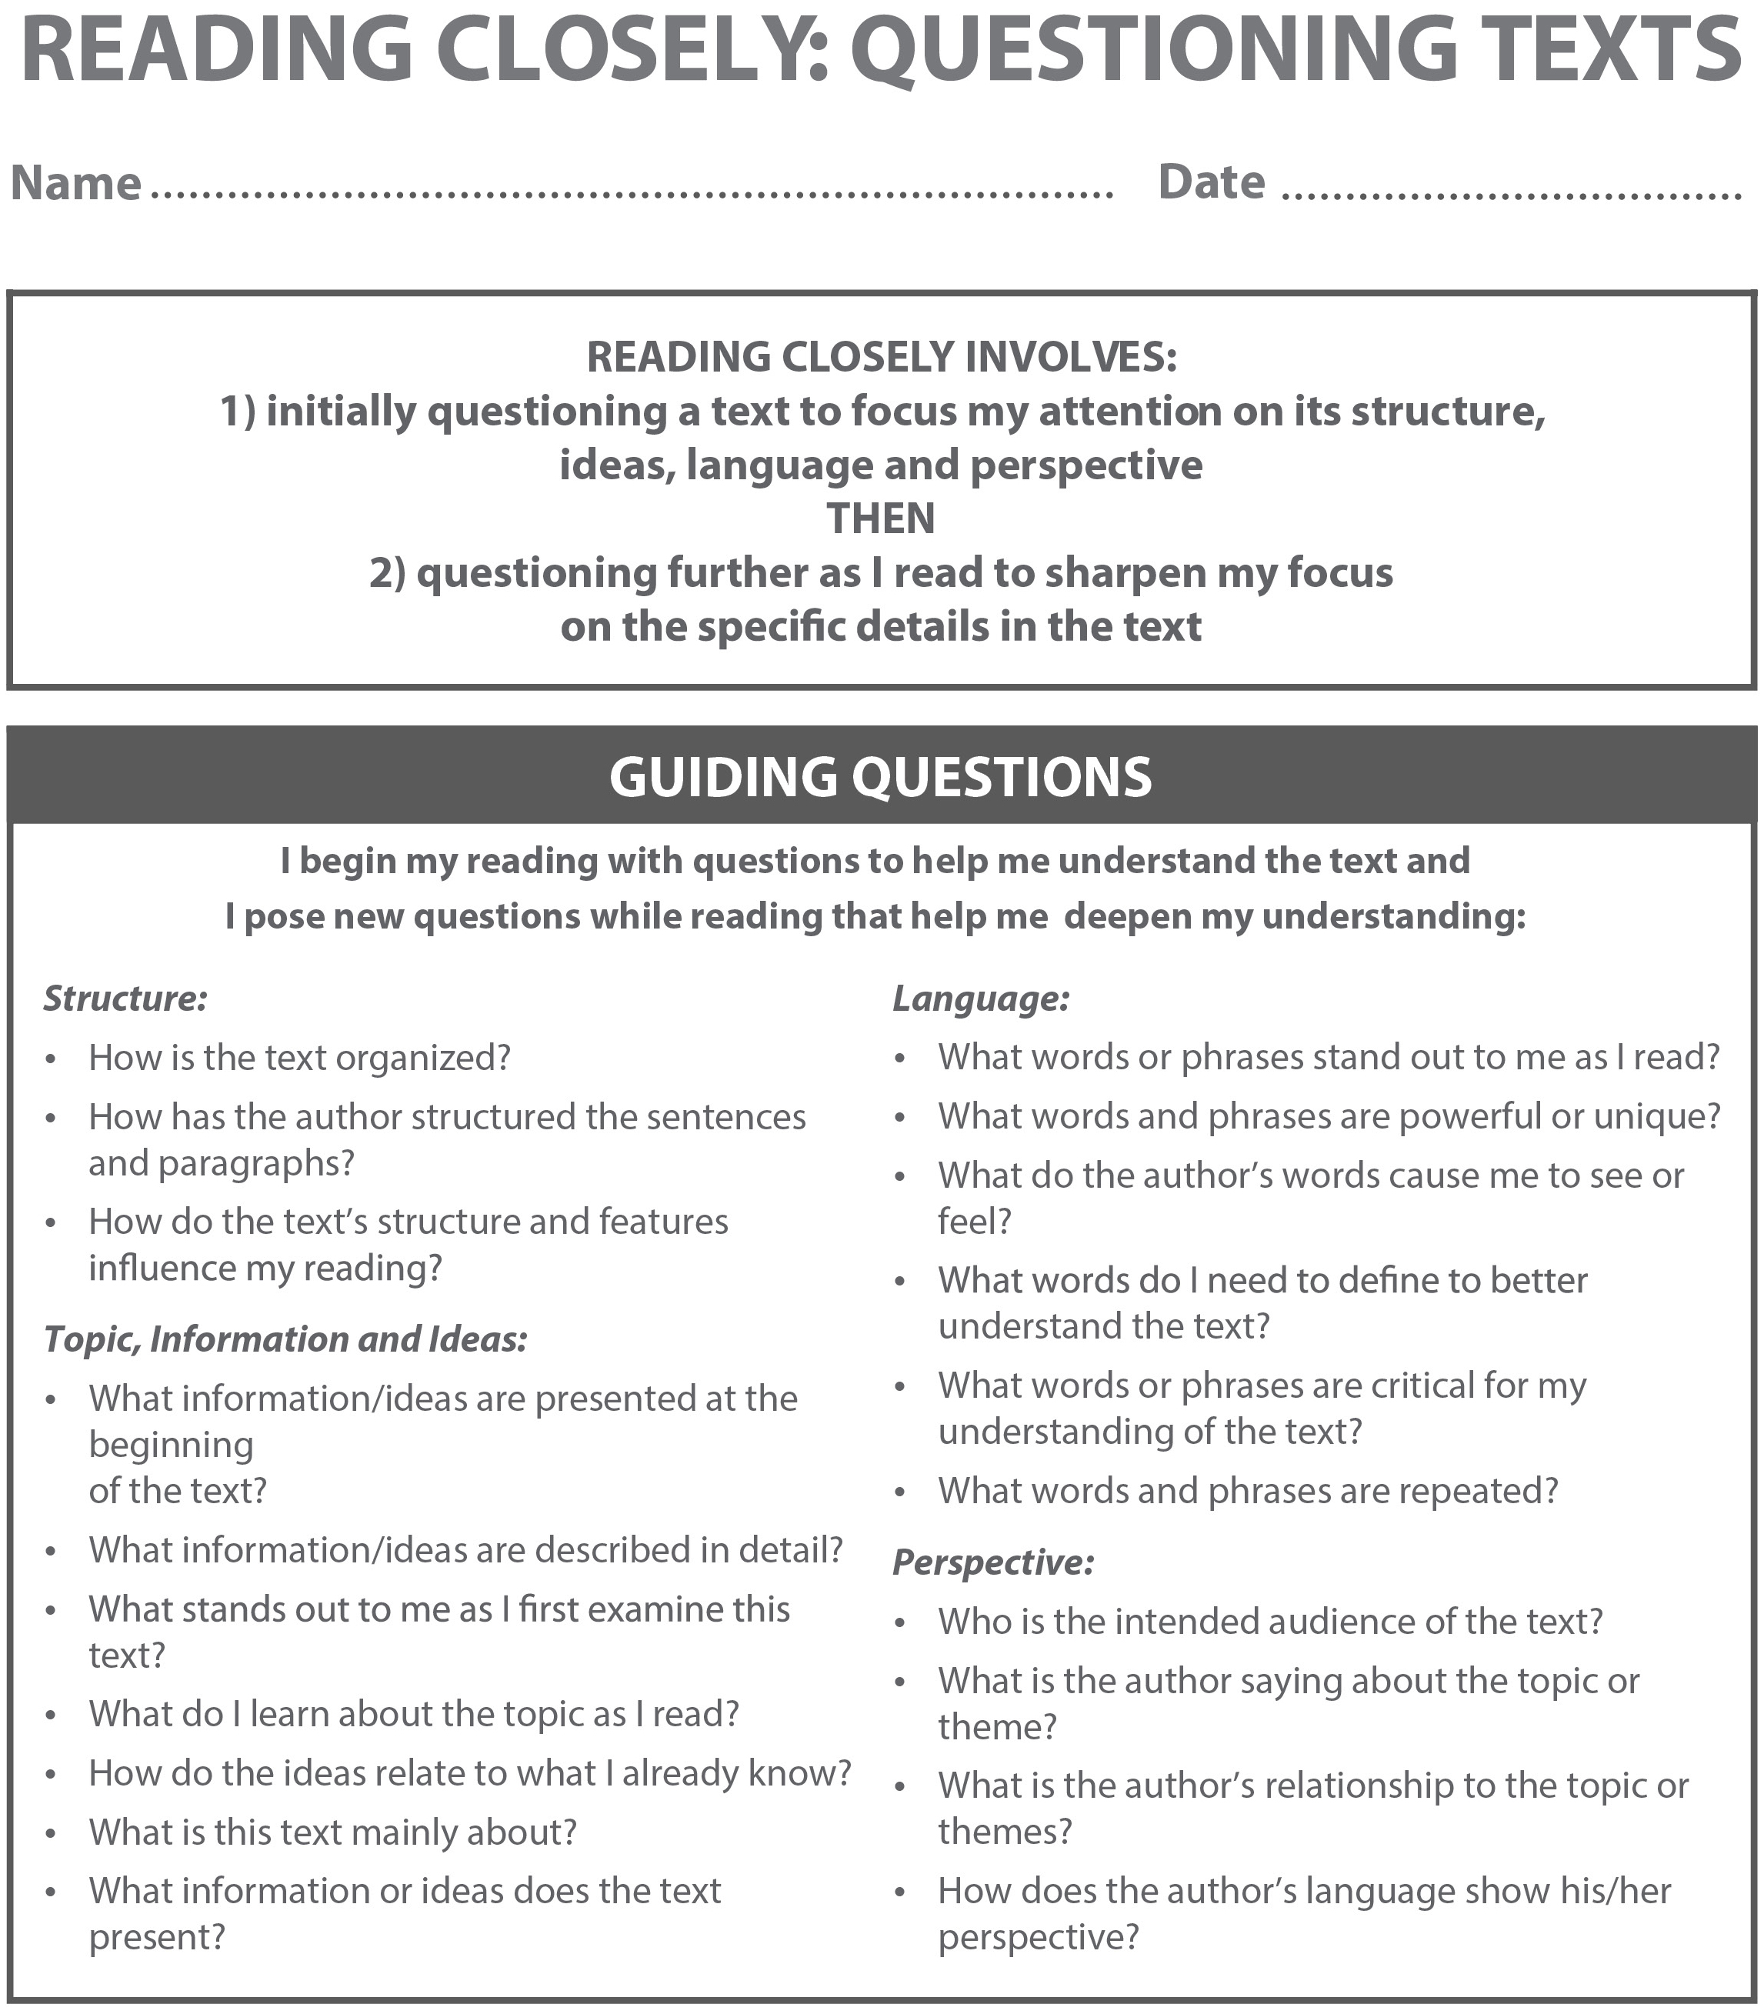

From Odell Education’s “Reading Closely for Details: Guiding Questions” handout. Used by permission.
Name:
Date:

The world, as first it was, to the Greeks was a sunless world in which land, air, and sea were mixed up together, over which ruled a deity called Chaos. A giant race of Titans lived on this newly made earth. One of the mightiest Titans was Prometheus.

Prometheus and his brother Epimethus were trusted to give special gifts, abilities, and instincts to the beasts, birds, and fishes of the world. They also were given the task of making a creature lower than the gods, less great than the Titans, yet in knowledge and in understanding higher than the beasts and birds and fishes. This being was called Man.

Prometheus took some clay from the ground at his feet, moistened it with water, and made it into an image, in form like the gods. Into its nostrils Eros breathed the spirit of life, Pallas Athené gave it a soul, and the first Man looked wonderingly round on the earth.

Prometheus, proud of the beautiful thing of his own creation, wanted to give Man a worthy gift, but no gift remained for him. He was naked, unprotected, more helpless than any of the beasts. And Prometheus pitied him more than the animals, since Man had a soul to suffer. Surely Zeus, ruler of Olympus, would have compassion for Man? But Prometheus looked to Zeus in vain; he did not have compassion for Man.

Prometheus pitied Man, and thought of a power belonging to the gods alone. “We shall give fire to the Man we have made,” he said to Epimethus. He waited patiently and, unseen by the gods, made his way into Olympus, lighted a hollow torch with a spark from the chariot of the Sun, and brought this royal gift to Man. With fire, Man no longer trembled in the darkness of caves when Zeus hurled his lightning across the sky. He was no longer scared of the animals that hunted him and drove him in terror. With fire, Man made weapons, defied the frost and cold, made tools and money, introduced the arts, and was able to destroy as well as to create.

From his throne on Olympus, Zeus looked down on the earth and saw blue-gray smoke that curled upward to the sky. He watched more closely and realized with terrible wrath that what he saw came from fire, that before had been the gods’ own sacred power. He gathered a council of the gods to decide how to punish Prometheus for deceiving him. Zeus chained Prometheus to the top of a mountain, and every day an eagle came and ate Prometheus’ liver. Every night, his liver grew back.

This council also decided to punish Man. They decided to create a thing that should forever charm the souls and hearts of men and forever be Man’s downfall. This thing was Pandora.
Adapted from: Lang, Jean. “Prometheus and Pandora”. A Book of Myths. New York: Thomas Nelson and Sons, 1914. 1–4. Web. 7 June 2013. Public domain.

How does Percy show that he is a hero in Chapter 17 of The Lightning Thief?

Use your evidence flags to mark evidence in this chapter that you believe shows Percy as a hero.
Think about the character traits of a hero, as well as the “hero’s journey” from earlier lessons.

