Grade 6: Module 2B: Unit 2: Lesson 15
Analyzing and Discussing: Modern Voices

Long-Term Targets Addressed (Based on ELA CCSS)
I can cite text-based evidence to support analysis of what a text says explicitly as well as inferences drawn from a literary text. (RL.6.1)
I can determine a theme or central idea and how it is conveyed through particular details. (RL.6.2)
I can analyze how a particular sentence, stanza, scene, or chapter fits in and contributes to the development of a literary text. (RL.6.5)
I can effectively engage in a range of collaborative discussions with diverse partners on sixth-grade topics, texts and issues, building on others’ ideas and expressing my own clearly. (SL.6.1)

Supporting Learning Targets | Ongoing Assessment
- I can cite evidence to analyze what poems says explicitly and what inferences can be made from poems in Technically, It’s Not My Fault and Blue Lipstick.  - I can describe how the structure of the poems “TyrannosaurBus Rex” and “Point A to Point B” in Technically, It’s Not My Fault and Blue Lipstick contributes to the theme.  - I can express my own ideas and build on others’ ideas during discussion of “Advanced English.” | - Modern Voices graphic organizer for “Advanced English” (from homework)  - Reading Tracker and Reviewer’s Notes  - Speaking and Listening Criteria Discussion Tracker

Agenda | Teaching Notes
- Opening  - Using Discussion Starters to Share Independent Reading (7 minutes)  - Unpacking Learning Targets (3 minutes)  - Work Time  - Identifying Theme, Finding Evidence, and Making Inferences with Two Concrete Poems (15 minutes)  - Using Speaking and Listening Criteria in Discussion (15 minutes)  - Closing and Assessment  - Back-to-Back, Face-to-Face: Using Voices to Share a Challenge (5 minutes)  - Homework  - Read independently to meet your goal. Complete the Reading Tracker and Reviewer’s Notes.  - Read “My Sister Is Crazy” from Blue Lipstick and complete the Modern Voices graphic organizer for “My Sister Is Crazy.” | - In this lesson, students continue to build on the skills of citing evidence to analyze what is being expressed and using it to make inferences from concrete poems in Blue Lipstick and Technically, It’s Not My Fault.  - As noted in Lesson 14, even though this lesson is officially part of Unit 2, conceptually it is a part of Unit 3. This was done is in order to give you time to assess and give students’ feedback on their draft essays between Lessons 13 and 16.  - As students complete Modern Voices graphic organizers for the concrete poems they read and analyze, they will add this information to their Modern Voices folders. These documents, along with their Themes of Adversity graphic organizers, will be used as they prepare for the discussion portion of the mid-unit assessment. Starting in Unit 2, Lesson 14, and throughout Unit 3, students will continue to build on effective strategies for successful collaborative discussion with diverse partners.  - Encourage students, as they explore the structure and messages conveyed in John Grandits’s concrete poetry, to consider and document specific moments or incidences in their own experience that relate to the themes expressed in the poems on their Modern Voices graphic organizers. These recollections will help as they prepare to select a theme and write their own monologues in the second half of Unit 3.  - In advance:  - Add paraphrase, clarify, and probe to the Academic Word Wall.  - Cut “Advanced English” discussion questions into strips.  - Post: Learning targets.

Lesson Vocabulary | Materials
paraphrase, clarify, probe | - Effective Discussions anchor chart (begun in Lesson 14)  - Academic Word Wall (begun in Lesson 14)  - Academic Word Wall (for Unit 2 Lessons 14 and 15 and all Unit 3 lessons; for teacher reference)  - “TyrannosaurBus Rex” (one per student and one to display)  - “Point A to Point B” (one per student and one to display)  - Modern Voices graphic organizer for “TyrannosaurBus Rex” (one per student)  - Modern Voices graphic organizer for “Point A to Point B” (one per student)  - Document camera  - Challenges of Modern Times anchor chart (begun in Lesson 14)  - Speaking and Listening Criteria Discussion Tracker (one per student and one to display)  - Equity sticks  - Role-Play Script (four total: one for teacher, one for each of the three selected role-playing students)  - “Advanced English” (from Lesson 14; one per student)  - “Advanced English” discussion questions (one per triad; cut into strips for drawing)  - “My Sister Is Crazy” (one per student)  - Modern Voices graphic organizer for “My Sister Is Crazy” (one per student)  - Reading Tracker and Reviewer’s Notes (from Lesson 14)

Opening | Meeting Students’ Needs
A. Using Discussion Starters to Share Independent Reading (7 minutes)  - Invite students to take their independent reading books and Reading Tracker and Reviewer’s Notes and join their triads.  - Remind students that their homework was to read their independent reading books and complete the Reading Tracker and Reviewer’s Notes.  - Explain that discussion is an important part of reading and analyzing what they have read.  - Direct students to the Effective Discussions anchor chart. Review the strategy of turning questions into statements as a way to share or begin discussions. Students will practice using that strategy in their book discussion. Add sentence stems as necessary.  - Tell each triad member to share what happened in their book or their response to the idea they chose to write about in the Reviewer’s Notes.  - After one person has shared, listening partners should acknowledge what they heard or ask a question to learn more or have something explained.  - Circulate and listen to students as they share and respond. Note successful discussion starters and responses that indicate understanding and interest.  - Refocus students whole class. Invite them to share discussion starters and responses they used or noticed. | - Opening with activities linked to independent reading homework holds students accountable for reading independently.  - Note students who have not completed their homework. Arrange to meet with them to check on their book choice, review goals, and identify strategies for success.  - Consider providing select students with specific sentence starters or writing prompts the day before. They can use these tools during homework time to prepare for this discussion. This scaffolding can be used any time independent reading is assigned for homework.

Opening (continued) | Meeting Students’ Needs
B. Unpacking Learning Targets (3 minutes)  - Direct students’ attention to the posted learning targets and read them aloud:  - “I can cite evidence to analyze what poems says explicitly and what inferences can be made from poems in Technically, It’s Not My Fault and Blue Lipstick.”  - “I can describe how the structure of the poems ‘TyrannosaurBus Rex’ and ‘Point A to Point B’ in Technically, It’s Not My Fault and Blue Lipstick contributes to the theme.”  - “I can express my own ideas and build on others’ ideas during discussion of ‘Advanced English.’”  - Students should be familiar with citing explicit evidence and using that evidence to make inferences from the targets and their work in the previous lesson.  - Cold call a student to share what explicit evidence is.  - Listen for: “Explicit evidence is details or information that makes clear what the author is saying.”  - Call on a student to share what inferences are.  - Listen for: “Inferences are conclusions or decisions you can make by considering the evidence in the reading.”  - Tell students they will read three new concrete poems in this lesson.  - Call on a student to share how the word structure relates to concrete poetry.  - Listen for: “The structure in concrete poetry is how the words are arranged to help share the message of the poem.”  - Explain that as students read the poems, they will also discuss their ideas about the messages the modern voices are expressing in the poetry.  - Remind students that the words explicit, inferences, and structure are posted on the Academic Word Wall. Encourage them to refer to the Academic Word Wall as they hear and use these words. | - Discussing and clarifying the language of learning targets help build academic vocabulary.  - Consider providing select students with index cards that have one academic vocabulary word contained in the learning targets. One the reverse side of the card, write the word’s meaning. When unpacking targets, ask these students to share the meaning of key academic vocabulary. This will help select students interact with important vocabulary, while also building their confidence and giving them an important voice in the class.

Work Time | Meeting Students’ Needs
A. Identifying Theme, Finding Evidence, and Making Inferences with Two Concrete Poems (15 minutes)  - Tell students they will read two more poems from Blue Lipstick and Technically, It’s Not My Fault. As they hear and read the poems, they will first identify the gist. After a second read, they will work together to determine the theme, look for explicit evidence, and make inferences.  - Distribute “TyrannosaurBus Rex” and “Point A to Point B” as well as the Modern Voices graphic organizer for “TyrannosaurBus Rex” and the Modern Voices graphic organizer for “Point A to Point B” to students.  - Remind them that they were introduced to and used graphic organizers with the poems on the covers of Blue Lipstick and Technically, It’s Not My Fault. Explain that they will use those documents as they work with their triad partners to analyze the poems.  - Use a document camera to display “TyrannosaurBus Rex.”  - Invite students to look at the graphics. Ask:  - “What do you notice?”  - “What do the images tell you about the gist or what this poem is about?”  - Call on volunteers to share out. Listen for responses that have to do with a school bus and the route.  - Remind students that writers of concrete poems purposefully use images and word arrangements to share their message.  - Tell students to listen and look at “TyrannosaurBus Rex” as you read aloud.  - Ask students to discuss in triads:  - “What do you think the poem is about now that you have listened to it and looked at the graphics?”  - Listen for students to note that the poem is about a bus that gives children rides to and from school.  - Tell students in the second read, they will read more closely for the theme and evidence. Invite students to quietly read the poem independently. If they finish while others are still reading, encourage them to reread it.  - When they have finished reading, ask triad partners to think and discuss, using discussion tips from the Effective Discussions anchor chart:  - “What is the theme?”  - “What evidence in the text supports the theme?” | - If students are using a copy of the book, point out that there is no table of contents or page numbers in the book. The titles of the poems are listed in order on the back covers. This will help with locating the poems. Poems are either one or two pages long.  - Consider giving select students a list of high-frequency themes encountered in literature. Initially, this list will help students simply identify an appropriate match of poem to theme. With repeated use, this will help these students to become more familiar with the concept of theme in general.  - Graphic organizers and recording forms engage students more actively and provide scaffolding that is especially critical for learners with lower levels of language proficiency and/or learning.  - Providing models of expected work supports all learners.

Work Time (continued) | Meeting Students’ Needs
  - “Based on the evidence, how does this poem connect to your own life?”
- Tell students to record their responses on their Modern Voices graphic organizer for “TyrannosaurBus Rex.”
- Circulate and listen to students citing evidence and making inferences as they analyze the theme of the poem. Model discussion strategies by asking probing and clarifying questions.
- Display the Modern Voices graphic organizer for “TyrannosaurBus Rex” on the document camera.
- Call on triad volunteers to share the theme they identified. Listen for responses that indicate that riding a school bus is like getting swallowed by a monster. Riding the bus to and from school can be challenging or adventurous.
- As students share, model documenting the theme or challenge on the graphic organizer. Encourage students to compare their responses and make changes or additions to their graphic organizers as you model.
- Now ask triad partners to discuss:
  - “What evidence in the poem can you find to support the theme you identified?”
- Select volunteers to share their triad discussion. As students share, fill in the “Evidence from Text” column. Encourage students to add to their graphic organizers. Listen for evidence that suggests the bus ride might be scary like “human sacrifices,” “I eat children,” or specific words like “terror” or “vicious.” Also listen for evidence that suggests the bus ride is fun such as, “My breakfast is giggling and laughing …” and other words like “jumping” and “noisy.”
- Then, ask students:
  - “What can you infer based on the evidence you found in the text?”
- As students share their inferences or thoughts, add to the “Inferences” column on the graphic organizer. Responses may include thoughts that the bus ride might be scary for some kids, fun or adventurous for others, or maybe boring.
- Direct students’ attention to the bottom of the graphic organizer.
- Ask them to consider if the theme of riding a bus to and from school connects or relates to them personally or how it might relate to other kids today. Ask students to write that connection with an example of evidence. For example: “I dread riding the bus. I don’t have anyone to sit by,” “I can’t wait to get on the bus and be with my friends,” or “The bus driver is so cool. He/she is really friendly.”
- Tell students the poem “Point A to Point B” expresses another perspective on getting to school.
- Invite students to now look at the graphics in “Point A to Point B.” Project the poem as students look at their copies. Ask:

Work Time (continued) | Meeting Students’ Needs
  - “What do you notice?”
  - “What do the images tell you about the gist or what this poem is about?”
- Listen for responses that indicate that going from one place to another isn’t a straight line.
- Read “Point A to Point B” aloud while students follow along.
- Ask students:
  - “Based on this first reading, what do you think the gist of the poem is?”
- Listen for responses that suggest the gist is about a girl who doesn’t want to walk to school and wants her mom to give her a ride.
- Tell students to read the poem independently. Point out that there may be a few twist and turns in the text. Explain that in this closer read, they are zooming in and looking for the theme and explicit evidence.
- After reading, call on students to share what they think the theme or challenge is. Guide students toward the challenge of the girl not wanting to walk to school and trying to convince her mom to give her a ride. Have students add the theme to their Modern Voices graphic organizer for “Point A to Point B” as you model.
- Ask students to take a minute to look for evidence on their own that tell how the narrator tackles that challenge: What reasons does she have for needing a ride?
- Ask students to record at least three examples in the second column of the Modern Voices graphic organizer for “Point A to Point B.”
- Then, ask them to use the evidence to make an inference, a statement about what they think.
- Invite students to compare evidence they collected and their inferences with the other members of their triad. Encourage them to practice using effective discussion language posted on the anchor chart as they paraphrase their thoughts and ask clarifying and probing questions.
- Circulate and listen as students discuss their analysis of “Point A to Point B.” Provide guidance to promote effective discussion.
- Refocus students whole group. Orient students’ attention to the Challenges of Modern Times anchor chart. Ask:
  - “What challenges from the concrete poems you read today could be added to this anchor chart?”

Work Time (continued) | Meeting Students’ Needs
- Call on students to share out. Add themes to the anchor chart as they share.
- Recognize students for their work with their triad partners. Comment on strengths you noticed in analyzing the poems and discussion. Offer next-step suggestions as well.
B. Using Speaking and Listening Criteria in Discussion (15 minutes)  - Tell students they will read another concrete poem from Blue Lipstick and then participate in a discussion about the poem.  - Distribute and display the Speaking and Listening Criteria Discussion Tracker. Explain that these criteria will help guide students’ discussion now and in the future. Tell students the criteria will be used to evaluate their participation in the Mid-Unit 3 Assessment discussion. Point out the parallels between this tracker and the Effective Discussion anchor chart.  - Explain that in this lesson they will focus on the first three criteria:  - Paraphrase ideas and questions  - Asks clarifying questions  - Asks probing questions  - Call on students to explain what they think the words paraphrase, clarifying, and probing mean. Listen for responses like: “Paraphrase means to summarize or put ideas and questions in your own words,” “Clarifying questions are questions that help make something clearer,” and “Probing questions help you dig deeper or find out more information.”  - Add definitions to the Academic Word Wall.  - Use equity sticks to select three students to role-play.  - Give these students the Role-Play Script and assign them roles as Student 1, Student 2, and Student 3.  - Ask them to read their part in the script:  - Student 1 reads: “I thought the message in the poem ‘TyrannosaurBus Rex’ was that even though riding the bus to and from school is routine, it can be challenging.”  - The teacher paraphrases the student’s idea: “In other words, you’re saying that riding the bus isn’t easy for everybody.”  - Student 2 reads: “I thought the message was that when something is boring or routine, like the daily bus route, you use your imagination to make it more interesting.” | - Using criteria such as the Speaking and Listening Criteria Discussion Tracker gives students a clear vision of what they need to be able to do to succeed with the learning targets.  - Some students may benefit from a set of cards that have question starters or generic questions that could be applied to any text. This tool will support language acquisition as well as relieve discussion related anxieties. Additionally, these cards could be labeled “clarifying” or “probing” to help students become familiar with the distinction between these two question types.  - Anchor charts provide a visual clue to students about what to do when you ask them to work collaboratively and/or independently. They also serve as note-catchers when the class is co-constructing ideas.

Work Time (continued) | Meeting Students’ Needs
  - The teacher clarifies: “Let me see if I understand. Are you saying that Robert, the narrator, was so bored he just imagined that the bus was a people-eating dinosaur?”
  - Student 3 reads: “I really like how the words are arranged near the end of the poem when the dinosaur’s stomach was full or the bus was loaded with little children.”
  - The teacher probes: “That’s interesting. Would you describe what you noticed?”
- Call on students to share sentence stems they heard you use in your responses.
- Where appropriate, add sentence stems to the Effective Discussions anchor chart. For example: “In other words, you’re saying …” could be added as a paraphrasing sentence stem; “Let me see if I understand …” could be added as a clarifying stem; and “That’s interesting. Would you describe …?” as a probing stem.
- Explain to students that they will have the opportunity to practice those skills in a discussion about another concrete poem.
- Ask students to take out the poem “Advanced English” that they read for homework.
- Invite them to read along as you aloud for gist.
- Cold call a student to share the gist of the poem. Responses should suggest the gist is about a girl who has a crush on a boy and would like to get to know him better.
- Tell students they will read the concrete poem again to themselves. This closer read will help prepare them for discussion.
- Tell students they will continue to work in triads. Explain the discussion guidelines:
  - Each member of the triad draws a question. Each member considers their own question and a response to share with the group. Refer to the Effective Discussions anchor chart for tips on how to turn a question into a statement.
  - Each person shares the question they selected and his/her response.
  - Other group members acknowledge what they heard by paraphrasing or asking a clarifying or probing question. Encourage students to refer to the Academic Word Wall and Effective Discussions anchor chart.
- Distribute “Advanced English” discussion questions. Ask students to begin.
- Circulate and listen as students discuss. Guide students to use paraphrasing and ask probing or clarifying questions. Make note of students who may need additional support.

Work Time (continued) | Meeting Students’ Needs
- Refocus students whole group. Ask them to reflect on their participation in the discussion by using the Speaking and Listening Criteria Discussion Tracker to mark stars or steps on the three criteria they practiced. Adding specific details to the notes will help strengthen discussion skills.
- Ask students what challenge the narrator of “Advanced English” faced.
- Add this challenge to the Challenges of Modern Times anchor chart.

Closing and Assessment | Meeting Students’ Needs
A. Back-to-Back, Face-to-Face: Using Voices to Share a Challenge (5 minutes)
- Ask students to:
  - Stand back-to-back with an elbow partner.
  - Choose a theme or challenge from the Challenges of Modern Times anchor chart that you connect with.
  - Think of a detail you can share to support your challenge.
  - Partners turn face-to-face. While one partner shares their challenge and detail, the other partner listens. Listening partners then use paraphrasing to convey understanding or ask a question that helps them learn more about the challenge (probe) or understand the challenge more clearly (clarify).
  - Reverse roles so the other partner can share their challenge and respond to the question the listening partner asks.
- Commend students for sharing their challenge and listening to their partners. Explain that just like in close reading, you can learn about yourself and others by using your voice to share with details, by listening, and by asking questions to understand more deeply.
- Distribute copies of “My Sister Is Crazy” from Blue Lipstick and the Modern Voices graphic organizer for “My Sister Is Crazy” for homework.
Homework | Meeting Students’ Needs
- Read independently to meet your goal. Complete the Reading Tracker and Reviewer’s Notes.
- Read “My Sister Is Crazy” from Blue Lipstick and complete the Modern Voices graphic organizer for “My Sister Is Crazy.”

Note: For Lesson 16, you will need to have students’ drafts with feedback, so they can apply that feedback when they revise.

Grade 6: Module 2B: Unit 2: Lesson 15
Supporting Materials

“TyrannosaurBus Rex”
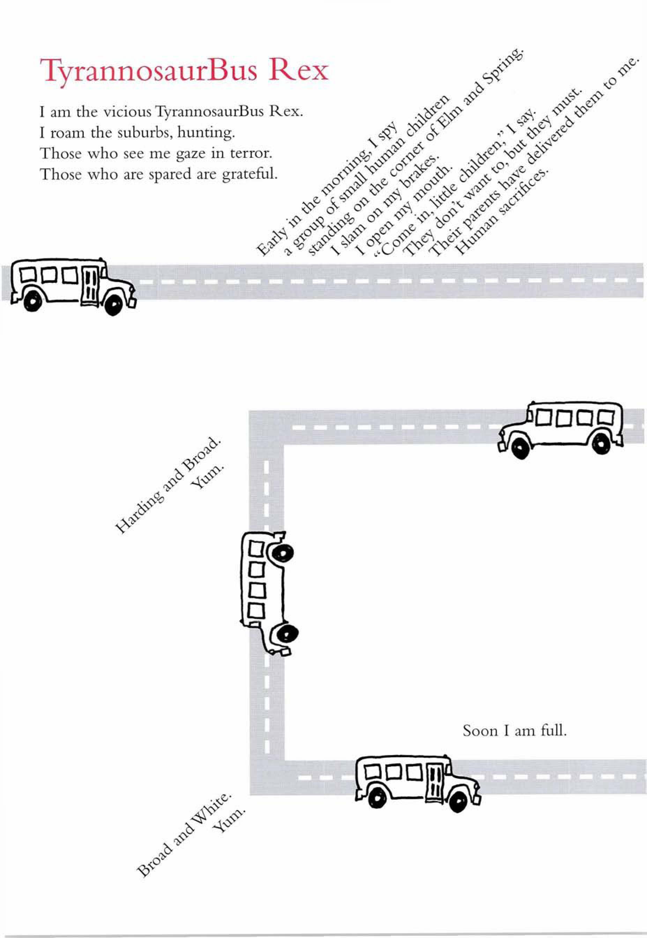
“TyrannosaurBus Rex”
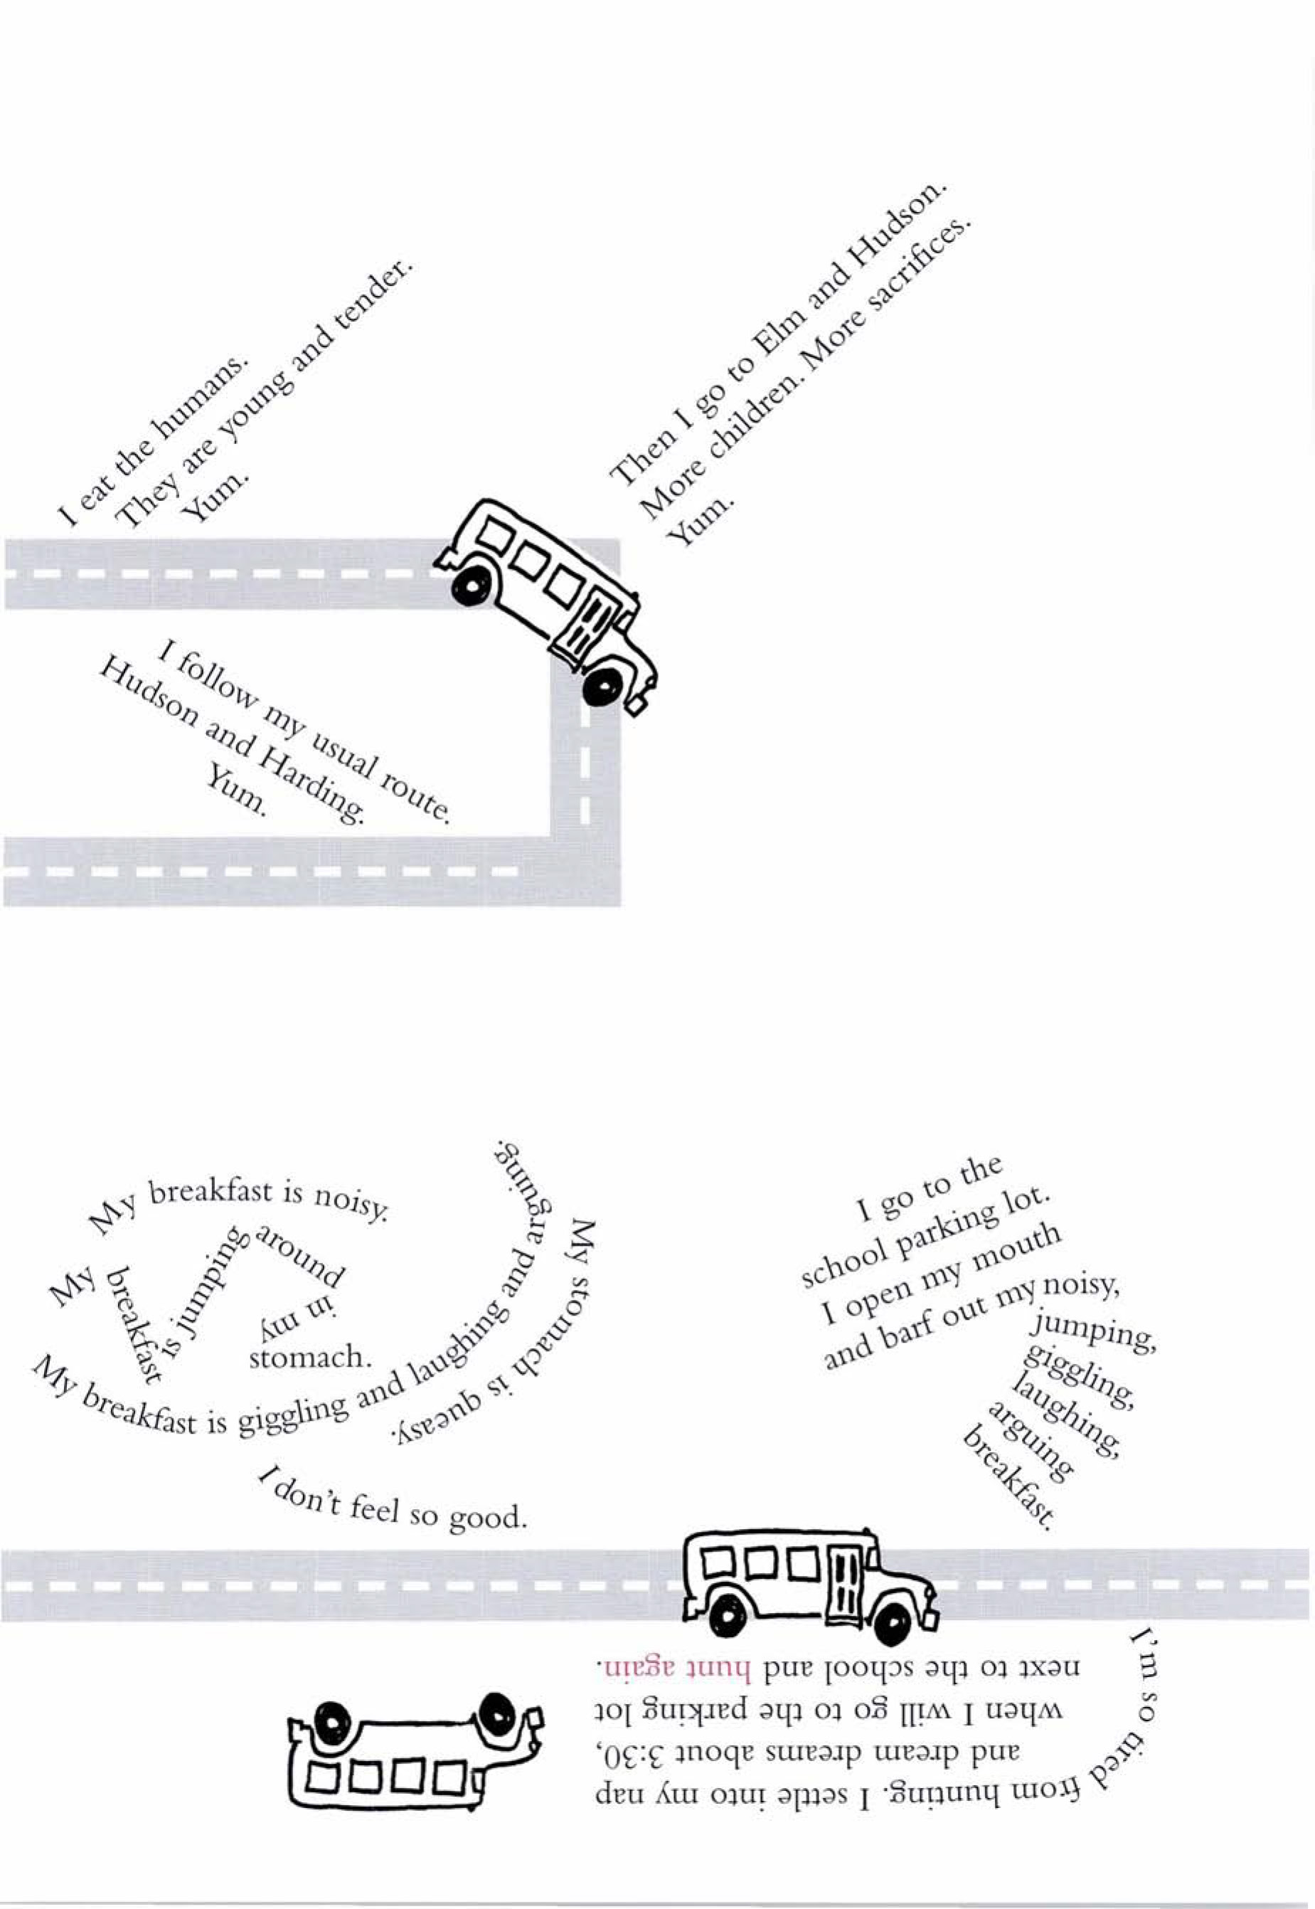
Grandits, John. Technically, It's Not My Fault: Concrete Poems. New York: Clarion, 2004. Print.
Modern Voices Graphic Organizer
“TyrannosaurBus Rex”

Name:
Date:

Theme or Challenge | Evidence from the Text | Inferences  (What this make me think)

Explain how you or the modern voices of today connect to this poem.

“Point A to Point B”
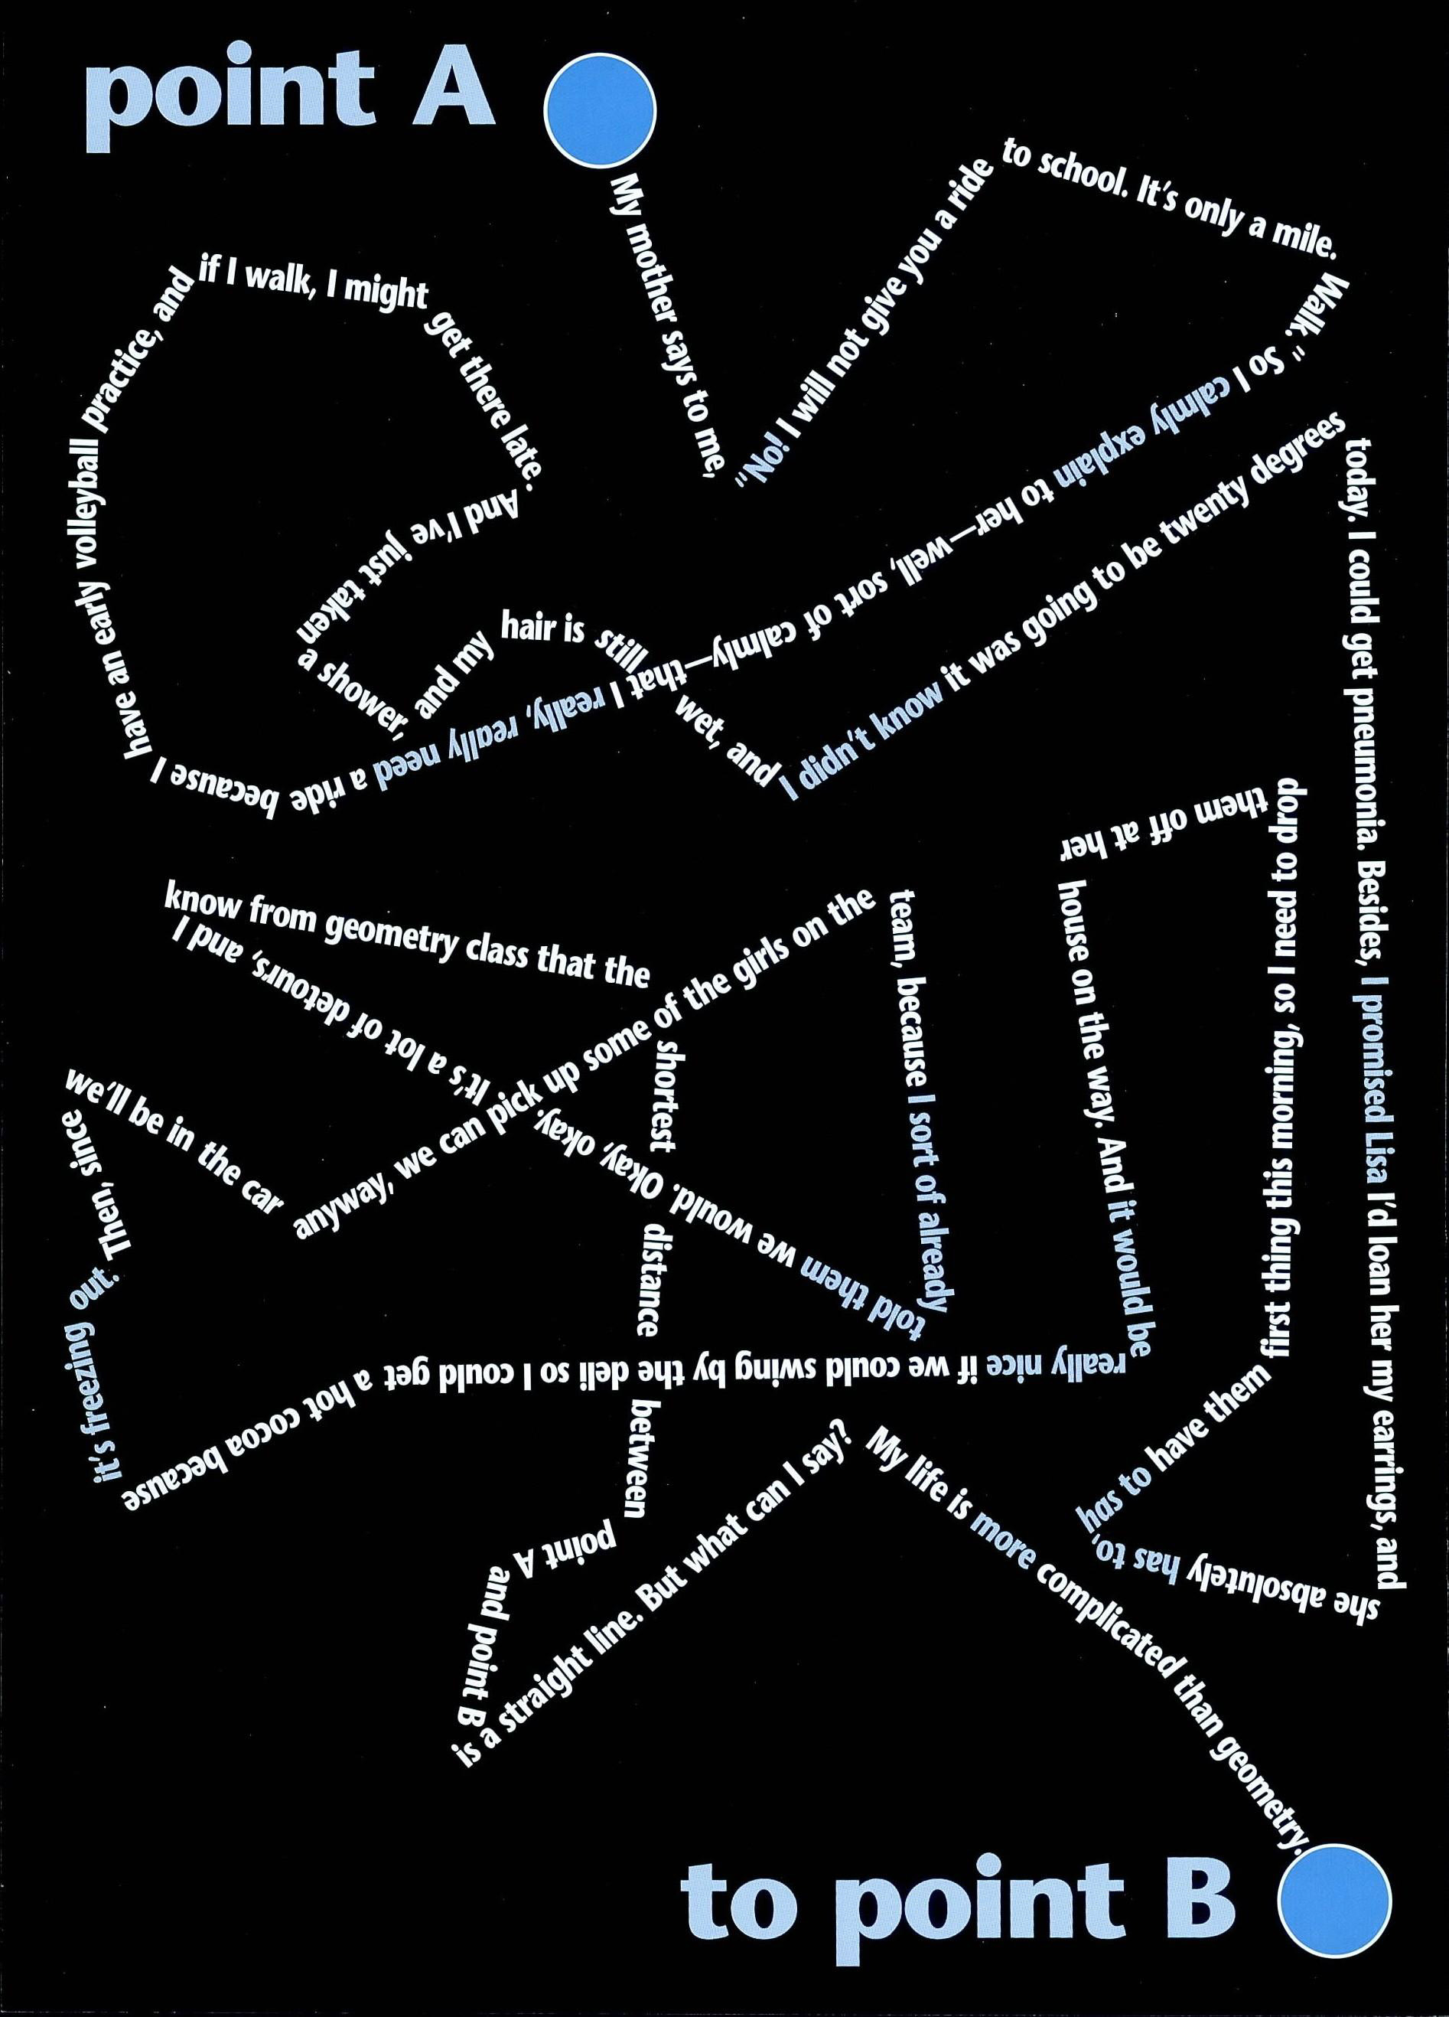
Concrete poems by John Grandits. Copyright © 2007 by John Grandits. Reprinted by permission of Clarion Books, an imprint of Houghton Mifflin Company. All rights reserved.
Modern Voices Graphic Organizer
“Point A to Point B”

Name:
Date:

Theme | Evidence from the Text | Inference  (What this makes me think)

Explain how you or the modern voices of today connect to this poem.

Speaking and Listening Criteria:
Discussion Tracker

Name:
Date:

Criteria | Stars | Steps
Paraphrases ideas and questions
Asks clarifying questions
Asks probing questions
Clearly explains own ideas
Responds to questions with details
Seeks out different peer perspectives and backgrounds
Acknowledges different peer perspectives and backgrounds
Respectfully compares own perspective with someone else’s

Notes/Comments
Star:
Next step:

Role-Play Script

Student 1: “I thought the message in the poem ‘TyrannosaurBus Rex’ was that riding the bus to and from school is routine, but it can be challenging.”

Teacher paraphrases a response to Student 1: “In other words, you’re saying that riding the bus isn’t easy for everybody.”

Student 2: “I thought the message was that when something is boring or routine, like the daily bus route, you use your imagination to make it more interesting.”

Teacher asks Student 2 a clarifying question: “Let me see if I understand. Are you saying that Robert, the narrator, was so bored he just imagined that the bus was a people-eating dinosaur?”

Student 3: “I really like how the words are arranged near the end of the poem when the dinosaur’s stomach was full or the bus was loaded with little children.”

Teacher asks Student 3 a probing question: “That’s interesting. Would you describe what you noticed?”

“Advanced English” Discussion Questions

What is the narrator’s problem?



What challenge does the narrator pose for herself, and why, in “Advanced English”?

What evidence helps explain how the narrator creates an opportunity to talk with Elton Simpson?

What do you notice about the graphics? How do they help convey the message of the poem “Advanced English”?

What does the narrator learn? How can this lesson help you identify a theme of the poem?

What does the dialogue show about Elton?

“My Sister Is Crazy”
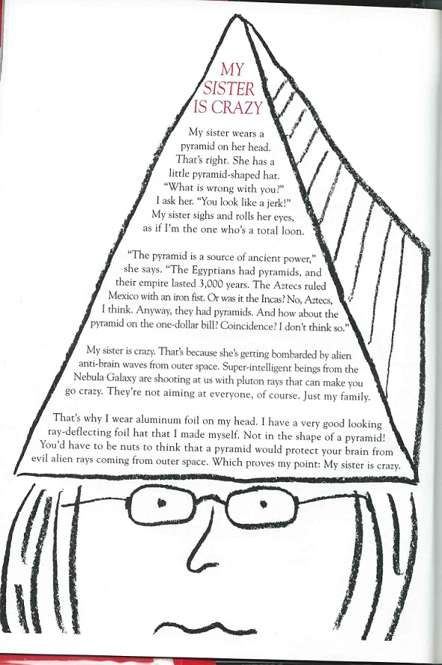
Concrete poems by John Grandits. Copyright © 2007 by John Grandits. Reprinted by permission of Clarion Books, an imprint of Houghton Mifflin Company. All rights reserved.

Modern Voices Graphic Organizer
“My Sister is Crazy”

Name:
Date:

Theme or Challenge | Evidence from the Text | Inferences  (What this make me think)

Explain how you or the modern voices of today connect to this poem.

