MODULE LESSONS
Grade 4: Module 1: Unit 3:
Lessons 8 & 9
End of Unit 3 Assessment: Reading a New Poem Aloud for Fluency
Language Arts Curriculum
Model Presentation with Images
W.4.2
Name: ____________________________________ Date: ___________________

He turns his head and pricks his ears to a sound that my ears can’t hear,
And suddenly he bolts, running like the wind!
A fiery red blur that I can barely focus my eyes on,
Legs reaching and stretching, spray clods of dirt like confetti at a wedding.
Black mane and tail streaming out behind him,
Flickering like dark flames licking at the air.
He stops suddenly, throwing his head high,
And flared nostrils snort the smoke of fire like a dragon in the crisp morning air.
My poem, “Breathing Fire,” is about my horse. I was inspired to write my poem about him because he means a lot to me and I spend a lot of time with him (show picture 1).

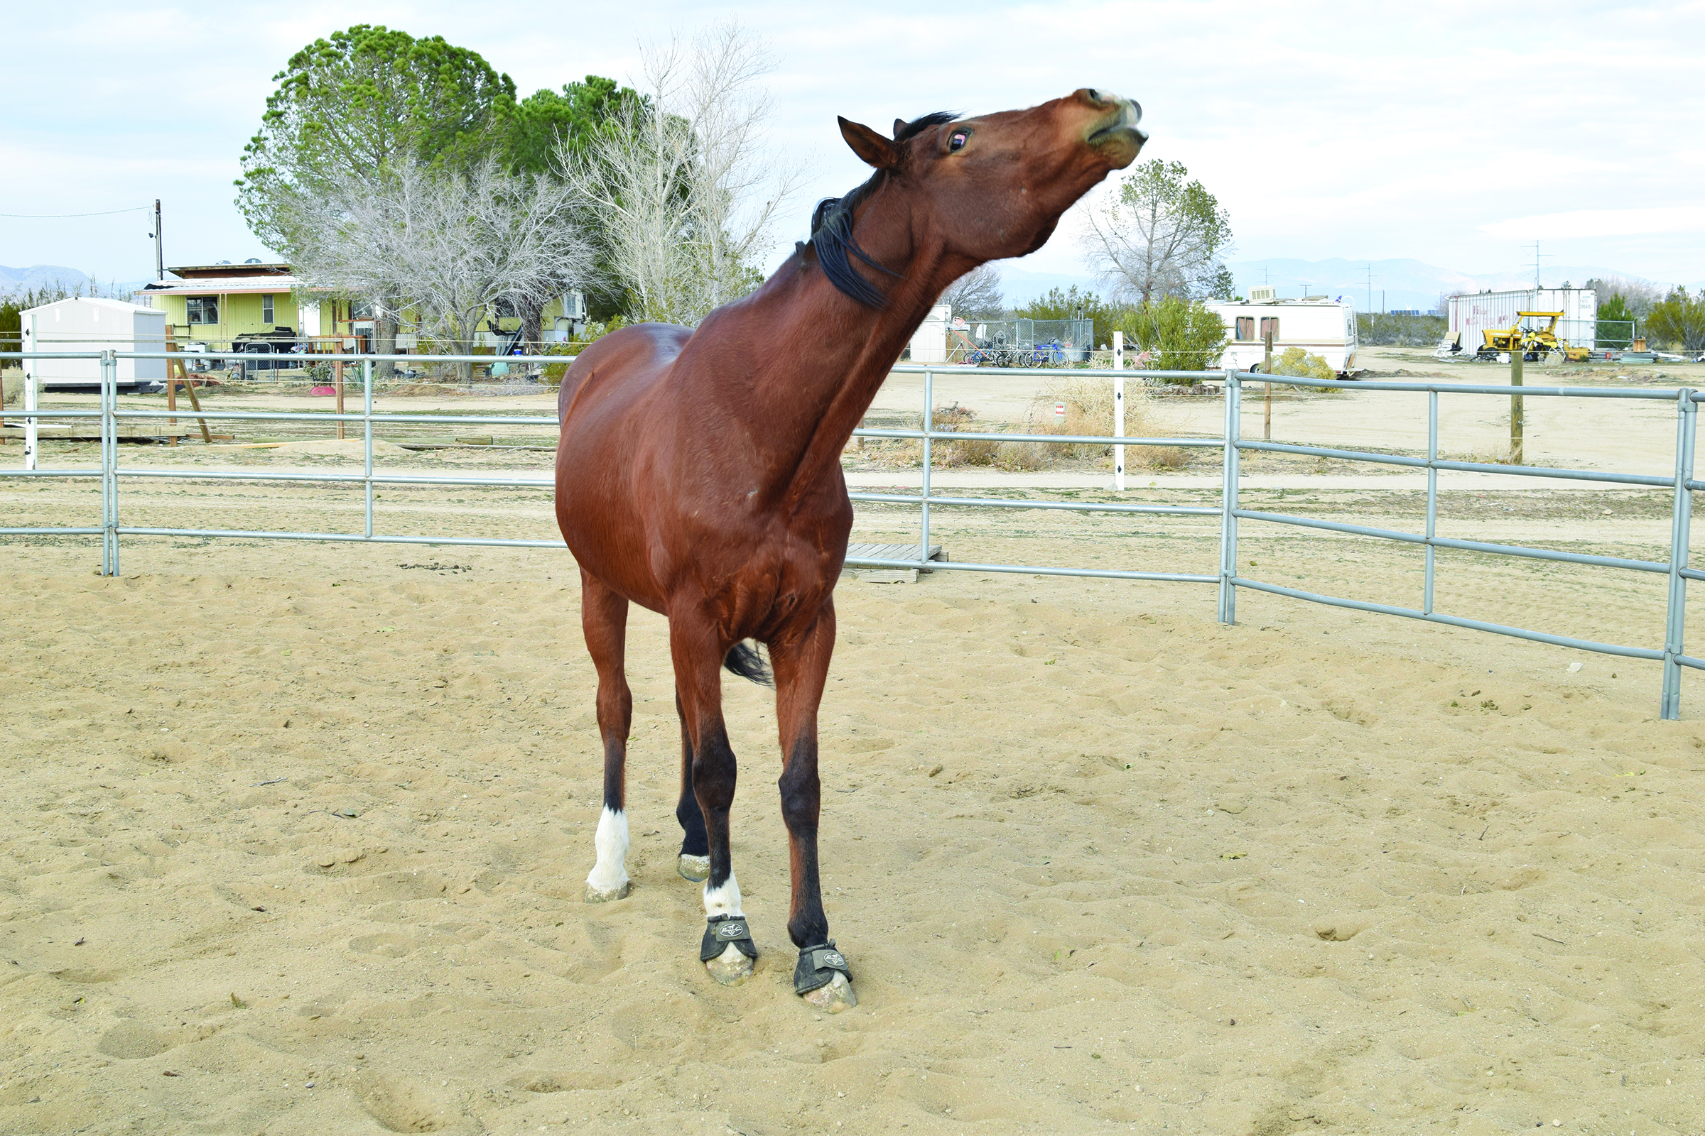
EL Education. For instructional use only.

This is a picture of him pulling silly faces. I particularly love to watch him run. When he runs I see a fiery, mythical creature, so I tried to convey this precisely through my word choice. This is a picture of him running (show picture 2).

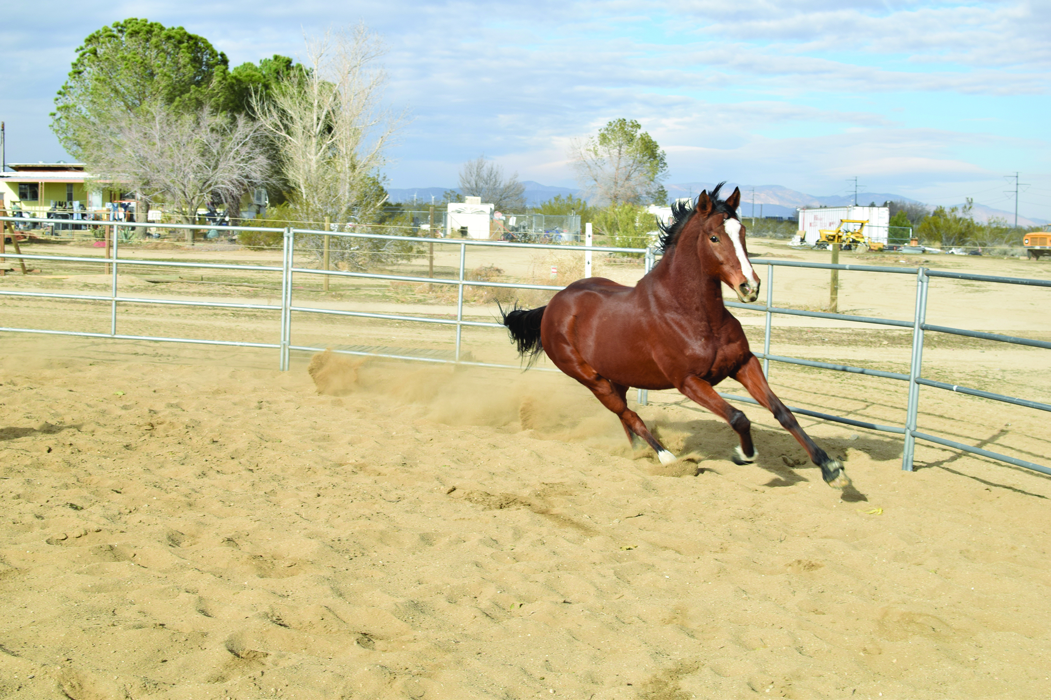
EL Education. For instructional use only.

As you can see from the picture, my horse’s coat is bright red, and in the morning sunlight it reminds me of the red glow of fire. In the line “A fiery red blur that I can barely focus my eyes on,” I used the words “fiery red” to describe this precisely. Also, you can see on the picture that he has a black mane and tail that stream out behind him when he runs. The way his hair moves in the wind makes me think of flames flickering, which is why I wrote, “Black mane and tail streaming behind him, Flickering like dark flames licking at the air.” I chose the word “licking” because the tips of his hair flutter like tongues licking at the air. Another thing that makes me think of a fiery, mythical creature is when he suddenly stops dead and throws his head high in the air. He snorts and breathes heavily from running fast reminding me of a dragon breathing fire, so I wrote, “Flared nostrils snort the smoke of fire like a dragon in the crisp morning air.” I chose to describe the “crisp morning air” because in the morning when it is particularly cold, breath in the air often looks like plumes of smoke in the air.

The words I have chosen in my poem were chosen to help you imagine my horse as the fiery, mythical creature that inspires me. I hope that it inspires you to see magical qualities next time you see a running horse.

Tracking Progress:
Reading Fluency
Name: ____________________________________ Date: ___________________
Learning Target: I can read aloud a new text fluently and accurately.

Standards I’m Tracking: RF.4.4

- How am I doing?
- For each criterion, self-assess by putting a check mark in the appropriate column.
- Strive to be honest with yourself. Remember, your ability grows with your effort, so it’s fine if you aren’t there yet!

You will receive feedback in a different colored pen on the checklist.
Standard | Characteristics of an Effective Summary | 4  Advanced | 3  Proficient | 2  Developing | 1  Beginning
*RF.4.4b,c | I can read all/almost all of the words correctly.
*RF.4.4c | I can correct myself and reread when what I read was wrong or didn’t make sense.
*RF.4.4a,b | I can read at a speed that is appropriate for the piece.
RF.4.4a,b | I can read smoothly without many breaks.

Standard | Characteristics of an Effective Collaborative Discussion | 4  Advanced | 3  Proficient | 2  Developing | 1  Beginning
RF.4.4a,b | I can read groups of related words and phrases together.
RF.4.4a,b | I can notice and read punctuation.  (Examples: Pauses after a comma and period, questions sound like questions, dialogue sounds like someone saying it, exclamations in an excited voice.)
RF.4.4b | I can use the appropriate tone to express the author’s meaning.
RF.4.4b | I can use facial expressions and body language to match the expression in my voice.
RF.4.4b | I can use the appropriate volume and change volume naturally as if I am talking to a friend.

- How have I improved since I last worked on this skill?

Teacher Response:

- How can I improve next time?

Teacher Response:

