Grade 7: Module 2A: Unit 3: Lesson 2
Researching: Asking the Right Questions

Researching:

Asking the Right Questions

Long-Term Targets Addressed (Based on ELA CCSS)
I can generate additional questions for further research. (W.7.7)
Supporting Learning Targets | Ongoing Assessment
- I can identify and understand the parts of the research process.  - I can determine the difference between an effective and ineffective research question. | - Researcher’s Notebook

Researching:

Asking the Right Questions

Agenda | Teaching Notes
- Opening  - Entry Task: Notice and Wonder (10 minutes)  - Work Time  - Introducing the Researcher’s Roadmap (15 minutes)  - Sorting Questions (15 minutes)  - Closing and Assessment  - Selecting a Model Research Question (5 minutes)  - Homework  - Continue reading in your independent reading book for this unit. | - This lesson introduces students to the research process and more specifically to the process of asking questions.  - There are several places where you can informally assess how well students can generate supporting research questions. As you listen to students work, keep a list of things the class as a whole is doing well and a list of what students struggle with. Let this guide your lesson planning for the reminder of this unit. Generating effective research questions can be challenging, so expect to provide a lot of support throughout these lessons, and especially note individual students who may benefit from additional targeted support.  - You will be showing students the model performance task in this lesson. As explained in the Unit 3 Overview (Preparation and Materials), you determine the format in which students publish their “brochures.” Ideally, students will publish them using technology, as this unit includes standard W.7.6. Once you have selected a format for publishing that makes sense for your situation, develop a model performance task in that format to share with students. Included with this lesson is the text for a model brochure—you can adapt it to any format you choose to use. Creating a model in the format students will use will allow them to see exemplar work and help you guide them effectively as they create their own.  - In the entry task, students need to see two images of modern garment factories: one with poor working conditions and the other with good working conditions. Find these images in advance; An internet search will yield many options.  - In advance: Set up the activity for Work Time Part A. The goal of the activity is for the class to come to a common understanding of the research process:  - Decide where and how you will plant the seven Research Process cards. Taping them to the underside of students’ desks or chairs can add some excitement to this activity. Consider giving them to students who are reluctant but able to participate in discussion.  - Post and review the Researcher’s Roadmap anchor chart, as well as the Research Process cards. Be ready to lead a class conversation about how the cards relate to the Researcher’s Roadmap.  - Also in advance, cut up the sample supporting research question strips.

Researching:

Asking the Right Questions

Lesson Vocabulary | Materials
effective, ineffective, reliable, generate, relevant, evaluate, synthesize, specific, answerable | - Entry Task (one per student)  - Two images to display for Entry Task (found in advance by teacher; see Teaching Notes)  - Researcher’s Roadmap anchor chart (new; teacher-created; see sample in supporting materials; also distribute one per student)  - Performance Task prompt (one per student)  - Document camera  - Model Performance Task: “iCare about the iPhone” (one to display; alternatively, create your own electronic version of this model; see Teaching Notes above)  - Research Process cards (one set of seven cards per class; either taped under students’ chairs or handed out in the beginning of class)  - Sample supporting research question strips (one set per trio of students)

Researching:

Asking the Right Questions

Opening | Meeting Students’ Needs
A. Entry Task: Notice and Wonder (10 minutes)
- Project or distribute the Entry Task, including the two images of modern garment factories. Invite students to look closely at each image and then write down what they notice and what they wonder.
- Give students a few quiet minutes and then “popcorn” out some of their answers.
- Remind students of their discussion from the previous lesson around fair working conditions. Ask one or two students to sum up what they took away from the class discussion yesterday and how their discussion relates to these two pictures.
- Tell students that effective research begins by asking a question. After looking at these two images, what is a question they have that would be a good research question? Listen for students to say something like: “What is the range of working conditions in the garment industry?” This is a good chance to informally assess where students are in terms of W.7.7. Tell them they will talk more about effective research questions later in the lesson.
- Ask a student to read the learning targets for today. Define what effective means (successful, does what it is supposed to do). Remind students that the prefix “-in” means “not,” as in ineffective—or “inept,” “insane,” or “insufficient.”

Researching:

Asking the Right Questions

Work Time | Meeting Students’ Needs
A. Introducing the Researcher’s Roadmap (15 minutes)  - Post and distribute the Researcher’s Roadmap anchor chart. Tell students that in this unit they will be conducting a short research project and then synthesizing their findings to craft their performance task. Remind them that their focus will be on the modern-day garment industry.  - Define any terms that may be unfamiliar. Consider defining reliable, generate, relevant, evaluate, and synthesize.  - Explain that in order to help them understand what they will do in this unit, today you are going to share your own final product, retrace the steps you took to produce the final performance task, and explain how you used the Researcher’s Roadmap to get there.  - Display the Performance Task prompt using a document camera. Read the prompt aloud and explain to students that, through their research, they are learning enough about working conditions to create a publishable brochure. If you have made an electronic version of the model performance task, project it now (see Unit 3 Overview, Preparation and Materials). If not, project the simple copy of “iCare about the iPhone” from the supplementary materials attached to this lesson.  - Give students a few minutes to read briefly over this work, then ask:  - “Who can explain how this relates to working conditions?”  - When most students have their hands up, call on one student to explain. Then ask:  - “How does this relate to our conversation yesterday about fair working conditions in developing and developed countries?”  - When most students have their hands up, call on another student to explain.  - The model began with: Direct students’ attention back to the Researcher’s Roadmap. Tell them that all good research begins with a question. Your model began with:  - “What are the working conditions like in the electronics industry?”  - Point out that you have planted seven Research Process cards in the classroom. Ask whoever has the overarching research question card to read it aloud. Ask the student to come up and place it where it belongs on the Researcher’s Roadmap anchor chart. Explain that you have distributed six other cards that illustrate each step on the Roadmap with an example from your process. | - To support English language learners, consider posting the definitions of vocabulary relevant to research for the duration of this unit.  - Making sure that students explicitly understand the research process will help them understand the purpose for research, as well as preview the kinds of work they will be doing.
Researching:

Asking the Right Questions

Work Time (continued) | Meeting Students’ Needs
- Ask students to look under their chairs to see if they have a card. If they do, they should read their cards. Ask students with cards to turn and talk with a student near them to decide which step on the Researcher’s Roadmap they have.
- Ask for a volunteer who thinks she or he has Step 1. Listen for this card:
- “I wanted to find a basic overview of the process of making electronics before I began thinking about working conditions.”
- Point out that this is Step 1 on the Roadmap, and ask the student to come and place it on the Roadmap.
- Explain that two students have Step 2. Ask for someone to volunteer. Listen first for this card:
  - “The first Web site I went to was called Investopedia …”
- Interject to point out the site out on the “works cited” section of the model. Ask the student to continue reading the card:
  - “… I decided that it was a credible site, and I skimmed it to find some information. From there, I found out that many of our electronic products were made by a company called Foxconn in China and, in fact, they make the iPhones. So I now had a more specific question: What is it like to work in a Foxconn factory?”
- Point out that this is Step 2 on the Roadmap but also a little of Step 3 because you are also beginning to gather credible sources. Explain that “credible” means you can trust the information that a source has. To decide that, you have to think about who the author is and the purpose of the source. For this one, you decided that the author of the source was an expert on the topic and that the purpose of the Web site is to help educate people. So, it is a credible site.
- Ask for a volunteer who thinks she or he has the other Step 2 card. Listen for:
  - “I also decided that ‘electronic’ was very broad, so I narrowed it down to making iPhones because I was very interested in that and I thought it would be a good case study—a detailed example that has been studied a lot and can help me infer about the larger subject of electronics.”
- Point out that narrowing your focus and getting more specific is part of Step 2.
- Ask for a volunteer who thinks she or he has Step 3. Listen for this card:
  - “Then I began to search some more. On the first Web site, the author talked about a report on a TV show on ABC called Nightline. I decided a national TV show whose purpose is to thoroughly inform their audience about a topic would be a credible source, so I went there first.”

Researching:

Asking the Right Questions

Work Time (continued) | Meeting Students’ Needs
- Point out that finding credible sources is Step 3 on the Roadmap.
- Ask for a volunteer who thinks she or he has Step 4. Listen for this card:
  - “I skimmed through the slide show based on the TV report and found some of the information I was looking for. I didn’t watch the whole TV show because I was just skimming.”
- Point out that this is Step 4 on the Roadmap and that in researching, you don’t read every part of the source closely.
- Ask for a volunteer who thinks she or he has Step 5. Listen for the last card to say this:
  - “Then I stopped and reassessed …”
- Interject to point out that this is Step 5 on the Roadmap; ask the student to continue reading:
  - “… I had lots of negative information. But that gave me more questions: Was there anything positive about working in these factories? Why are people working there? Has Foxconn changed anything since these reports came out?”
- Point out that after step 5, researchers usually loop back to step 2 and repeat the process.
- Tell students that you continued to repeat this process until you had enough information to publish your findings and move on to Step 6 on the Roadmap.
B. Sorting Questions (15 minutes)  - Emphasize the importance of asking good research questions. Remind students of the learning targets for today and say: “In this unit, we are going to focus on this portion of the research process. If you can work hard and learn how to generate good supporting research questions, you will have a strong foundation when you conduct a larger research project at the end of year ( Module 4).” Express your confidence in their ability to learn this skill.  - Arrange students in triads. Distribute the sample supporting research question strips. Tell students they will be sorting the questions into two piles. Remind them that you are working with the model today: “Tomorrow you will generate questions about the garment industry, but today we are looking at an example from the electronics industry.” | - Use of protocols (like Four Corners) allows for total participation of students. It encourages critical thinking, collaboration, and social construction of knowledge. It also helps students practice their speaking and listening skills.

Researching:

Asking the Right Questions

Work Time (continued) | Meeting Students’ Needs
- Tell students they will read each question and decide if it is an effective or ineffective supporting research question to research. Explain that an effective supporting research question is answerable and relevant; ineffective questions are not. For instance, “Do children work in any iPhone factories?” is an effective supporting research question because it has to do with working conditions in factories that make iPhones and it is answerable. On the other hand, “Will the working conditions in China ever improve?” is not an effective research question. Even though it is about working conditions in China, it is not answerable with current information—you can only guess the answer.
- Direct students to read the questions aloud, discuss with their partners, and then put them in the appropriate pile.
- Circulate to informally assess how well students can determine whether a question is effective or ineffective. For students who are having trouble, probe with questions like:
  - “Do you think you will be able to find an answer to this question?”
  - “What does this question have to do with working conditions?”
  - Do this question lead to a yes or no answer, or will you find more information?”
- After they have had time to sort, direct the students to make a list of the qualities they think make an effective research question.
- Create a class list of criteria for effective research questions that the students add to their copies of the Researcher’s Roadmap and that you add to the class Researcher’s Roadmap anchor chart. Direct the conversation to include the words relevant, specific, and answerable. Define as needed.
- Invite students to re-examine their piles and make any changes. Invite each group to share three or four from each pile.

Researching:

Asking the Right Questions

Closing and Assessment | Meeting Students’ Needs
A. Selecting a Model Research Question (5 minutes)
- Ask students to choose an exemplar question from their “good questions” pile and write it in Part II of their Researcher’s Notebook. This will be a model for them.
Homework | Meeting Students’ Needs
A. Continue reading in your independent reading book for this unit.

Grade 7: Module 2A: Unit 3: Lesson 2
Supporting Materials

Entry Task

Name:
Date:

Directions: Please look carefully at the two images. Then write your responses on the chart below.

I notice… | I wonder…

Researcher’s Roadmap Anchor Chart

Good researchers stop often to look around and see where they are, check their maps, and set their course toward their final destination. They sometimes take side trips, but they use their route-finding tools to reach their destinations.
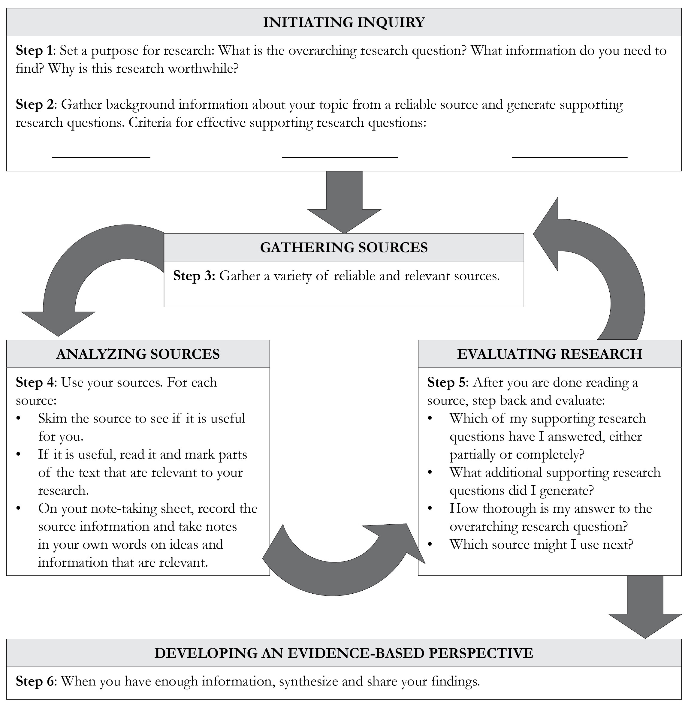

Performance Task Prompt

Overview
Throughout this module, we have explored working conditions. We read Lyddie to glimpse the factories of the past and understand the challenges faced by workers. We studied César Chávez’s speech to contemplate how individuals and groups affect working conditions. Now we are going to explore the working conditions of today and think about how you, a teenage consumer, influence working conditions around the world.

Prompt
You want to be an informed consumer, so you’ve decided to research some of the working conditions going on, right now, for the clothes you wear every day. Then you want to share this information with your peers so other teenagers can be informed consumers as well. Working conditions in the garment industry vary, and you want to remind your peers that the way they spend their dollars matters.

Preparation: Research (individually)
Conduct a short research project and complete a Researcher’s Notebook. In your notebook you will gather information, generate questions, and summarize your findings in a well-written paragraph in which you acknowledge the source and synthesize your sources. The Researcher’s Notebook will be the End of Unit 3 Assessment and will include:
Setting a Purpose for Research
Research notes
Synthesizing findings
Suggestions for Further Study as second to last item in list
Plan of action

Performance Task: Publish (with a partner)
With a partner, you will create Threads: A Young Person’s Guide to Buying Clothes. This is a publishable brochure written for your peers, which will share your research findings with them. The brochure will include:
Overview
Working conditions in the garment industry
Advice to consumers

Below are key criteria students need to address when completing this task. Specific lessons during the module build in opportunities for students to understand the criteria, offer additional criteria, and work with their teacher to construct a rubric on which their work will be critiqued and formally assessed. .

Performance Task Prompt

Key Criteria for Success (aligned with ELA CCSS)

Brochure will demonstrate:
- Clear informational writing, appropriate to audience and task
- Coherent synthesis of current issues related to working conditions in the garment industry, drawing on evidence from research and reflecting both problems and solutions
- Mastery of conventions
- Use of technology to share ideas

Model Performance Task:
iCare about the iPhone

Overarching research question: What are the working conditions like in the electronics industry?

Get the Big Picture
Look in your pocket. Do you have an iPhone? Want to know how that’s made? Apple doesn’t make its iPhones. Foxconn does. Foxconn is a huge company in China that employs thousands of people.

Did You Know?
- Foxconn workers sometimes work more than 90 hours a week. That’s twice as long as the time you spend in school.
- Foxconn workers get paid $1.78 an hour—that means less than 10% of the money you pay for an iPhone goes to the person who helped make it.
- Foxconn provides apartments for its workers but they have to sleep with many other workers in each room.
- Factory working is hard. Workers stand for long hours and work with dangerous chemicals. There have been some employee suicides that some people believe are due to the repetitive, isolating work.
- Working conditions are improving. Recently Foxconn stopped letting workers log in so much overtime, but didn’t give them a cut in pay.
- Foxconn workers are thankful for a job and want to earn more money.

Want to Do Something? Do This!
The truth is, Apple isn’t the only company that uses Foxconn products. Many major brands do. If you stopped buying iPhones, the workers wouldn’t even have a job. So don’t stop buying, but do start pressuring. Find out more. Write a letter to Apple saying that you care about how iPhones are made. Your voice matters.

Works Cited
Duhigg, Charles and David Barboza. “In China, Human Costs Are Built into an iPad.” The New York Times. Web. 25 January 2012.

Independent Investigation of Apple Supplier, Foxconn Report Highlights. Rep. N.p.: Fair Labor Organization, March 2012. Web. <http://www.fairlabor.org/sites/default/files/documents/reports/foxconn_investigation_report.pdf>.

Smith, Catharine. “Foxconn Working Conditions 2012: Company Cuts Hours, Employees Ask Why.” The Huffington Post. TheHuffingtonPost.com, 30 Mar. 2012. Web. 06 May 2013.

“The Cost of Making an iPhone” Investopedia, Web. 4 September 2012.

Weir, Bill. “Apple’s Chinese Factories: Exclusive.” ABC News. ABC News Network, 21 Feb. 2012. Web. 06 May 2013.

Model Performance Task:
iCare about the iPhone

Overarching research question: What are the working conditions like in the electronics industry?
I wanted to find a basic overview of the process of making electronics before I began thinking about working conditions.

The first Web site I went to was called Investopedia. I decided that it was a credible site, and I skimmed it to find some information. From there, I found out that many of our electronic products were made by a company called Foxconn in China and, in fact, they make the iPhones. So I now had a more specific question: What is it like to work in a Foxconn factory?

I also decided that “electronic” was very broad, so I narrowed it down to making iPhones because I was very interested in that and I thought it would be a good case study—a detailed example that has been studied a lot and can help me infer about the larger subject of electronics.

Then I began to search some more. On the first Web site, the author talked about a report on a TV show on ABC called Nightline. I decided a national TV show would be a credible source, so I went there first.

I skimmed through the slide show based on the TV report and found some of the information I was looking for. I didn’t watch the whole TV show because I was just skimming.

Then I stopped and reassessed. I had lots of negative information. But that gave me more questions: Was there anything positive about working in these factories? Why are people working there? Has Foxconn changed anything since these reports came out?

Sample Supporting Research Question Slips

Effective | Ineffective
Who makes the iPhone in China? | Who designed the iPhone?
Does more than one company make the iPhone? | Why are iPhones so popular?
How many hours does the average factory employee work each week? | Will the working conditions in China ever improve?
What is a “living wage” in China? Does the iPhone factory pay a living wage? | Do the workers in the iPhone factories get to eat candy bars?
What do the iPhone factory workers say about their jobs? | Do the workers in the iPhone factories speak Chinese or something else?
Who monitors the working conditions in the iPhone factories? | What are the parts of an iPhone?
Has Apple done anything recently to improve the working conditions in the iPhone factories? | Who makes an Xbox?
Do children work in any iPhone factories? | What time do the iPhone factory workers get to eat lunch?
Can iPhone factory workers form unions? | What are some popular apps I can get for the iPhone?
How much does it cost to make an iPhone? How much of that cost is labor? | What can an iPhone do that’s different from a regular phone?
 | How much does an iPhone weigh?

