Grade 7: Module 1: Unit 1: Lesson 1
Reading the Map and Beginning Chapter 1

Long-Term Targets Addressed (Based on ELA CCSS)
I can determine the central ideas of a literary text. (RL.7.2)
I can effectively engage in discussions with diverse partners about seventh-grade topics, texts, and issues. (SL.7.1)
Supporting Learning Targets | Ongoing Assessment
- I can effectively participate in discussion with my classmates.  - I can determine the meaning of visual representations on a map.  - I can read for gist as we begin Chapter 1 in A Long Walk to Water. | - I Notice/I Wonder note-catcher  - Reader’s Notes

Agenda | Teaching Notes
- Opening  - Engaging the Reader Part I: Scenarios (10 minutes)  - Introducing Learning Targets (10 minutes)  - Work Time  - Engaging the Reader Part II: Reading the Map (10 minutes)  - Reading First Section of Chapter 1: Getting the Gist in Reader’s Notes (10 minutes)  - Closing and Assessment  - Debrief: Revisiting Learning Targets and Creating Partner Discussion Criteria (5 minutes)  - Homework | - This first lesson is designed to engage students’ curiosity about the topic of the module. During the lesson, students will uncover clues to the topic and infer about what they will be learning. At the start of the lesson, do NOT reveal to students that they will be studying South Sudan or the Second Sudanese Civil War. If students ask for more details, it’s a perfect time to say: “Let’s find out!” (The mystery is built up on purpose. But it is not a big problem if, for some reason, you had already announced in advance the topic of this upcoming module. If so, reframe the early parts of this lesson to “I wonder what this setting was like?”).  - During this lesson students will begin to get a sense of setting before starting the novel. Students discuss two scenarios (see supporting materials) and then examine the map on the inside cover of the novel. This inquiry-based approach helps to create a “need to know” for students about the characters in the novel and the route indicated on the map. In Lesson 2, students will read the rest of Chapter 1 (about Salva) and will be able to confirm some of their ideas about the map and characters. The scenarios are based on the basic background information provided on the back jacket of the novel.  - Read through the lesson carefully for several key reminders about when NOT to give the mystery away, and when to refocus students on specific details in the text (including the map).

Agenda | Teaching Notes
- Time is spent deconstructing the learning targets with students at the beginning of this lesson. This gives students a clear vision for what learning will focus on for each lesson. This research-based strategy supports struggling learners most. Using learning targets also helps teach academic vocabulary.
- This lesson introduces the structure for discussions that will carry students through the module using the Think-Pair-Share and cold call protocols. Build on existing norms and routines for collaborative work in your classroom. The focus on effective collaboration ties directly to SL.6.1. Discussion is a vital support as students work with text throughout the modules.
- This lesson introduces a simple routine of reading a text to “get the gist,” which students will record in their Reader’s Notes. “Gist” is simply one’s initial sense of what a text is mostly about: it is a low stakes first “toe hold” into making sense of a text, preceding and less formal than identifying main idea. Getting the gist is particularly useful when grappling with complex text. Yet even though A Long Walk to Water is not highly complex for 7th graders, it is useful to practice this skill. Students will practice together to “get the gist” in the first few lessons with explicit teacher feedback. This lays a strong foundation for students to build their close reading skills. In subsequent lessons, and with more difficult texts, students will build on this understanding of the gist of a reading in order to help them pay close attention to the text and ask or answer questions that might assist in deepening their understanding. Accelerate if appropriate, but be sure students know how to get the gist.
- The Reader’s Notes serve as the note-catcher for students’ record of the story. Students will add notes to this document as they read each chapter, and they will refer to their Reader’s Notes for a Literary Analysis at the end of Unit 2 and a Two-Voice Poem at the end of the module. The Reader’s Notes regularly serve as an Opening task for subsequent lessons in which students discuss their understanding of the gist of the reading in partnered pairs, share with the class, and receive feedback from the teacher to ensure that all students succeed in making meaning of the text.
- Note that in many lessons, the teacher reads a portion of the text aloud. During these read-alouds, students are expected to be looking at the text and actively reading in their heads. The teacher reads aloud slowly, fluently, without interruption or explanation. This read-aloud process, when done in this fashion, promotes fluency for students: they are hearing a strong reader read the text aloud with accuracy and expression, and are simultaneously looking at and thinking about the words on the page.
- In advance: Review the map on the front title pages of the novel.

Agenda | Teaching Notes
- In advance: Create two sets of pairs that will work together to read, think, talk, and write about A Long Walk to Water and other texts during this unit: one set for “A Days” and one set for “B Days”. Use intentional groupings that complement existing seating charts. Heterogeneous groups support students in discussing texts and answering questions about text.
- In advance: Prepare seating charts arranged for “A-Day” and “B-Day” partnerships (see Unit 1 overview, Preparation and Materials, for details on this structure). For Lessons 1–3, students will be in their “A-Day” partnerships.
- Post the learning targets where all students can see them.
- Review the Fist to Five checking for understanding technique (see Appendix).

Lesson Vocabulary | Materials
scenario, determine, representation, central ideas, literary text; plains, route (front map on title pages), cradle (v) (1) | - Discussion Scenarios (numbers 1 and 2 for each pair of students)  - Fist to Five chart (for Teacher Reference)  - A Long Walk to Water (book; one per student)  - Document camera  - I Notice/I Wonder note-catcher (one per student; one to project)  - Reader’s Notes (one per student; one to project)  - Partner Talk Expectations anchor chart (new; teacher-created; see Work Time A)  - Examples of Nonlinguistic Representations of Learning Target Vocabulary (for Teacher Reference)  - Examples of sentence starters for think-pair-share (for Teacher Reference)

Opening | Meeting Students’ Needs
A. Engaging the Reader Part I: Scenarios (10 minutes)  Note: assumed seating chart with students arranged in partner pairs—consider this day’s seating chart to be an “A Day” (see Teacher Notes above).  - Tell students that today they will begin a long-term study of a topic. Let them know that much of the important work they will be doing—reading, thinking, and writing—will be done in partners. They will have one partner on certain days, and a different partner on other days (if there is an uneven number of students, a triad is fine).  - Explain that before you introduce the topic of study, you would like students to think and talk about a few scenarios (or situations). In order to do this, they must be able to “effectively participate in discussions” with their partners.  - Post the first learning target, “I can effectively participate in discussion with my classmates.” Explain to students that this is one of their learning targets for the day. If students are unfamiliar with learning targets, explain their purpose briefly: learning targets will help them to know what they are expected to learn. Tell them that each time a learning target is introduced, it will be discussed by the class so that its meaning is clear.  - Invite students to turn to the partner next to whom they are sitting. This will be their “A-Day” partner. Ask students to make sure that the partners know each other’s names. Ask them to briefly discuss “what it means to ‘effectively participate in a discussion.’” Ask a few partners to share out their thinking. Tell students that you would like them to continue to think about what this target means throughout the lesson. They will revisit the target at the end of this lesson to reflect on their progress and set goals for future discussions  - Distribute the Discussion Scenarios to each pair of students: give one partner Scenario #1 and the other partner Scenario #2.  - Tell students that these scenarios will give them a chance to think about how people are affected by various factors in their lives. Tell them that this is an idea they will dig into more deeply during their study over the coming weeks.  Note: Do NOT yet reveal the topic of the module. This will allow students to become engaged with the topic and generate curiosity as they begin to read the novel. | - Consider providing nonlinguistic symbols (e.g., two people talking for discuss, a pen for record, a magnifying glass for details, a light bulb for main idea) to assist ELLs in making connections with vocabulary. These symbols can be used throughout the year. Specifically, these can be used in directions and learning targets. Examples of possible nonlinguistic symbols for this lesson can be found at the end of this lesson.

Opening Continued | Meeting Students’ Needs
B. Introducing Learning Targets (10 minutes)  - Tell students that now you will give them a bit more information about the topic they will study. Post the learning targets for students: “I can determine the meaning of visual representations on a map.” “I can read for gist as we begin Chapter 1 in A Long Walk to Water.”  - Explain to them that they will often determine the meaning of learning targets by circling key words and discussing the meaning of the targets with a partner. Then they will share out their thinking and clarify the meaning of the targets with the entire class.  - Guide students through this process with the second learning target:  - Circle the words determine and representations and explain that these words are important for understanding the learning target. Tell students that they are also likely to encounter these words in future reading.  - Ask students to turn to a partner and discuss the meanings of the words determine and representations.  - Have partners share out their thinking on the meanings of both of these words.  - Then clarify the meanings of these words. For example, tell students that the word determine means to decide after study. Tell them that the word representations is made up of the root word present, meaning “to show or symbolize,” and its affixes (beginning and endings) re- and -tion. Explain that adding these affixes changes the meaning of the word present with re- meaning “again” (like repeat) and -tion meaning “the act of doing something.” Explain that when these parts of the word are put together, re-presenta-tion, the word means the act of showing or symbolizing something again, in this case with visuals or pictures on a map.  - Have students turn to a partner and explain what they think the learning target means now. Have a few pairs share.  - Annotate the learning targets to help students clarify the meaning of the target. For example, you can write the meanings of the words determine and representations above these words in the target.  - Use a similar process to help students clarify their understanding of the last learning target.  - Ask a student volunteer to read aloud the learning target, “I can determine the meaning of visual representations on a map.” Prompt all students to raise their hands to represent how they feel about their ability to meet this learning target right now, using the Fist to Five checking for understanding technique. Refer students to the Fist to Five chart to cue their hand raising. This self-assessment helps students to rate themselves on a continuum from 0 (fist), meaning far from the target, to five (five fingers), having solidly met the target. | - Post a chart indicating the meaning of the different options of the Fist to Five checking for understanding technique.. An example can be found at the end of this lesson.
Opening Continued | Meeting Students’ Needs
- Describe to the students any patterns that you notice in this early self-assessment. (Ex. “I see that a number of students are
holding up 4s or 5s. Great! Many of you are confident in your ability to make meaning of a map. This will be a great help to us.” “I wonder if those of you who have held up 2s or 3s are unsure about what you’ll see on the map.”)

Work Time | Meeting Students’ Needs
A. Engaging the Reader Part II: Reading the Map (10 minutes)  - Distribute the I Notice/I Wonder Note-catcher to each student and project it on a document camera (or make a chart of it on chart paper or on your board).  - Model Notice and Wonder for students:  - I Notice: Simply observing something (i.e., “I notice the walls in our classroom are white.”)  - I Wonder: Questioning the meaning, history, or purpose of what they see (i.e., “I wonder why classrooms never seem to be painted different colors.”)  - Distribute the novel A Long Walk to Water. Tell all students to open the book to the image of the map on the front title pages.  - Ask students to think, then talk with a partner, about something they “notice” and something they “wonder.” Encourage students to generate some “wonder” questions that connect the map back to the scenarios they read and discussed earlier (e.g., “I wonder if this is where the characters are traveling?). Be sure to give think time, and then just a minute for them to talk with a partner.  - Then cold call a few students to share out. Do NOT explain the map at this point; simply elicit students’ comments.  - Chart students’ comments on the projected I Notice/I Wonder note-catcher. If students need more guidance, model one of a “notice” and “wonder” about the map.  - Again ask students to Think-Pair-Share. Students should add any new notices or wonders from their partners to their note-catcher. Cold call students again, and add to your projected Notice/Wonder chart.  - Without explaining the significance, be sure that students have noticed that there is a dotted line on the map and that there are different environments on the map that are indicated on the map key. If students need more guidance, invite them to describe the different environments that the dotted line crosses.  - Do not give away whose journey this is. But do focus students on two aspects of the map. First, the visual key. Ask students,  - “What are plains?”  - Guide students to find the visual code for plains: the lines with bits of grass poking up. Tell them that as they begin reading, they will learn more about the physical environment the main characters in the novel are in.  - Second, focus students on the dotted line connecting Loun-Ariik and Kakuma. Simply ask:“What do these dots and lines represent? | - Modeling provides a clear vision of the expectation for students. For example: “I see a dotted line that matches the key listing for Salva’s Route.” “I wonder who Salva is.”  - For students needing additional supports, consider providing additional support with a more scaffolded I Notice/I Wonder graphic organizer. An example can be found at the end of this lesson.  - Varying the methods of response for students makes the task accessible for all students. Because this task uses a visual map, offer students a choice to draw the things they notice instead of writing.  - Some students may benefit from being given sentence starters for Think-Pair-Share. An example of sentence starters can be found at the end of this lesson.  - Some students may benefit from being privately prompted before they are called upon in cold call. Although cold call is a participation technique that necessitates random calling, it is important to set a supportive tone so that use of cold call is a positive experience for all.

Work Time | Meeting Students’ Needs
- Give students a moment to think, then call on a volunteer. Listen for students to recognize that the line represents a path. Focus students on the word route. Ask them to define this term. If necessary, define it briefly for them: a route is like a path. They will learn more about why this route is important as they read the novel.
- At this point, ask students if they think they know what the topic of study will be. Call on a few students to share their ideas. Based on the map and scenarios, students may come to the conclusion that they will be reading about kids who live in Southern Sudan. They may also infer that there is a civil war going on. Confirm this for students, but do not elaborate. Explain that they will learn more about the topic and characters in the novel as they read the text. Do not reveal any more details about the characters or the route on the map.
B. Reading First Section of Chapter 1: Getting the Gist in Reader’s Notes (10 minutes)  - Distribute the Reader’s Notes document to each student and project it on a document camera (or make a chart of it on chart paper or on your board). Ask students to open the book to page 1. Ask:  - What do you notice about how this text is laid out?”  - Give students a moment to think, then turn and talk with a partner about this question. Invite a few students to share out. Listen for students to notice the different sections of the text.  - Probe, asking,  - “What do you notice about the type? The dates?”  - Students should notice that at the start of the chapter, a section is dated in the present and is italicized, and the text is in a different color and is relatively short. The section that follows is dated in the past, has standard type, and is quite a bit longer. Explain that each chapter follows this pattern and that the class will revisit why they think the author made these choices after reading this first chapter.  - Tell students that reading a text first just to “get the gist” helps them get oriented. Then they’ll have a chance to dig more deeply later into the meaning of the words and what the words tell us about the characters, the plot, and the theme.  - Tell students that you will read the first section aloud as they read in their heads. Emphasize that it is important that they follow along so they are looking at and thinking about the words on the page.  - Read aloud the first section (beginning with “Southern Sudan, 2008. Going was easy.” through “…. Heat. Time. And thorns.”). Be sure to read the location and date, since it will be important for students to continue to attend to this text feature. | - The Reader’s Notes serve as necessary scaffolding throughout this module, and their use is especially critical for learners with lower levels of language proficiency and/or learning.

Work Time | Meeting Students’ Needs
- Prompt students to write in their Reader’s Notes, Columns 1 and 2, their first ideas about what this section is about. Tell them that it is fine if they don’t have time to jot much down; they will return to Chapter 1 in the next lesson.
- Cold call on one student to share what s/he thought this section was about. Write this comment on the projected Reader’s Notes, in Column 2. Then cold call on two additional students to share what they thought the section was about, and write a synthesized comment on the projected Reader’s Notes in Column 3. Prompt students to write any new ideas about this section in their Reader’s Notes, Column 3.
- Be sure that students notice that this section is about a girl named Nya, and that Nya is carrying an empty container on a long walk through a hot environment.
- Ask students what sentence from the text gives them the information that the section is about a girl named Nya. (Third sentence: “Tall for her eleven years, Nya could switch…”) Ask students if the text tells us anything else about Nya, and prompt students to read the words from the text. (Example: Students may say that Nya was playful with her empty container. The text says, “…could switch the handle…swing the container…cradle it…even drag it behind her…”) Do not explain much about her; students will continue to learn about her as they read more chapters.
- Prompt all students to put their Reader’s Notes and the novel, A Long Walk to Water, safely into an established location for class materials, either an in-class working folder or student bags and binders. Monitor that all students have a routine established for bringing materials between home and school.

Closing and Assessment | Meeting Students’ Needs
A. Debrief: Revisiting Learning Targets and Creating Partner Discussion Criteria (5 minutes)  - Reread the day’s learning targets:  - “I can effectively participate in discussion with my classmates.”  - “I can determine the meaning of visual representations on a map.”  - “I can read for gist as we begin Chapter 1 in A Long Walk to Water.”  - Tell students that they will come back to these in the next lesson. Focus students on this specific target: “I can effectively participate in discussion with my classmates.”  - Ask students to turn to their partners and discuss the following question: “When working with a partner, what are important expectations you should have for each other?” Define expectation as something you can look forward to.  - Tell students they will have the next few minutes to discuss with one another specific expectations they should have in discussions with their partners. Ask them to think about what worked best for discussion during the lesson and how they or the class might improve upon it.  - Post the blank Partner Talk Expectations anchor chart. After a few minutes of discussion, bring students back to whole group. Invite each partner pair to share what they believe is the most important expectation they agreed upon.  - As students share, begin to chart their responses on the anchor chart. Listen for responses such as “We should take turns speaking and listen to each other,” “We should speak respectfully,” and “We should all be prepared.”  - Thank students for their reflection and tell them that these are the expectations to which they will be held as they begin their exciting work reading, thinking, discussing, and writing about the experiences of people from South Sudan. | - Anchor charts provide a visual cue to students about what to do when you ask them to work independently. They also serve as note-catchers when the class is co-constructing ideas.
Homework | Meeting Students’ Needs
- None.

Note: Throughout this unit, students will be using graphic organizers to document their thinking. Be sure to have a routine for class materials, either an in-class working folder, or student bags and binders.

Grade 7: Module 1: Unit 1: Lesson 1
Supporting Materials
Directions

Teacher directions: Make copies of these scenarios for your class. Cut the scenarios into strips, in order to distribute Scenario 1 to one person in each partnership, and Scenario 2 to the other person in each partnership.

SCENARIO 1
You are 11 years old. You have been separated from your family by a war. In order to survive, you must walk to an area of safety hundreds of miles away. On the journey you must avoid soldiers and dangerous wildlife, and manage to find food and water. The journey will take months. You do not know if you will survive or ever see your family again.

If this was an experience you had to live through, how do you think
it would affect the person you grew up to be?

SCENARIO 2
You are 11 years old. You live with your family in an area far from towns or cities. Your family does not have any running water or electricity. You are responsible for getting water for your family to drink. To do this, you must walk eight hours every day to a pond and back. You will have to do this every day for years and years.

If this was an experience you had to live through, how do you think
it would affect the person you grew up to be?

SCENARIO 1
You are 11 years old. You have been separated from your family by a war. In order to survive, you must walk to an area of safety hundreds of miles away. On the journey you must avoid soldiers and dangerous wildlife, and manage to find food and water. The journey will take months. You do not know if you will survive or ever see your family again.

If this was an experience you had to live through, how do you think
it would affect the person you grew up to be?

SCENARIO 2
You are 11 years old. You live with your family in an area far from towns or cities. Your family does not have any running water or electricity. You are responsible for getting water for your family to drink. To do this, you must walk eight hours every day to a pond and back. You will have to do this every day for years and years.

If this was an experience you had to live through, how do you think
it would affect the person you grew up to be?

  Record    Wondering |   Notice    Explain    Discuss
DISCUSS: Image Copyright Jacek Chabraszewski, 2013. Used under license from Shutterstock.com.
EXPLAIN: Image Copyright Pressmaster, 2013. Used under license from Shutterstock.com.
NOTICE: Image Copyright Zurijeta, 2013. Used under license from Shutterstock.com.
RECORD: Image Copyright Kamira, 2013. Used under license from Shutterstock.com.
WONDERING: Image Copyright Ollyy, 2013. Used under license from Shutterstock.com..

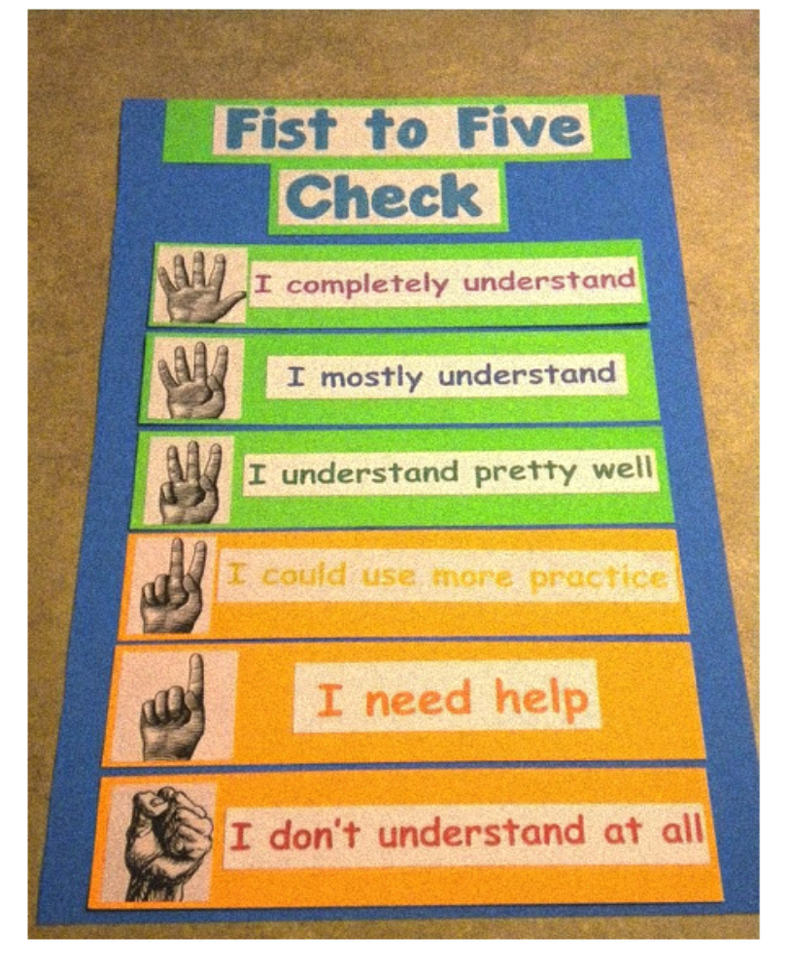

(Example from http://classroomcollective.tumblr.com/post/25456453723)

I notice … | I wonder …

I notice … | I wonder …
- Describe the information in the square in the top right-hand corner of the map.  - Describe the information in the square in the top left-hand corner of the map.  - Draw the shape of “Salva’s route.” | - Circle a question you think is interesting.  - a. How can there be swampland right next to a desert?  - b. How big are the mountains in this area?  - c. What animals live in the grasslands here?  - Circle a question you think is interesting:  - a. Is Sudan the biggest country in Africa?  - b. What are the names of all of the countries surrounding Sudan?  - c. Where is Sudan in relation to the Earth’s equator?  - 3. Ask a question you have about Salva’s route.

One thing I notice is

Will you tell me more about that?

Column 1 | Column 2 | Column 3 | Column 4 | Column 5
Chapter and page numbers | What Nya’s story is about—my first ideas | What Nya’s story is about—any new ideas | What Salva’s story is about—my first ideas | What Salva’s story is about—any new ideas

