MODULE LESSONS
Grade 4: Module 1: Unit 3: Lesson 1
Poetry Workshop: Writing a Poem, Part I—Planning
Language Arts Curriculum
Writing a Poem: Planning Graphic Organizer
W.4.5
Name: ____________________________________ Date: ___________________

Topic Ideas
Topic 1 Ideas:  (structure, imagery, rhythm and rhyme, repetition) | Topic 2 Ideas:  (structure, imagery, rhythm and rhyme, repetition)
Topic Choice

Poetry Options
W.4.5

Poetry Options:

- Animals (tigers, elephants, bears, etc.)
- People (family members, friends, people you see a lot in your life, etc.)
- Pets (cats, dogs, rabbits, etc.)
- Vehicles (cars, boats, planes, trains, etc.)
- Big event (birthday, trip, death, etc.)
- Favorite place (beach, city, country of origin, vacation, etc.)
- Sports (soccer, softball, etc.)
- Arts (painting, playing/listening to music, dance, etc.)
Photographs to Inspire Poetry

Name: ____________________________________ Date: ___________________

 | 
Pandu, D. “Sumatra Tiger.” May 2012. Flickr. Web. Accessed 18 Mar. 2016. <https://flic.kr/p/cnFb9w> | Mignon, S. “Verdure autour de la source de la  Woluwe (Forêt de Soignes).” Oct 2010. Flickr. Web. Accessed 18 Mar. 2016. <https://flic.kr/p/4dr9YH>
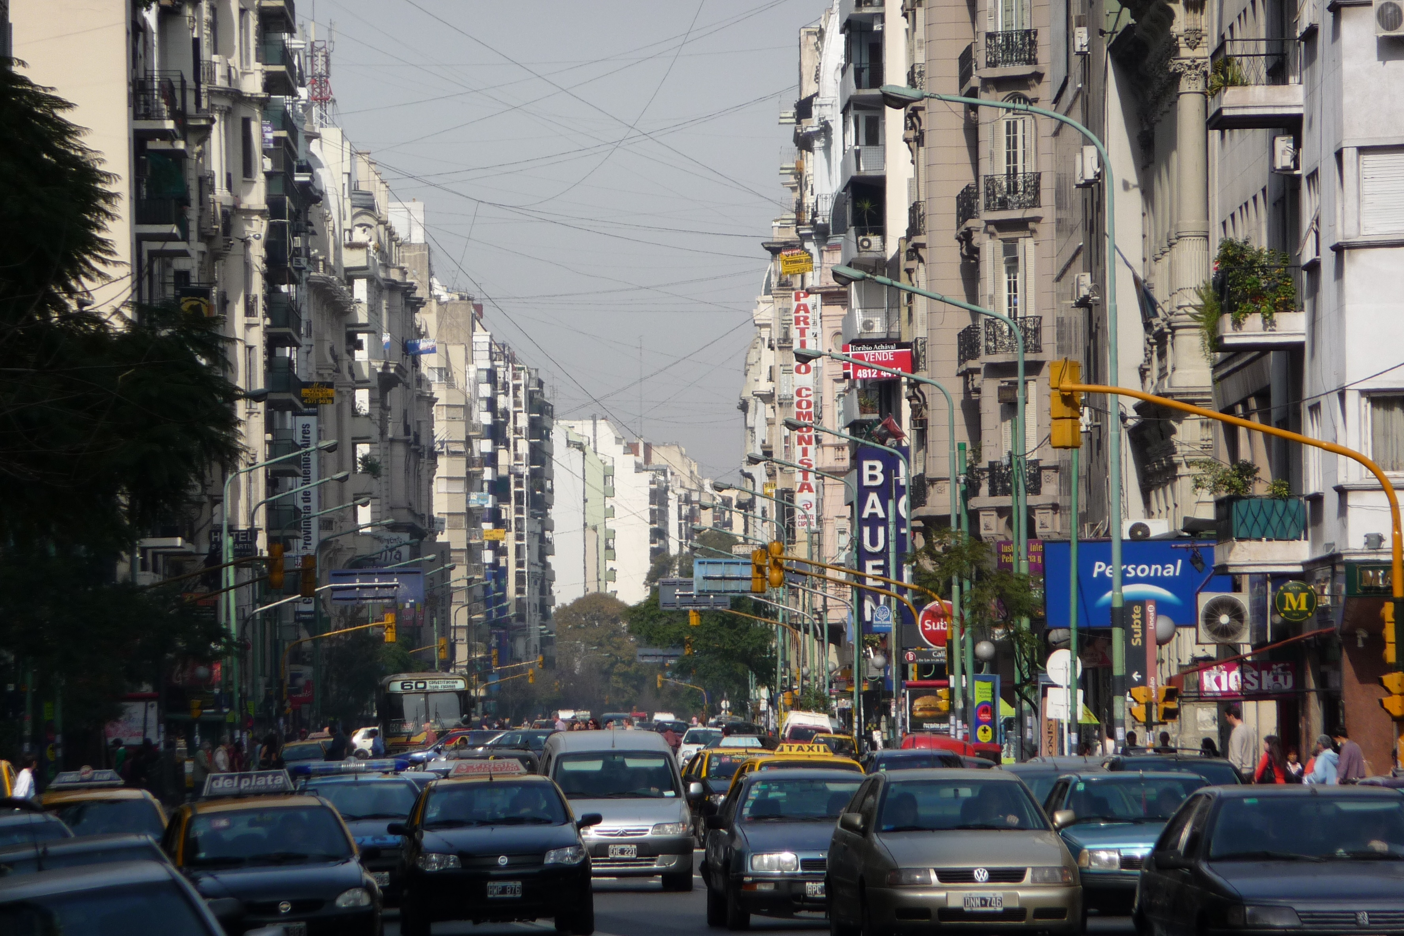 | 
Dougiamas, M. “Busy Streets.” Aug. 2009. Flickr. Web. Accessed 18 Mar. 2016. <https://flic.kr/p/6Q5gab> | Brenn, M. “Cappadocia.” Aug. 2012. Flickr. Web. Accessed 18 Mar. 2016. <https://flic.kr/p/dBd8UG>

Discussion Norms Anchor Chart
(Example for Teacher Reference)
SL.4.1

- I listen carefully and wait my turn to speak (I do not interrupt).
- I ask questions to better understand what people are saying.
- I make comments that contribute to the discussion.
- I respond to questions to help people better understand what I am saying and to build on the discussion.
- I stay on topic.
- I link my ideas to those of others.
- I speak in complete sentences.
- I assume positive intent.

Discussion Norms Anchor Chart
Cue | Response
Expand a response
- “Can you say more about that?”  - “Can you give an example?”  - “I’m interested in what you said about _______________. Can you tell me more?”  - “Can you give us more details about _______________?”  - “How did you come to that conclusion? What made you think that?”  - “What did you learn/do you hope to learn from __________? Why?” | - “Sure, I think that ______________.”  - “OK. One example is ______________.”
Clarify a response
- “So, do you mean _____?”  - “I’m not sure I understand ________________. Can you clarify?”  - “Could you say that again? I’m not sure I understand.” | - “Yes, you’ve got it.”  - “No, sorry, that’s not what I mean. I mean _____.”

