MODULE LESSONS
Grade 4: Module 4: Unit 1: Lesson 3
Answering Questions about a Text: Chapter 3 of The Hope Chest
Language Arts Curriculum

Reading Guide: The Hope Chest, Chapter 3
(Example, for Teacher Reference)
RL.4.1, RL.4.4, RL.4.7, L.4.4, L.4.5c
After reading Chapter 3 of The Hope Chest, look at this artwork inspired by the chapter and answer the following questions:
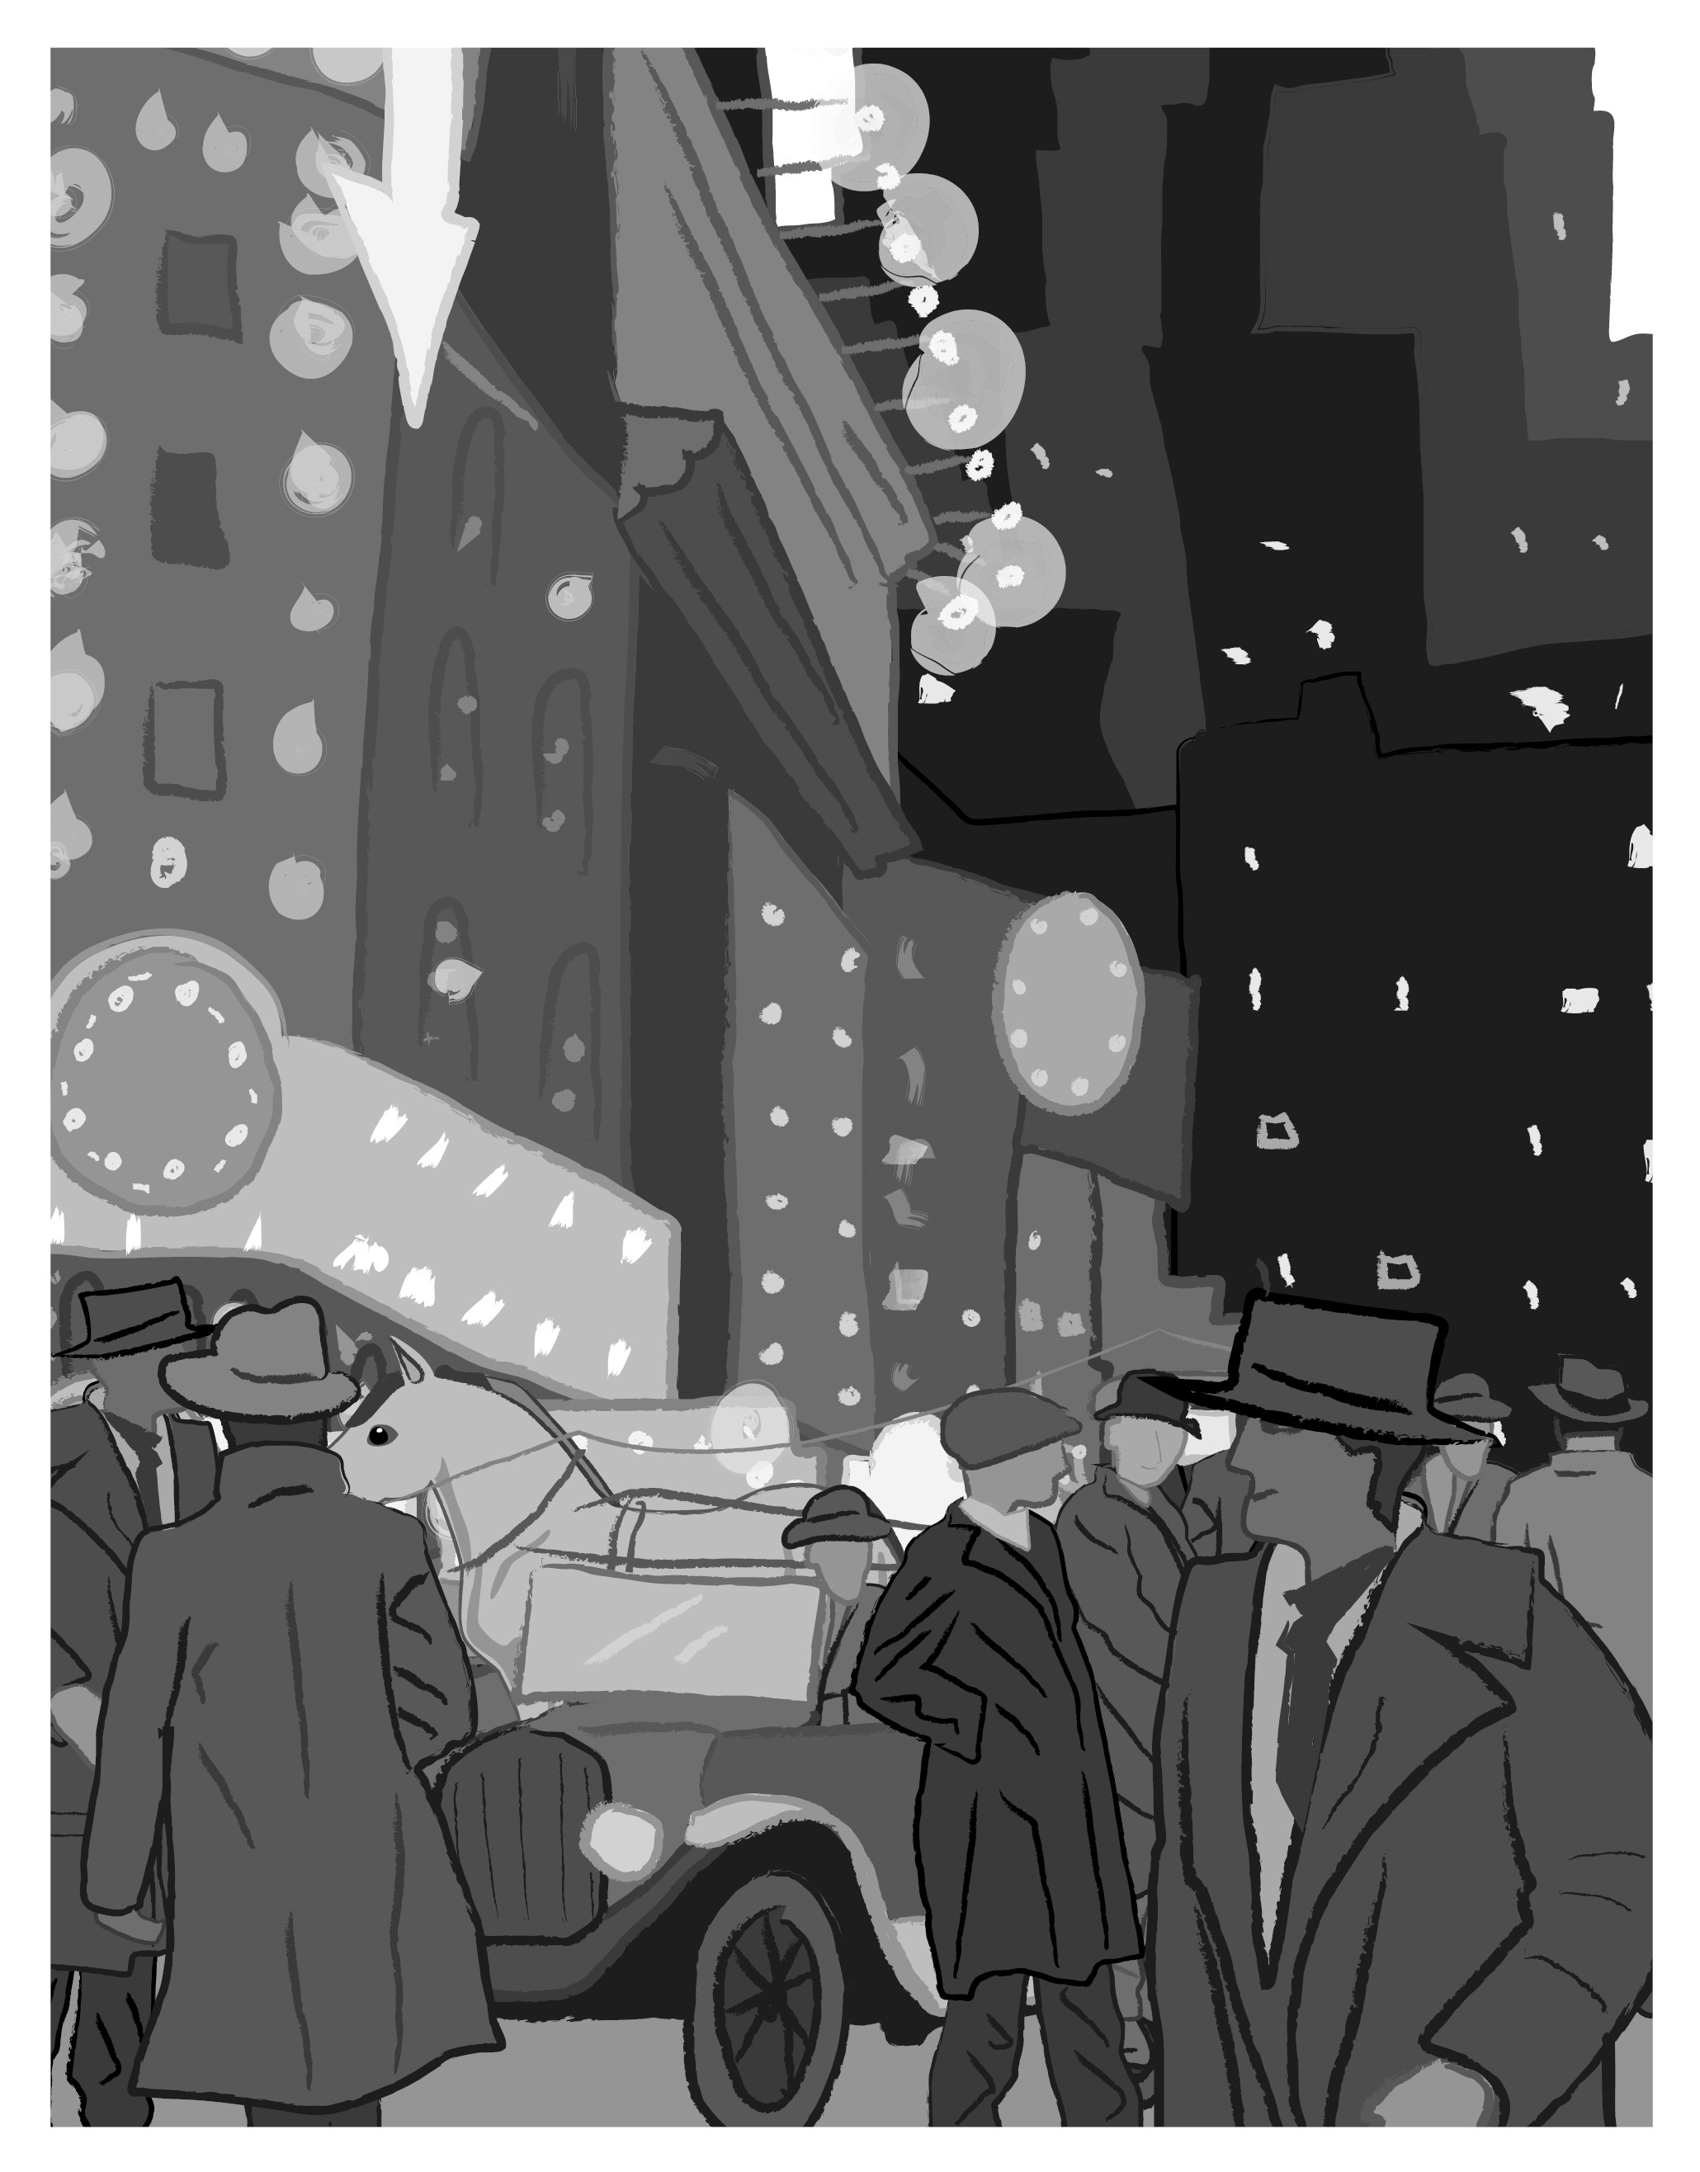
Illustration by Stacey Posnett for EL Education

- a. How does the illustration reflect the description in the text? Refer to details in the text. (RL.4.1, RL.4.7)
Sample student response: The artwork shows New York City at night. It reflects the description, “Motorcars, streetcars, and horse-drawn wagons rumbled by, guided by electric or kerosene lamps mounted on the front.”
b. What does the artwork help you understand about this scene that the text does not? (RL.4.7)
Sample student response: The artwork makes me think that perhaps it is cold because everyone is wearing hats and coats, and that there isn’t much space because there are buildings, vehicles, and people everywhere. It is very busy!

- a. Read this sentence from page 31: “She was conscious that other people had suitcases and even trunks ...”
Use the dictionary to determine the meaning of the word conscious and write the meaning in your own words. (RL.4.4, L.4.4c)
Sample student response: Aware of and responding to surroundings

  - What is a synonym for conscious? (L.4.5c)
Suggested response: Aware
  - What is an antonym for conscious? (L.4.5c)
Suggested response: Ignorant

- Read this sentence from page 39: “‘I’m sorry about your parents,’ Violet added belatedly.” Look at the affixes and root of this word. What do you think belatedly means? (RL.4.4, L.4.4b, L.4.5c)
Sample student response: To be late with something you say or do

- How does Violet respond to Myrtle when they first meet? Why? Use details from the text to support your answer (RL.4.1, RL.4.3)
Sample student response: Violet isn’t sure how to respond to Myrtle when they first meet because she “hasn’t been introduced to a colored person before, let alone introduced herself.” She becomes irritated with Myrtle because she seems so young yet seems to know so much about the city, and she speaks to Violet as though she really doesn’t know much.
Reading Guide: The Hope Chest, Chapter 3
RL.4.1, RL.4.4, RL.4.7, L.4.4, L.4.5c
Name: ____________________________________ Date: ___________________
After reading Chapter 3 of The Hope Chest, look at this artwork inspired by the chapter and answer the following questions:
Illustration by Stacey Posnett for EL Education

- a. How does the illustration reflect the description in the text? Refer to details in the text. (RL.4.1, RL.4.7)

b. What does the artwork help you understand about this scene that the text does not? (RL.4.7)

- a. Read this sentence from page 31: “She was conscious that other people had suitcases and even trunks ...”
Use the dictionary to determine the meaning of the word conscious and write the meaning in your own words. (RL.4.4, L.4.4c)

  - What is a synonym for conscious? (L.4.5c)

  - What is an antonym for conscious? (L.4.5c)

- Read this sentence from page 39: “‘I’m sorry about your parents,’ Violet added belatedly.” Look at the affixes and root of this word. What do you think belatedly means? (RL.4.4, L.4.4b, L.4.5c)

- How does Violet respond to Myrtle when they first meet? Why? Use details from the text to support your answer (RL.4.1, RL.4.3)

For ELLs: Language Dive Guide I:
The Hope Chest
(For Teacher Reference)

Notes: Refer to the Language Dive in Module 3, Unit 1, Lesson 5, for detailed notes on how the Language Dive format has changed starting in Module 3.
Sentence: But they were both caged in by other people’s plans for them, with no hope of escape. (from Chapter 3, page 39, paragraph 4, of The Hope Chest, by Karen Schwabach).
Language Learning Target:
I can understand and practice using synonyms and antonyms to demonstrate understanding of new words and phrases.
I can understand and practice using figurative language to express a feeling.

Rationale: This sentence is compelling because it includes the coordinating conjunction but to connect this sentence to the previous sentence, and includes the figurative language caged in to describe how two of the main characters felt, which helps address L.4.5. This sentence connects to the big idea by demonstrating the inequalities that Violet and Myrtle faced, which are the impetus for their desire to cause social change. Invite students to discuss each chunk briefly, but encourage extended conversation and practice with the highlighted focus structure But they were both caged in. Note that the practice focus structure is presented after all of the chunks are deconstructed to provide additional context and allow for better understanding and discussion. After discussing this structure, students practice using it to discuss why others may have felt caged in during the women’s suffrage movement. Students apply their understanding of the meaning and structure of this sentence when discussing the inequalities that Violet and Myrtle faced during this lesson, and when learning about idioms in future lessons.
Time: 15 minutes

Throughout the Language Dive | Follow the same routines found in Module 3, Unit 1, Lesson 5.
Deconstruct | Remind students of the Questions We Can Ask during a Language Dive anchor chart. Refer to the chunk chart for language goals; display the sentence strip chunks; distribute the note-catcher. Follow the same routine found in Module 3, Unit 1, Lesson 5, to assist students in deconstructing, reconstructing, and practicing the chosen sentence.
Practice (Focus Structure)
Reconstruct
Practice (Sentence)
For ELLs: Language Chunk Chart I:
The Hope Chest
(For Teacher Reference)
But they were both caged in
Deconstruct:  Language Goals | - they: “Who is this sentence about?” Violet and Myrtle (plural pronoun/subject)  - were both caged in: “What happened to them?” Violet and Myrtle felt caged in, or limited or restricted, by their situations, even though their situations were different. (verb phrase)  - caged in: “Were Violet and Myrtle literally in a cage?” No; Karen Schwabach uses the phrase caged in figuratively to help us imagine how confined Violet and Myrtle felt by their situations. caged in is an idiom, which students will learn more about in Lesson 6. (adjective; idiom)  - But: “Can you figure out why the Karen Schwabach wrote but?” but signals that this sentence will show a contrast between the previous idea in the text and the subsequent idea. Note that but could be replaced by yet or however without changing the meaning. (linking word/coordinating conjunction)  - Students can barricade themselves behind a line of chairs to get the literal sense of Violet and Myrtle being caged in. Alternatively, they can close their eyes and visualize Violet and Myrtle literally being in a cage. Students can then take 30 seconds in pairs to describe how this would make them feel, listing as many synonyms for this feeling as possible (examples: trapped, confined, limited). Then they can switch pairs and share antonyms for this feeling (examples: liberated, freed, empowered).
by other people’s plans for them,
Deconstruct:  Language Goals | - “What were Violet and Myrtle caged in by?” other people’s plans; not being able to make their own decisions about their future (prepositional phrase)  - Students can take 30 seconds in pairs to list other people’s plans for Violet and Myrtle (examples: Violet getting married and having many children, Myrtle being a maid and “knowing her place”). Then they can switch pairs and share what Violet and Myrtle wanted for themselves (examples: to go to college, to get jobs they wanted, to gain the right to vote).

with no hope of escape.
Deconstruct:  Language Goals | - “What does this chunk tell us?” This chunk emphasizes how caged in Violet and Myrtle were. They felt so trapped that they saw no hope of escape, no opportunity other than getting married and being a maid.  - “Can you figure out why Karen Schwabach chose the word escape instead of opportunity?” (escape helps convey the same imagery as caged in, of being trapped.)  - Students can discuss how the meaning of the sentence would change if no were replaced with little.
But they were both caged in
Practice (Focus Structure) | - “What is the contrast between the previous idea in the paragraph and the idea in this sentence, shown by but?” The contrast is between the difference in their situations (marriage and being a maid) and the similarity in feeling caged in.  - Students can use these sentence frames and what they have learned in The Hope Chest to describe why others may have felt caged in during the women’s suffrage movement: ✎ ________ felt caged in because __________. (Many women felt caged in because they did not have the right to vote.)  - To provide lighter support: “How can you use an antonym of caged in to convey the same meaning of this sentence?” _______ did not feel ______ because _______. (Many women did not feel liberated because they did not have the right to vote.)  - To provide heavier support: Provide a word/phrase bank for students to use when completing the sentence frame.  - “What if we replace caged in with restricted or controlled?” (We lose some interesting imagery.)

But they were both caged in by other people’s plans for them, with no hope of escape.
Reconstruct | - “How can you say this sentence in your own words?” (Violet and Myrtle both felt trapped, unable to make their own decisions about their futures.)  - “What do you think Violet and Myrtle might do to cause social change?” (Responses will vary.)  - “How does the Language Dive add to your understanding of the big idea?” (It connects to the big idea by referring to the inequalities that Violet and Myrtle faced, which are the impetus for their desire to cause social change.)
Practice (Sentence) | - Students can complete the sentence frames using their own words: ✎  - But they were both ______________, with ____________. (But they were both confined by other people’s ideas about their future, with no opportunity to make their own decisions.  - To provide lighter support: “Can we divide this sentence into two or more sentences? What do we have to remove or change?”  - To provide heavier support: Invite students to discuss the meaning of the sentence in home language groups.  - Language Chunk Wall suggestions:  - Language to connect words, phrases, clauses: But they were both caged in  - Language to capture a reader’s imagination or attention: But they were both caged in  - Nouns and noun phrases and clauses (people, places, things, ideas): by other people’s plans for them,/with no hope of escape.

For ELLs: Language Dive Sentence Strip
Chunks I: The Hope Chest

But they were both caged in
by other people’s plans for them
with no hope of escape.
For ELLs: Language Dive Note-catcher I:
The Hope Chest
Name: ____________________________________ Date: ___________________

But they were both caged in by other people’s plans for them, with no hope of escape.

Directions: Fill in the blanks to complete the following sentences.

- _____________________________________________ felt caged in because

__________________________________________________________________.

Sketch your sentence here:

- But they were both _____________________________________________

__________________________________________________________________.

Sketch your sentence here:

