MODULE LESSONS
Grade 4: Module 4: Unit 1: Lesson 1
Discovering Our Topic: Responding to Inequality: Ratifying the 19th Amendment
Language Arts Curriculum

Infer the Topic Resources
Note to teacher: Post the following resources around the room. Consider writing the quotes in large print on chart paper to make them easy to see.

1. | “American women regained the right to vote in 1920, 113 years after they lost it.”  Schwabach, Karen. The Hope Chest. New York, Random House, 2008.
2. | “Freeing both women and African Americans seemed to be two parts of the same goal.”  Schwabach, Karen. The Hope Chest. New York, Random House, 2008.
3. | “No Southern state gave women full voting rights.”  Schwabach, Karen. The Hope Chest. New York, Random House, 2008.
4. | “No Southern state gave women full voting rights.”  Schwabach, Karen. The Hope Chest. New York, Random House, 2008. 4.
5. | “1965: The Voting Rights Act eliminates so-called literacy tests, which had been used to keep African Americans from voting in some Southern states.”  Schwabach, Karen. The Hope Chest. New York, Random House, 2008.
6. | “Public facilities were segregated throughout the South.”  Schwabach, Karen. The Hope Chest. New York, Random House, 2008.
7. | 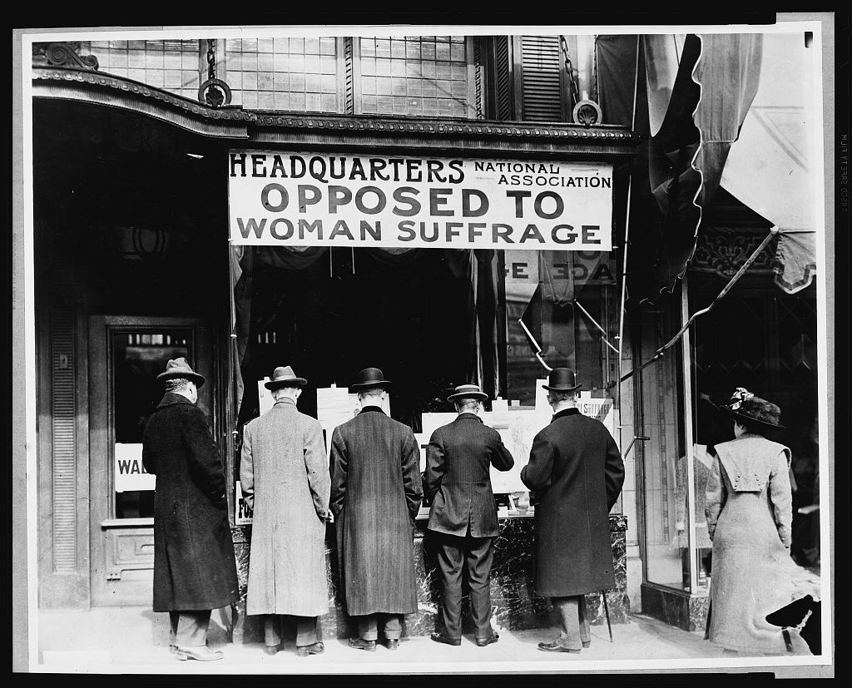  Harris and Ewing. “National Anti-Suffrage Association.” Photograph. Library of Congress. 1911. Web. http://www.loc.gov/pictures/item/97500067/

8. | 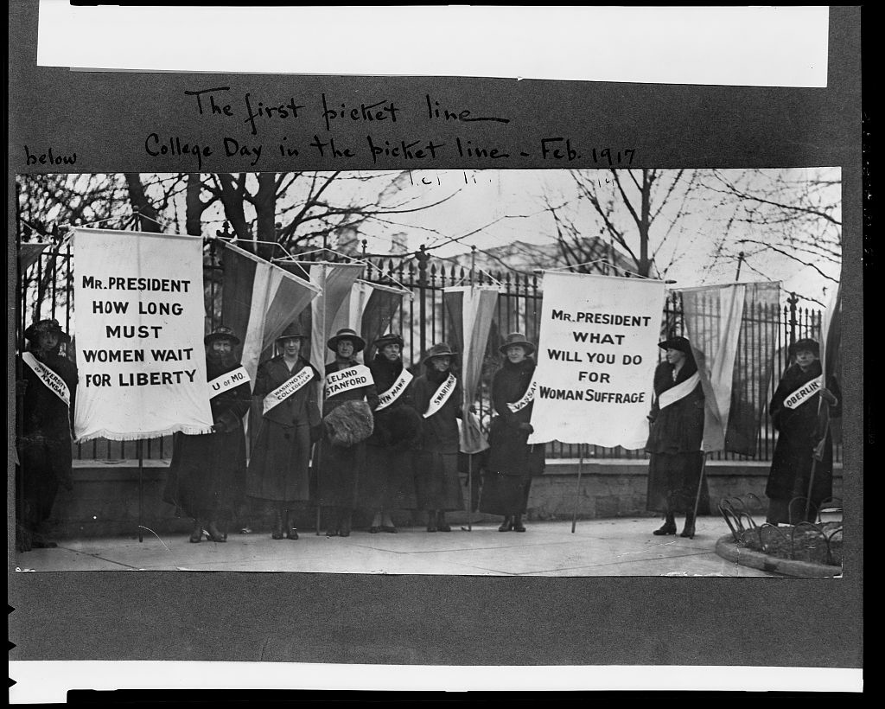  “The first picket Line—College Day in the picket line.” Library of Congress. Photograph. Feb. 1917. Web. http://www.loc.gov/pictures/item/97500299/
9. | 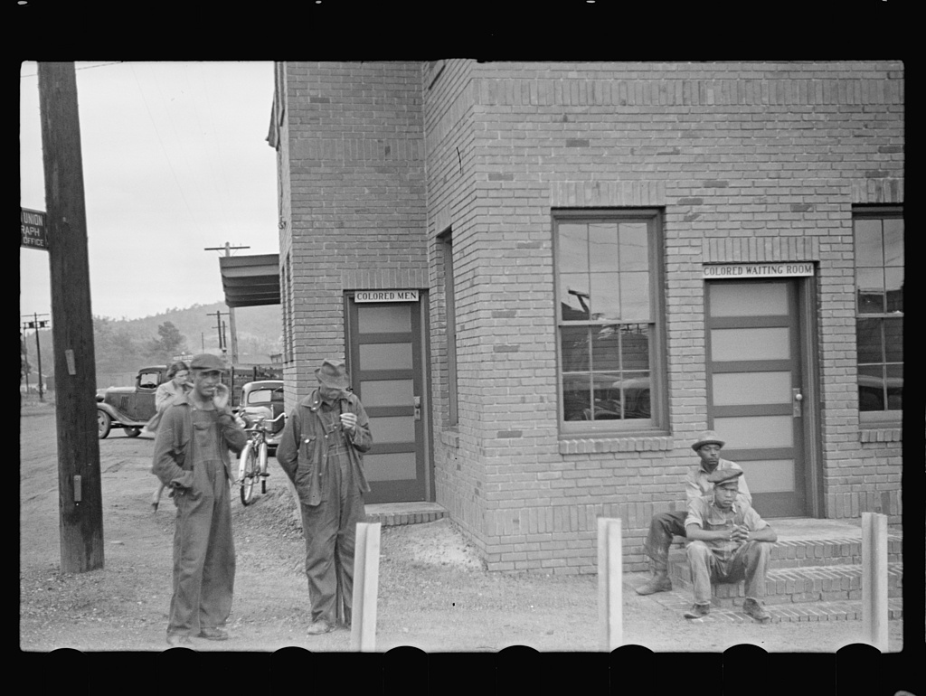  Vachon, John for the Farm Security Administration/Office of War Information. “Railroad station, Manchester, Georgia.” Photograph. Library of Congress. May 1938. Web. <https:// www.loc.gov/item/fsa1997003449/PP/>.

10. | 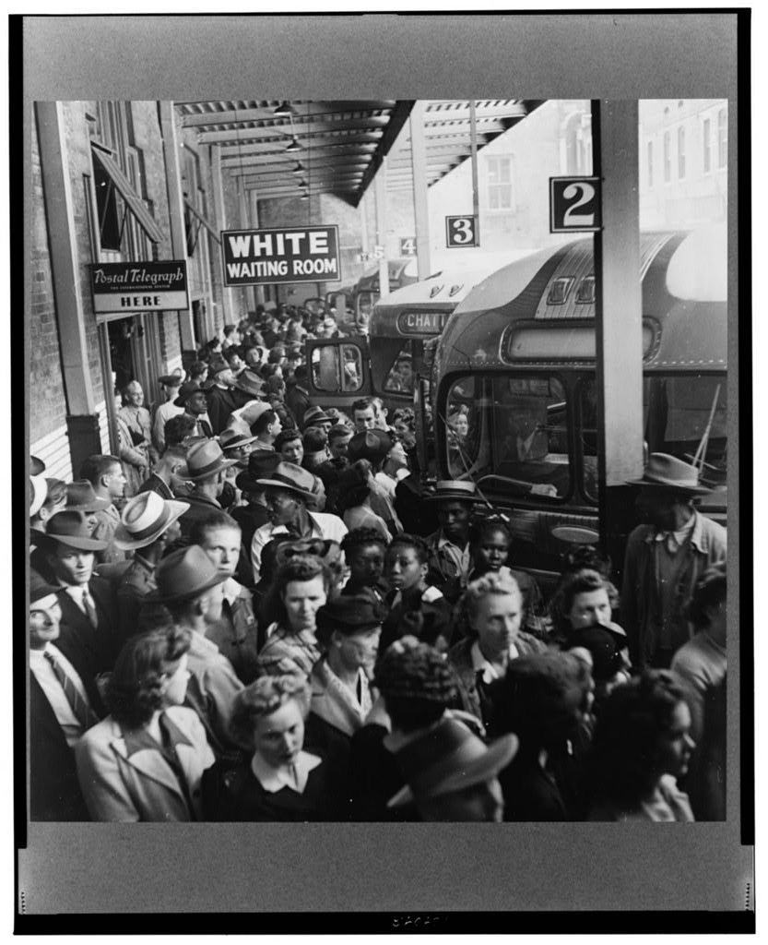  Bubley, Esther for the Farm Security Administration/Office of War Information. “A Greyhound bus trip from Louisville, Kentucky, to Memphis, Tennessee, and the terminals. Waiting for the bus at the Memphis terminal.” Photograph. Library of Congress. Sept. 1943. Web. http://www.loc.gov/pictures/item/owi2001035876/PP/

I Notice/I Wonder Note Catcher
RI.4.1, W.4.8
Name: ____________________________________ Date: ___________________

What do you think you will be learning bout in this module?

I Notice  (things I see) | I Wonder  (questions I have)
Directions for Infer the Topic
- Choose your first resource. Take your I Notice/I Wonder note-catcher with you.
- Look carefully at the resource. Be respectful of others who might be looking at the same thing. Record what you notice (what you see) and what you wonder (questions) on your note-catcher. (3 minutes)
- When instructed, find a partner who looked at a different resource. Describe your resource and share your notices and wonders. Explain what you think you are going to be learning about in this module. (2 minutes)
- When instructed, stay with your partner and together find another pair. Share your notices and wonders and what you think you are going to be learning about in this module. (3 minutes)
- On your own, choose a new resource and repeat steps 2–4.

