MODULE LESSONS
Grade 2: Module 4: Unit 1: Lesson 10
Reading, Speaking, and Listening: Comparing and Contrasting
“The Ants and the Grasshopper” and
“Bunnyyarl the Flies and Wurrunnunnah the Bees”
Language Arts Curriculum

Compare and Contrast T-Chart Class
Notes: “The Ants and the Grasshopper”
and “Bunnyyarl the Flies and
Wurrunnunnah the Bees”
(Example, for Teacher Reference)
RL.2.9

Things that are the same | Things that are different
Beginning  Both versions take place when the seasons change.  Both have characters who do not want to work. | 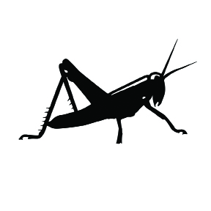 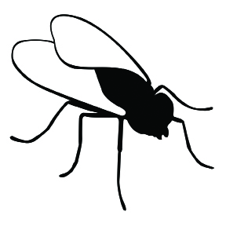 The characters are a grasshopper and ants.
 |  The characters are lazy people and hard-working people.
Middle  Both have characters who are hungry in the winter.  Both the grasshopper and the carefree people want to eat the food that others have collected. | 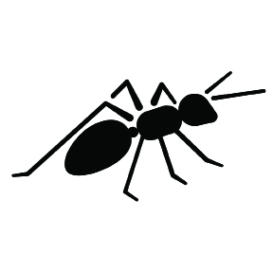 The grasshopper plays music.
 | The lazy people play all day.
End  In both versions the busy characters have enough food. | The ants do not share their food with the Grasshopper.  The Grasshopper does not get any food and goes hungry.
End  In both versions the busy characters have enough food. | The characters get turned into insects.  The hard workers move away.
Central Message  Both versions are about working hard instead of playing. | The central message is not about helping others.
 | The central message is about helping others.
Compare and Contrast T-Chart Class
Notes: “The Ants and the Grasshopper”
and “Bunnyyarl the Flies and
Wurrunnunnah the Bees”
RL.2.9

Things that are the same | Things that are different
Beginning

Both have characters who do not want to work.
Middle

Both the grasshopper and the carefree people want to eat the food that others have collected.
End | The Grasshopper does not get any food and goes hungry.
End | The hard workers move away.
Central Message
Language Dive Guide:
“The Ants and the Grasshopper”
(For Teacher Reference)

Notes | Refer to the Language Dive in Module 3, Unit 1, Lesson 8, for detailed notes on how the Language Dive format has changed starting in Module 3.
Sentence | “I didn’t have time to store up any food,” whined the Grasshopper; “I was so busy making music that before I knew it the summer was gone.”  (from section 3 of “The Ants and the Grasshopper”)
Rationale | This sentence is compelling because it uses the conjunction that to connect two clauses that signal cause and effect to help address the Daily Learning Targets. This sentence connects to the guiding question by illustrating one character’s challenge that must be overcome to make the world a better place. After discussing this structure, students practice using it to discuss characters in different versions of the same story. Students apply their understanding of the meaning and structure of this sentence when comparing and contrasting different versions of the same story, and when writing paragraphs during the Unit 1 Assessment. Invite students to discuss each chunk briefly, but encourage extended conversation and practice with the focus structure that before I knew it the summer was gone.” Note that this Language Dive includes some additional teacher moves to connect to Lesson 10’s work comparing and contrasting two different versions of the same story.
Time | 15 minutes
Throughout the Language Dive | Follow the same routines found in Module 3, Unit 1, Lesson 8.
Deconstruct | Refer to the chunk chart for language goals; display the sentence strip chunks; display and distribute the note-catcher. Follow the same routine found in Module 3, Unit 1, Lesson 8, to assist students in deconstructing, reconstructing, and practicing the chosen sentence.
Practice (Focus Structure)
Reconstruct
Practice (Sentence)
Language Dive Chunk Chart:
“The Ants and the Grasshopper”
(For Teacher Reference)

“I didn’t have time
Deconstruct: Language Goals | - “What didn’t the Grasshopper have?” Enough time.  - Grasshoppers can pretend they don’t have time by looking at imaginary watches and acting surprised.
to store up any food,”
Deconstruct: Language Goals | - “What didn’t the Grasshopper have enough time to do?” Collect food; put away food; save food (object of preposition; phrasal verb)  - any: “How would the meaning of this chunk change if we replaced any with much?” It would mean that the Grasshopper stored up some food. Now it means the Grasshopper didn’t save any at all.  - “How is this similar to or different from the problem the flies had in ‘Bunnyyarl the Flies and Wurrunnunnah the Bees’?” The flies also did not collect any food.  - Invite the flies and the grasshoppers to pretend to open an empty refrigerator.
whined the Grasshopper;
Deconstruct: Language Goals | - How did the Grasshopper tell the ants that he didn’t have time to collect food?” He whined. (verb)  - “Why did the author use a semicolon?” The semicolon links two parts of the sentence that could be separate sentences on their own.  - Grasshoppers can reread the first two chunks in a whiny voice.
“I was so busy making music
Deconstruct: Language Goals | - “What did the Grasshopper say he did instead of storing up food?” (main clause) He played music; played his fiddle.  - Grasshoppers can pretend to play imaginary musical instruments.  - “Is this similar to or different from the problem the flies had in “Bunnyyarl the Flies and Wurrunnunnah the Bees?” Similar because they were having fun, but different because the flies were dancing, playing, and singing.  - Grasshoppers and flies can all stand up. The grasshoppers can pretend to play music as the ants dance and sing.
that before I knew it the summer was gone.”
Deconstruct: Language Goals | - “What happened because the grasshopper was so busy making music?” The summer ended and he had no food. (dependent clause)  - that: “Can you figure out why the author used the word that?” that connects the two ideas. so … that is often used to signal cause and effect. so busy --> he didn’t pay attention to the changing season.  - the summer was gone: “Where did the summer go?” The summer ended. This is an expression that means the summer season passed or is over. (figurative language)  - Before I knew it: “When did the summer end?” Sooner than the Grasshopper thought it would end; before he had time to pay attention to it. (prepositional phrase of time; idiomatic phrase)

Practice  (Focus structure) | - Invite students to use this structure to tell their partners about the flies in “Bunnyyarl the Flies and Wurrunnunnah the Bees”:  - The flies were [so + adjective] ______ that they ______. (The flies were so carefree that they did not collect any honey. The flies were so busy singing that they had to ask the bees for food.)  - To provide lighter support: “Can you extend the sentence frame by adding a phrase that tells when or where? How?” (The flies were so carefree that they did not collect any honey in the summertime.)  - To provide heavier support: Provide a word/phrase bank for students to use when completing the sentence frame. Encourage students to refer to the Parts of Speech anchor chart to review the definition of a noun.  - Students can act out their sentences with partners. They can then write and sketch the sentences in their note-catchers. 
“I didn’t have time to store up any food,” whined the Grasshopper; “I was so busy making music that before I knew it the summer was gone.”
Reconstruct | - “Can you say this sentence in your own words?” (The Grasshopper said that he didn’t realize the summer was over because he was so busy playing music.)  - “How does this Language Dive add to your understanding of the guiding question?” (It tells us about the problem the Grasshopper had that the characters need to solve to make the world a better place.)

Practice (Sentence) | - “Can we say this sentence in a different order? How?”  - To provide lighter support: “Can we divide this sentence into two or more sentences? What do we have to remove or change?”  - To provide heavier support: Invite students to discuss the meaning of the sentence in home language groups. Add the nouns in students’ home languages to the Parts of Speech anchor chart.  - Students can each hold a chunk and switch places to show the sentence in a different, correct order.  - Language Chunk Wall suggestions:  - Language to connect words, phrases, clauses: that before I knew it the summer was gone.”  - Nouns and noun phrases and clauses (people, places, things):  - Adjectives and adjectival phrases and clauses (describing nouns): “I was so busy making music  - Verbs and verb phrases (actions, states of being): whined the Grasshopper; / “I didn’t have time

Language Dive Sentence Strip Chunks:
“The Ants and the Grasshopper”

“I didn’t have time
to store up any food,”
whined the Grasshopper;
“I was so busy making music
that before I knew it the summer was gone.”

Language Dive Note-catcher:
“The Ants and the Grasshopper”
Name: ___________________________ Date: _____________
The flies were [so + adjective] _________________________________

that they _________________________________________________

