MODULE LESSONS
Grade 1: Module 4: Unit 3: Lesson 7
Unit 3 Assessment: Identifying Reasons Humans Need Birds
Language Arts Curriculum

Bird Adjectives Anchor Chart
(Example, for Teacher Reference)
L.1.1f
Note to Teachers: Create the chart in advance. The first two columns will be completed during Lesson 7; the remaining column will be completed in Lesson 8. Three new adjectives will be introduced in Lesson 9, for a total of six adjectives on this chart.

Adjectives to Describe Birds
Adjective | Definition | Facts about birds that show this
amazing | causing great wonder
important | having great meaning
fascinating | capturing one’s interest and attention
Bird Adjective Cards 1–3
Note to Teachers: Each student will receive one card. Keep these cards for Lessons 8 and 10.

amazing  causing great wonder | amazing  causing great wonder
important  having great meaning | important  having great meaning
fascinating  capturing one’s interest and attention | fascinating  capturing one’s interest and attention
amazing  causing great wonder | amazing  causing great wonder
important  having great meaning | important  having great meaning
fascinating  capturing one’s interest and attention | fascinating  capturing one’s interest and attention
We Need Birds Anchor Chart
(Example, for Teacher Reference)
Note to Teachers: Draw the icons in the “People need birds” column before the lesson. The remainder of this column will be completed with students during the Closing.

Author’s point | Plants need birds. 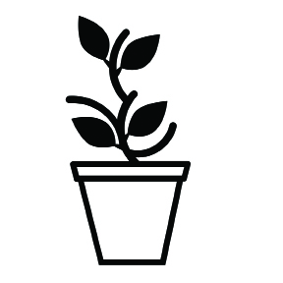 |   Animals need birds. |   People need birds.
Reason #1 | Plants need birds.    Birds drop seeds in waste cans.  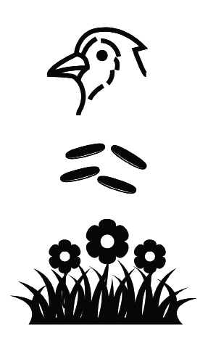  Birds eat and release seeds. |   Birds are chained up.  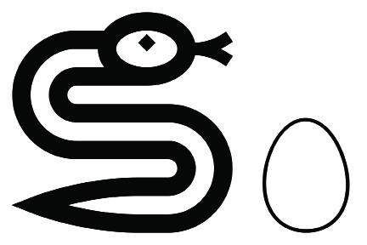  Animals eat eggs.  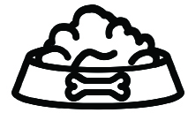  Birds bring food. | 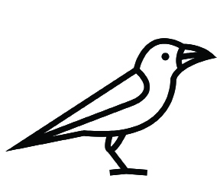  Birds are helpful.    Birds are found all over the world.  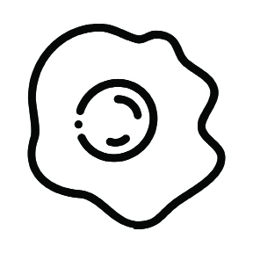  Birds give people food.
Reason #2 | 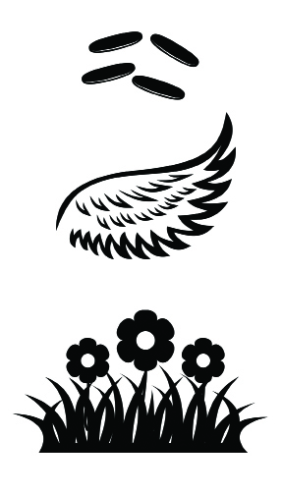  Carry seeds on wings  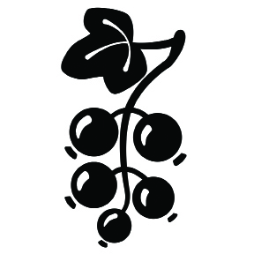  Eat berries  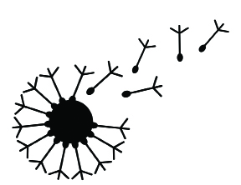  Wind carries seeds. |   Build homes for other animals  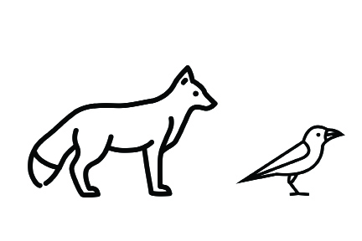  Eat adult birds    Make pretty music | Birds give people food.  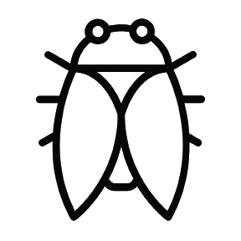  Birds eat insects that can hurt plants.
Opinion Posters

Plants Need Birds
Opinion Posters, continued

Animals Need Birds
Opinion Posters, continued

People Need Birds

