MODULE LESSONS
Grade K: Module 4: Unit 2: Lesson 1
Speaking, Listening, and Writing: Exploring Why Trees
Are Important to Communities
Language Arts Curriculum
Opinion Icons
Set 1: What should we have for a snack?
Apples   | Carrots   | Crackers  

Set 2: What should we do at recess?
Ball   | Tag   | Playground  

Enjoying Trees Journal, Part 2 - Page 1
(Example, for Teacher Reference)
W.K.8, L.K.1b, L.K.2a, L.K.2b, L.K.6
Directions: Look at the picture. Write a sentence to describe the tree and where it is.
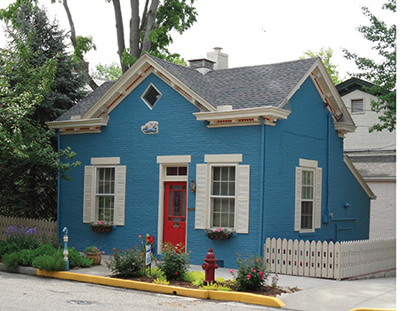

The tree is next to the house.
Enjoying Trees Journal, Part 2 - Page 2
(Example, for Teacher Reference)
W.K.8, L.K.1b, L.K.2a, L.K.2b, L.K.6
Directions: Look at the picture. Write a sentence to describe the tree and where it is.
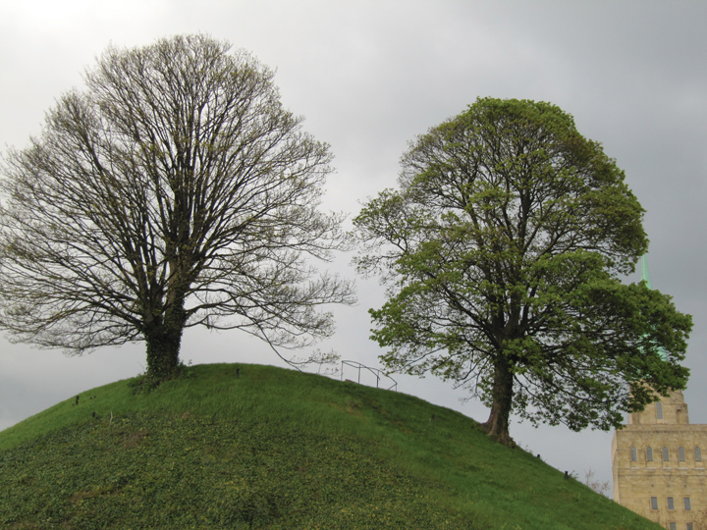

The tree is on the hill.
Enjoying Trees Journal, Part 2 - Page 3
(Example, for Teacher Reference)
W.K.8, L.K.1b, L.K.2a, L.K.2b, L.K.6
Directions: Look at the picture. Write a sentence to describe the tree and where it is.
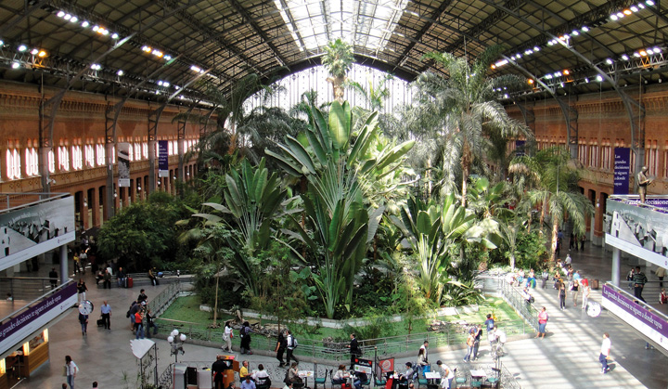

The tree is in the building.
Enjoying Trees Journal, Part 2 - Page 4
(Example, for Teacher Reference)
W.K.8, L.K.1b, L.K.2a, L.K.2b, L.K.6
Directions: Look at the picture. Write a sentence to describe the tree and where it is.
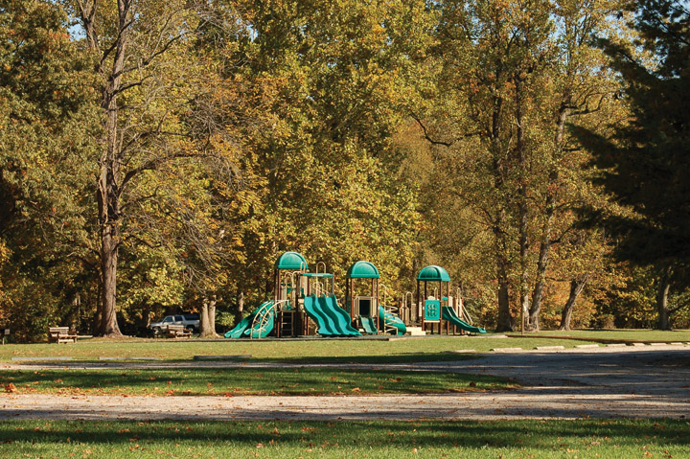

The tree is beside the playground.
Enjoying Trees Journal, Part 2 - Page 1
Name: ____________________________Date: _____________
W.K.8, L.K.1b, L.K.2a, L.K.2b, L.K.6
Directions: Look at the picture. Write a sentence to describe the tree and where it is.
Enjoying Trees Journal, Part 2 - Page 2
Name: ____________________________Date: _____________
W.K.8, L.K.1b, L.K.2a, L.K.2b, L.K.6
Directions: Look at the picture. Write a sentence to describe the tree and where it is.

Enjoying Trees Journal, Part 2 - Page 3
Name: ____________________________Date: _____________
W.K.8, L.K.1b, L.K.2a, L.K.2b, L.K.6
Directions: Look at the picture. Write a sentence to describe the tree and where it is.

Enjoying Trees Journal, Part 2 - Page 4
Name: ____________________________Date: _____________
W.K.8, L.K.1b, L.K.2a, L.K.2b, L.K.6
Directions: Look at the picture. Write a sentence to describe the tree and where it is.

Image Credits
Ratcliff, Ken. “Blue house.” Photograph. Flickr. 18 May 2013. Web.
Haun, Dirk. “Trees on a Hill.” Photograph. Flickr. 24 April 2012. Web.
Ib..ez, .lvaro. “Jardín Tropical en la Estación de Atocha.” Photograph. Flickr. 21 September 2009. Web.
Virginia State Parks. “Mason Neck.” Photograph. Flickr. 22 October 2012. Web.

