MODULE LESSONS
Grade K: Module 4: Unit 1: Lesson 6
Reading and Writing: Focused Read-aloud, Session 1: Oliver’s Tree
Language Arts Curriculum
Character Comparison Anchor Chart:
Oliver’s Tree
(Example, for Teacher Reference)
RL.K.1, RL.K.2, RL.K.3, RL.K.9
Note to Teachers: The bolded information is added to the anchor chart during the focused read-aloud of Oliver’s Tree in Work Time A. Student answers may vary slightly.
Character Comparison: Oliver’s Tree
 | Characters’ Experiences
 | Oliver |  |  |  | Charlie and Lulu   |  | Is it the same or different?
Beginning   | - Finds a tree that is too small  - Finds a tree that is too big  - Falls out of a  tree when the  branch breaks |  |  |    | - Hide and play in tree  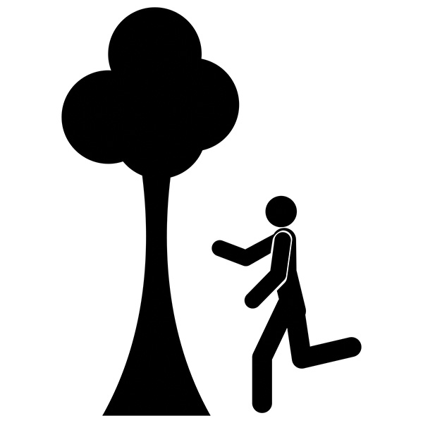 |  | D
Middle   | - Feels sad and stops playing |  |  |  | - Feel sad for  Oliver |  | S
 | - Falls asleep |  | 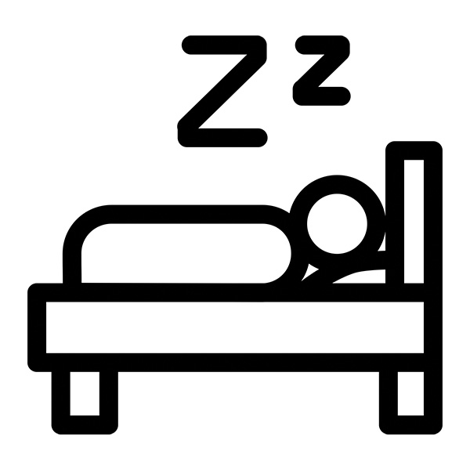 |  | - Build a  treehouse so Oliver can  play too |  | D
End | - Uses imagination  to play with trees |  |  |  | - Use  imagination  to play with  trees |  | S

Model Tree Parts Image
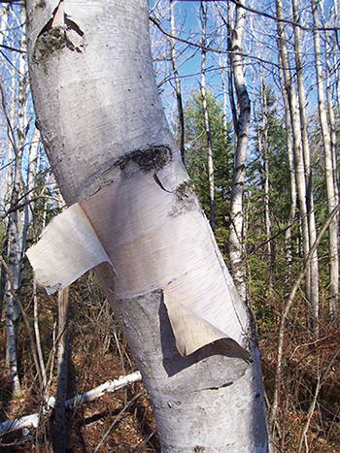

Model of Pencil Sketch 1
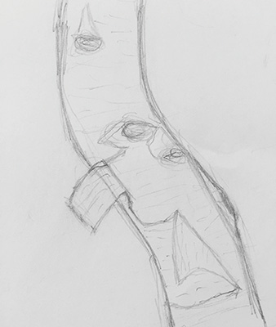
Tree Parts Images
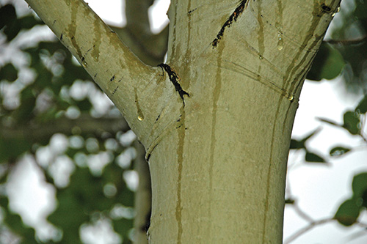
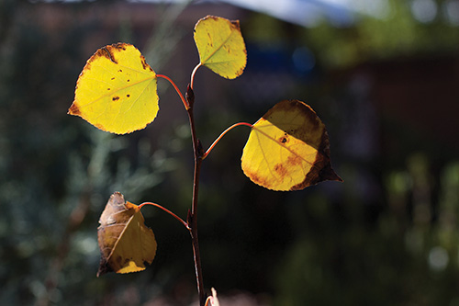

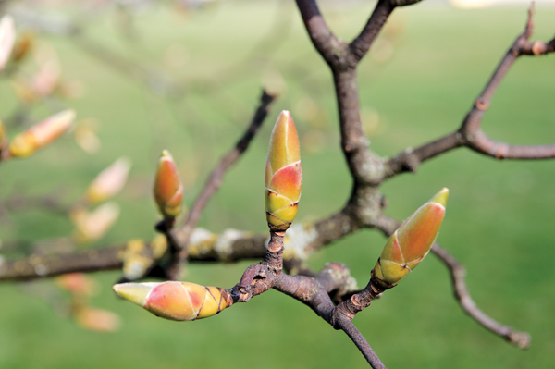
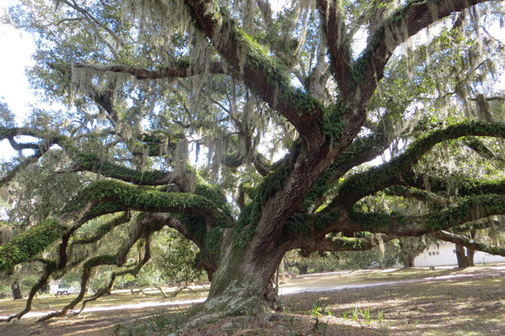

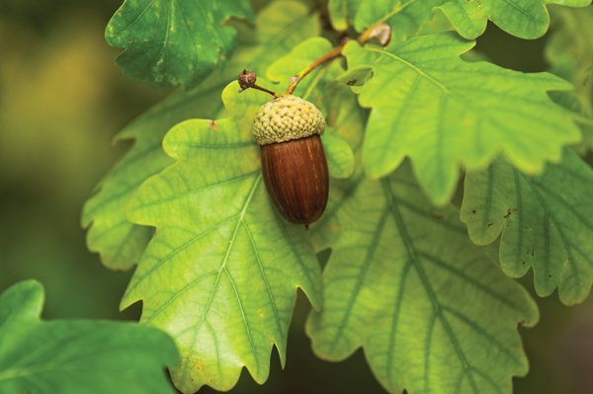
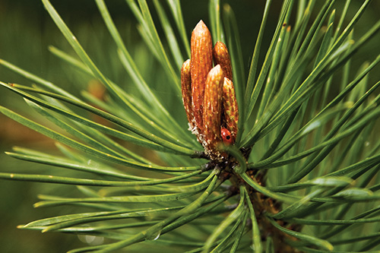

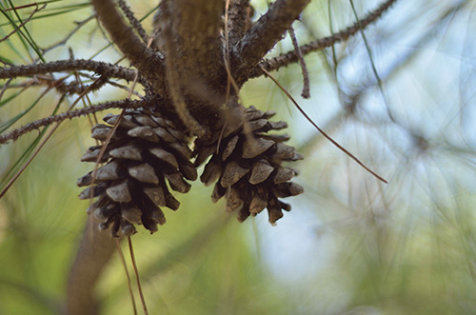
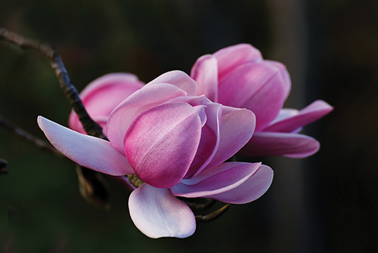

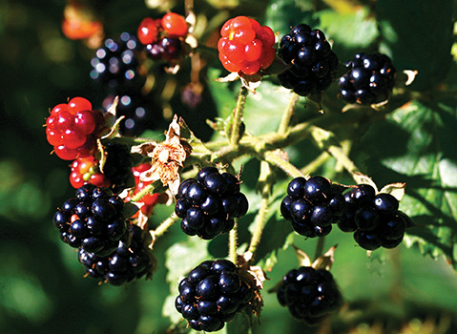
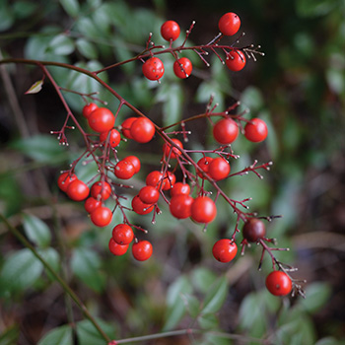

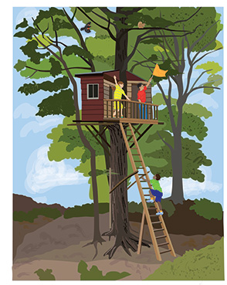
Enjoying Trees Image 4
Image Credits
InAweofGodsCreation. “White Paper.” Photograph. Flickr. 19 November 2005. Web.
Model sketch by Anna Loring for EL Education.
St. John, James. “Populus tremuloides (quaking aspen) (Rocky Mountains National Park, Colorado, USA) 3.” Photograph. Flickr. 26 July 2007. Web.
Levine, Alan. “Aspen’s Last Quakes.” Photograph. Flickr. 6 November 2015. Web.
Timmy L. “Buds.” Photograph. Flickr. 28 April 2013. Web.
Maynor, Natalie. “Cumberland Island, Georgia.” Photograph. Flickr. 26 January 2016. Web.
3523Studio. “Fruit Oak Tree Ripe in Autumn, on a Sunny Day.” Photograph. Shutterstock. n.d. Web.
Varlan, Horia. “Tiny Ladybird Among Long Fir Tree Buds.” Photograph. Flickr. 2 May 2008. Web.
Jennie-O. “Pinecones.” Photograph. Flickr. 7 August 2013. Web.
Spragg, Bernard. “Magnolia. Campbellii.” Photograph. Flickr. 28 August 2010. Web.
West, Liz. “Berries.” Photograph. Flickr. 4 August 2008. Web.
Steiner, Nate. “Berries.” Photograph. Flickr. 13 March 2010. Web.
Illustration by Stacey Posnett for EL Education.

