MODULE LESSONS
Kindergarten: Module 4: Unit 1: Lesson 4
Reading, Asking Questions, and Writing: Close Read-aloud, Session 3: A Tree for Emmy and Enjoying Trees Journal
Language Arts Curriculum

A Tree for Emmy Character Comparison
Anchor Chart
(Example, for Teacher Reference)
RL.K.1, RL.K.2, RL.K.3, RL.K.9
Note to Teachers: The bolded information is added to the anchor chart during the close read-aloud of A Tree for Emmy in Work Time A. Student answers may vary slightly.

Character Comparison: A Tree for Emmy
 |   Emmy |   Emmy’s Family | Is it the same or different?
Beginning |       Plays with the mimosa tree:  - Swings from branches  - Pretends she is a bug with flowers  - Shakes the seedpods | - Does not play with the mimosa tree   | D
  Middle | - Wants a  mimosa tree    - Visits garden stores to look for a mimosa  - Cannot find a mimosa | - Wants to get a tree for Emmy  - Visits garden stores to look for a mimosa  - Cannot find a mimosa | S
End  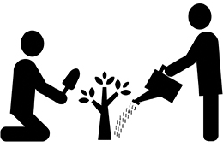 | - Finds a mimosa at Grandma’s to plant at home | - Does not find a mimosa tree | D
 |   - Builds a fence to protect the tree | - Builds a fence to protect the tree | S

Enjoying Trees Image 3
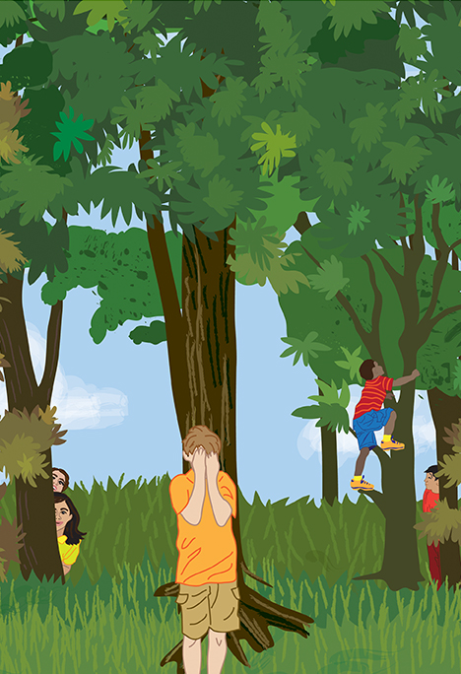
Image Credits
Page 3. Illustration by Stacey Posnett for EL Education.

