MODULE LESSONS
Kindergarten: Module 4: Unit 1: Lesson 3
Reading, Asking Questions, and Writing: Close Read-aloud, Session 2: A Tree for Emmy and Enjoying Trees Journal
Language Arts Curriculum

Character Comparison Anchor Chart:
A Tree for Emmy
(Example, for Teacher Reference)
RL.K.1, RL.K.2, RL.K.3, RL.K.9
Note to Teachers: The bolded information is added to the anchor chart during the close read-aloud of A Tree for Emmy in Work Time A. Student answers may vary slightly.
Character Comparison: A Tree for Emmy
 | Emmy |  | Emmy’s  Family |  | Is it the same or different?
Beginning | Plays with the mimosa tree:    - Swings  from  branches    - Pretends she is  a bug with flowers    - Shakes the  seedpods |  | - Does not play with the mimosa tree   |  | D
Middle | - Wants a mimosa tree |  | - Wants to get a tree for Emmy |  | S
End
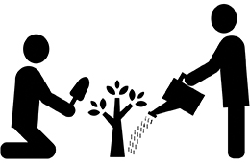
Tree Stretch Chart
- Plant your roots firmly in the ground.  (Stand with your feet shoulder-width apart; fold forward, relaxing your back and neck, with your head down) | 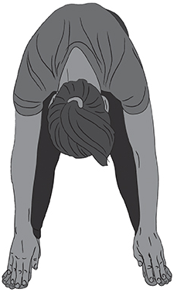
- Grow your trunk up toward the sun and sky.  (Slowly roll up to straighten your back.) | 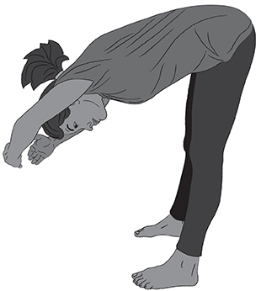
- Grow your branches up toward the sun and sky.  (Slowly stretch your arms up, creating a V shape above your head.) | 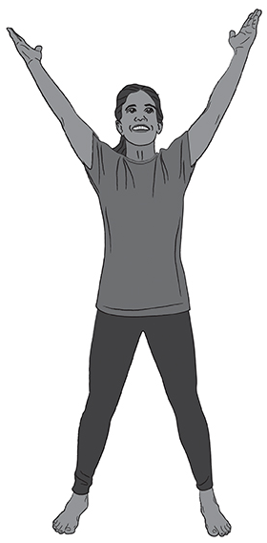
- Grow your leaves out toward the sun and sky.  (Slowly stretch your fingers wide.) | 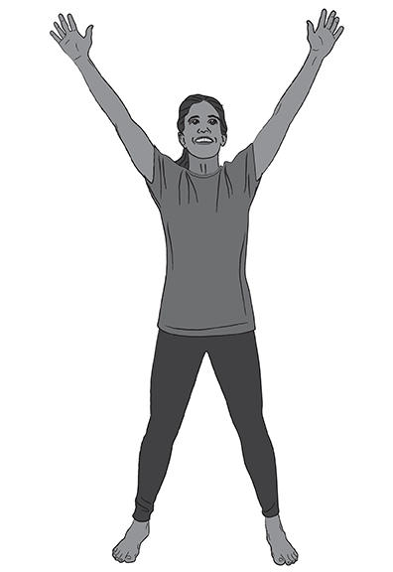
- Sway your leaves and branches in the wind.  (Slowly wave your arms back and forth above your head.) | 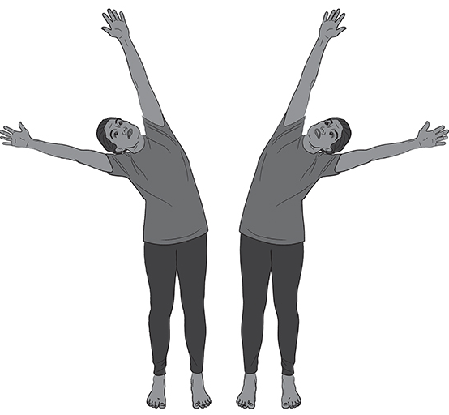

Enjoying Trees Image 2
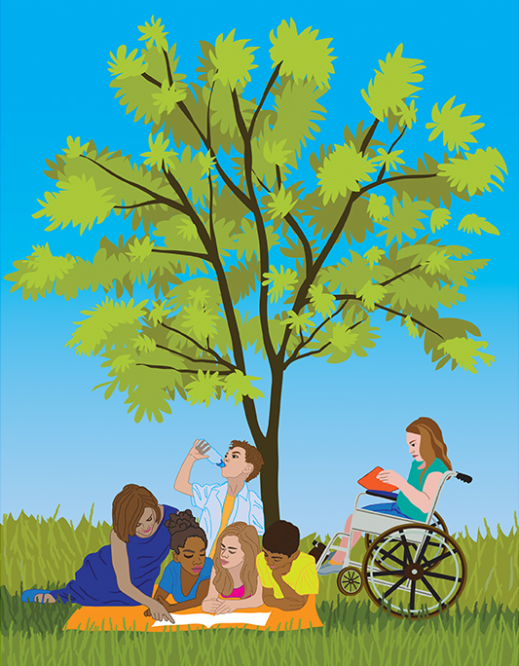
Unit 1 Guiding Question Anchor Chart
(Example, for Teacher Reference)
Note to Teachers: The information added to the anchor chart will be dependent on student ideas. The new information added here in bold is just an example.

Why are trees important to us and our community?
Other people enjoy trees by …
Napping under a tree | 
Smelling a tree | 
Hiding in them for hide and seek | 
Climbing a tree | 
Playing in a treehouse | 
Swinging from the branches
Playing with the flowers
Shaking the seedpods
Planting trees

Image Credits
Pages 3-5. Illustrations by Stacey Posnett for EL Education.

