MODULE LESSONS
Grade 5: Module 3: Unit 2: Lesson 8
Planning a Presentation
Language Arts Curriculum

Model Presentation  (Example, for Teacher Reference)  RI.5.1, RI.5.9, SL.5.4, SL.5.5 | 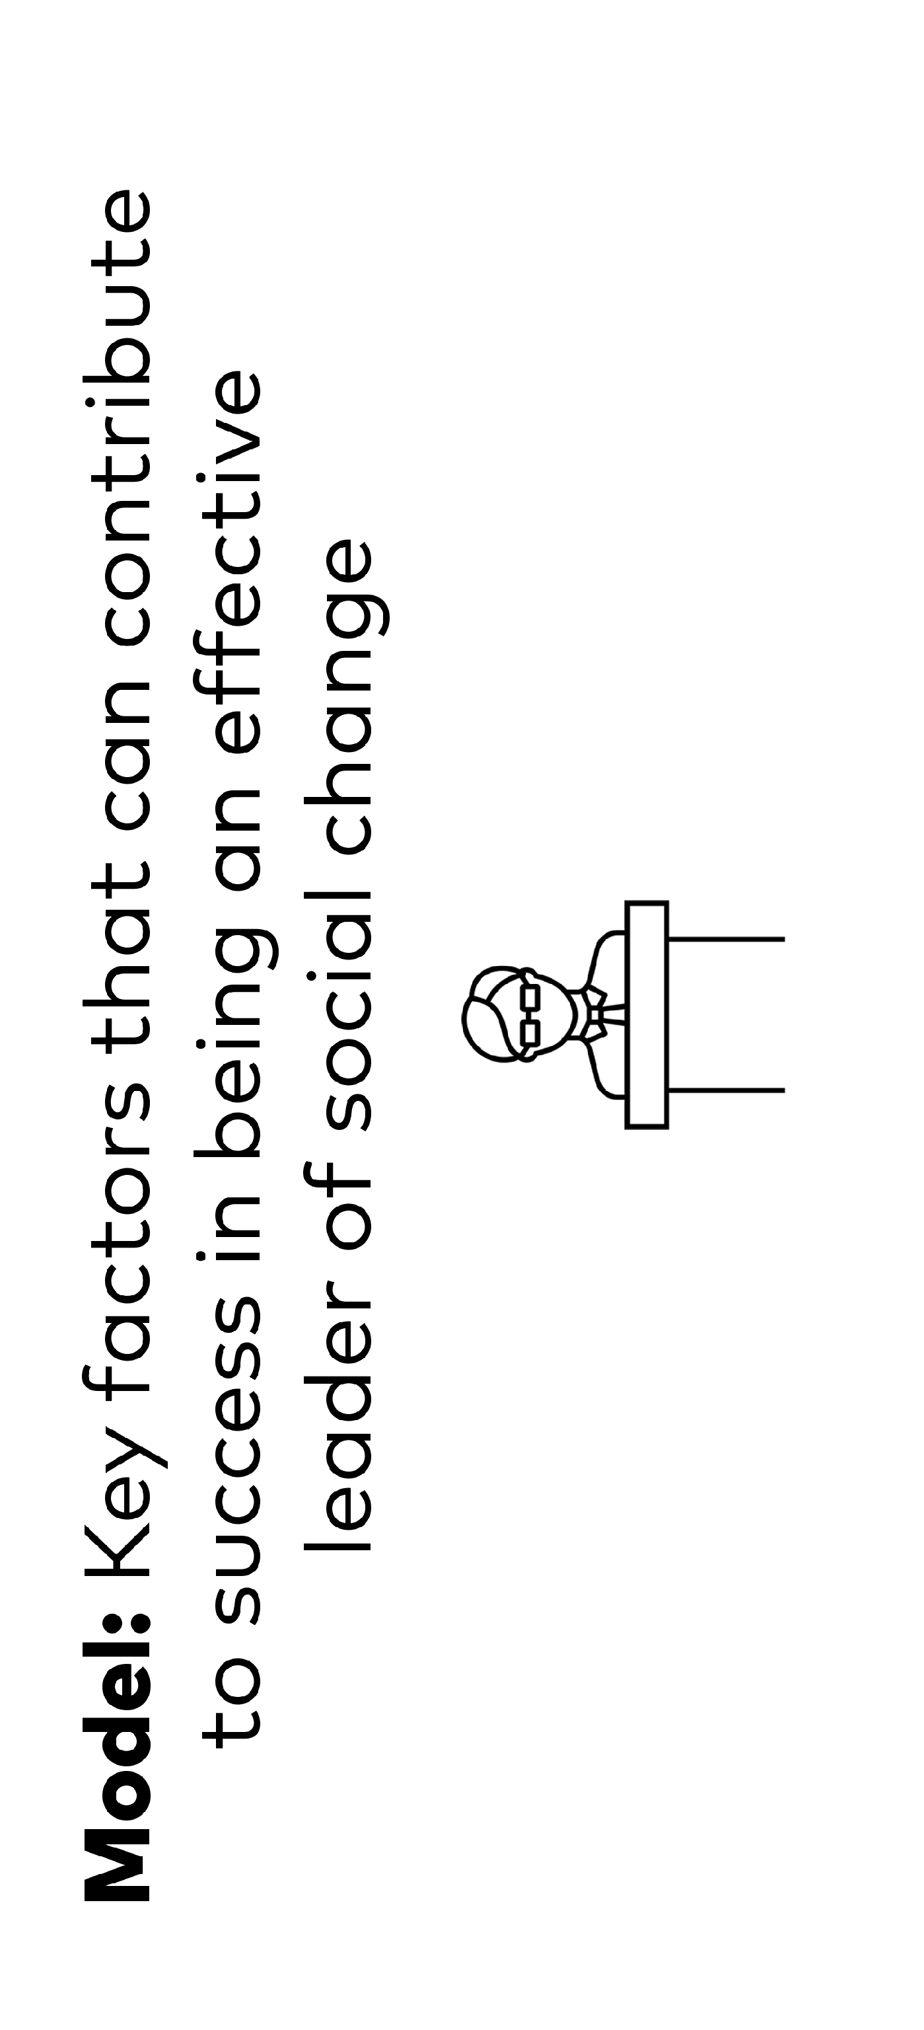

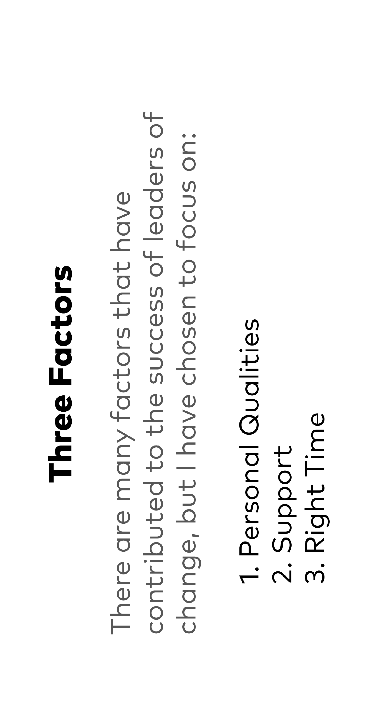




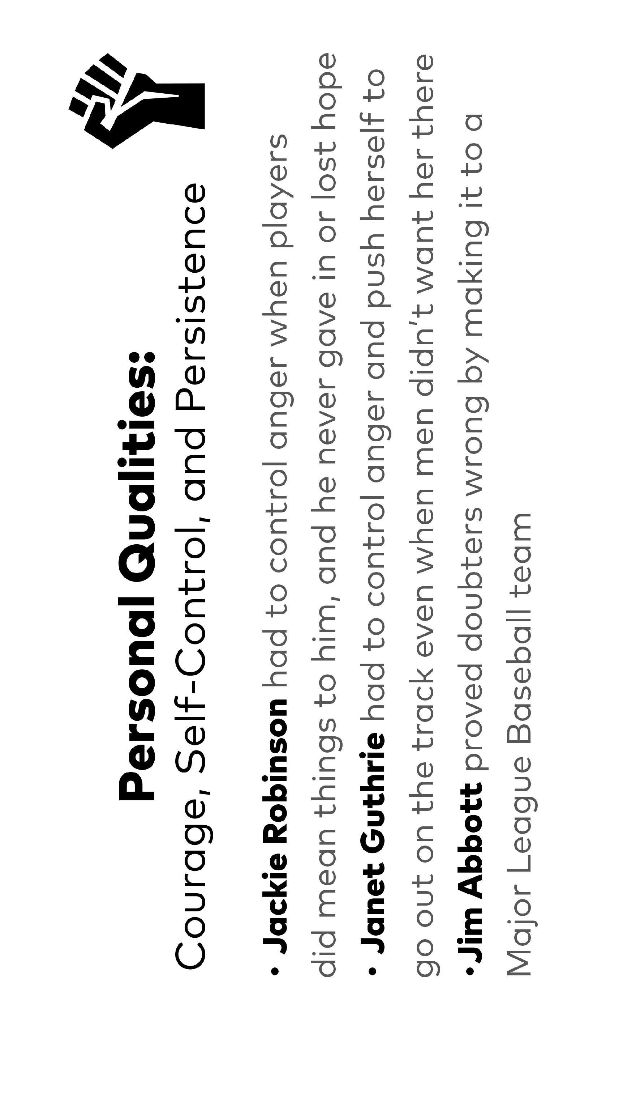


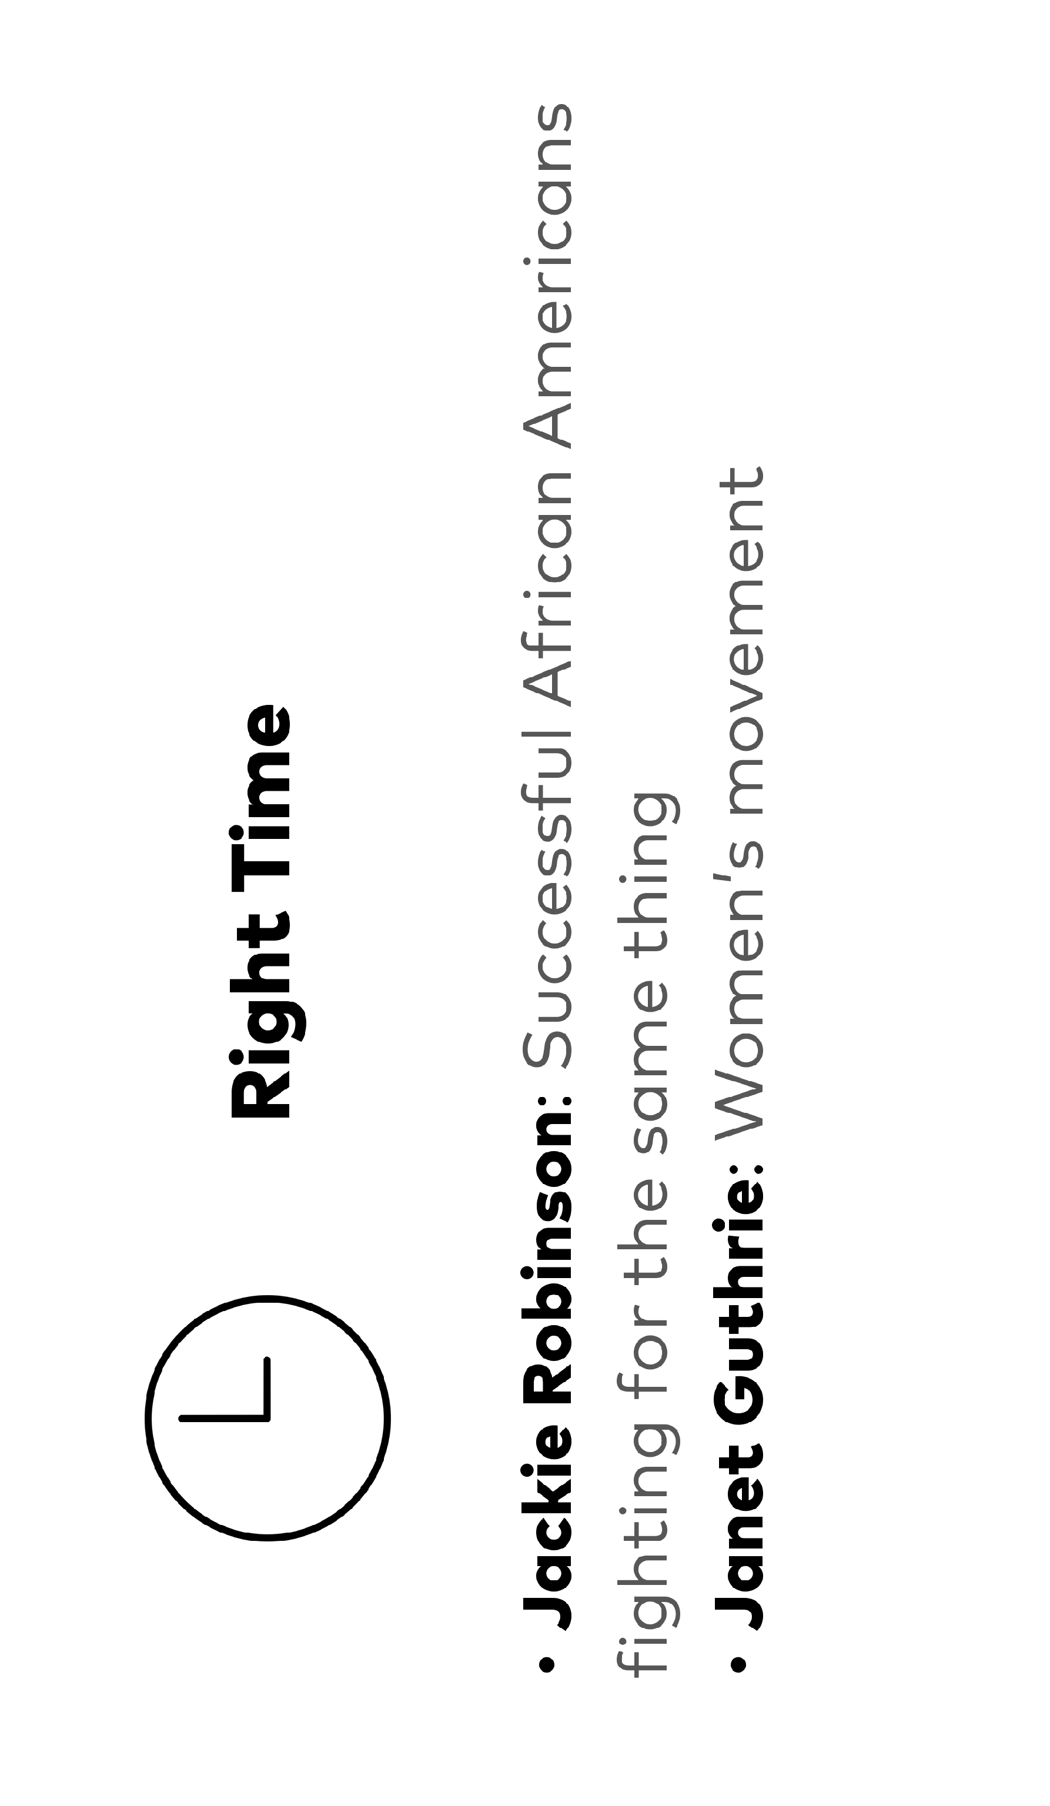
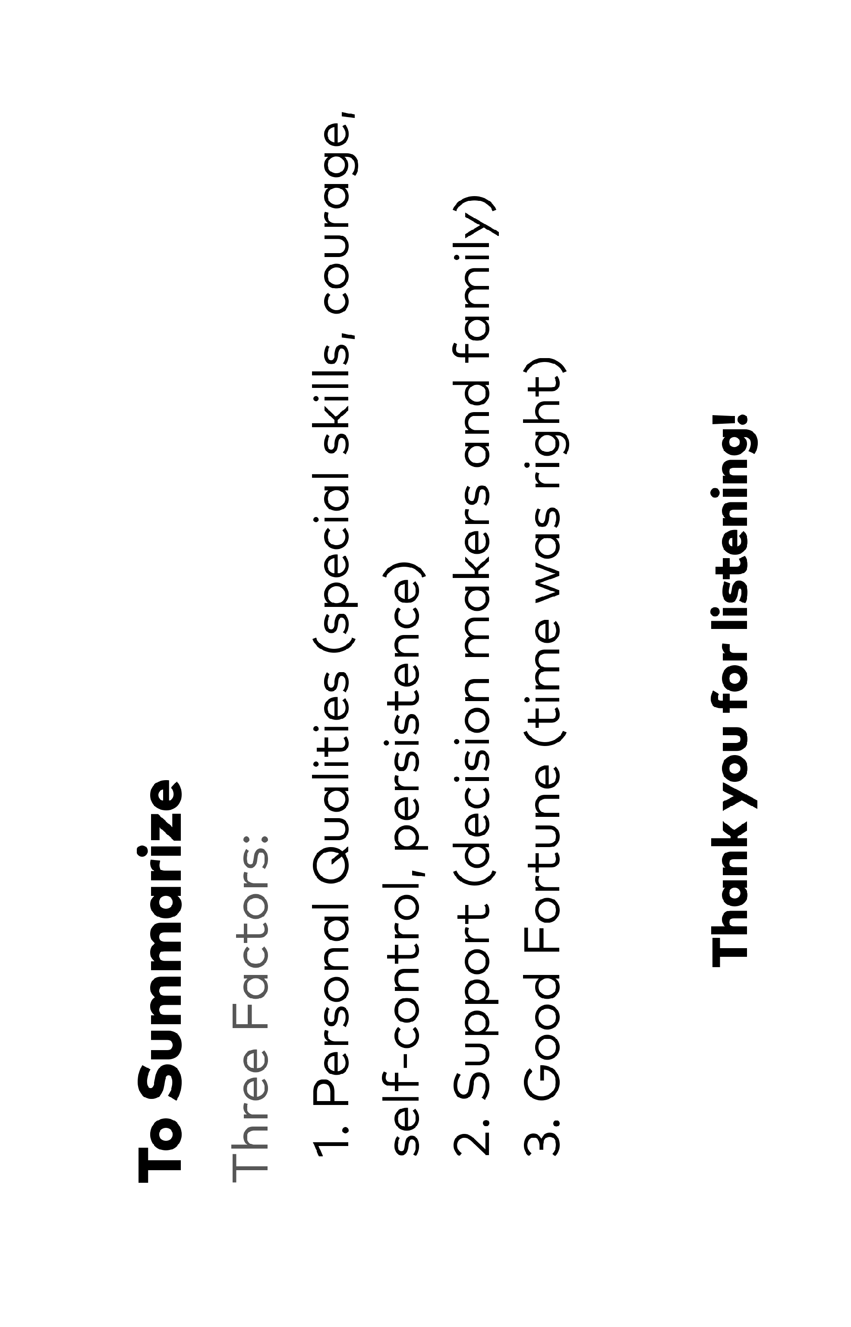

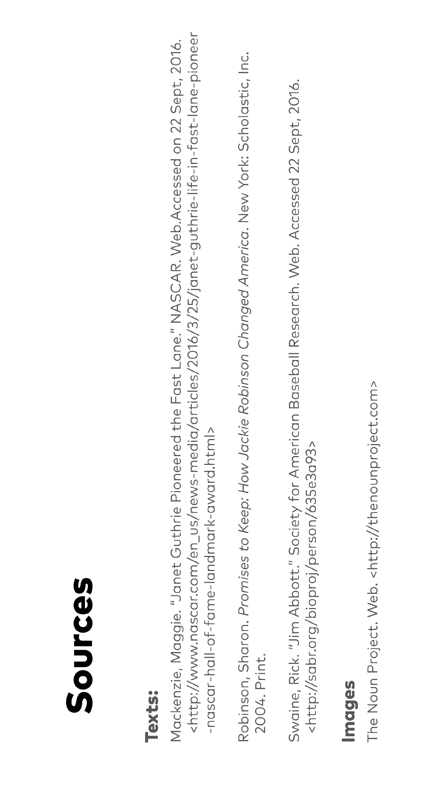

Effective Presentation Anchor Chart
(Example, for Teacher Reference)
RI.5.1, RI.5.9, SL.5.4, SL.5.5
Structure
- Introduces the three factors chosen
- Introduces the athletes chosen as examples, and the sport they are famous for
- Describes the first factor with athlete examples
- Describes the second factor with athlete examples
- Describes the third factor with athlete examples
- Conclusion summarizes the three factors
- Provides a list of sources, including images

Presentation
- Uses slides and notes—doesn’t read from a script
- Eye contact with the audience
- Expressive with face and body language
- Loud enough volume for audience to hear
- Speaking at a pace that is easy to follow

Presentation Planning Graphic Organizer  RI.5.1, RI.5.9, SL.5.4, SL.5.5  Name: ___________________________________________________________ Date: ___________________  What are the key factors that can contribute to success in being an effective leader of social change? | Factors | 1.  2.  3. | Multimedia
 | Factors | 1.  2.  3. | Athlete Examples
 | Factors | 1.  2.  3. | Content
 | Factors | 1.  2.  3. | Slide No.

Multimedia
Athlete Examples
Content
Slide No.

Factors | 1.  2.  3. | Multimedia
Factors | 1.  2.  3. | Athlete Examples
Factors | 1.  2.  3. | Content
Factors | 1.  2.  3. | Slide No.

Multimedia
Athlete Examples
Content
Slide No.

