MODULE LESSONS
Grade 1: Module 3: Unit 3: Lesson 3
Reading and Writing: Expert Birds, Day 1
Language Arts Curriculum

Mystery Bird Riddle Card #3
SL.1.1c, SL.1.3

Note to Teachers: Because students will write their own riddles for the performance task, consider rewriting the text on this card by hand for students to provide a more accurate model.
Mystery Bird Riddle #3
This bird has bright and colorful feathers and a long tail. It has a heavy and sharp beak. Its beak helps it to crush seeds and cut through fleshy fruit. This bird has gripping toes to grab onto branches or to grab fruit or nuts.
What is this bird?
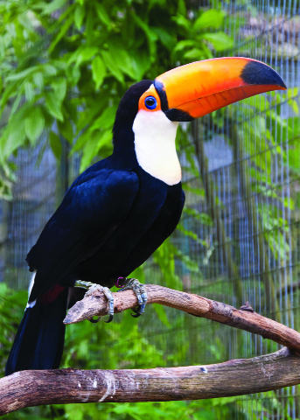  TOUCAN | 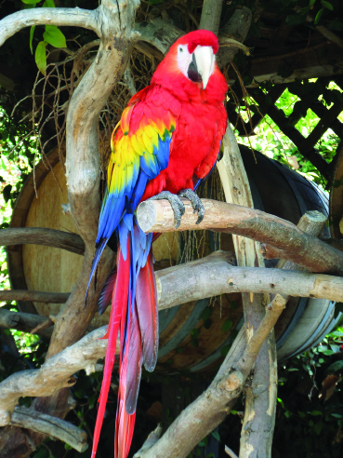  MACAW
Expert Research Groups Chart
(For Teacher Reference)
Note to Teachers: Create a visual to show student groups for Work Time A. Consider using a chart like this:

Hummingbird Group | Woodpecker Group | Blue Jay Group | Pelican Group | Penguin Group | Wood Duck Group
Students | Students | Students | Students | Students | Students
Name (1)  Name (2)  Name (3)  Name (4) | Name (1)  Name (2)  Name (3)  Name (4) | Name (1)  Name (2)  Name (3)  Name (4) | Name (1)  Name (2)  Name (3)  Name (4) | Name (1)  Name (2)  Name (3)  Name (4) | Name (1)  Name (2)  Name (3)  Name (4)
Expert Bird Scientific Drawing Criteria
Anchor Chart
(Example, for Teacher Reference)
Steps to Create a High-Quality
Scientific Drawing
Think about the shapes you see. | 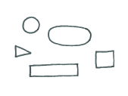
Think about size. | 
Think about placement. | 
Think about details. | 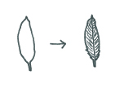
Cardinal Photograph
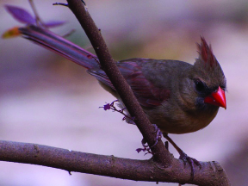
Cardinal Expert Bird Scientific Drawing Card: Teacher Model
(For Teacher Reference)
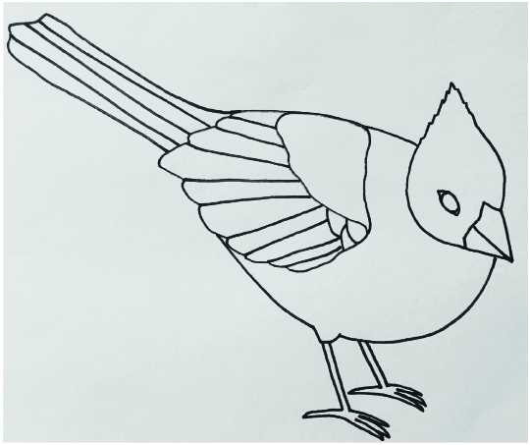
Expert Bird Photographs
Hummingbird Photograph

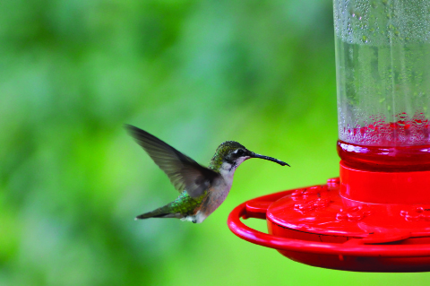
Woodpecker Photograph
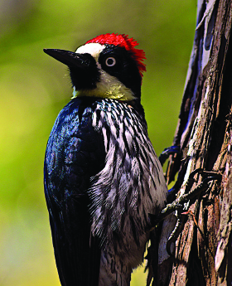
Blue Jay Photograph
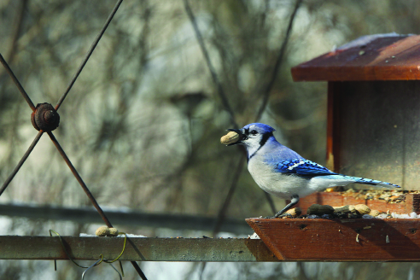
Pelican Photograph
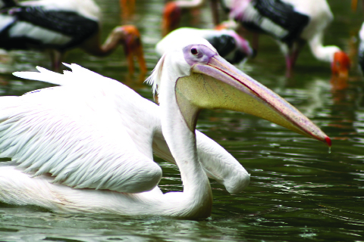
Penguin Photograph
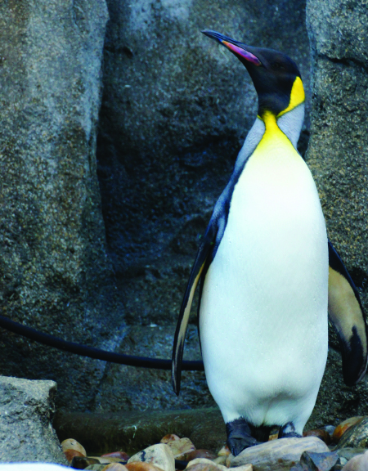
Wood Duck Photograph
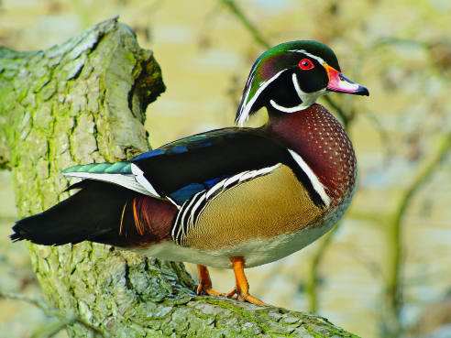

Image Credits
Page 2. Parfitt, Chris. “Toucan.” Photograph. Flickr. 23 May 2011. Web.
Page 2. Dowe, Chuck. “Scarlet Macaw 1.” Photograph. Flickr. 2 Feb 2014. Web.
Page 4. Illustrations by Anna Loring for EL Education.
Page 5. glenn_e_wilson. “Cardinal.” Photograph. Flickr. 30 March 2008. Web.
Page 6. Illustration by Anna Loring for EL Education.
Page 7. likeaduck. “Hummingbird.” Photograph. Flickr. 5 Sept 2010. Web.
Page 8. Wilson, John. “Woodpecker.” Photograph. Flickr. 29 Jan 2015. Web.
Page 9. Engberg, Robert. “Blue Jay.” Photograph. Flickr. 16 March 2013. Web.
Page 10. Ooi, Phalinn. “Pelican.” Photograph. Flickr. 24 Sept 2009. Web.
Page 11. Spragg, Bernard. “King Penguin.” Photograph. Flickr. 21 August 2012. Web.
Page 12. Vassen, Frank. “Wood Duck (Aix sponsa), Parc du Rouge-Cloître, Brussels.” Photograph. Flickr. 11 March 2012. Web.

