Language Arts Curriculum
MODULE LESSONS
Kindergarten: Module 3: Unit 3: Lesson 1
Reading, Speaking, and Listening: Discovering a New Research Topic

Mystery Photos
Note to Teachers: Copy enough photos onto cardstock, in color if possible, for each student to have one or two photos.

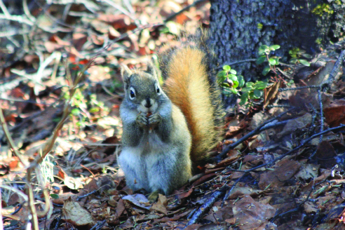 | 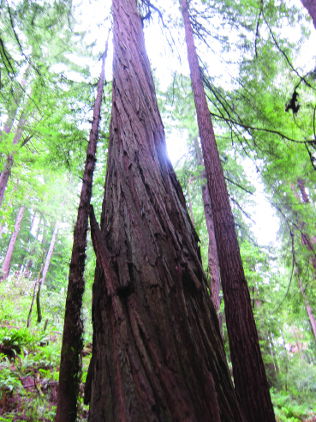
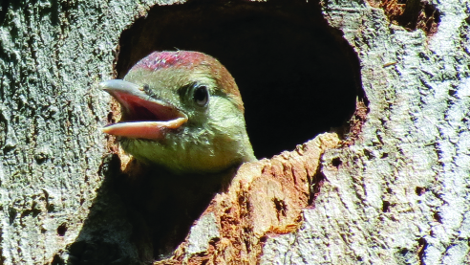 | 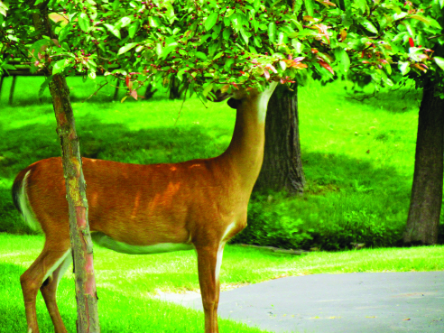
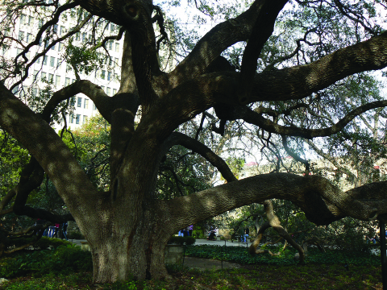 | 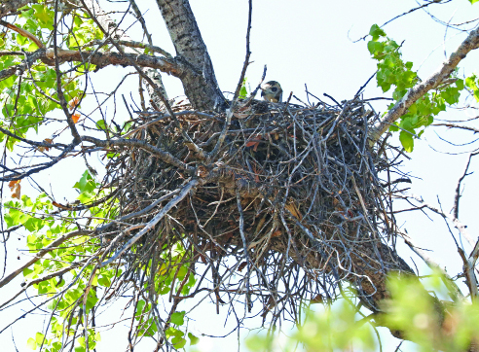
Unit 3 Guiding Question Anchor Chart
(Example, for Teacher Reference)

What patterns can we observe in how living things meet their needs to live and grow?
Language Dive Guide: Are Trees Alive?
(For Teacher Reference)
Notes | Refer to the Language Dive in Module 3, Unit 1, Lesson 5, for detailed notes on how the Language Dive format has been modified starting in Module 3.
Sentence | Instead of using noses and lungs, leaves breathe through thousands of tiny pores known as stomata. (from page 11 of Are Trees Alive? by Debbie S. Miller)
Rationale | This sentence is compelling because it uses academic vocabulary, prepositions, and an adverbial phrase. It addresses L.K.6 by giving them practice using words and phrases acquired through conversation and through text. It connects to the guiding question by providing an example of the NGSS cross-cutting concept of patterns of living things. Students practice using the structure of the sentence to retell key details from the text and to make connections between people and trees. Invite students to discuss each chunk briefly but encourage extended conversation and practice with the focus structure Instead of using noses and lungs. Students apply their understanding of the meaning and structure of the sentence as they learn about how different trees meet their needs throughout the unit. Note that the chunk Instead of using noses and lungs is presented out of order to show that the sentence is about how leaves breathe.
Time | Consider allotting 15 minutes in Lesson 1 and 10 minutes in Lesson 7 for this Language Dive.
Throughout the Language Dive | Follow the same routines found in Module 3, Unit 1, Lesson 5.
Lesson 1:  - Deconstruct  - Reconstruct | Refer to the chunk chart for language goals; display the sentence strip chunks; display and distribute the note-catcher. Follow the same routine found in Module 3, Unit 1, Lesson 3, to assist students in deconstructing, reconstructing, and practicing the chosen sentence.
Lesson 7:
- Deconstruct-Reconstruct
- Practice (Focus Structure and Sentence)
Language Dive Chunk Chart: Are Trees Alive?
(For Teacher Reference)
Lesson 1
leaves breathe
Deconstruct: Language Goals | - leaves: “What is this sentence about?” This sentence is about leaves. Point to the illustration of leaves on page 11 of Are Trees Alive? and display real leaves or pictures of leaves you have collected in the classroom. (subject; plural noun)  - breathe: “What do leaves do?” breathe; take air in and out. (verb)  - Staying seated, students can inhale and exhale deeply and calmly to demonstrate how we breathe air.
through thousands of tiny pores
Deconstruct: Language Goals | - “How do leaves breathe?” The way leaves breathe is using lots of little holes. Note that through is also commonly used to mean from one side to another. Pores are what leaves breathe air through. Pores are openings or holes in the leaves. (prepositional phrase)  - Students can pretend to use a magnifying glass to peer at a leaf through thousands of tiny pores.  - Point to the illustration of tiny holes and the magnifying glass on page 11 of Are Trees Alive?
known as stomata
Deconstruct: Language Goals | - “What do scientists call these tiny pores?” Stomata; known as means the author is going to tell us another name for the tiny pores or holes in the leaves.  - Students can point to the stomata in the pictures in the texts Are Trees Alive? (page 11) and What’s Alive? (page 18).  - Add stomata to the Word Wall. (adjectival phrase)
Instead of using noses and lungs
Deconstruct: Language Goals | - “They breathe through stomata, instead of using what?” noses and lungs, the parts that humans and many animals use to breathe  - “Why did the author use the phrase Instead of?” to say what leaves don’t use to breathe; instead of means in place of or as an alternative. (adverbial phrase)  - noses and lungs: “Why did the author use these words?” noses and lungs are what people and animals use to breathe air in and out. Noses (and mouths) bring the air to the lungs. Students can point to their noses, and then to where their lungs are inside their bodies. Show pictures of noses and lungs. Now we know the author is comparing leaves and trees to people or animals. (noun phrase)  - Explain that this chunk is out of order. Show students that it belongs in the beginning but makes sense both at the beginning and end.  - Students can draw examples of things trees and people both do in different ways. (Instead of arms, trees have branches that hold nests.) Then students share what they have drawn with a partner, using the frame.  - Tell students they will revisit this sentence again in Lesson 7. Over the next few days, students can think about how to use the words instead of to compare how trees and people get their needs met in different ways.
Lesson 7
Instead of using noses and lungs
Deconstruct-Reconstruct | - Using their note-catchers, students review their ideas from Lesson 1 and Think-Pair-Share ideas they thought of to use instead of since the last lesson.  - “How can you say this sentence in your own words?” Leaves take in air, but they do not use noses and lungs. They use tiny pores, or holes called stomata, to breathe.  - “How does this Language Dive add to your understanding of the guiding question?” This sentence helps answer our guiding question by providing a specific example of a pattern that all living things need the same things, in this case, air. It compares how a person breathes with how a tree breathes.
Practice  (Focus Structure) | - Instead of using ______ [tree part], trees have ______ [animal part]. (Instead of using legs, trees have trunks.)  - To provide lighter support: Instead of using ______ [animal part],  trees ______ [action word] using ______ [tree part]. (Instead of using mouths, trees drink using roots.)  - To provide heavier support: Provide a word/phrase bank for students to use when completing the sentence frame.  - Take a moment to clarify how roots are like legs because they help trees stand (page 2), but also like our mouths because they help trees drink water.  - Ask:  - “What tree parts did you write about? What animal parts did you write about? How are they similar and different?” I used roots and mouths. They are similar because they are both used to drink; they are different because one is underground and part of a plant and one is part of an animal.
Instead of using noses and lungs, leaves breathe through
thousands of tiny pores known as stomata.
Practice  (Sentence) | - “Can we say this sentence in a different order? How?” Students can each hold a chunk and switch places to show the sentence in a different, correct order. (Leaves breathe through thousands of tiny pores known as stomata instead of using noses and lungs.)  - To provide lighter support: “Can we divide this sentence into two or more sentences? What do we have to remove or change?” Instead of using noses and lungs, leaves breathe through thousands of tiny pores. These are known as stomata. Add these are at the beginning of the second sentence.  - To provide heavier support: Invite students to discuss the meaning of the sentence in home language groups.  - Language Chunk Wall suggestions:  - Language to compare or contrast: Instead of using noses and lungs,  - Verbs and verb phrases (actions, states of being): leaves breathe  - Language to talk about location (e.g., prepositions): through thousands of tiny pores  - Nouns and noun phrases (people, places, things): known as stomata.
Language Dive Sentence Strip Chunks:
Are Trees Alive?
leaves breathe
through thousands of tiny pores
known as stomata.
Instead of using noses and lungs,
Language Dive Note-catcher: Are Trees Alive?
Name: ___________________________ Date: _____________
Sketch one thing that both trees and people do, but in different ways.

Instead of _________________  __________________________,  (something people have) | trees use ___________________  __________________________.  (something trees have)
Model of Informational Collage
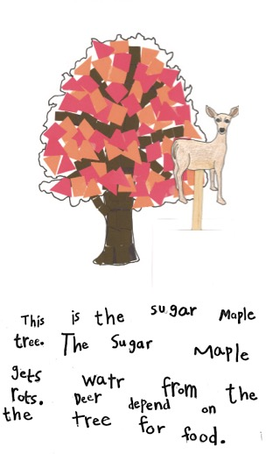

Non-model of Informational Collage
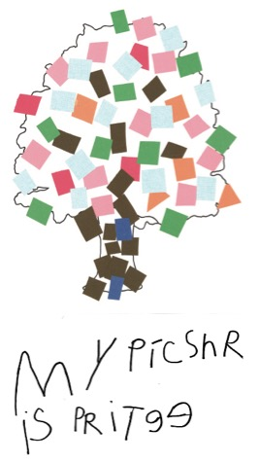
High-Quality Work Anchor Chart
(Example, for Teacher Reference)
W.K.5, W.K.8

Note to Teachers: In the future, more expectations of high quality will be added as they are taught and discussed with students.

High-Quality Work …
- has carefully planned and created artwork
- includes details in the artwork and writing
- is written in your best handwriting

Image Credits
Page 2. Hannawacker, Robb. “Red squirrel.” Photograph. Flickr. 2 May 2009. Web.
Page 2. Lind, Neeta. “IMG_5044.” Photograph. Flickr. 24 June 2013. Web.
Page 2. Kelly. “Gorge Metro Park.” Photograph. Flickr. 5 June 2013. Web.
Page 2. Rogan, Jill. “Deer in Elmira, NY.” Photograph. Flickr. 14 June 2015. Web.
Page 2. Linehan. Peter. “Live oak at the Alamo 2”. Photograph. Flickr. 19 February 2012. Web.
Page 2. Schmierer, Alan. “218 - NORTHERN GOSHAWK (6-3-2016) harshaw road, patagonia mts, santacruz co, az -04.” Photograph. Flickr. 3 June 2016. Web.
Page 2. Virens (Latin for greening). “Acer saccharum - Sugar Maple fall leaves.” Photograph. Flickr. 5 Oct 2009. Web.
Pages 10-11. Models by Anna Loring for EL Education.

