MODULE LESSONS
Grade 2: Module 3: Unit 2: Lesson 9
Small Group Research: Using Photos to Gather Information about Insect Pollinators
Language Arts Curriculum

Entrance Ticket: “It’s Pollination Time”
Name: _________________________ Date: ______________

Directions: Choose an adjective and adverb from the word bank to complete the sentence.

_____________ bees fly _____________ from flower to flower.

Word Bank:
round wing smoothly
head quickly hairy
happily small stinger
Pollinator Photographs: Butterflies and
Moths Photographs #3–6
Note to Teachers: Print and distribute one photo per pair of students in the Butterflies and Moths research group.

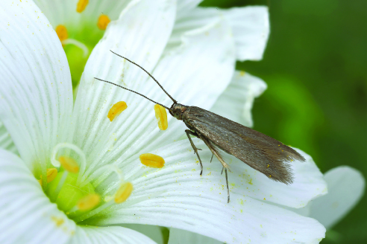

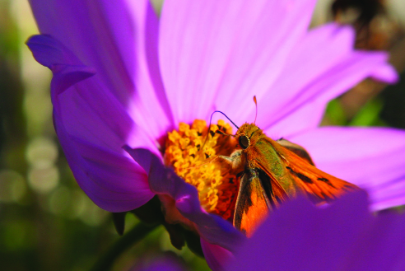

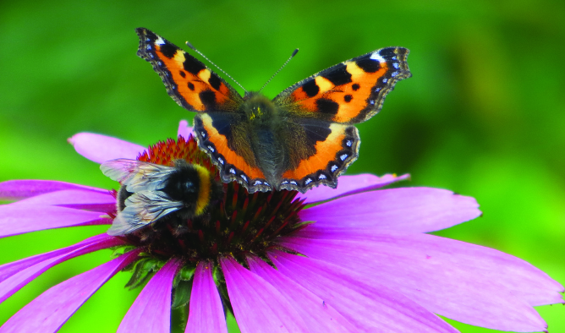

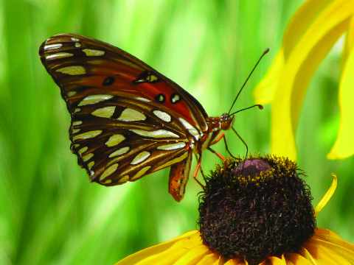
Pollinator Photographs: Flies and Wasps Photographs #3–6
Note to Teachers: Print and distribute one photo per pair of students in the Flies and Wasps research group.

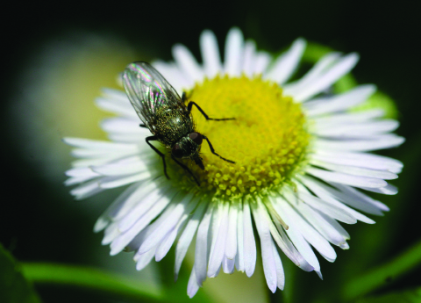

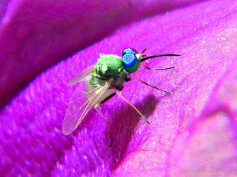
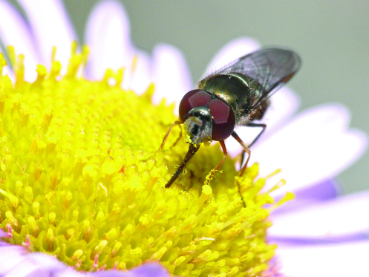

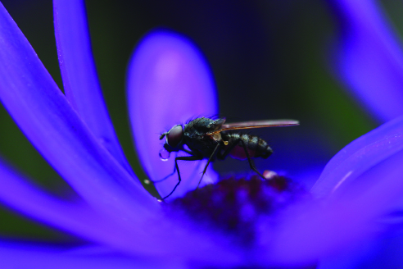
Pollinator Photographs:
Beetles Photographs #3–6
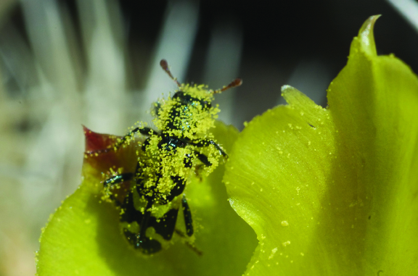

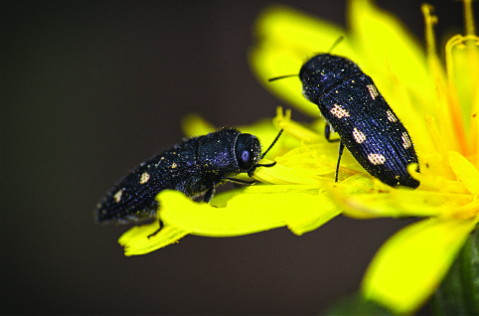
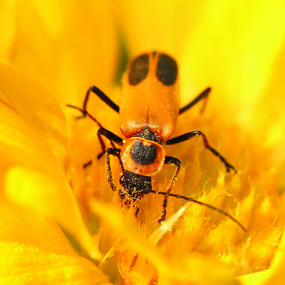

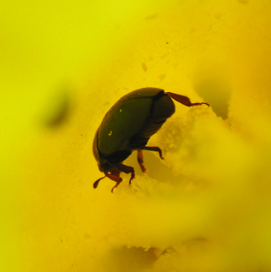
Language Dive Guide III: What Is Pollination?
Notes | Refer to the Language Dive in Module 3, Unit 1, Lesson 8 for detailed notes on how the Language Dive format has changed starting in Module 3.
Sentence | Butterflies and moths have long proboscises, or mouthparts, which can reach the nectar and pollen inside flowers. (from page 18 of What Is Pollination? by Bobbie Kalman)
Language Learning Target | - I can understand and practice using defining unknown words in sentences.  - I can understand and practice using complex English language structures to give information about parts of pollinators.
Rationale | This sentence is compelling and complex because it uses academic vocabulary and a subordinate clause to address the Daily Learning Target, L.2.1e, and L.2.4a, and connects to the guiding question by providing information about pollinators. Invite students to discuss each chunk briefly, but encourage extended conversation and practice with the focus structure have long proboscises, or mouthparts. After discussing this structure, students practice using it to create their own sentences using academic vocabulary. Students apply their understanding of the meaning and structure of this sentence when adding information to their Research about Pollinators: Student Notes and writing their informational paragraphs for the Unit 2 Assessment.
Time | 10 minutes
Throughout the Language Dive | Follow the same routines found in Module 3, Unit 1, Lesson 8.
Deconstruct | Refer to the Language Dive chunk chart for language goals and display the Language Dive sentence strip chunks; display and distribute the Language Dive note-catcher. Follow the same routine found in Module 3, Unit 1, Lesson 8 to assist students in deconstructing, reconstructing, and practicing the chosen sentence.
Practice (Focus Structure)
Reconstruct
Practice (Sentence)
Chunk Chart III: What Is Pollination?
Butterflies and moths
Deconstruct: Language Goals | - “What is this sentence about?” The sentence is about butterflies and moths. (nouns)
have long proboscises, or mouthparts,
Deconstruct: Language Goals | - “What do butterflies and moths have?” long mouthparts  - or mouthparts: “What is the meaning of proboscises? How do we know?” mouthparts; authors sometimes give us clues to the meanings of words in their sentences using the word or.  - long: “How does the author describe these proboscises?” they are long, like pencils or rulers.  - mouthparts: “What two words do you see in this word? What does that make you think this word means?” mouth and parts; parts of the mouth  - Students can sketch butterflies with long mouthparts.
which can reach the nectar and pollen
Deconstruct: Language Goals | - “What does this chunk tell us?” This chunk gives us more information about the proboscises, or mouthparts. The mouthparts can reach nectar and pollen. (relative clause)  - which: This refers to the proboscises. (pronoun)  - Students can pretend their arms are proboscises trying to reach nectar and pollen.
inside flowers.
Deconstruct: Language Goals | - “Where is the nectar and pollen?” This chunk tells us where the nectar and pollen is and where the proboscises can reach. (prepositional phrase)

have long proboscises, or mouthparts,
Practice  (Focus Structure) |  | - __________ have a __________ [academic vocabulary], or __________ [definition].  (Flowers have a stamen, or the male part of the flower that makes pollen.)  - To provide lighter support: Invite students to identify unknown vocabulary words from the text and have them infer the definition, using the sentence frame to write their inferences.  - To provide heavier support: Provide a word bank for students to use when completing the sentence frame.
Butterflies and moths have long proboscises, or mouthparts, which can reach the nectar and pollen inside flowers.
Reconstruct | - “How can you say this sentence in your own words?” Butterflies and moths have long mouthparts, called proboscises, that help them get pollen and nectar.  - “How does this Language Dive add to your understanding of the guiding question?” The sentence helps us understand how parts of pollinators help them pollinate flowers, which helps plants grow and survive.
Practice  (Sentence) | - __________ [pollinator] have __________ [body part], which can __________ [verb phrase]. (Bumblebees have long tongues, which can reach nectar in flowers.  - To provide lighter support: “Can you use an academic vocabulary word in this sentence? How?” (Bumblebees have long tongues, or proboscises, which can reach nectar in flowers.)  - To provide heavier support: Invite students to discuss the meaning of the sentence in home language groups.  - Language Chunk Wall suggestions:  - Nouns and noun phrases (people, places, things): Butterflies and moths  - Adjectives and adjectival phrases and clauses (describing nouns): have long proboscises, or mouthparts  - Language to make references: which can reach the nectar and pollen  - Language to talk about location (e.g., prepositions): inside flowers.
Language Dive Sentence Strip Chunks III:
What Is Pollination?
Butterflies and moths
have long proboscises, or mouthparts,
which can reach the nectar and pollen
inside flowers.
Language Dive Note-catcher III:
What Is Pollination?
Name: _________________________ Date: _______________
Butterflies and moths/ have long proboscises, or mouthparts,/ which can reach the nectar and pollen/ inside flowers.

Sketch butterflies with long mouthparts.

______________________ have a ______________________
or ________________________________________________.
______________________ have ________________________,
which can __________________________________________.
Image Credits
Page 3. Clement, Patrick. “37.002 BF487 Coleophora lutarea.” Photograph. Flickr. 23 May 2016. Web.
Page 3. Morgan, John. “Moth in Violet.” Photograph. Flickr. 22 Sept 2013. Web.
Page 4. Becks. “Red Admiral and a Bee.” Photograph. Flickr. 26 Aug 2013. Web.
Page 4. Nola.Agent. “Butterfly.” Photograph. Flickr. 27 June 2008. Web.
Page 5. Privantu, Radu. “Fly on a Flower.” Photograph. Flickr. 22 June 2008. Web.
Page 5. Peterson, Bob. “Bee Fly with Sapphire Eyes - Tmemophlebia sp.” Photograph. Flickr. 23 June 2016. Web.
Page 6. Taylar, Ingrid. “Pollinator.” Photograph. Flickr. 22 April 2010. Web.
Page 6. Nieminen, Tomi. “Fly.” Photograph. Flickr. 19 August 2012. Web.
Page 7. Martin, Steve L. “Ornate Checkered Beetle.” Photograph. Flickr. 17 April 2010. Web.
Page 7. Portellano, Ram.n. “Bupr.stidos almorzando.” Photograph. Flickr. 25 May 2014. Web.
Page 8. photochem_PA. “Pennsylvania leatherwing beetle, face in pollen.” Photograph. Flickr. 16 Aug 2014. Web.
Page 8. Orangeaurochs. “Pollen beetle at the back of a daffodil, Sandy, Bedfordshire.” Photograph. Flickr. 22 March 2015. Web.

