MODULE LESSONS
Grade 2: Module 3: Unit 2: Lesson 5
Whole Group Research: Using Text to Gather Information about Bees
Language Arts Curriculum

“It’s Pollination Time,” Version 1
L.2.1, L.2.1e

(sung to the tune of “The Farmer in the Dell”)

It’s pollination time.
It’s pollination time.
Heigh ho, the bees all know,
It’s pollination time.
The bees all leave their hive and busily they go
Buzzing to the garden to help the flowers grow.
Black and yellow bees spot flowers and they land
Gently slurping nectar from every part they can.
A sticky pollen spot, a sticky pollen spot:
The bee’s hairy body is caked from bottom to top.
The bees leave hungrily, the hungry bees they leave.
Those bees wildly zig and zag to every flower they see.
It’s pollination time.
It’s pollination time.
Heigh ho, the bees all know,
It’s pollination time.

Written by Julia Handelman for EL Education.
What Researchers Do Anchor Chart
Example, for Teacher Reference

How do we build our research skills and share our learning?
Researchers are curious and take initiative to learn about the world around them. To find out more about it, they…

Ask and search for answers to questions. | 
Share and discuss ideas. | 
Gather information from texts. | 
Observe and record. | 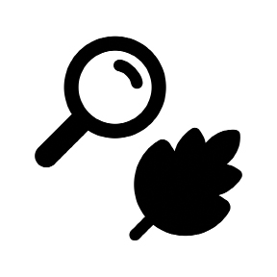
Use models to explain an idea. | 
Take notes to collect information to answer a research question. | 

Research about Bees: Class Notes
Example, for Teacher Reference

Research question: How do pollinators help plants grow and survive?

 | Why this pollinator is attracted to flowers | Body structures that support pollination | How this pollinator moves pollen
Bees | Collect nectar and pollen to eat | Long tongues  Hairy bodies | Carries pollen from flower to flower

Language Dive Guide II:
What Is Pollination?
For Teacher Reference

Notes | Refer to the Language Dive in Module 3, Unit 1, Lesson 8, for detailed notes on how the Language Dive format has changed starting in Module 3.
Sentence | The long-tongued bees are important pollinators of many plants, such as beans, tomatoes, and clover. (from page 17 of What Is Pollination? by Bobbie Kalman)
Language Learning Target | - I can understand and practice using adjectives to describe nouns.  - I can understand and practice using academic English language structures to research and collect information about pollinators.
Rationale | This sentence is compelling because it uses adjectives to help address the Daily Learning Target and L.2.1e, and connects to the guiding question, including information related to how pollinators help plants grow and survive. Invite students to discuss each chunk briefly, but encourage extended conversation and practice with the focus structure The long-tongued bees. Students will apply their understanding of the meaning and structure of this sentence as they take class notes about bees and as they write informational paragraphs for the Unit 2 Assessment.
Time | Consider allotting 10 minutes on Day 1 and 10 minutes on Day 2 for this Language Dive.
Throughout the Language Dive | Follow the same routines found in Module 3, Unit 1, Lesson 8.
Day 1:  - Deconstruct  - Reconstruct | Refer to the chunk chart for language goals; display the sentence strip chunks; distribute the note-catcher. Follow the same routine found in Module 3, Unit 1, Lesson 8 to assist students in deconstructing, reconstructing, and practicing the chosen sentence.
Day 2:
- Deconstruct
- Reconstruct
- Practice (Focus Structure and Sentence)
Chunk Chart II: What Is Pollination?
Lesson 5
The long-tongued bees
Deconstruct: Language Goals | - “What is the sentence about?” The sentence is about bees. (noun phrase)  - “Why does the author use the adjective long-tongued?” To describe the kind of bees the sentence is about. Long describes the tongue of the bee, and together, long-tongued describes the bee. (adjective)  - Students can sketch a long-tongued bumblebee. 
are important pollinators
Deconstruct: Language Goals | - “What do the long-tonged bees do?” They are pollinators; they  pollinate flowers (verb phrase)  - “Why does the author use the adjective important?” to describe the pollinators; to tell us we should care about them because they make a big difference (adjective)
of many plants,
Deconstruct: Language Goals | - “What do these bees pollinate?” many different kinds of plants (prepositional phrase)
such as beans, tomatoes, and clover.
Deconstruct: Language Goals | - “What are examples of the plants these bees pollinate?” beans, tomatoes, clover  - “Why does the author use the phrase such as?” Authors use this phrase to give examples; a similar phrase is for example. (conjunction)  - “Why do you think long-tongued bees pollinate some plants that short-tongued bees do not?” because their long tongues allow them to get the nectar from spaces that short tongues cannot reach.

Lesson 6
The long-tongued bees
Deconstruct-Reconstruct | - “How can you say this sentence in your own words?” Long-tongued bees are important pollinators.  - “How does this Language Dive add to your understanding of the guiding question?” It gives us more information about pollinators that help plants grow and survive.
Practice  (Focus Structure) | - “Can we say bees long-tongued? Why do you think that?” No, in English, adjectives must come before the nouns they describe, not after.  - Can you create some other hyphenated adjectives that might describe effective pollinators? (sticky-bodied insects)  - To provide lighter support:  - “What’s another way of saying this structure?” The bees with  long-tongues, the long-tongued bumble bees  - To provide heavier support:  - “What are some other ways we can describe bees?”
The long-tongued bees are important pollinators of many plants, such as beans, tomatoes, and clover.
Practice  (Sentence) | - “Can we say this sentence in a different order? How?” Students can each hold a chunk and switch places to show the sentence in a different, correct order. (Of many plants, such as beans, tomatoes, and clover, the long-tongued bees are important pollinators.)  - To provide lighter support:  - “Can we divide this sentence into two or more sentences? What do we have to remove or change?” The long-tongued bees are important pollinators. They pollinate many plants, such as beans, tomatoes, and clover. Remove of and begin a new sentence with they pollinate.  - To provide heavier support: Invite students to discuss the meaning of the sentence in home language groups. Add the nouns in  students’ home languages to the Parts of Speech anchor chart.  - Language Chunk Wall suggestions:  - Adjectives and adjectival phrases (describing nouns): The  long-tongued bees/are important pollinators  - Language to talk about belonging: of many plants,  - Language to provide an example: such as beans, tomatoes, and clover.
Language Dive Sentence Strip Chunks II:
What Is Pollination?
The long-tongued bees
are important pollinators
of many plants,
such as beans, tomatoes, and clover.

Language Dive Note-catcher II:
What Is Pollination?
Name: _________________________ Date: _______________
The/ long-tongued bees/ are important pollinators/ of many plants,/ such as beans, tomatoes, and clover.

Sketch a long-tongued bumblebee.

Scientific Drawings Anchor Chart
Example, for Teacher Reference

Note to Teachers: Consider adding examples or picture icons to enhance students’ understanding.

When you draw a scientific drawing, remember to....
- Observe closely before you begin drawing.
- Draw only what you can see.

Bee Photograph #1
Note to Teachers: Print two copies and cut out each image to be used during Work Time C.

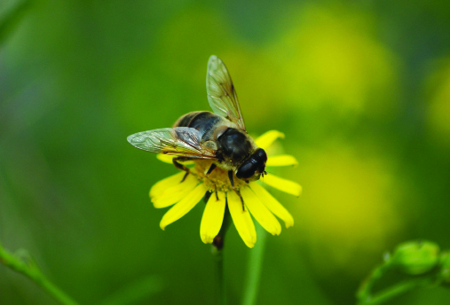

Bee Photograph #2
Note to Teachers: Print two copies and cut out each image to be used during Work Time C.

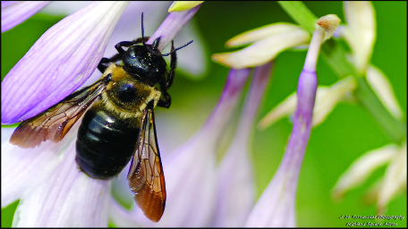

Bee Photograph #3
Note to Teachers: Print two copies and cut out each image to be used during Work Time C.

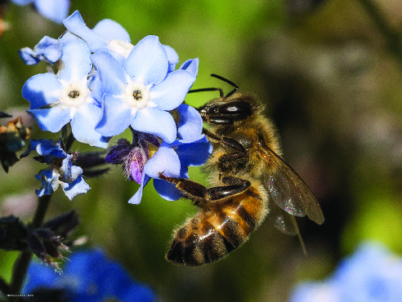

Image Credits
Page 12. Evans, Christopher. “DSC_1045.” Photograph. Flickr. 13 June 2007. Web.
Page 13. Turnauckas, Mark. “Bee Wear.” Photograph. Flickr. 16 July 2010. Web.
Page 14. Elliott, David. “bee.” Photograph. Flickr. 17 May 2014. Web.

