MODULE LESSONS
Grade 2: Module 3: Unit 1: Lesson 6
Unit 1 Assessment: Using Strategies to Read Informational Text
Language Arts Curriculum

Compound Words Anchor Chart
Example, for Teacher Reference

Individual Word #1 | Individual Word #2 | Compound Word | Prediction: “I think the new word means…”
sun | flowers | sunflowers | (sample response) “flowers that look like the sun”
pea | pod | peapod
water | melon | watermelon
blue | berries | blueberries
Picture Card Sets
Note to Teachers: Print and cut one set per pair of students. Consider laminating for future reuse.

sunlight   | air  
water   | roots  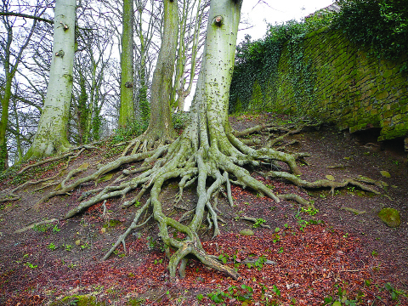
leaves
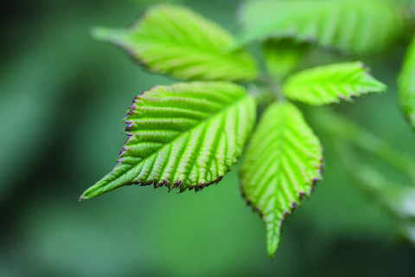

Sentence Frame
Note to Teachers: Print one frame per each pair of students. Consider laminating for future re-use.

Plants need _________________ to _________________.

The ____________________ are the part of the plant that

helps meet this need.

Plants need _________________ to _________________.

The ____________________ are the part of the plant that

helps meet this need.

Plants need _________________ to _________________.

The ____________________ are the part of the plant that

helps meet this need.
Sentence Frame
Example, for Teacher Reference

Sample student responses:

Plants need air to survive. The leaves are the part of the plant that helps meet this need.

Plants need air and sunlight to make food. The leaves are the part of the plant that helps meet this need.

Plants need water to grow. The roots are the part of the plant that helps meet this need.
Plant Frayer Model Anchor Chart
Example, for Teacher Reference

*Possible student responses, based on the information in the text

Definition | Visual | Examples
A living thing | (sketches drawn to show variety of plants in the text) | Trees  Orchids  White water lilies
Characteristics
- Different sizes
- Some grow fruit and flowers
- Can be used for food, clothes, and homes
- Has roots, stems, and leaves
- Most start from a seed
- Need soil, air, water, sunlight, food, and space to grow
- Need air to survive. Leaves help meet this need.
- Need air and sunlight to make food. Leaves help meet this need.
- Need water to grow. Roots help meet this need.

Image Credits
Page 3. Meaden, Jerry. “Sun Over Vancouver.” Photograph. Flickr. 8 September 2014. Web.
Page 3. Lin, Soe. “Jamaica Pond, Boston Straight into the sun, flare colors; Sony NEX 5n, 30mm f3.5 macrolens.: Photograph. Flickr. 30 Oct 2011. Web.
Page 3. Huizing, Ineke. “_MG_7754.jpg.” Photograph. Flickr. 21 Dec 2012. Web.
Page 3. Green, Tim. “Tree roots.” Photograph. Flickr. 25 Feb 2008. Web.
Page 3. Acid Pix. “leaf.” Photograph. Flickr. 26 June 2011. Web.

