MODULE LESSONS
Grade 1: Module 3: Unit 2: Lesson 3
Reading Aloud to Research and Take Notes: Feathers: Not Just for Flying
Language Arts Curriculum

Feathers Simile Anchor Chart
(Example, for Teacher Reference)
Note to Teachers: Create this anchor chart on chart paper. Use the simile icons in the supporting materials for the picture clues.

Feathers can …

Simile |  | Picture Clue
1. | Warm like a blanket | 
2. | Cushion like a pillow | 
3. | Soak up water like a sponge | 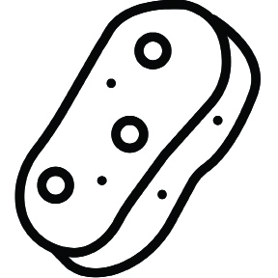
4. | Clean up messes like a scrub brush | 
5. | Distract attackers like a bullfighter’s cape | 
6. | Hide a bird from predators like camouflage clothing | 
Feathers Simile Anchor Chart (continued)
7. | Make high-pitched sounds like a whistle | 
8. | Attract attention like fancy jewelry | 
9. | Dig holes like a backhoe | 
10. | Carry building supplies like a forklift | 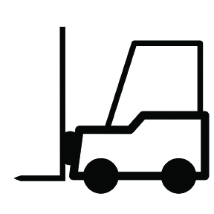
Simile Icons
(For Teacher Reference)
Note to Teachers: Cut out and use the icons below for the Picture Clue column of the Feather Similes anchor chart during the Opening.

What Researchers Do Anchor Chart
(Example, for Teacher Reference)
Note to Teachers: Fill in the new bold rows prior to lesson.

How do we build our research skills and share our learning?
Researchers are curious about the world around them. To find out more about it, they …

Ask questions |  | 
Closely observe |  | 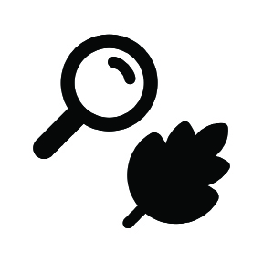
Share and discuss ideas |  | 
Gather evidence from texts |  | 
Look for Titles and Headings | 
Study pictures, photographs, and illustrations | 
Read captions | 
Record observations using drawings and labels |  | 
Find patterns |  | 
Take notes to collect information to answer  a research question |  | 
Share what you learned with others through writing |  | 
Feathers: Class Notes
(Example, for Teacher Reference)
RI.1.2, RI.1.5, RI.1.6, RI.1.7, W.1.7
Note to Teachers: Create this anchor chart on chart paper. Use feather pictures
1–9 for the pictures in the third column.

How do birds use their feathers to survive?
Describe the feather.  The feather is … | How does this feather help the bird survive?  The … | Example  (with picture)
fluffy, soft, warm | Keeps the bird warm | Blue jay
comfortable | Lines nest to keep eggs warm | Wood duck
big and wide | Blocks the sun so the bird can see fish | Heron
thick | Protects from the sun | Red-tailed hawk
bright white | Distracts predators | Dark-eyed junco
colored to match habitat | Hides the bird from enemies | Cardinal
fancy, pretty | Attracts a mate | Peacock
trap air, air-filled | Helps the bird float | Swan
tightly packed, slick | Helps the bird slide across ice and snow | Penguin
Feather Pictures 1–9
(For Teacher Reference)
Note to Teachers: Cut out the following pictures from the extra copy of Feathers: Not Just for Flying. Add these to the Feathers: Class Notes during Work Time A.

Bird | Picture
Blue jay | Feather on page 1
Wood Duck | Feather on page 2
Heron | Feather on page 7
Red-tailed Hawk | Feather on page 1
Dark-eyed Junco | Feather on page 2
Cardinal | Feather on page 2
Peacock | Feather on page 1
Swan | Feather on page 1
Penguin | Feather on page 25

